**Dr. AMBEDKAR INSTITUTE OF TECHNOLOGY**

Near Jnana Bharathi Campus, Bengaluru

-

560 056.

)

An Autonomous Institution, Aided by Government of Karnataka

(

**DEPARTMENT OF COMPUTER SCIENCE AND ENGINEERING**

**Cloud Computing Laboratory Report**

Submitted in the

Partial Fulfilment of

**Cloud Programming Laboratory**

**Course Code:**

**18**

**CSL**

**77**

**No. of Credits: 4 = 4 : 0 :0 (L : T : P)**

Submitted by

**D**

**EEKSHITH**

**S A**

**DA18CS**

**1**

**042**

Submitted to

**Mr. Praveena M V**

**Dept. of CSE**

**Dr.AIT**

**Department of Computer Science &**

**Engineering**

**2021**

**-**

**22**



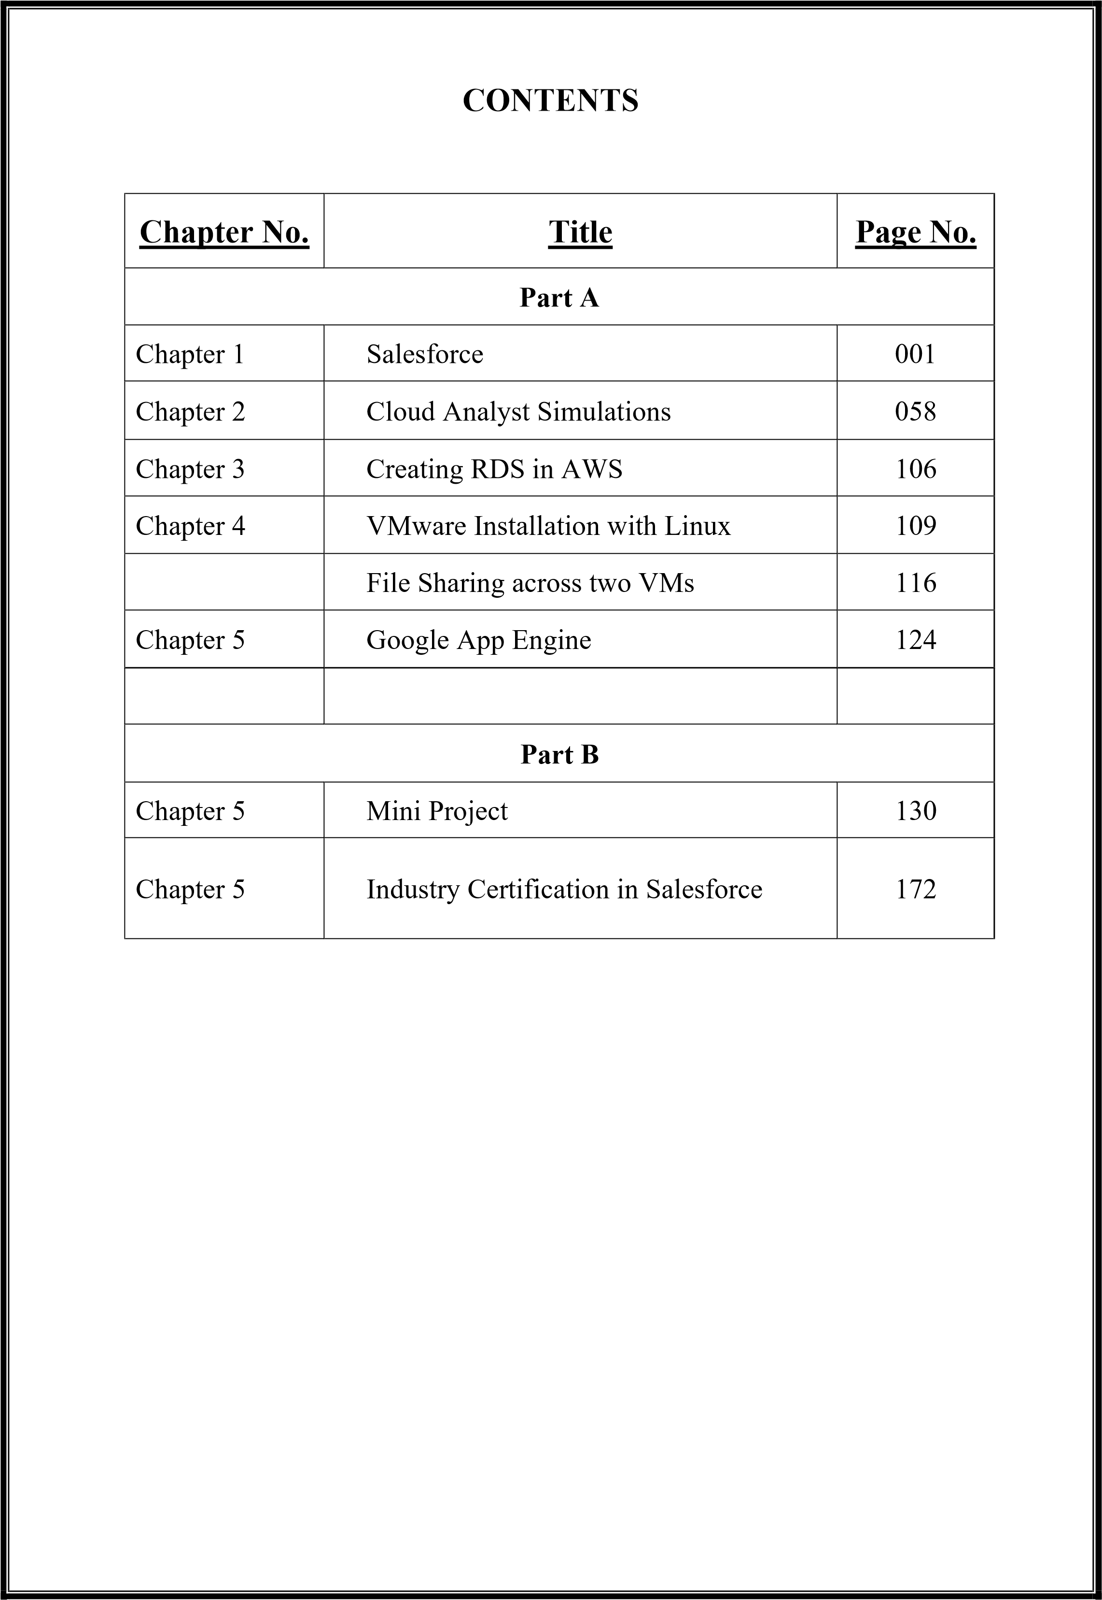

#### SALESFORCE

Salesforce is an American cloud-based software company headquartered in San Francisco, California. It provides customer relationship management (CRM) service and also provides enterprise applications focused on customer service, marketing automation, analytics, and application development.

**History**

The company was founded on February 3, 1999 by former Oracle executive Marc Benioff, together with Parker Harris, Dave Hoelterhoff, and Frank Dominguez as a software as a service (SaaS) company, and was launched publicly between September and November 1999.In June 2004, the company had its initial public offering on the New York Stock Exchange under the stock symbol CRM and raised US$110 million. Early investors include Larry Ellison, Magdalena Yesil, Halsey Minor, Stewart Henderson, Mark Iscaro, and Igor Sill, a founding member of Geneva Venture Partners. In October 2014, Salesforce announced the development of its Customer Success Platform to tie together Salesforce's services, including sales, service, marketing, analytics, community, and mobile apps. In October 2017, Salesforce launched a Facebook Analytics tool for business-to-business marketers. In September 2018, Salesforce partnered with Apple intended on improving apps for businesses. In February 2020, co-chief executive officer Keith Block stepped down from his position in the company. Marc Benioff remained as chairman and chief executive officer. On December 1, 2020, it was announced that Salesforce would acquire Slack form $27.7 billion. The acquisition closed on July 21.In February 2021, Salesforce announced that CFO Mark Hawkins would be retiring from his position after six years of working for the company; however, retaining a position as CFO emeritus until October. Amy Weaver was selected as his replacement.

Salesforce.com's customer relationship management (CRM) service comprises several broad categories: Commerce Cloud, Sales Cloud, Service Cloud, Data Cloud (including Jigsaw), Marketing Cloud, Community Cloud (including Chatter), Manufacturing Cloud, Analytics Cloud, App Cloud, Vaccine Cloud,IoT and Work.com with over 100,000 customers.

**Main services**

Salesforce's main services are tools for case, task and issue management. It also gives customers tracking abilities for their raised cases and conversation features for social networking Web sites, provides analytical tools and other services including email alert, Google search, and access to customers' entitlement and contracts. They also partner with companies like IBM, Accenture, and Saggezza to help integrate Salesforce's cloud-based services into their businesses.

**Lightning Platform**

Lightning Platform (also known as Force.com) is a platform as a service (PaaS) that allows developers to create add-on applications that integrate into the main Salesforce.com application. [failed verification] These third-party applications are hosted on Salesforce.com's infrastructure.

Force.com applications are built using declarative tools, backed by Lightning [further explanation needed] and Apex, a proprietary Java-like programming language for Force.com, as well as Visualforce, a framework including an XMLsyntax typically used to generate HTML. The Force.com platform typically receives three complete releases a year. As the platform is provided as a service to its developers, every single development instance also receives all these updates.

In 2015, a new framework for building user interfaces – Lightning Components – was introduced in beta. Lightning components are built using the open-source Aura Framework but with support for Apex as the server-side language instead of Aura's JavaScript dependency. This has been described as an alternative to, not necessarily a replacement for, Visualforce pages.

As of 2013, the Force.com platform has 1.4 million registered developers. Lightning Base Components is the component library built on top of Lightning Web Components.

**Experience Cloud**

Experience Cloud (formerly Community Cloud) provides Salesforce customers the ability to create online web properties for external collaboration, customer service, channel sales, and other custom portals in their instance of Salesforce. Tightly integrated to Sales Cloud, Service Cloud, and App Cloud, Experience Cloud can be quickly customized to provide a wide variety of web properties. Experience Cloud combines the functionality of the former Salesforce Customer and Partner Portals with some additional features.

**Work.com**

\Work.com, previously Rypple, is a social performance management platform for managers and employees. It allows continuous coaching, real-time feedback, and recognition. It is aimed at sales management, customer service, marketing, and can be utilised by human resource departments.

Work.com, then known as "Rypple", was founded by Daniel Debow and David Stein, to create a simple way of asking for feedback anonymously at work. The company was formed in May 2008 and their client list included Mozilla, Facebook, LinkedIn and the Gilt Groupe. Rypple aims to get employees to build and manage their own coaching networks.

In September 2011, Rypple announced that they had hired Bohdan Zabawskyj as its Chief Technology Officer. In 2011, Rypple developed a more formalized management methodology called OKR ("Objectives and Key Results") for Spotify. Rypple also partnered with Facebook to create "Loops", short for "feedback loops", which gathers feedback from co-workers, including praise, progress against goals, and coaching from supervisors into one channel.

In December 2011, Salesforce.com announced that they would acquire Rypple. The transaction was completed in 2012 and Rypple was rebranded as Work.com in September 2012.

**AppExchange**

Launched in 2005, the Salesforce AppExchange is an online application marketplace for third-party applications that run on the Force.com platform. Applications are available for free, as well as via yearly or monthly subscription models. Applications available range from integrations with SharePoint to mobile approval management. As of June 2016, it features 2,948 applications which have driven 3+ million installs. The "AppExchange" is also a place customers can search for cloud consulting partners to help them implement the technology in their own organization. Cloud consulting partners for Salesforce include large companies like IBM's "Bluewolf" and Accenture as well as smaller ones like Cloudreach.

**MyTrailhead**

Launched in 2019, Salesforce's myTrailhead is an online training platform that can be customized for the specific needs of its customers. The platform extends functionality to provide users with training content specific to their usage of Salesforce and enables them to create and publish their own training content and programs.

**Technologies**

Salesforce is powered by the Model–view–controller architecture.

**Apex**

Apex is a proprietary programming language provided by the Force.com platform to developers similar to Java and C#. It is a strongly typed, object-oriented, case- insensitive programming language, following a dot-notation and curly-brackets syntax. Apex can be used to execute programmed functions during most processes on the Force.com platform including custom buttons and links, event handlers on record insertion, update, or deletion, via scheduling, or via the custom controllers of Visualforce or Lightning Experience pages.

Due to the multitenant nature of the platform, the language has strictly imposed governor limitations to guard against any code monopolizing shared resources. Salesforce provides a series of asynchronous processing methods for Apex to allow developers to produce longer-running and more complex Apex code.

**Lightning**

In 2014, Salesforce made public the front end of its platform, called Lightning. This component-based framework is what the Salesforce mobile app is built on. Salesforce built on this framework in 2015 by releasing the Lightning Design System, an HTML style framework with default CSS styling built in. This framework allows customers to build their own components to either use in their internal instances or sell on the AppExchange.

Lightning Experience, released in 2016, is the new redesigned interface in Salesforce for processes enhancement. Since then all the apps available on AppExchange need to be Lightning and those built on Classic have to migrate to Lightning as Classic is not to be updated any more by Salesforce. The platform offers an option for developers to employ migration techniques to enable the new user-friendly interface and switch to Lightning.

**What is Salesforce used for?**

* Engage customers with relevant, empathetic digital marketing from anywhere.
* Sell smarter and grow your business faster from anywhere.
* Quickly launch and scale ecommerce built around your customer — from anywhere.
* Provide great customer service from anywhere.
* Go digital fast and empower your teams to work from anywhere.

**Part A - 1A - Creation of web applications on Salesforce Cloud Platform**

#### Q1) Create a web application to enter student details like Name, USN, Semester, Section and CGPA to a database on Salesforce Cloud Platform

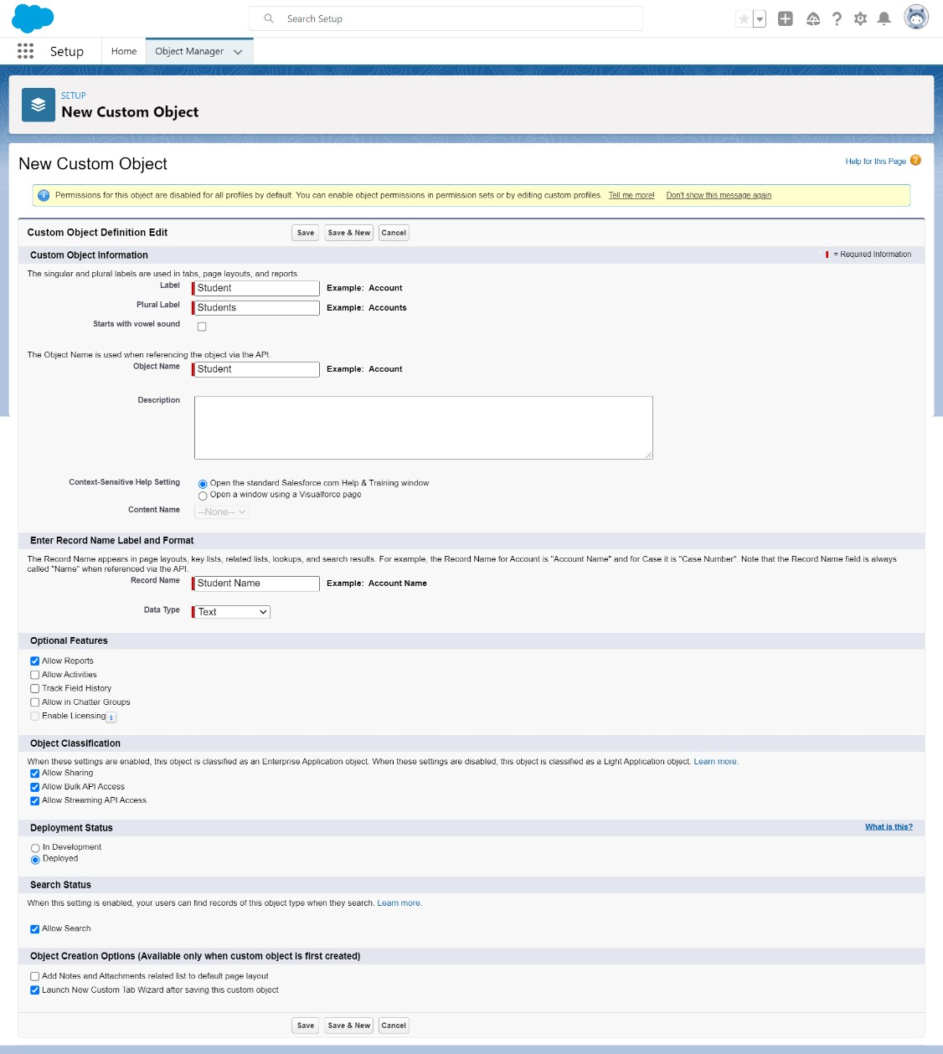

1. Launch your Salesforce Trailhead Playground by opening any module and Switch to Lightning Experience if you are currently in Salesforce Classic by clicking your picture in the right top corner and then click on “Switch to Lightning Experience”.
2. Then go to Setup gear icon and click “Setup”.
3. Click on “Object Manager” and click “Create> Custom Object” to create new Custom Object.
4. Name the object “Student”.
5. Allow Reports and Allow Search.
6. Check the box in front of “Launch New Custom Tab Wizard after saving this custom object”.
7. To create a Tab for the Object: Select any Tab Style for the object “Student”. Click Next, Next, leave the defaults and save.

To add fields to the Object: Go to “Fields & Relationships” option of Student object and Click “New”.

Add the following fields one after the other:

* 1. Field Label: USN (Length 10), Data Type: Text, provide an example USN as Help Text, make it as Required Field and Don’t allow Duplicate Values and make it as Case Insensitive.
  2. Field Label: Section (Length 1), Data Type: Text, make it as Required Field.
  3. Field Label: Semester (Length 1, Decimal Place 0), Data Type: Number, make it as Required Field.
  4. Field Label: CGPA (Length 2, Decimal Places 2), Data Type: Number, make it as Required Field.

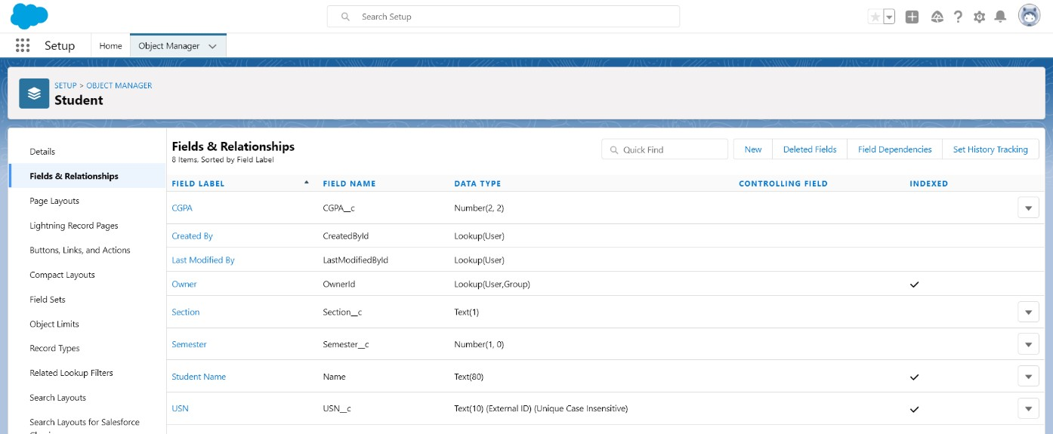

**Semester Validation:**

To add a rule to the Semester so that it should always be greater than 0 and less than or equal to 8:

* 1. Go to Validation Rule of Student Object and click “New”.
  2. Name it as “Semester validation”.
  3. Error Condition Formula: OR (Semester__c >8, Semester__c <=0).
  4. Error Message: Please Enter a Semester from 1-8.
  5. Error Location: Field – Semester.
  6. Click Save.

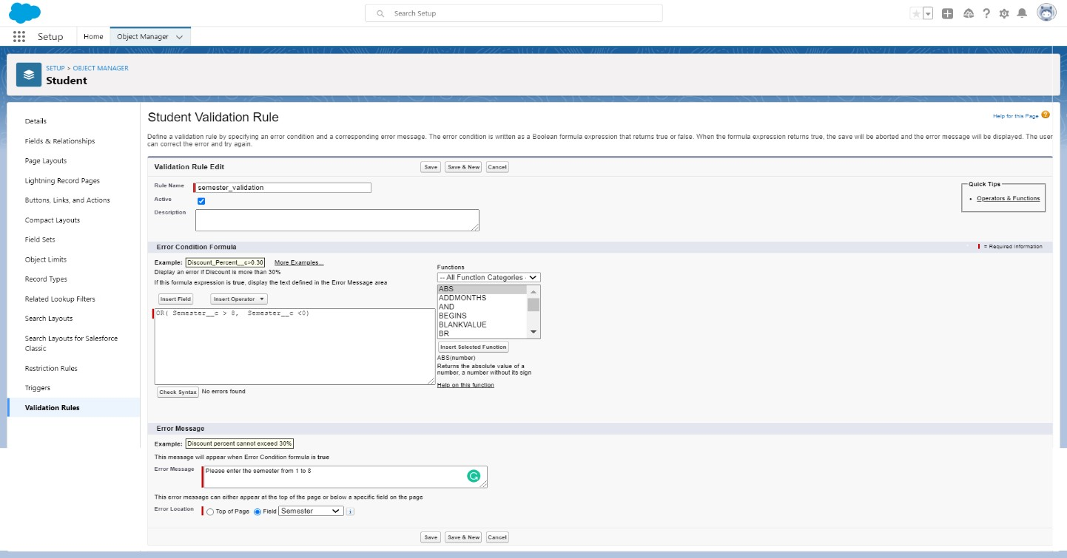

**CGPA Validation:**

To add a rule to the CGPA so that it should not take CGPA greater than 10:

1. Go to Validation Rule of Student Object and click “New”
2. Name it as “CGPA validation”.
3. Error Condition Formula: CGPA__c > 10 4. Error Message: Please Enter a Correct CGPA.
4. Error Location: Field –CGPA
5. Click Save

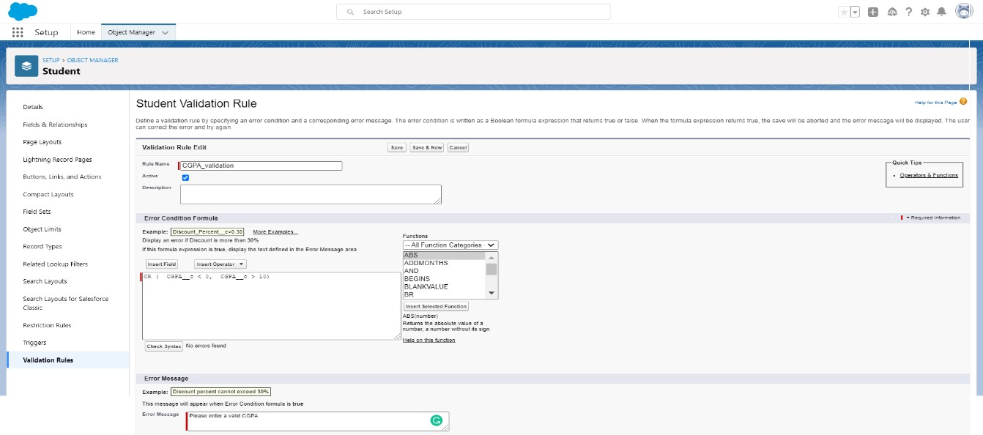

**USN Validation:**

To add a rule to the USN so that it should validate only student’s serial number.

1. Go to Validation Rule of Flight Object and click “New”
2. Name it as “USN Validation”.
3. Error Condition Formula: NOT(REGEX(USN__c,"[1-5]{1} +[A-Z]{2} + [0-9]{2} +[A-Z]{2} + [09]{3}"))
4. Error Message: Please enter a valid USN. 5. Error Location: Field – USN

6. Click Save.

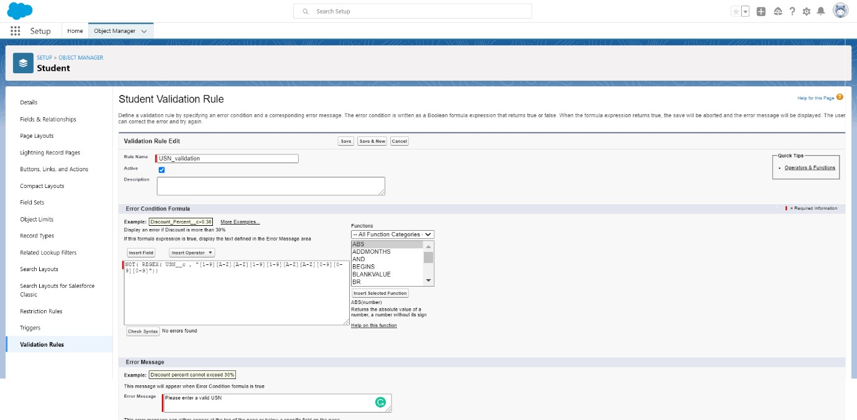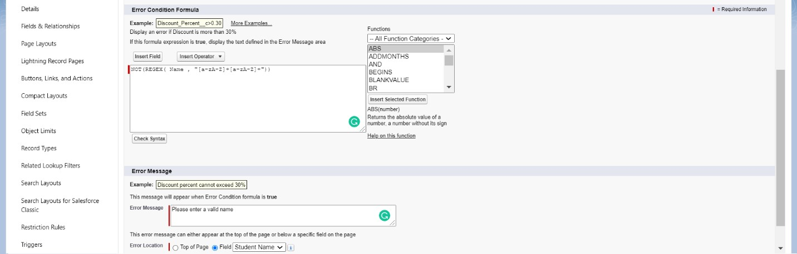

**Name validation:**

1. To add a rule to the Student Name so that the name should only start with letter but not digit:
2. Go to Validation Rule of Student Object and click “New”
3. Name it as “Student Name Validation”
4. Error Condition Formula: “NOT (REGEX (Name,"[a-z A-Z]+[a-z A-Z]+"))”
5. Error Message: “Please Enter a valid name”.
6. Error Location: Field –Student Name.
7. Click Save.

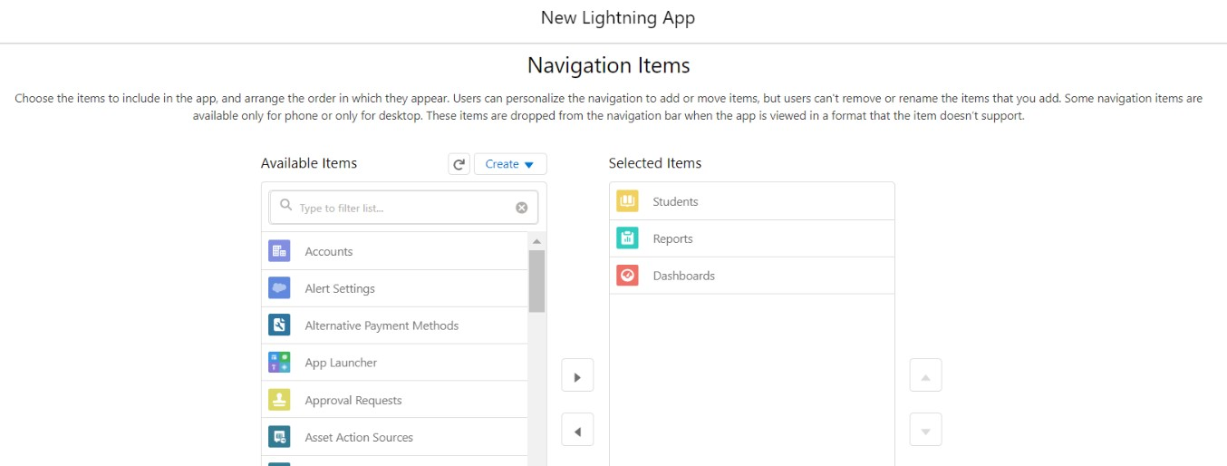

**To create an application:**

1. Go to “Setup” and type “App Manager” in Quick Find Box.
2. Click on “New Lightning App” to create a Lightning Application.
3. Name it as “Student Details”, give the description for your application.
4. Uploading Image and changing colours are optional, then click Next.
5. Navigation Style: Standard Navigation, click Next.
6. No need to add any Utility Bar, click Next.
7. Add the following Items: Students, Reports and Dashboards, click Next.
8. Assign it to System Administrator Profile by selecting System Administrator and pressing right arrow and then click Save & Finish.
9. Go to App Manager, select your application and select Students and click “New” to add some details to your application.

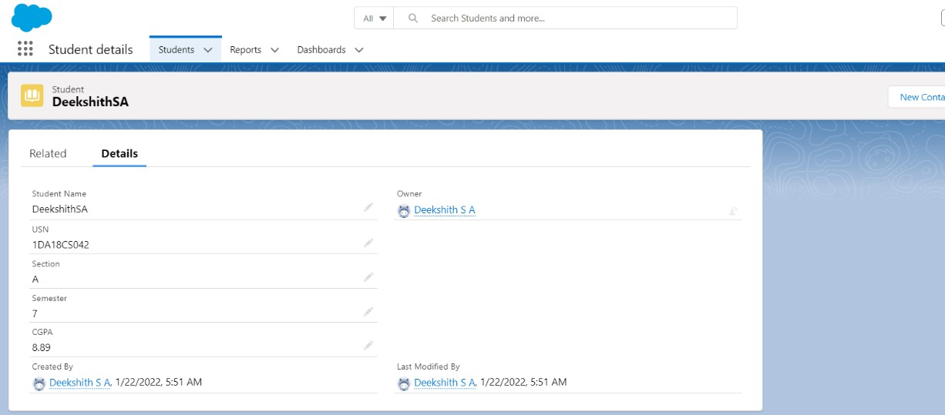

Make sure you will get error messages when you give invalid Name, USN, Semester and CGPA.

**Reports and Dashboards:**

To Create a Students Report:

1. Go to “Reports tab” Click on “New Folder” And give it any name and Click Save.
2. Click on “New Report” and from search bar Search for “Students” and then select it and then click continue.
3. Add the required Columns to get the Completed Entered data.
4. If you Want the report to be grouped by any specific Fields then Search for the field in “Add groups” otherwise it is optional.
5. Click on save and name the report as “New Students Report” and then select the folder which you have created.
6. Click Save and then Click Run

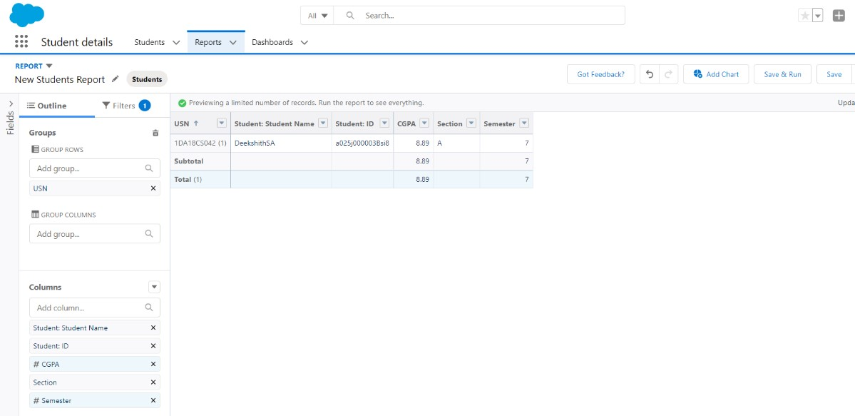

To Create a Students Dashboard:

1. Go to “Dashboard tab” and then click on “New Folder” and give it any Name.
2. Click on “New Dashboard” and then name it as “Students Dashboard” and select folder that you have created Click on Create.
3. Click on the report that you have created and click on that and click select.
4. Select any style to represent the data in dashboard.
5. Add any filter(s), otherwise it is optional.
6. Click on Save and Click Run.

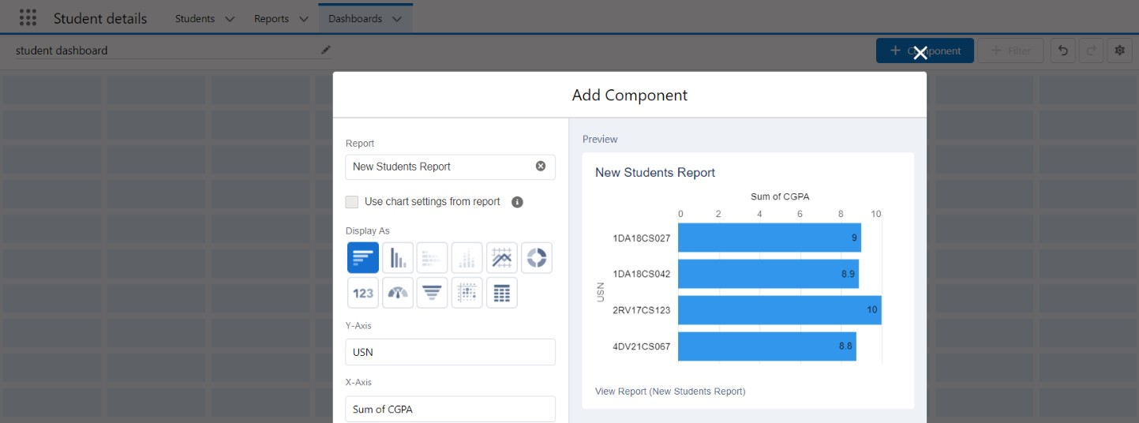

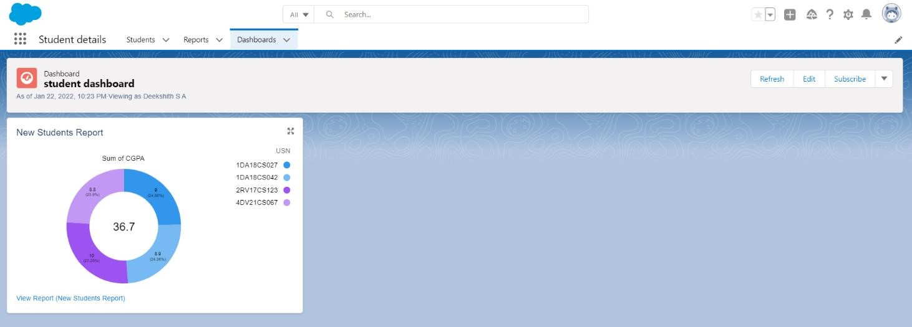

**Q2) Create a Web Application to implement an online cart for adding items to a shopping cart and deleting it.**

Launch your Salesforce Trailhead Playground by opening any module and Switch to Lightning Experience if you are currently in Salesforce Classic by clicking your picture in the right top corner and then click on “Switch to Lightning Experience”.

Then go to Setup gear icon and click “Setup”.

Click on “Object Manager” and click “Create> Custom Object” to create new Custom Object.

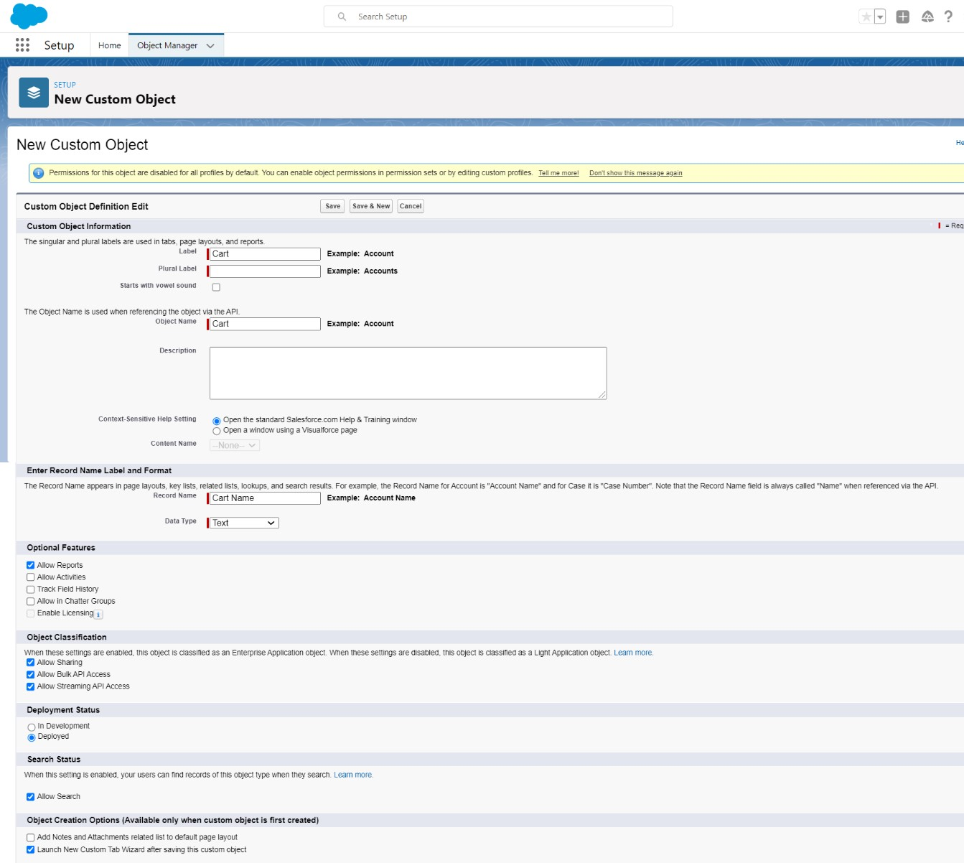

1. Name the object “Cart”.
2. Allow Reports and Allow Search.
3. Check the box in front of “Launch New Custom Tab Wizard after saving this custom object”
4. To create a Tab for the Object: Select any Tab Style for the object “Cart”. Click Next, Next, leave the defaults and save.

To add fields to the Object:

Go to “Fields & Relationships” option of cart object and Click “New”.

Add the following fields one after the other:

* + Field Label: Item Name, Data Type: Text Area, make it as Required Field.

•

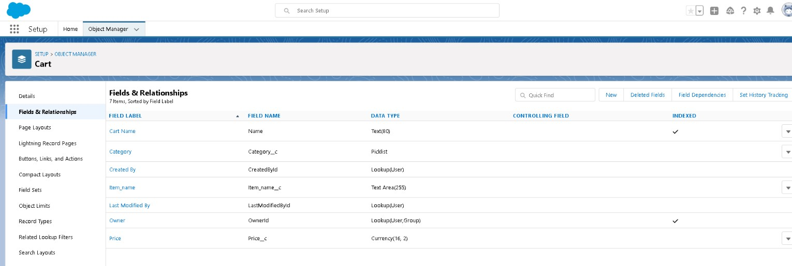

* + Field Label: Category, Data Type: Picklist, click radio button in front of Enter values, with each value separated by a new line value are: Books, Electronics & Accessories, Furniture & Home Appliances, Fashion – Men, Fashion – Women, Fashion – Kids, Footwear and Others.
  + Make it as Required Field and Restrict the values to the values in the picklist.
  + Field Label: Quantity, Data Type: Number, make it as Required Field.
  + Field Label: Price, Data Type: Currency (Length 16, Decimal Places 2), Make it as Required Field.

**To create an application:**

1. Go to “Setup” and type “App Manager” in Quick Find Box.
2. Click on “New Lightning App” to create a Lightning Application.
3. Name it as “Online Shopping Cart”, give the description for your application.
4. Uploading Image and changing colours are optional, then click Next.
5. Navigation Style: Standard Navigation, click Next.
6. No need to add any Utility Bar, click Next.
7. Add the following Items: Carts, Reports and Dashboards, click Next.
8. Assign it to System Administrator Profile by selecting System Administrator and pressing right arrow and then click Save & Finish.
9. Go to App Manager, select your application and select Carts and click “New” to add some details to your application.

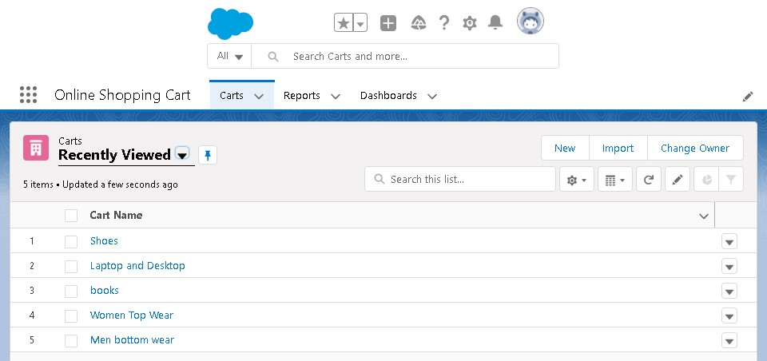

**Reports and Dashboards:**

To Create a Carts Report:

1. Go to “Reports tab” Click on “New Folder” And give it any name and then click Save.
2. Click on “New Report” and from search bar Search for “Carts” and then select it and click Continue.

• Add the required Columns to get the Completed Entered data.

1. If you Want the report to be grouped by any specific Fields then Search for the field in “Add groups” otherwise it is optional.
2. Click on save and name the report as “New Carts Report” and then select the folder which you have created.
3. Click Save and then Click Run

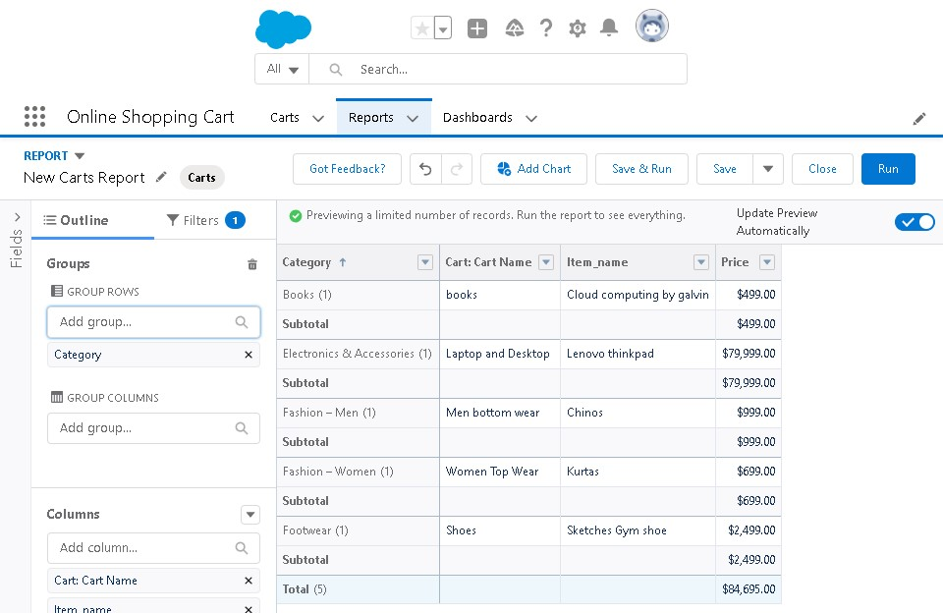

To Create a Carts Dashboard:

1. Go to “Dashboard tab” and then click on “New Folder” and give it any Name.
2. Click on “New Dashboard” and then name it as “Shopping cart” and select folder that you have created Click on Create.
3. Click on the report that you have created and click on that and click select.
4. Select any style to represent the data in dashboard.
5. Add any filter(s), otherwise it is optional.
6. Click on Save and Click Run

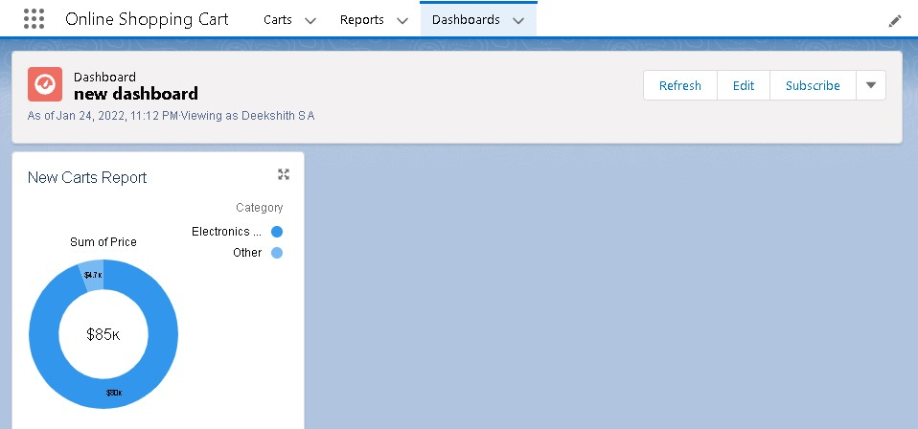

**Q3) Create a web application to enter the faculty details like faculty ID, faculty name, and salary to a database and calculate the income tax to be paid by the faculty at the end of the financial year.**

Launch your Salesforce Trailhead Playground by opening any module and Switch to Lightning Experience if you are currently in Salesforce Classic by clicking your picture in the right top corner and then click on “Switch to Lightning Experience”.

Then go to Setup gear icon and click “Setup”.

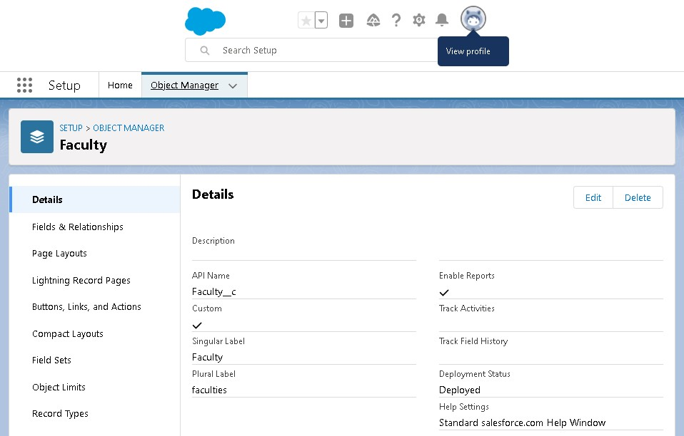

1. Click on “Object Manager” and click “Create> Custom Object” to create new Custom Object.
2. Name the object “Faculty”
3. Allow Reports and Allow Search.
4. Check the box in front of “Launch New Custom Tab Wizard after saving this custom object”
5. To create a Tab for the Object: Select any Tab Style for the object “Faculty”. Click Next, Next, leave the defaults and save.

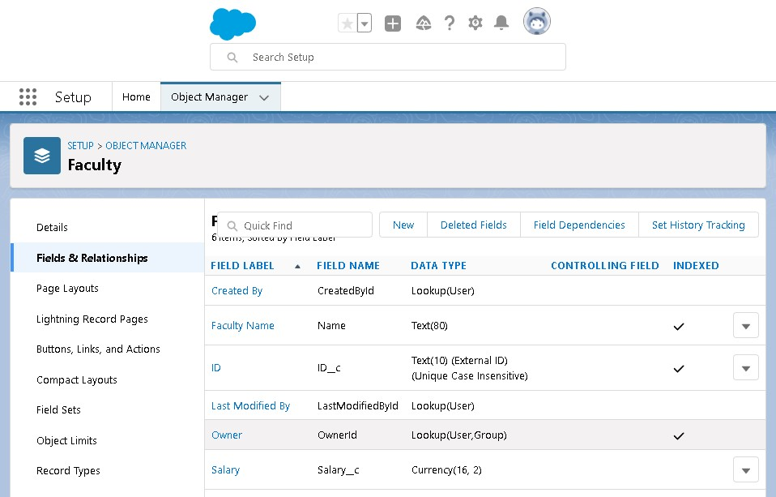

To add fields to the Object:

Go to “Fields & Relationships” option of Student object and Click “New” Add the following fields one after the other:

* Field Label: ID (Length 10), Data Type: Text, provide an example ID as Help Text, make it as Required Field, don’t allow Duplicate Values, make it as Case Insensitive and Set this field as the unique record identifier from an external system
* Field Label: Salary, Data Type: Currency (Length 16, Decimal Places 2), Make it as Required Field

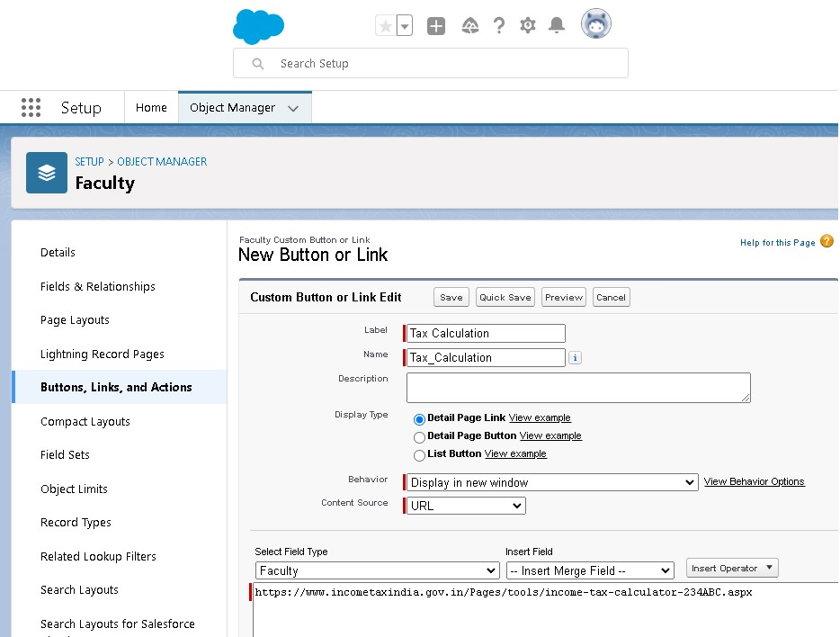

To calculate Income Tax to be paid:

1. Go to “Buttons, Links and Actions” of Faculty Object and click “New Button or Link”
2. Name it as “Tax Calculation”
3. Select the radio button “Detail Page Link” as it is a website link.
4. Behaviour: Display in new window.
5. Content Source: URL.
6. Field Type: Faculty
7. In the empty space provided, type https://www.incometaxindia.gov.in/Pages/tools/income-taxcalculator-234ABC.aspx
8. It is a link which redirects to the income tax calculation website.
9. Link Encoding: Unicode (UTF-8).
10. Click Save
11. Go to Page Layout, Click Faculty Layout.
12. Click Custom Links, Drag and drop the “Tax Calculation” link in the Custom Link area. 13. Click Save

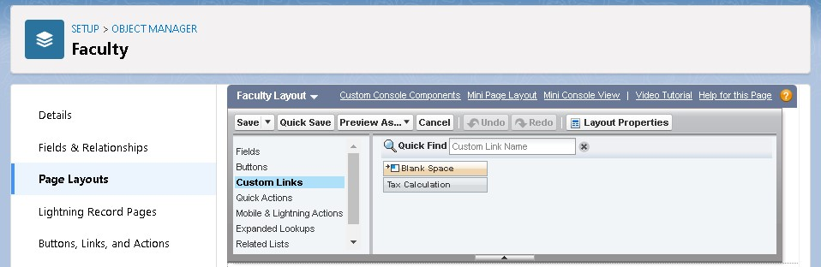

To add a rule to the faculty name so that it should take only valid names:

1. Go to Validation Rule of Faculty object and click “New”
2. Name it as “Name Validation”.
3. Error Condition Formula: NOT (REGEX (Name,” [a-z] [A-Z] + [ a-z] [A-Z] +”)).
4. Error Message: Please Enter a valid name.
5. Error Location: Field – Faculty name.
6. Click Save

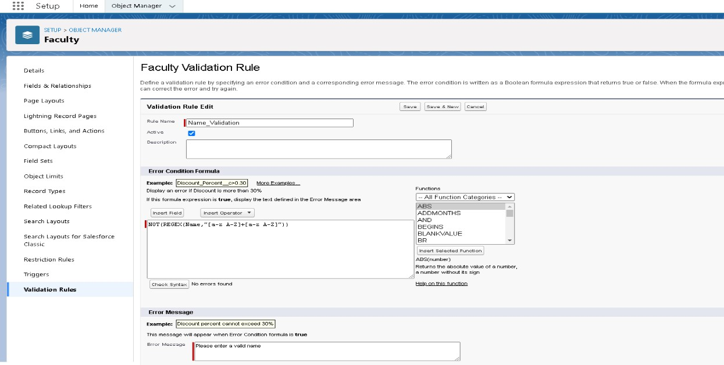

**To create an application:**

1. Go to “Setup” and type “App Manager” in Quick Find Box.
2. Click on “New Lightning App” to create a Lightning Application.
3. Name it as “Faculty Database”, give the description for your application.
4. Uploading Image and changing colours are optional, then click Next.
5. Navigation Style: Standard Navigation, click Next.
6. No need to add any Utility Bar, click Next.
7. Add the following Items: Faculties, Reports and Dashboards, click Next.
8. Assign it to System Administrator Profile by selecting System Administrator and pressing right arrow and then click Save & Finish.

Go to App Manager, select your application and select Faculties and click “New” to add some details to your application.

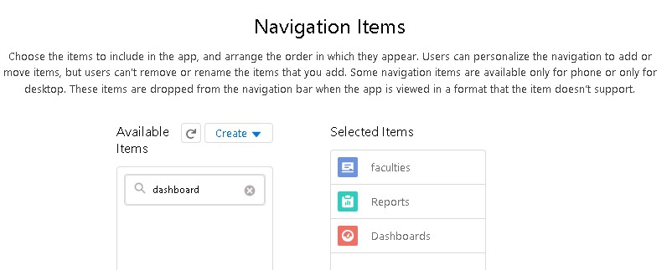

Click the entry you added, go to details. Make sure you will get an error message when you enter an invalid name and invalid id.

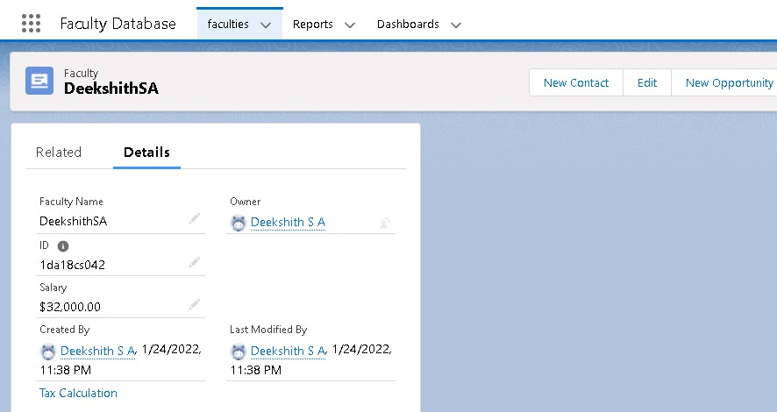

Press the “Tax Calculation” link to calculate income tax.

Click OK so that it will redirect you to the income tax calculator website.

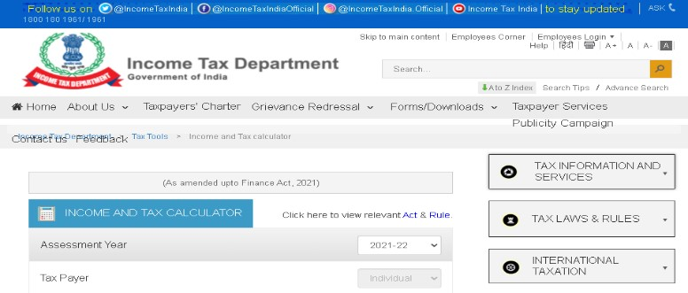

Enter the required Details and press “Calculate”.

**Reports and Dashboards:**

To Create a Faculty Report:

1. Go to “Reports tab” Click on “New Folder” And give it any name and click on Save.
2. Click on “New Report” and from search bar Search for “Faculty” and then select it then Click Continue.
3. Add the required Columns to get the Complete Entered data.
4. If you want the report to be grouped by any specific Fields then Search for the field in “Add groups” otherwise it is optional.
5. Click on save and name the report as “New Faculties Report” and then select the folder which you have created.
6. Click Save and then Click Run

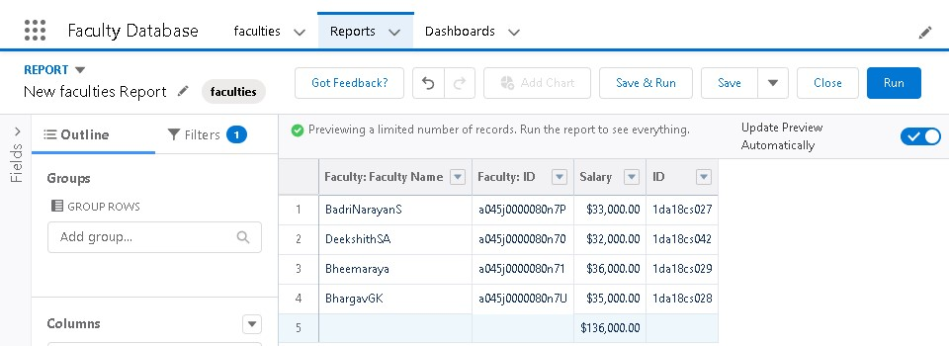

To Create a Faculty Dashboard:

1. Go to “Dashboard tab” and then click on “New Folder” and give it any Name.
2. Click on “New Dashboard” and then name it as “Income Tax Dashboard” and select folder that you have created Click on Create.
3. Click on the report that you have created and click on that and click select.
4. Select any style to represent the data in dashboard.
5. Add any filter(s), otherwise it is optional.
6. Click on Save and Click Run

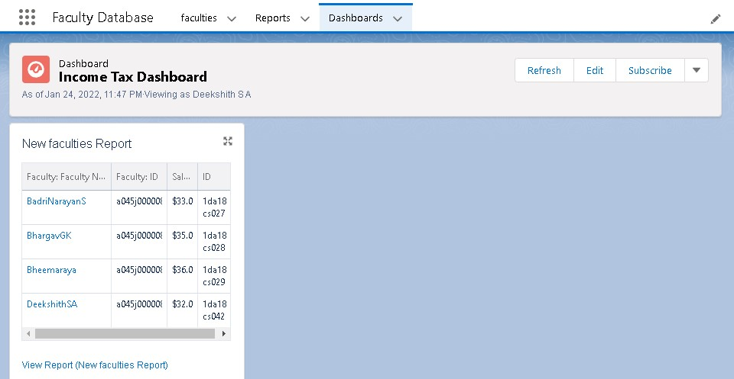

**Q4) Create a web application to book a flight from a source to destination and store the status of flight, and departure timings on database.**

Launch your Salesforce Trailhead Playground by opening any module and Switch to Lightning Experience if you are currently in Salesforce Classic by clicking your picture in the right top corner and then click on “Switch to Lightning Experience”

Then go to Setup gear icon and click “Setup”.

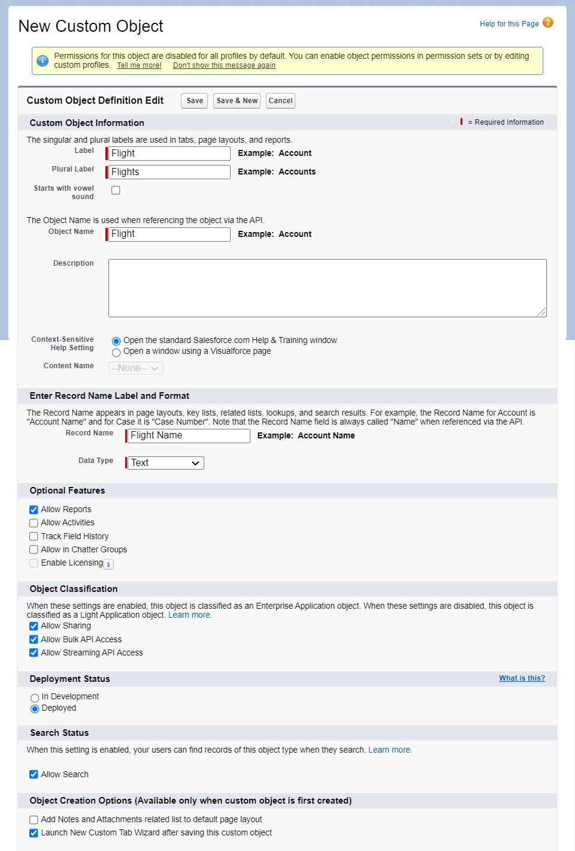

1. Click on “Object Manager” and click “Create > Custom Object” to create new Custom Object.
2. Name the object “Flight”.
3. Allow Reports and Allow Search.
4. Check the box in front of “Launch New Custom Tab Wizard after saving this custom object”.
5. To create a Tab for the Object: Select any Tab Style for the object “Flight”. Click Next, then, leave the defaults and save.

**To add fields to the Object:**

Go to “Fields & Relationships” option of Student object and Click “New”.

Add the following fields one after the other:

* Field Label: Source, Data Type: Text Area, make it as Required Field.
* Field Label: Destination, Data Type: Text Area, make it as Required Field.
* Field Label: Departure Timing, Data Type: Date/Time, make it as Required Field.

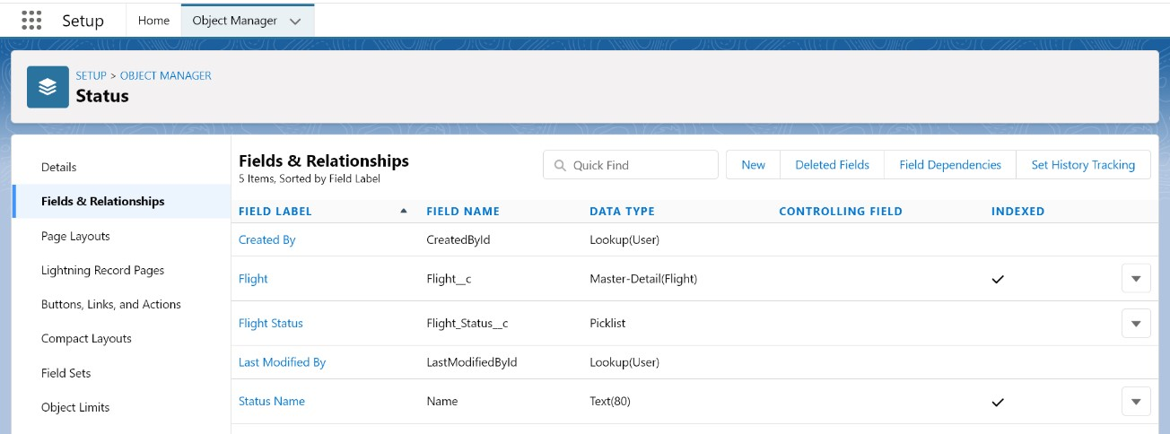

**Validation Rules:**

**Date and time Validation:**

To add a rule to the departure timing so that it is greater than today’s date and the present time:

1. Go to Validation Rule of Flight Object and click “New”
2. Name it as “Date Time should be in Range”
3. Error Condition Formula: Departure_Timing__c<NOW ()
4. Error Message: Departure Date/Time cannot be in past of present.
5. Error Location: Field – Departure Timings.
6. Click Save

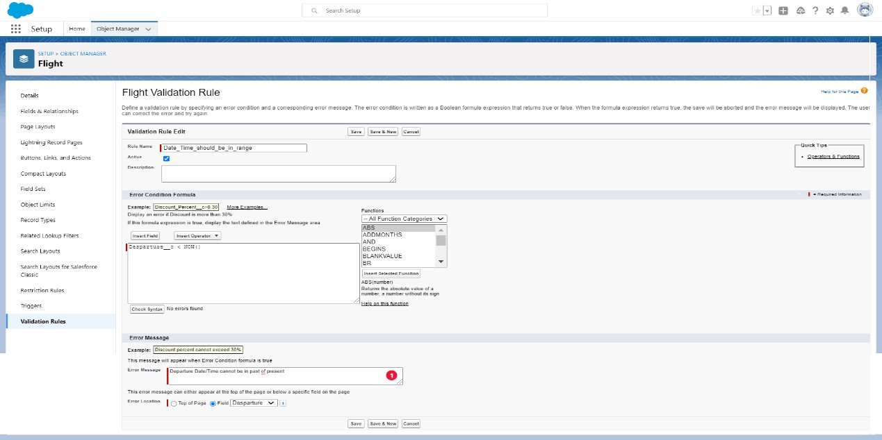

**Source and Destination Validation:**

To add a rule to the Source and destination so that source and destination should not be equal:

1. Go to Validation Rule of Flight Object and click “New”
2. Name it as “Source and destination Checking”
3. Error Condition Formula: Source__c = Destination__c 4. Error Message: Source and destination can never be equal.
4. Error Location: Top of the Page.
5. Click Save.

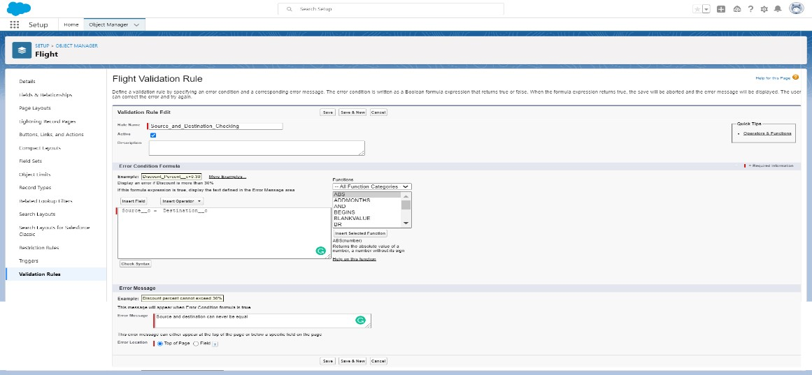

Create one more object to provide status of the flight:

1. Name the Object “Status”
2. Allow Reports and Allow Search.
3. Check the box in front of “Launch New Custom Tab Wizard after saving this custom object” 4. Create a Tab for the Object.

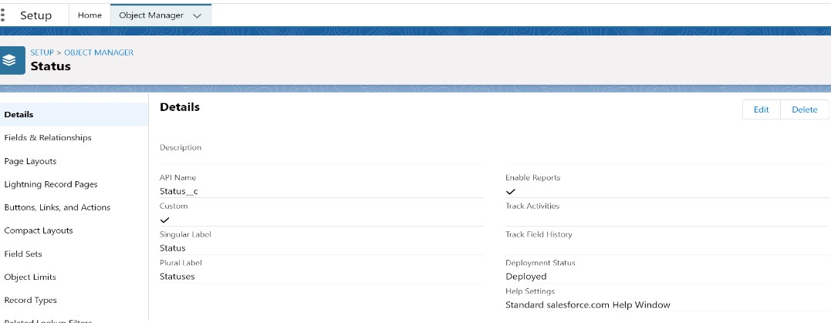

To add fields to the Object: Go to “Fields & Relationships” option of Student object and Click “New”.

Add the following fields one after the other:

* Field Label: Flight Name, Data Type: Master-Detail Relationship, Related to: Flight. Sharing Setting: Read-Only. Leave the defaults and save. Master – Detail relationship is provided to enter status only to the existing flights.
* Field Label: Flight Status, Data Type: Picklist, click radio button in front of Enter values, with each value separated by a new line. Values are: Arrived, Cancelled, Delayed and Departed. Make it as Required Field and Restrict the values to the values in the picklist.

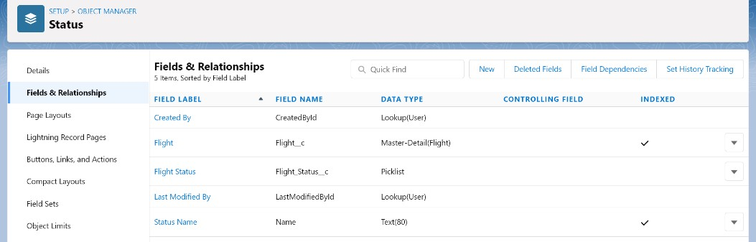

**To create an application:**

1. Go to “Setup” and type “App Manager” in Quick Find Box.
2. Click on “New Lightning App” to create a Lightning Application.
3. Name it as “Flight Details”, give the description for your application.
4. Uploading Image and changing colours are optional, then click Next.
5. Navigation Style: Standard Navigation, click Next.
6. No need to add any Utility Bar, click Next.
7. Add the following Items: Flights, Statuses, Reports and Dashboards, click Next.
8. Assign it to System Administrator Profile by selecting System Administrator and pressing right arrow and then click Save & Finish.

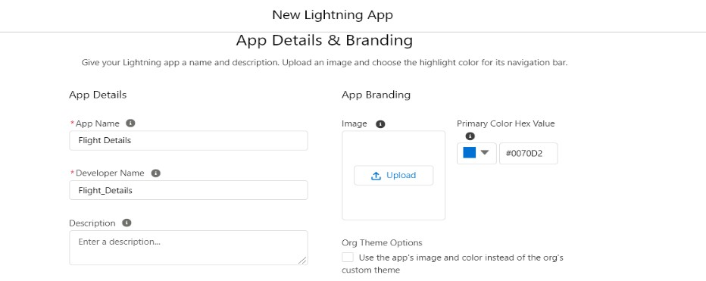

Go to App Manager, select your application and select Flights and click “New” to add some details to your application

Make sure you will get an error message when you try to give the Departure Timing less than the current time and today’s date

**Reports and Dashboards:** To Create a Flights Report:

1. Go to “Reports tab” Click on “New Folder” And give it any name and then click Save.
2. Click on “New Report” and from search bar Search for “Flights” and then select it and Click Continue.
3. Add the required Columns to get the Complete Entered data.
4. If you want the report to be grouped by any specific Fields then Search for the field in “Add groups” otherwise it is optional.
5. Click on save and name the report as “New Flights Report” and then select the folder which you have created.
6. Click Save and then Click Run.

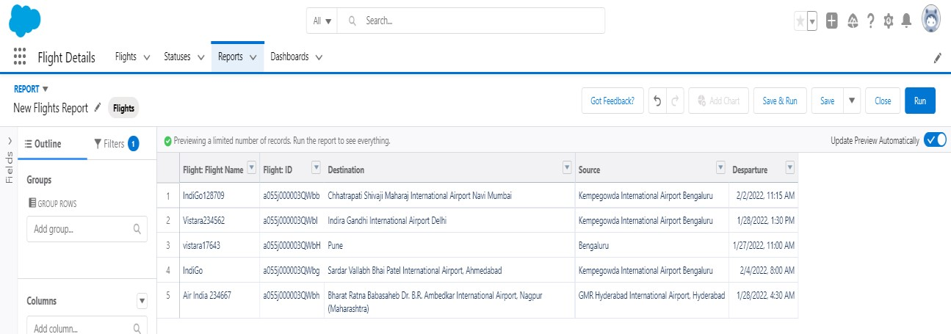

To Create a Status Report:

1. Go to “Reports tab” Click on “New Folder” And give it any name and then click Save.
2. Click on “New Report” and from search bar Search for “Flights with Status” and then select it and then click Continue.
3. Add the required Columns to get the Complete Entered data.
4. If you want the report to be grouped by any specific Fields then Search for the field in “Add groups” otherwise it is optional.
5. Click on save and name the report as “New Flights with status Report” and then select the folder which you have created.
6. Click Save and then Click RunTo Create a Status Dashboard:
7. Go to “Dashboard tab” and then click on “New Folder” and give it any Name.
8. Click on “New Dashboard” and then name it as “Status” and select folder that you have created Click on Create.
9. Click on the report that you have created and click on that and click select.
10. Select any style to represent the data in dashboard.
11. Add any filter(s), otherwise it is optional.
12. Click on Save and Click Run

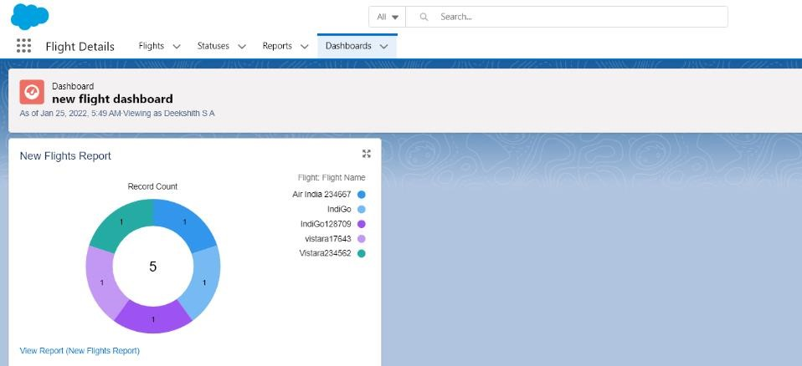

**Q5) Create a collaborative learning environment for a particular learning topic using Google Apps. Google Drive, Google Docs and Google Slides must be used for hosting ebooks, important articles and presentations.**

Open http://drive.google.com/ and Sign In with your google account.

Create a new folder named “My Learning Environment” by clicking “New” button on the top left corner.

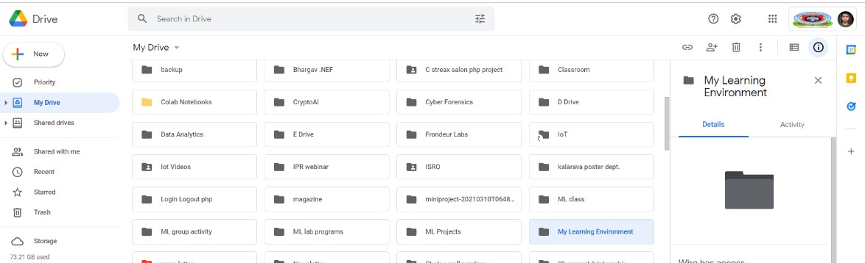

Right click on the folder created and tap “Share” then click on “Advanced”.

Under the “Who has Access” section click on “Change” of the first option.

Now check on the “On- Public on the web” option & set the Access to “Can View Only” and Click Save. This will make your folder to be accessible by anyone on the internet to view its contents and download them

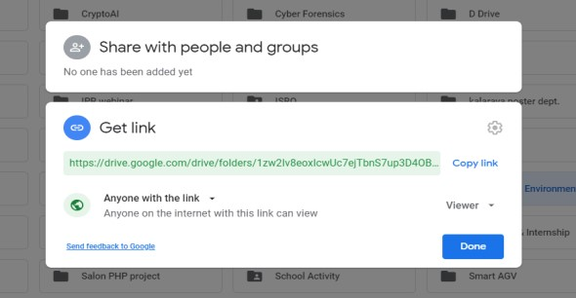

Copy the link and post it or share it to anyone you like.

Adding Learning Contents to your Environment:

Double click on the folder you just created and click “New” button again.

Add these items:

* Folder: Named “E-Books” where you will open the folder and click “New” and “Upload a file” like a Book from your hard drive

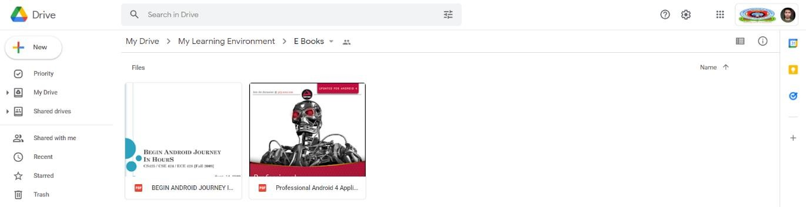

* Google Docs: Named “Important Quotes” where you will add some important links to the doc file.

The file will keep saving hence you need to press save. click “Share” if you wish to share it

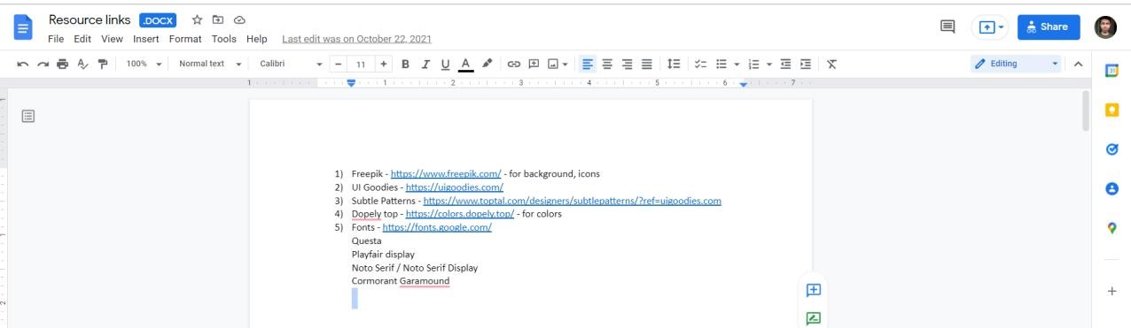

* Google Slide: Named “Welcome Folks” make a few changes and add your content and choose your theme

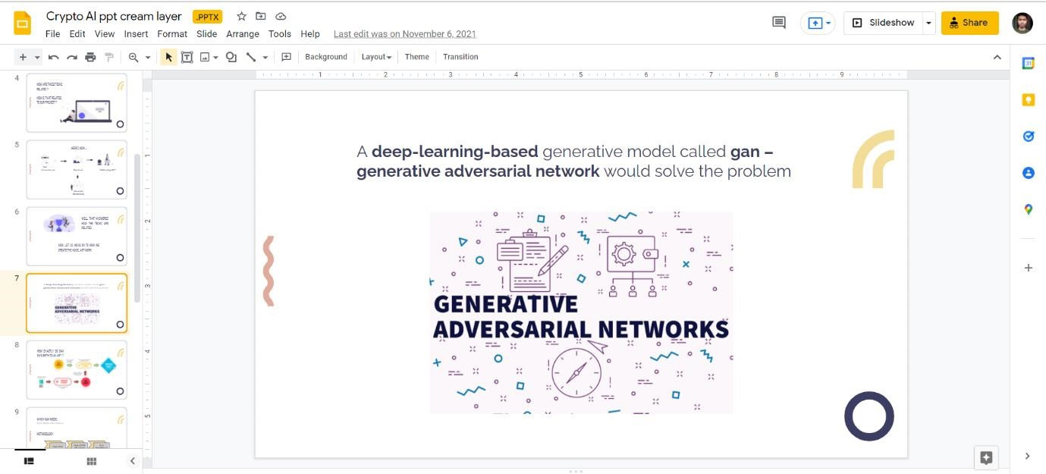

You may also add many other items as necessary.

At any point in future if you wish to share this environment right click on the folder and click share. Copy the link and share.

**Q6) Develop Department events registration app with an object containing event name, date/time, venue as parent relationship, another object containing student name, branch, event name, date/time, venue as child relationship.**

Launch your Salesforce Trailhead Playground by opening any module and Switch to Lightning Experience if you are currently in Salesforce Classic by clicking your picture in the right top corner and then click on “Switch to Lightning Experience”.

Then go to Setup gear icon and click “Setup”.

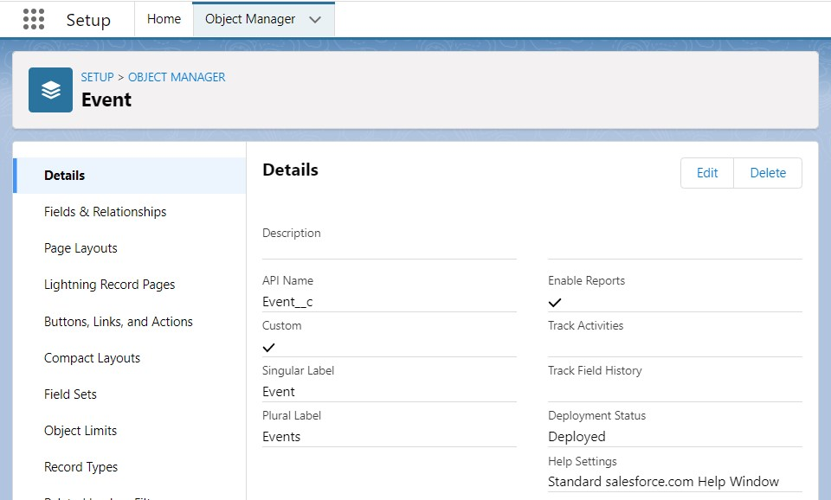

1. Click on “Object Manager” and click “Create > Custom Object” to create new Custom Object.
2. Name the object “Event”.
3. Allow Reports and Allow Search.
4. Check the box in front of “Launch New Custom Tab Wizard after saving this custom object”.
5. To create a Tab for the Object:
6. Select any Tab Style for the object “Event”. Click Next, Next, leave the defaults and save.

**To add fields to the Object:**

Go to “Fields & Relationships” option of Student object and Click “New”.

Add the following fields one after the other:

* Field Label: Event Time, Data Type: Date/Time, make it as Required Field.
* Field Label: Event Venue, Data Type: Text Area, make it as Required Field.

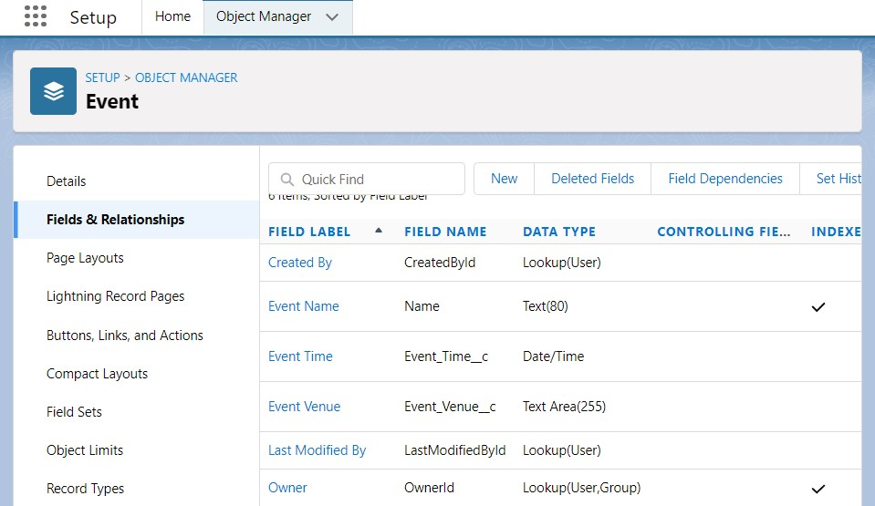

To add a rule to the Event Date/Time so that it is greater than today’s date and the present time:

1. Go to Validation Rule of Event Object and click “New”.
2. Name it as “Date and Time in Range”.
3. Error Condition Formula: Event_Time__c <NOW () 4. Error Message: Date or time less than the current one.
4. Error Location: Field – Event Time.
5. Click Save.

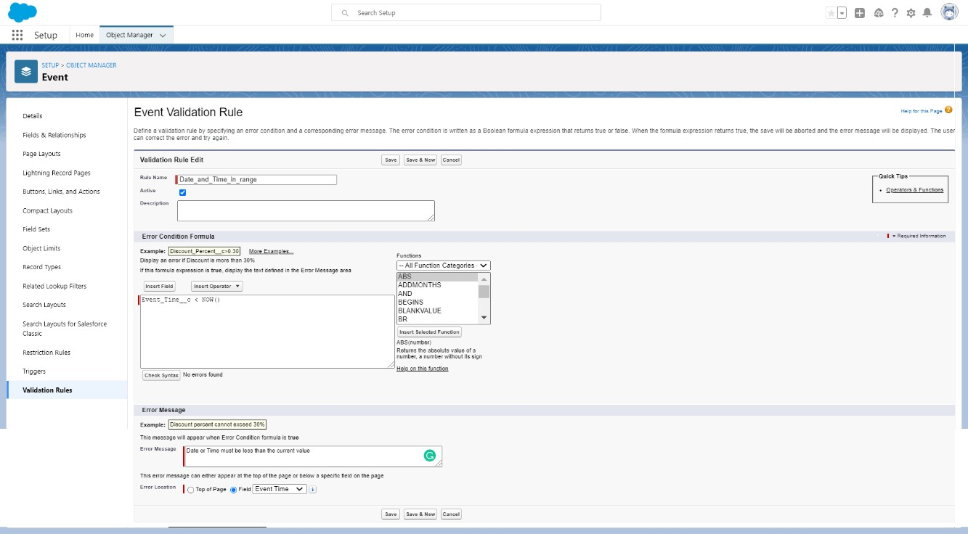

Create one more object to store student details:

1. Name the Object “Student1”.
2. Allow Reports and Allow Search.
3. Check the box in front of “Launch New Custom Tab Wizard after saving this custom object”.
4. Create a Tab for the Object.

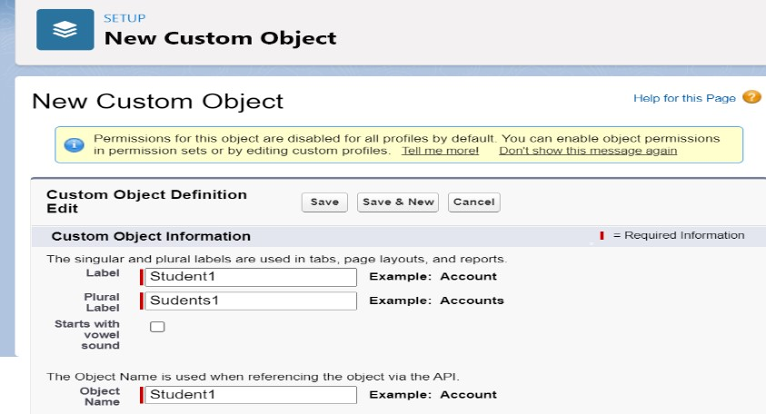

To add fields to the Object:

Go to “Fields & Relationships” option of Student object and Click “New”.

Add the following fields one after the other:

* Field Label: Event Name, Data Type: Text.
* Field Label: Event Time, Data Type: Master-Detail Relationship, Related to: Event. Sharing Setting:

Read-Only. Leave the defaults and save.

* Field Label: Event Venue, Data Type: Look up Relationship, Related to: Event.
* Field Label: Branch, Data Type: Text, Make it as a Required Field.

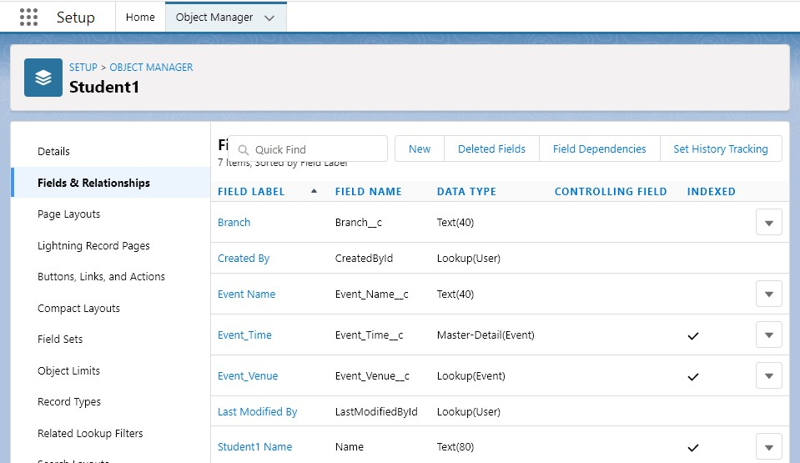

To create an application:

1. Go to “Setup” and type “App Manager” in Quick Find Box.
2. Click on “New Lightning App” to create a Lightning Application.
3. Name it as “Events’ Registrations”, give the description for your application.
4. Uploading Image and changing colours are optional, then click Next.
5. Navigation Style: Standard Navigation, click Next.
6. No need to add any Utility Bar, click Next.
7. Add the following Items: Events, Students, Reports and Dashboards, click Next.
8. Assign it to System Administrator Profile by selecting System Administrator and pressing right arrow and then click Save & Finish.

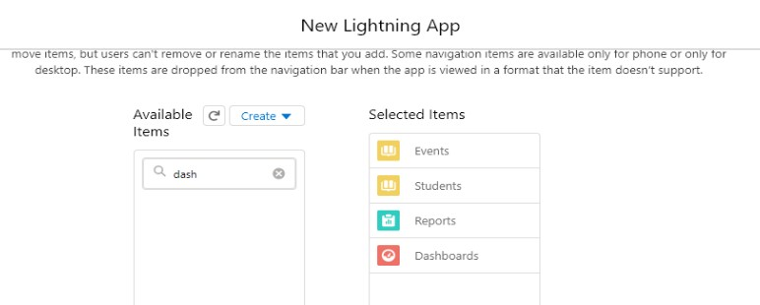

Go to App Manager, select your application and select Events and click “New” to add some details to your application.

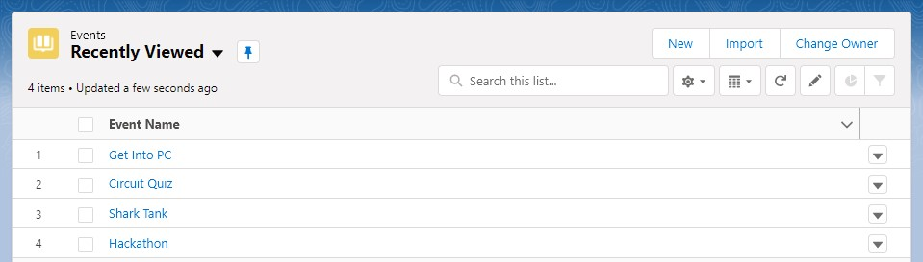

Make sure you will get an error message when you try to give the Event Time less than the current time and today’s date and also you can’t select events which are not there in the list.

**Reports and Dashboards:**

To Create an Event Report:

1. Go to “Reports tab” Click on “New Folder” And give it any name and Click Save.
2. Click on “New Report” and from search bar Search for “Events” and then select it then Click Continue.
3. Add the required Columns to get the Complete Entered data.
4. If you want the report to be grouped by any specific Fields then Search for the field in “Add groups” otherwise it is optional.
5. Click on save and name the report as “New Events Report” and then select the folder which you have created.
6. Click Save and then Click Run

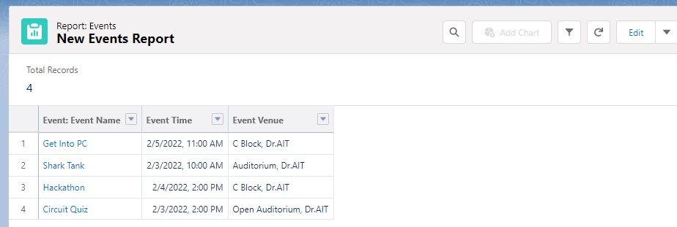

To Create a Students Report:

1. Go to “Reports tab” Click on “New Folder” And give it any name and Click Save.
2. Click on “New Report” and from search bar Search for “Students with Events” and then select it then Click Continue.
3. Add the required Columns to get the Complete Entered data.
4. If you want the report to be grouped by any specific Fields then Search for the field in “Add groups” otherwise it is optional.
5. Click on save and name the report as “New Events with Students Report” and then select the folder which you have created

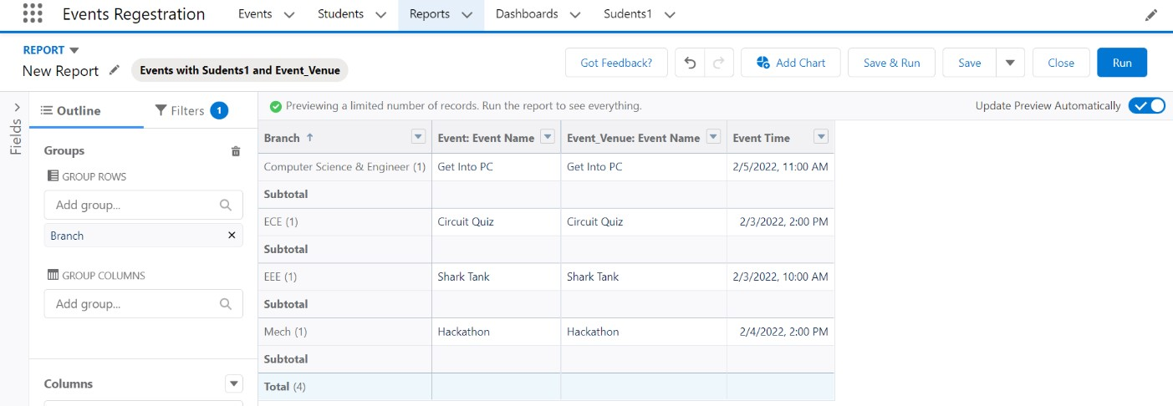

To Create an Event Dashboard:

1. Go to “Dashboard tab” and then click on “New Folder” and give it any Name.
2. Click on “New Dashboard” and then name it as “Event Dashboard” and select folder that you have created, Click on Create.
3. Click on the report that you have created and click on that and click select.
4. Select any style to represent the data in dashboard.
5. Add any filter(s), otherwise it is optional.
6. Click on Save and Click Run

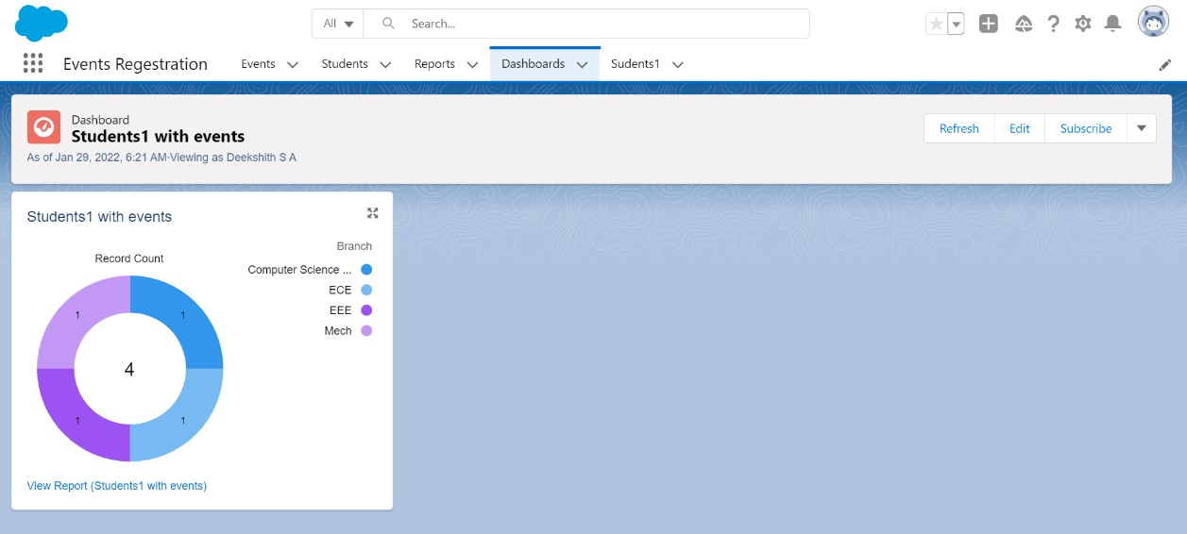

To Create a Student1 Dashboard:

1. Go to “Dashboard tab” and then click on “New Folder” and give it any Name.
2. Click on “New Dashboard” and then name it as “Students with Events Dashboard” and select folder that you have created, Click on Create.
3. Click on the report that you have created and click on that and click select.
4. Select any style to represent the data in dashboard.
5. Add any filter(s), otherwise it is optional.
6. Click on Save and Click Run

**Q7) Develop Blood Donation registration app with an object which records donors name, age and blood group as parent relationship and another object containing haemoglobin level, donated or not details.**

Launch your Salesforce Trailhead Playground by opening any module and Switch to Lightning Experience if you are currently in Salesforce Classic by clicking your picture in the right top corner and then click on “Switch to Lightning Experience”

Then go to Setup gear icon and click “Setup”.

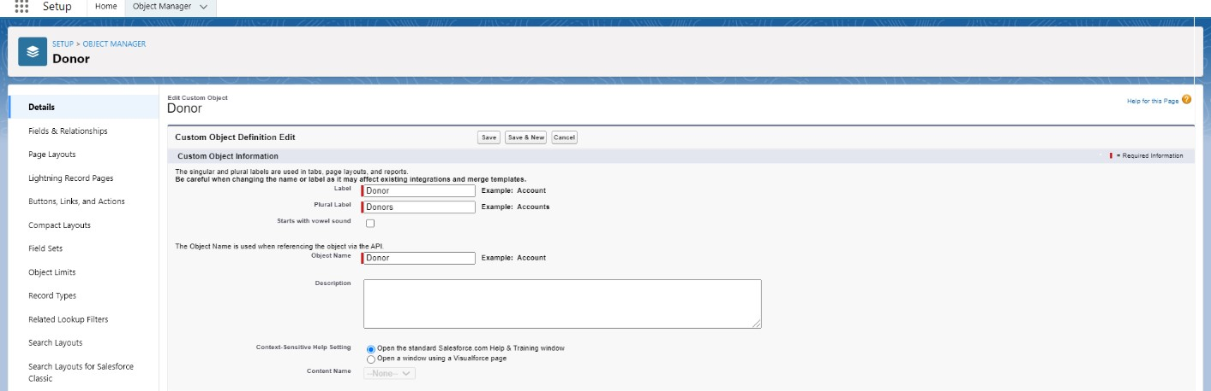

1. Click on “Object Manager” and click “Create > Custom Object” to create new Custom Object.
2. Name the object “Donor”
3. Allow Reports and Allow Search.
4. Check the box in front of “Launch New Custom Tab Wizard after saving this custom object”.
5. To create a Tab for the Object: Select any Tab Style for the object “Donor”. Click Next, Next, leave the defaults and save.

To add fields to the Object:

Go to “Fields & Relationships” option of Student object and Click “New”.

Add the following fields one after the other:

* Field Label: Age, Data Type: Number (3,0).
* Field Label: Blood Group, Data Type: Picklist, click radio button in front of Enter values, with each value separated by a new line. Values are: A+ve, B+ve, A-ve, B-ve, O+ve, O-ve, AB+ve, AB-ve. Make it as Required Field and Restrict the values to the values in the Picklist.
* Field Label: Gender, Data Type: Picklist, click radio button in front of Enter values, with each value separated by a new line.Values are: Male, Female, Others. • Field Label: Weight, Data Type: Number (3,2).

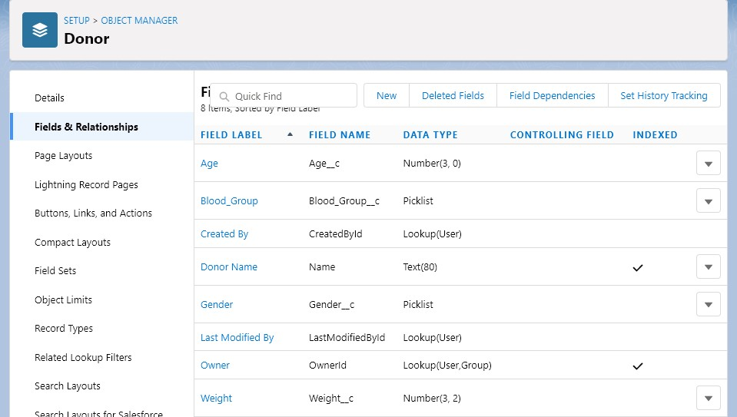

Create one more object to store Collection details:

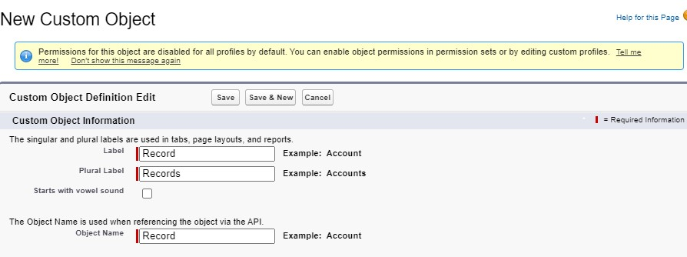

1. Name the Object “Record”.
2. Allow Reports and Allow Search.
3. Check the box in front of “Launch New Custom Tab Wizard after saving this custom object”
4. Create a Tab for the Object.

To add fields to the Object:

Go to “Fields & Relationships” option of Student object and Click “New”.

Add the following fields one after the other:

* Field Label: Haemoglobin level, Data Type: Number (2,2).
* Field Label: Donor Name, Data Type: Look up Relationship, Related to: Donor.
* Field Label: Blood Group, Data Type: Look up Relationship, Related to: Donor.
* Field Label: Age, Data Type: Master-Detail Relationship, Related to: Donor. Sharing Setting: ReadOnly. Leave the defaults and save.
* Field Label: Status, Data Type: Picklist, Values: Donated, Not Donated, Make it as a Required Field

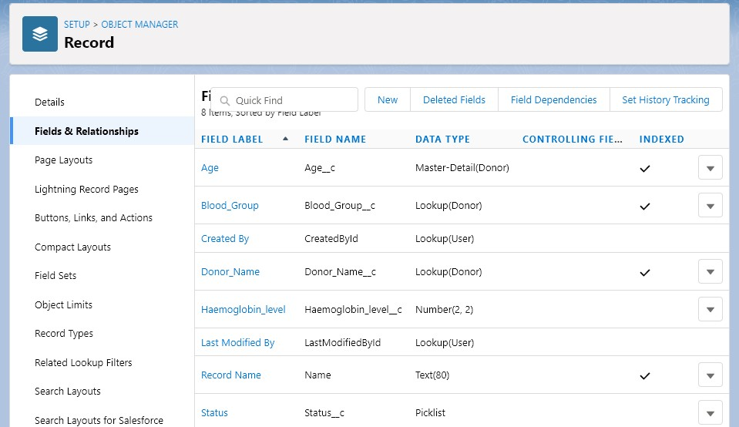

**Validation Rules:**

**Age Validation:**

1. To add a rule to the Donor age so that it is greater than 18 years:
2. Go to Validation Rule of Donor Object and click “New”
3. Name it as “Age Validation”.
4. Error Condition Formula: age__c < 18.
5. Error Message: Age must be greater than 18.
6. Error Location: Field – Age.
7. Click Save

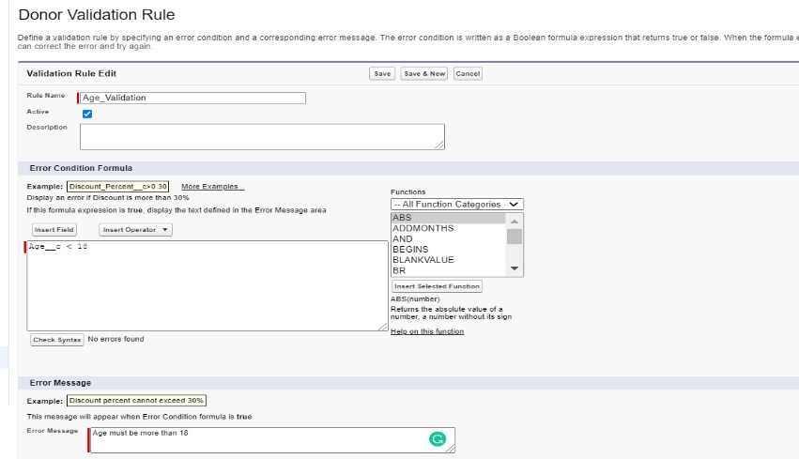

**Weight Validation:**

To add a rule to the Donor Weight so that it Should be greater than 50:

1. Go to Validation Rule of Donor Object and click “New”
2. Name it as “Weight Validation”.
3. Error Condition Formula: weight__c < 50.
4. Error Message: Eat more and gain your weight to 50 kgs.
5. Error Location: Field –weight.
6. Click Save

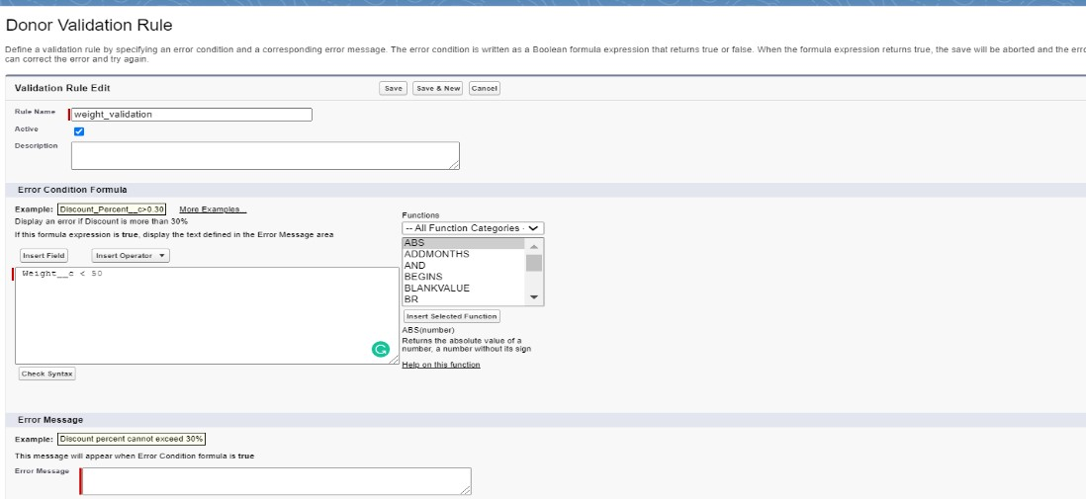

**To create an application:**

1. Go to “Setup” and type “App Manager” in Quick Find Box.
2. Click on “New Lightning App” to create a Lightning Application.
3. Name it as “Blood Donation”, give the description for your application.
4. Uploading Image and changing colours are optional, then click Next.
5. Navigation Style: Standard Navigation, click Next.
6. No need to add any Utility Bar, click Next.
7. Add the following Items: Donors, Records, Reports and Dashboards, click Next.
8. Assign it to System Administrator Profile by selecting System Administrator and pressing right arrow and then click Save & Finish.

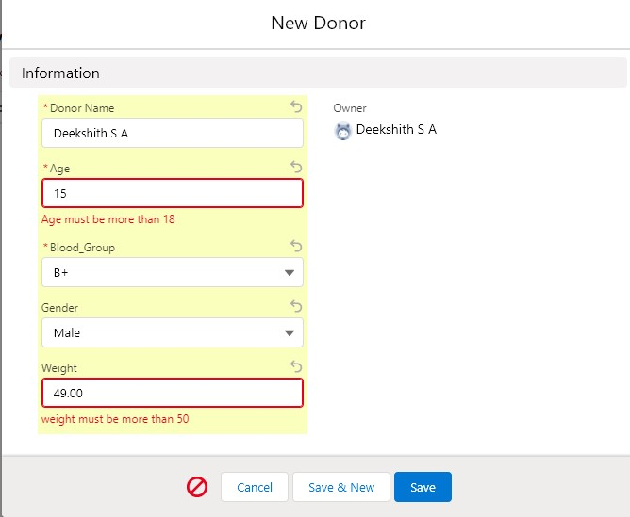

Go to App Manager, select your application and select Donors and click “New” to add some details to your application.

Make sure you can’t donate when your age is less than 18 years and when your weight is not 50 kgs.

**Reports and Dashboards:**

To Create a Donor Report:

1. Go to “Reports tab” Click on “New Folder” And give it any name then click on Save.
2. Click on “New Report” and from search bar Search for “Donors” and then select it and then click on Continue.
3. Add the required Columns to get the Complete Entered data
4. If you want the report to be grouped by any specific Fields then Search for the field in “Add groups” otherwise it is optional.
5. Click on save and name the report as “New Donor Report” and then select the folder which you have created.
6. Click Save and then Click Run.

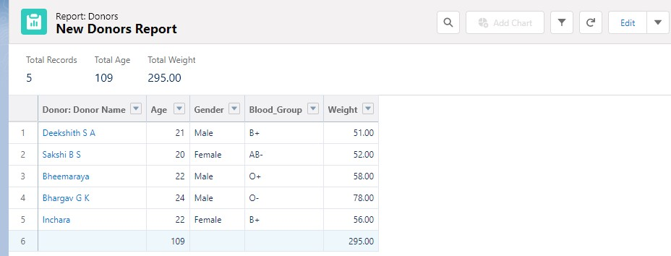

To Create a Records Report:

1. Go to “Reports tab” Click on “New Folder” And give it any name then click on Save.
2. Click on “New Report” and from search bar Search for “Donors with records” and then select it and then click on Continue.
3. Add the required Columns to get the Complete Entered data.
4. If you want the report to be grouped by any specific Fields then Search for the field in “Add groups” otherwise it is optional.
5. Click on save and name the report as “New Donors with record Report” and then select the folder which you have created.
6. Click Save and then Click Run.

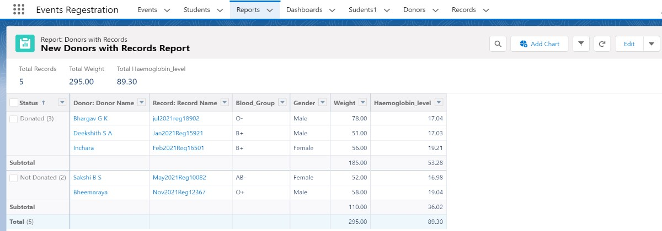

To Create a Donor Dashboard:

1. Go to “Dashboard tab” and then click on “New Folder” and give it any Name.
2. Click on “New Dashboard” and then name it as “Donors Dashboard” and select folder that you have created Click on Create.
3. Click on the report that you have created and click on that and click select.
4. Select any style to represent the data in dashboard.
5. Add any filter(s), otherwise it is optional.
6. Click on Save and Click Run

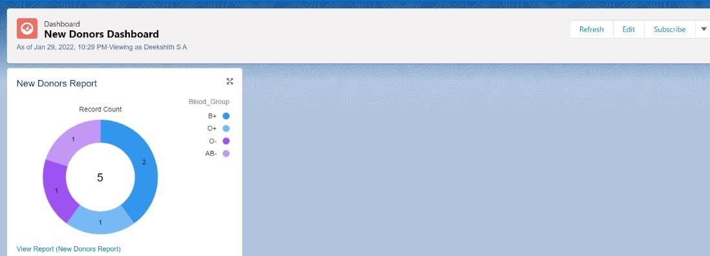

To Create a Records Dashboard:

1. Go to “Dashboard tab” and then click on “New Folder” and give it any Name.
2. Click on “New Dashboard” and then name it as “Donors with record Dashboard” and select folder that you have created Click on Create.
3. Click on the report that you have created and click on that and click select.
4. Select any style to represent the data in dashboard.
5. Add any filter(s), otherwise it is optional.
6. Click on Save and Click Run

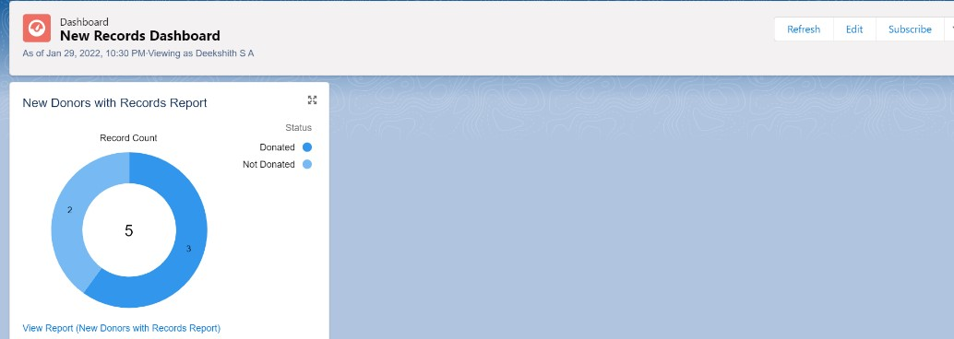

**Q8) Develop Attendance maintenance app with an object to record student details and attendance and a provide a link to college websites' results webpage.**

Launch your Salesforce Trailhead Playground by opening any module and Switch to Lightning Experience if you are currently in Salesforce Classic by clicking your picture in the right top corner and then click on “Switch to Lightning Experience”

Then go to Setup gear icon and click “Setup”.

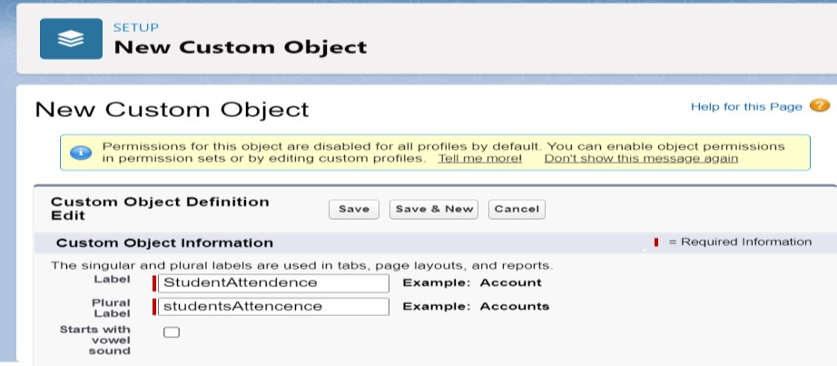

1. Click on “Object Manager” and click “Create > Custom Object” to create new Custom Object.
2. Name the object “Student”.
3. Allow Reports and Allow Search.
4. Check the box in front of “Launch New Custom Tab Wizard after saving this custom object”.
5. To create a Tab for the Object: Select any Tab Style for the object “Student”. Click Next, Next, leave the defaults and save.

To add fields to the Object:

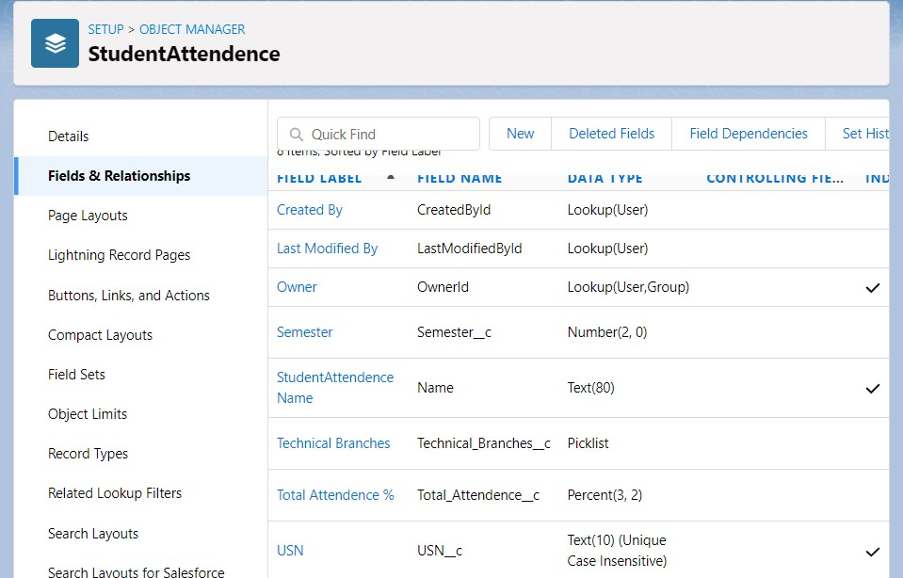

Go to “Fields & Relationships” option of Student object and Click “New”.

Add the following fields one after the other:

* Field Label: USN (Length 10), Data Type: Text, provide an example USN as Help Text, make it as Required Field and Don’t allow Duplicate Values and make it as Case Insensitive.
* Field Label: Technical Branches, Data Type: Picklist, click radio button in front of Enter values, with each value separated by a new line. Values are: CSE, ISE, TCE, EEE, EC etc. Make it as Required Field and Restrict the values to the values in the picklist.
* Field Label: Total Attendance %, Data Type: Percent (3,2).
* Field Label: Semester, Data Type: Number (2,0).

**To include Custom Links:**

1. Go to “Buttons, Links and Actions” of “Student” Object and click “New Button or Link”.
2. Name it as “Check Details”.
3. Select the radio button “Detail Page Link” as it is a website link.
4. Behaviour: Display in new window.
5. Content Source: URL.
6. Field Type: Student.
7. In the empty space provided, type http://www.drait.edu.in/ It is a link which redirects to the income tax calculation website.
8. Link Encoding: Unicode (UTF-8).
9. Click Save
10. Go to Page Layout, Click Student Layout.
11. Click Custom Links, Drag and drop the “Check Details” link in the Custom Link area.
12. Click save.

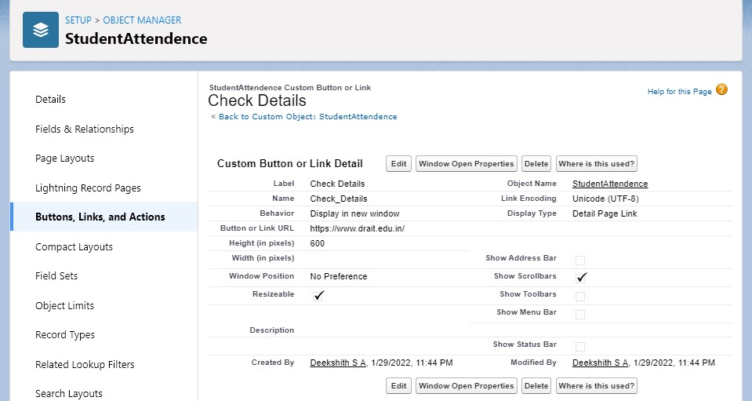

**To create an application:**

1. Go to “Setup” and type “App Manager” in Quick Find Box.
2. Click on “New Lightning App” to create a Lightning Application.
3. Name it as “Attendance Management”, give the description for your application.
4. Uploading Image and changing colours are optional, then click Next.
5. Navigation Style: Standard Navigation, click Next.
6. No need to add any Utility Bar, click Next.
7. Add the following Items: Student, Records, Reports and Dashboards, click Next.
8. Assign it to System Administrator Profile by selecting System Administrator and pressing right arrow and then click Save & Finish.

Go to App Manager, select your application and select Student and click “New” to add some details to your application.

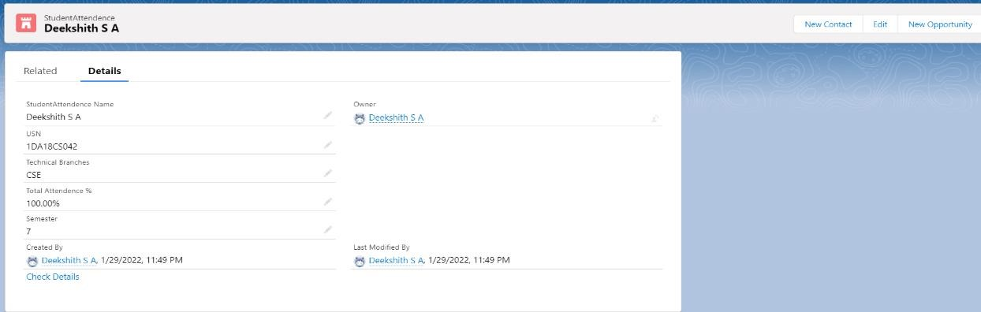

Make Sure you are redirected to the College Website When you click on the Check Details Link.



**Reports and Dashboards:**

To Create a Student Report:

1. Go to “Reports tab” Click on “New Folder” And give it any name then click Save
2. Click on “New Report” and from search bar Search for “Attendance Management” and then select it then click Continue.
3. Add the required Columns to get the Complete Entered data.
4. If you want the report to be grouped by any specific Fields then Search for the field in “Add groups” otherwise it is optional.
5. Click on save and name the report as “New Students Report” and then select the folder which you have created.
6. Click Save and then Click Run.

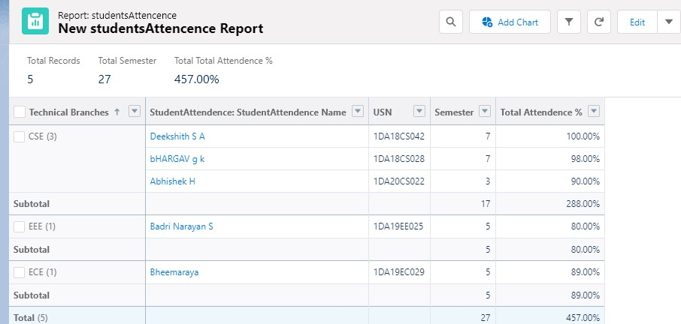

To Create a Student Dashboard:

1. Go to “Dashboard tab” and then click on “New Folder” and give it any Name.
2. Click on “New Dashboard” and then name it as “Attendance Management” and select folder that you have created Click on Create.
3. Click on the report that you have created and click on that and click select.
4. Select any style to represent the data in dashboard.
5. Add any filter(s), otherwise it is optional.
6. Click on Save and Click Run

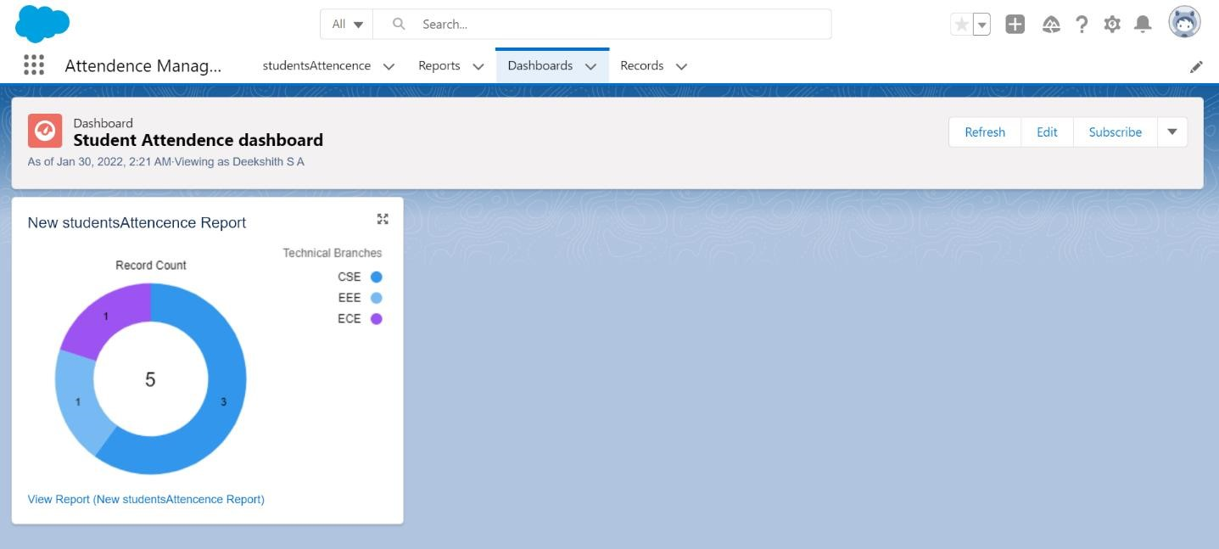

**Q9) Create a web application with objects to maintain database of an art gallery which contains objects like artists, arts, inventory and provide a link to any of the art gallery website**.

Launch your Salesforce Trailhead Playground by opening any module and Switch to Lightning Experience if you are currently in Salesforce Classic by clicking your picture in the right top corner and then click on “Switch to Lightning Experience”.

Then go to Setup gear icon and click “Setup”.

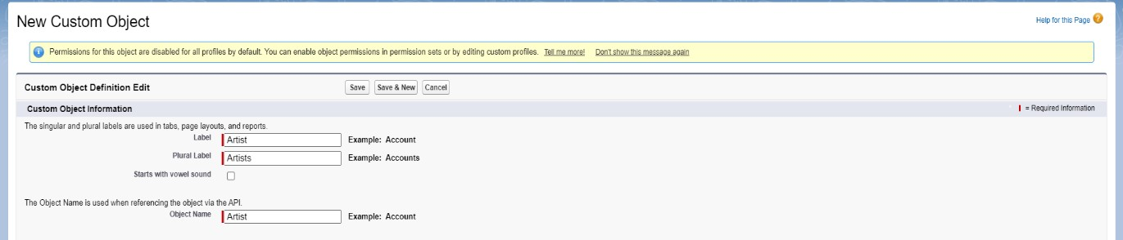

* 1. Click on “Object Manager” and click “Create > Custom Object” to create new Custom Object.
  2. Name the object “Artist”.
  3. Allow Reports and Allow Search.
  4. Check the box in front of “Launch New Custom Tab Wizard after saving this custom object”.
  5. To create a Tab for the Object: Select any Tab Style for the object “Artist”. Click Next, Next, leave the defaults and save.

To add fields to the Object:

Go to “Fields & Relationships” option of Student object and Click “New”.

Add the following fields one after the other:

* + Field Label: ID (Length 10), Data Type: Text, provide an example ID as Help Text, make it as required Field, don’t allow Duplicate Values, make it as Case Insensitive and Set this field as the unique record identifier from an external system.
  + Field Label: Art Name and Details, Data Type: Text, Make it as a required field.
  + Field Label: Style, Data Type: Picklist. Values: Pencil Sketching, craft design, free hand, Human portrait, drawing, painting etc. Make it as Required Field and restrict values to the values in the picklist

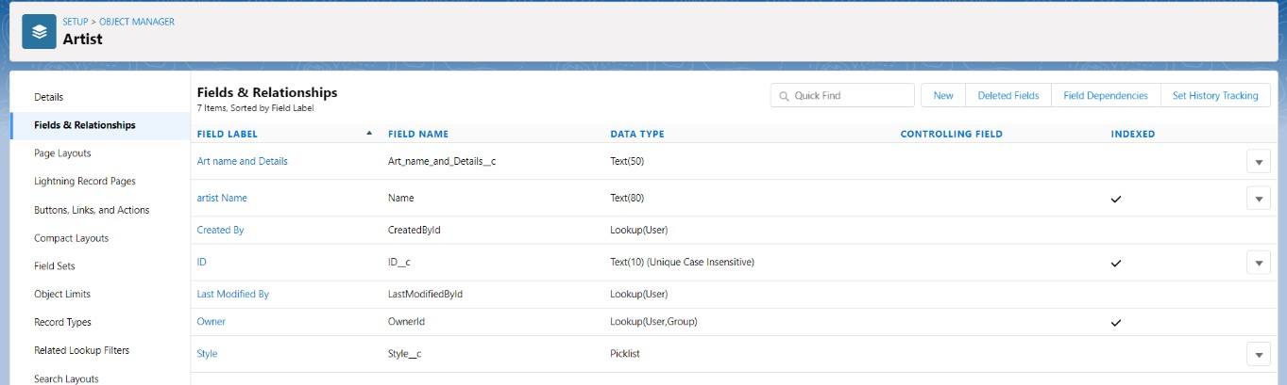

Create one more object to store Collection details:

* 1. Name the Object “Art”.
  2. Allow Reports and Allow Search
  3. Check the box in front of “Launch New Custom Tab Wizard after saving this custom object”.
  4. Create a Tab for the Object.

To add fields to the Object:

Go to “Fields & Relationships” option of Student object and Click “New”.

Add the following fields one after the other:

* + Field Label: Art Name and Details, Data Type: Master-Detail Relationship, Related to: Artist. Sharing Setting: Read-Only. Leave the defaults and save.
  + Field Label: ID (Length 10), Data Type: Text, provide an example ID as Help Text, make it as required Field, don’t allow Duplicate Values, make it as Case Insensitive and Set this field as the unique record identifier from an external system.

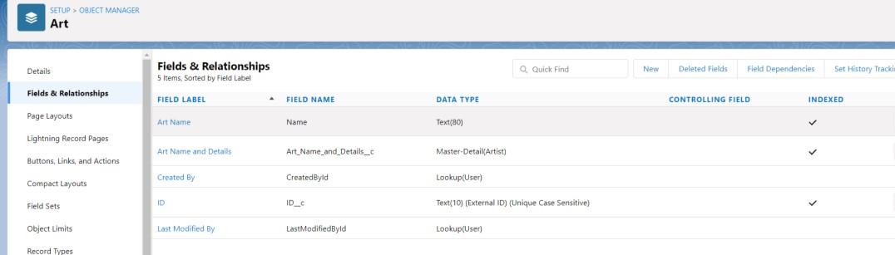

Create one more object to store inventory details:

* 1. Name the Object “Inventory”.
  2. Allow Reports and Allow Search.
  3. Check the box in front of “Launch New Custom Tab Wizard after saving this custom object” 4. Create a Tab for the Object.

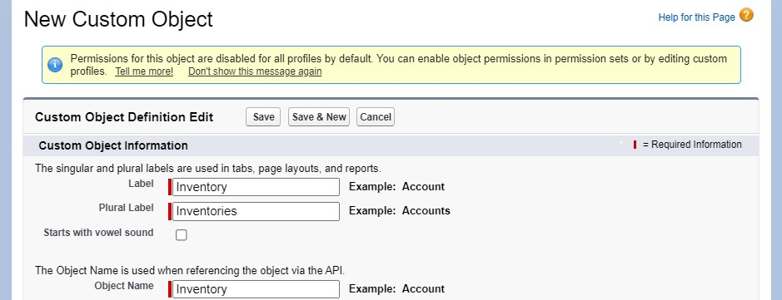

To add fields to the Object:

Go to “Fields & Relationships” option of Student object and Click “New”.

Add the following fields one after the other:

* + Field Label: Quantity, Data Type: Number. Make it as a required field.

**To give a link to any art gallery website:**

* 1. Go to “Buttons, Links and Actions” of Art Object and click “New Button or Link”.
  2. Name it as “Gallery”.
  3. Select the radio button “Detail Page Link” as it is a website link.
  4. Behaviour: Display in new window.
  5. Content Source: URL 27. Field Type: Gallery.
  6. In the empty space provided, type, http://www.aakritiartgallery.com/ Link
  7. Encoding: Unicode (UTF-8).
  8. Click Save.
  9. Go to Page Layout, Click Art Layout.
  10. Click Custom Links, Drag and drop the “Gallery” link in the Custom Link area.
  11. Click save.

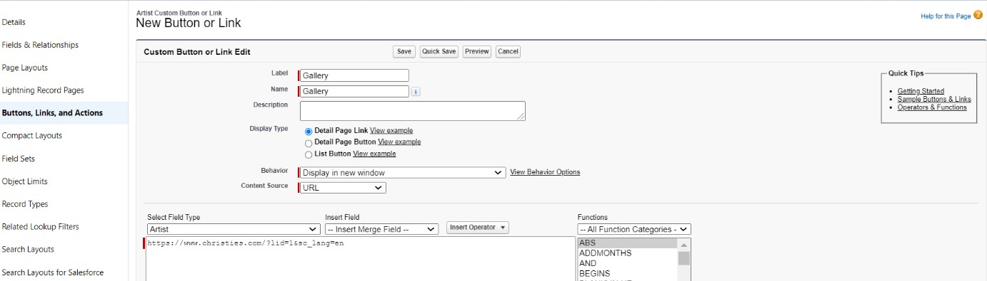

To add a rule to the Artist id so that it should take valid id:

* 1. Go to Validation Rule of Artist Object and click “New”.
  2. Name it as “Artist id validation”.
  3. Error Condition Formula: NOT(BEGINS(ID__c,’ART’)).
  4. Error Message: Please Enter a Valid id of an artist.
  5. Error Location: Field –id.
  6. Click Save

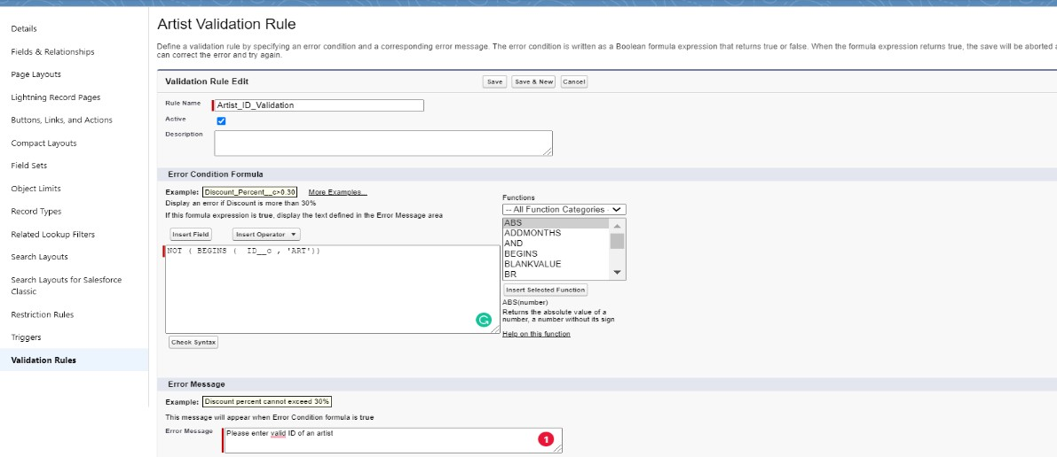

**To create an application:**

* 1. Go to “Setup” and type “App Manager” in Quick Find Box.
  2. Click on “New Lightning App” to create a Lightning Application.
  3. Name it as “Art Gallery Database”, give the description for your application.
  4. Uploading Image and changing colours are optional, then click Next.
  5. Navigation Style: Standard Navigation, click Next.
  6. No need to add any Utility Bar, click Next.
  7. Add the following Items: Artists, Arts, Inventories, Reports and Dashboards, click Next.
  8. Assign it to System Administrator Profile by selecting System Administrator and pressing right arrow and then click Save & Finish.

Go to App Manager, select your application and select Faculties and click “New” to add some details to your application.

Click the entry you added, go to details.

Press the “Gallery” link to check the details.

Click OK so that it will redirect you to the website. Make sure it should an error when an invalid id is given.

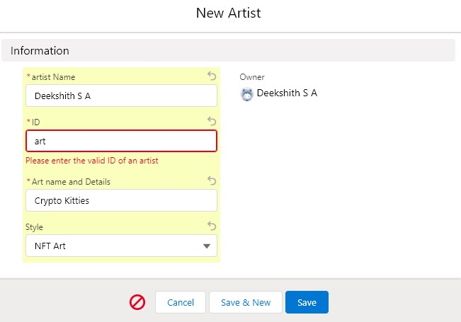

**Reports and Dashboards:**

To Create an Artists Report:

* 1. Go to “Reports tab” Click on “New Folder” And give it any name and Click Save.
  2. Click on “New Report” and from search bar Search for “Artists” and then select it and then Click Continue.
  3. Add the required Columns to get the Complete Entered data.
  4. If you want the report to be grouped by any specific Fields then Search for the field in “Add groups” otherwise it is optional.
  5. Click on save and name the report as “New Artists Report” and then select the folder which you have created.
  6. Click Save and then Click Run

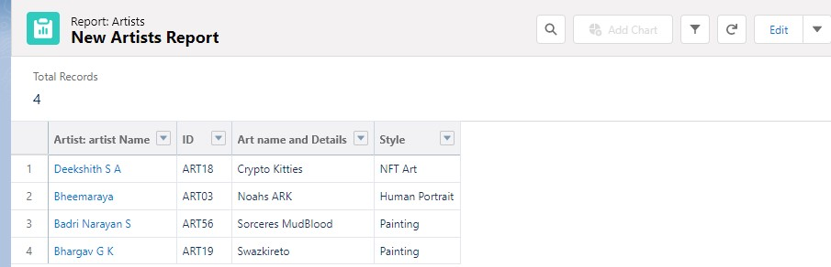

To Create an Arts Report:

* 1. Go to “Reports tab” Click on “New Folder” And give it any name.
  2. Click on “New Report” and from search bar Search for “Artists with Arts” and then select it.
  3. Add the required Columns to get the Complete Entered data.
  4. If you want the report to be grouped by any specific Fields then Search for the field in “Add groups” otherwise it is optional.
  5. Click on save and name the report as “New Artists with Arts Report” and then select the folder which you have created.
  6. Click Save and then Click Run

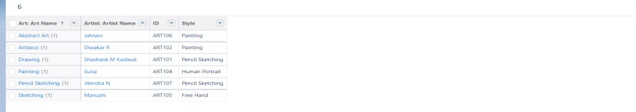

To Create an Inventory Report:

* 1. Go to “Reports tab” Click on “New Folder” And give it any name.
  2. Click on “New Report” and from search bar Search for “Inventories” and then select it.
  3. Add the required Columns to get the Complete Entered data.
  4. If you want the report to be grouped by any specific Fields then Search for the field in “Add groups” otherwise it is optional.
  5. Click on save and name the report as “New Inventories Report” and then select the folder which you have created.
  6. Click Save and then Click Run.

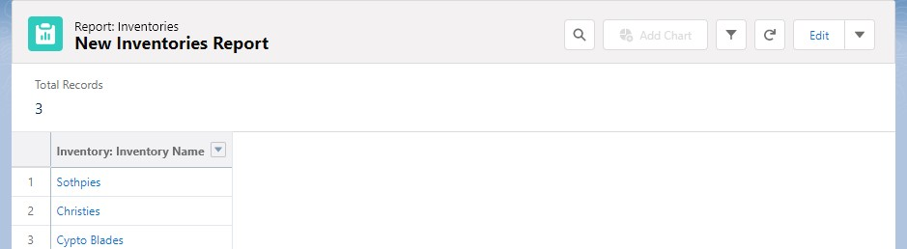

To Create an Artists Dashboard:

* 1. Go to “Dashboard tab” and then click on “New Folder” and give it any Name.
  2. Click on “New Dashboard” and then name it as “Art Gallery Dashboard” and select folder that you have created Click on Create.
  3. Click on the report that you have created and click on that and click select.
  4. Select any style to represent the data in dashboard.
  5. Add any filter(s), otherwise it is optional.
  6. Click on Save and Click Run

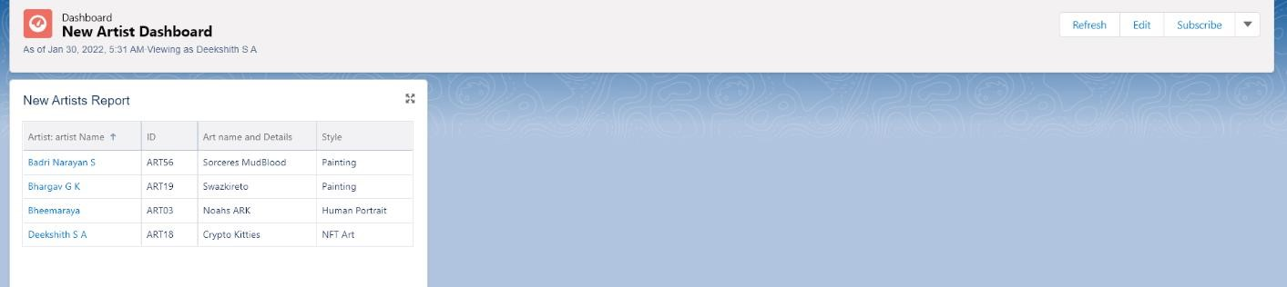

To Create an Arts Dashboard:

* 1. Go to “Dashboard tab” and then click on “New Folder” and give it any Name.
  2. Click on “New Dashboard” and then name it as “Artists with art Dashboard” and select folder that you have created Click on Create.
  3. Click on the report that you have created and click on that and click select.
  4. Select any style to represent the data in dashboard.
  5. Add any filter(s), otherwise it is optional.
  6. Click on Save and Click Run

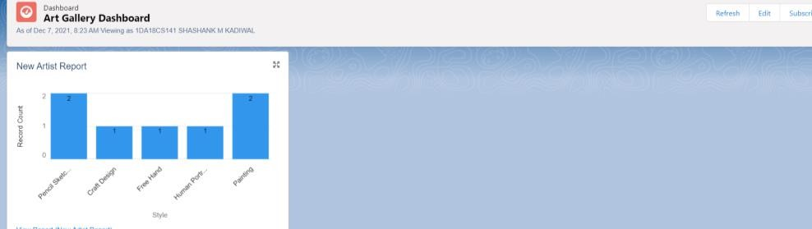

To Create an Inventory Dashboard:

* 1. Go to “Dashboard tab” and then click on “New Folder” and give it any Name.
  2. Click on “New Dashboard” and then name it as “Inventory Dashboard” and select folder that you have created Click on Create.
  3. Click on the report that you have created and click on that and click select.
  4. Select any style to represent the data in dashboard.
  5. Add any filter(s), otherwise it is optional.
  6. Click on Save and Click Run

**Q10) Create a web application with objects to record details about staff, syllabus and activities of a department and provide a link to college website from any of the objects.**

Launch your Salesforce Trailhead Playground by opening any module and Switch to Lightning Experience if you are currently in Salesforce Classic by clicking your picture in the right top corner and then click on “Switch to Lightning Experience”

Then go to Setup gear icon and click “Setup”.

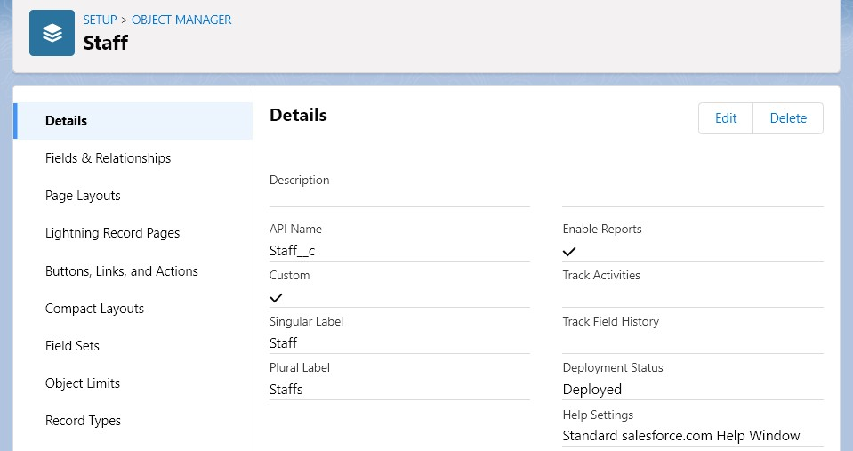

* 1. Click on “Object Manager” and click “Create > Custom Object” to create new Custom Object.
  2. Name the object “Staff”.
  3. Allow Reports and Allow Search.
  4. Check the box in front of “Launch New Custom Tab Wizard after saving this custom object”.
  5. To create a Tab for the Object: Select any Tab Style for the object “Staff”. Click Next, Next, leave the defaults and save.

To add fields to the Object:

Go to “Fields & Relationships” option of Student object and Click “New”.

Add the following fields one after the other:

* + Field Label: ID (Length 10), Data Type: Text, provide an example ID as Help Text, make it as

Required Field, don’t allow Duplicate Values, make it as Case Insensitive and Set this field as the unique record identifier from an external system.

* + Field Label: Branch, Data Type: Text, Make it as a required field.

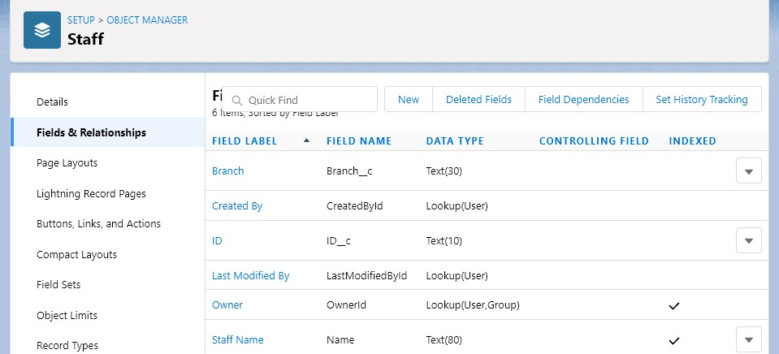

Create one more object to store Syllabus details:

* 1. Name the Object “Syllabus”.
  2. Allow Reports and Allow Search.
  3. Check the box in front of “Launch New Custom Tab Wizard after saving this custom object” 4. Create a Tab for the Object.

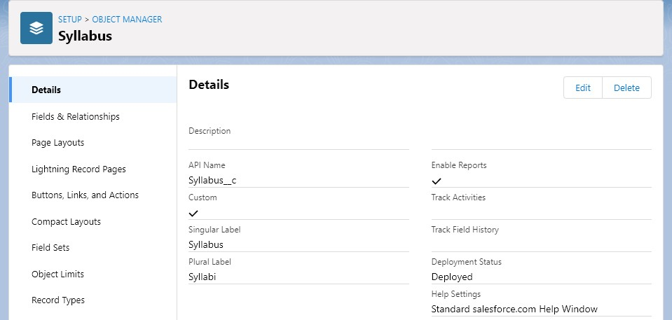

To add fields to the Object:

Go to “Fields & Relationships” option of Student object and Click “New”.

Add the following fields one after the other:

* + Field Label: Subject Code, Data Type: Text.
  + Field Label: Credits, Data Type: Number.

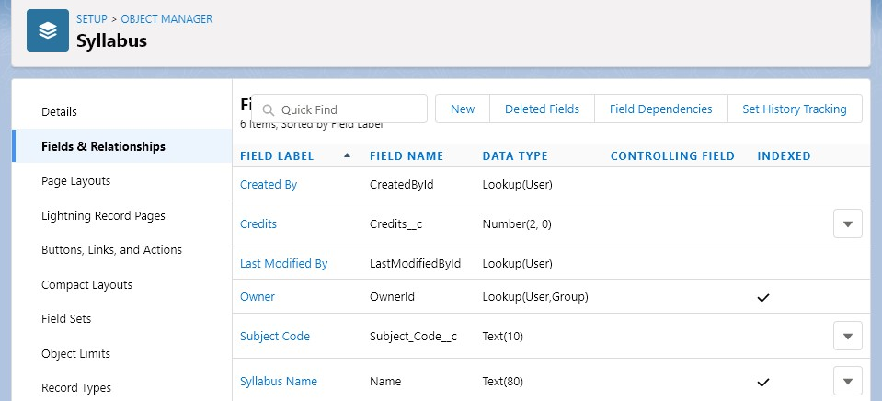

Create one more object to store department activities’ details:

* 1. Name the Object “Activities”.
  2. Allow Reports and Allow Search.
  3. Check the box in front of “Launch New Custom Tab Wizard after saving this custom object”
  4. Create a Tab for the Object.

To add fields to the Object:

Go to “Fields & Relationships” option of Student object and Click “New”.

Add the following fields one after the other:

* + Field Label: Details, Data Type: Text. Make it as a required field

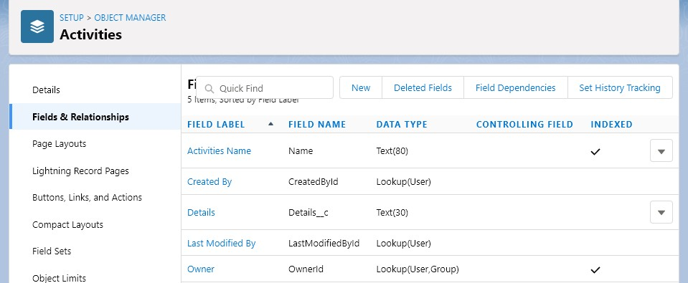

**Validation Rules:**

**Staff id Validation:**

* 1. To add a rule to the Staff is so that it should take only valid ids:
  2. Go to Validation Rule of Staff Object and click “New”
  3. Name it as “Staff id validation”.
  4. Error Condition Formula: NOT(BEGINS(ID__c,’STAFF’)).
  5. Error Message: Please enter a valid staff Id.
  6. Error Location: Field – ID.
  7. Click Save.

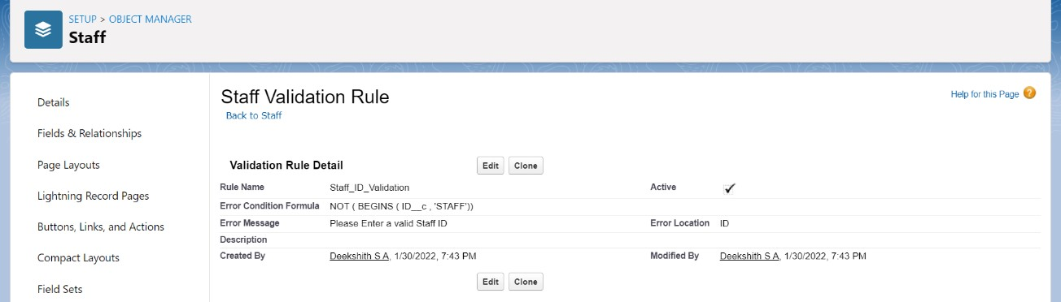

**To add a rule to the Subject code so that it should not take invalid sub code:**

* 1. Go to Validation Rule of Syllabus Object and click “New”.
  2. Name it as “Sub code validation”
  3. Error Condition Formula: NOT (REGEX (Subject_Code__c, “[0-9]{2} +[a-z] [A-Z]{2} + [0-9]{2}

+”)).

* 1. Error Message: Please Enter a valid Subject code.
  2. Error Location: Field – Subject Code.
  3. Click Save

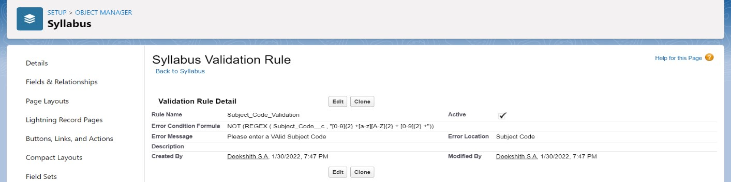

**To add a rule to the Credits so that it Should not take more than 4 credits:**

* 1. Go to Validation Rule of Syllabus Object and click “New”.
  2. Name it as “Credits validation”.
  3. Error Condition Formula: OR (credits__c >4, Credits__c <=0).
  4. Error Message: Please Enter the credits which is less than 4.
  5. Error Location: Field –Credit.
  6. Click Save.

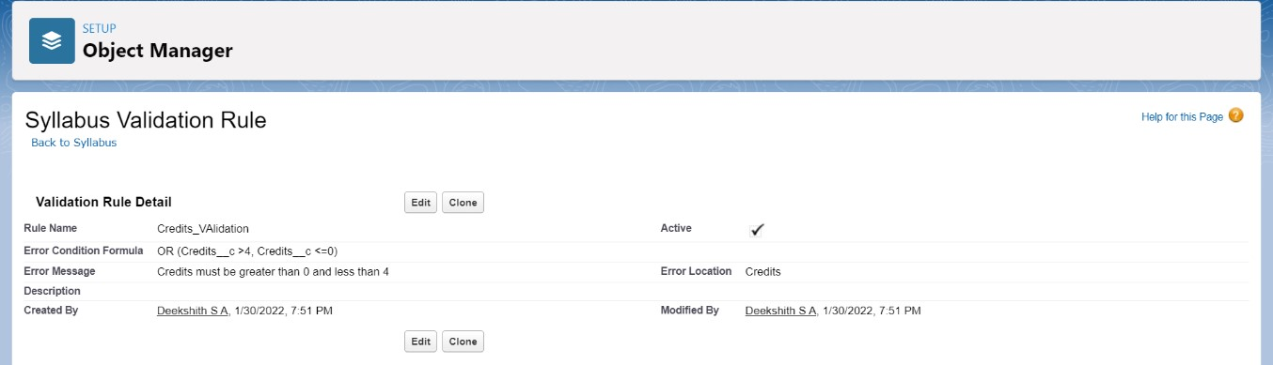

To give a link to college website:

* 1. Go to “Buttons, Links and Actions” of Art Object and click “New Button or Link”.
  2. Name it as “College”.
  3. Select the radio button “Detail Page Link” as it is a website link.
  4. Behaviour: Display in new window.
  5. Content Source: URL.
  6. Field Type: College.
  7. In the empty space provided, type https://www.drait.edu.in/
  8. Link Encoding: Unicode (UTF-8).
  9. Click Save
  10. Go to Page Layout, Click Activities Layout.
  11. Click Custom Links, Drag and drop the “College” link in the Custom Link area.
  12. Click Save.

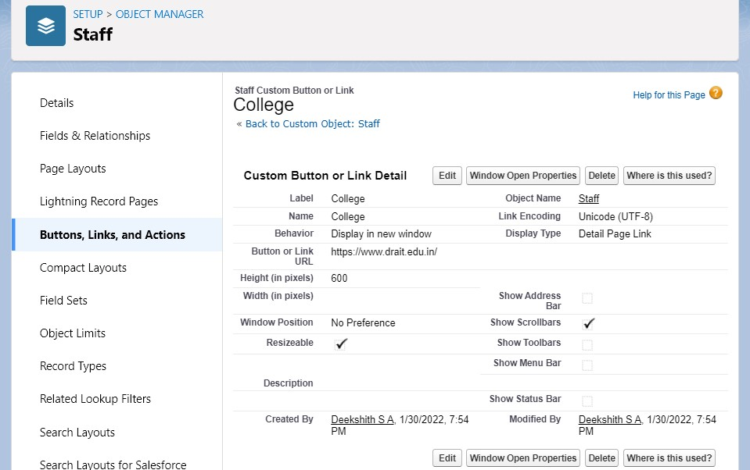

To create an application:

* 1. Go to “Setup” and type “App Manager” in Quick Find Box.
  2. Click on “New Lightning App” to create a Lightning Application.
  3. Name it as “Department Details”, give the description for your application.
  4. Uploading Image and changing colours are optional, then click Next.
  5. Navigation Style: Standard Navigation, click Next.
  6. No need to add any Utility Bar, click Next.
  7. Add the following:
  8. Items: Staff, Syllabuses, Activities, Reports and Dashboards, click Next.
  9. Assign it to System Administrator Profile by selecting System Administrator and pressing right arrow and then click Save & Finish.

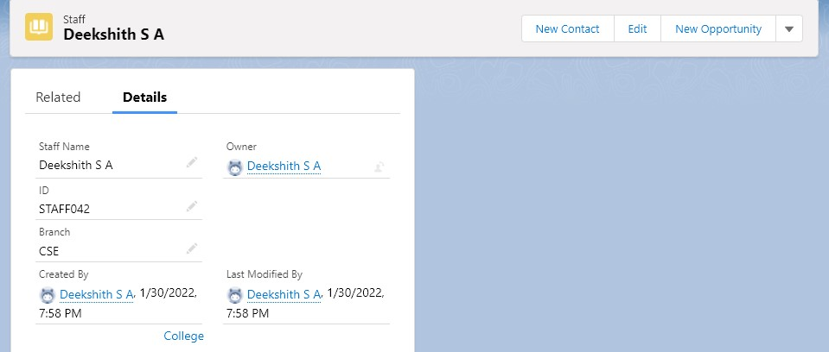

Go to App Manager, select your application and select Faculties and click “New” to add some details to your application.

Click the entry you added, go to details.

Press the “College” link to check the details.

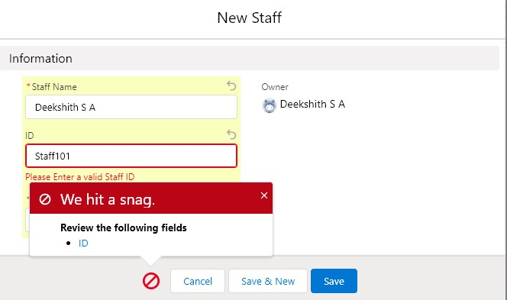

Click OK so that it will redirect you to the website. Make Sure You will get an error when u give invalid staff id, credits and Subject code.

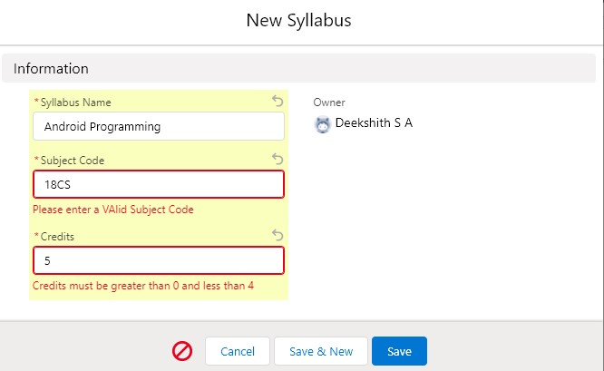

**Reports and Dashboards:**

**To Create a Staff Report:**

* 1. Go to “Reports tab” Click on “New Folder” And give it any name then select Save.
  2. Click on “New Report” and from search bar Search for “Staffs” and then select it then select Continue.
  3. Add the required Columns to get the Complete Entered data.
  4. If you want the report to be grouped by any specific Fields then Search for the field in “Add groups” otherwise it is optional.
  5. Click on save and name the report as “New Staffs Report” and then select the folder which you have created.
  6. Click Save and then Click Run.

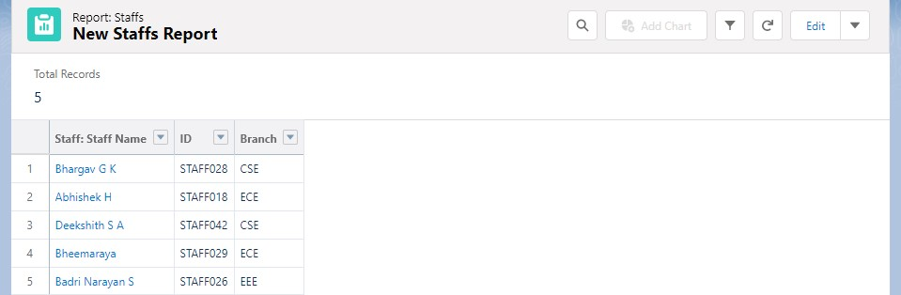

**To Create a Syllabus Report:**

* 1. Go to “Reports tab” Click on “New Folder” And give it any name then select Save.
  2. Click on “New Report” and from search bar Search for “Syllabus” and then select it then select Continue.
  3. Add the required Columns to get the Complete Entered data.
  4. If you want the report to be grouped by any specific Fields then Search for the field in “Add groups” otherwise it is optional.
  5. Click on save and name the report as “New Syllabus Report” and then select the folder which you have created.
  6. Click Save and then Click Run

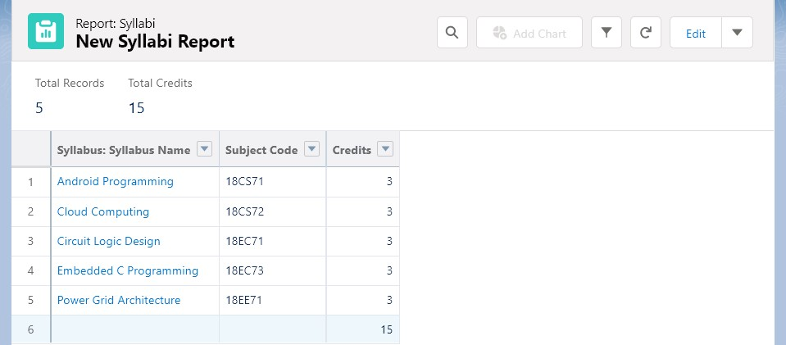

**To Create an Activities Report:**

* 1. Go to “Reports tab” Click on “New Folder” And give it any name then select Save.
  2. Click on “New Report” and from search bar Search for “Activities” and then select it then select Continue.
  3. Add the required Columns to get the Complete Entered data.
  4. If you want the report to be grouped by any specific Fields then Search for the field in “Add groups” otherwise it is optional.
  5. Click on save and name the report as “New Activities Report” and then select the folder which you have created.
  6. Click Save and then Click Run

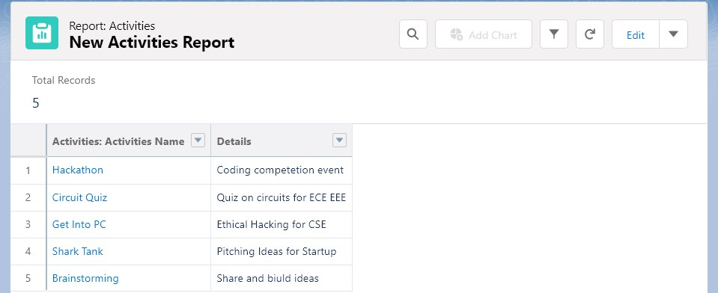

**To Create a Staff Dashboard:**

* 1. Go to “Dashboard tab” and then click on “New Folder” and give it any Name.
  2. Click on “New Dashboard” and then name it as “Staff dashboard” and select folder that you have created Click on Create.
  3. Click on the report that you have created and click on that and click select.
  4. Select any style to represent the data in dashboard.
  5. Add any filter(s), otherwise it is optional.
  6. Click on Save and Click Run

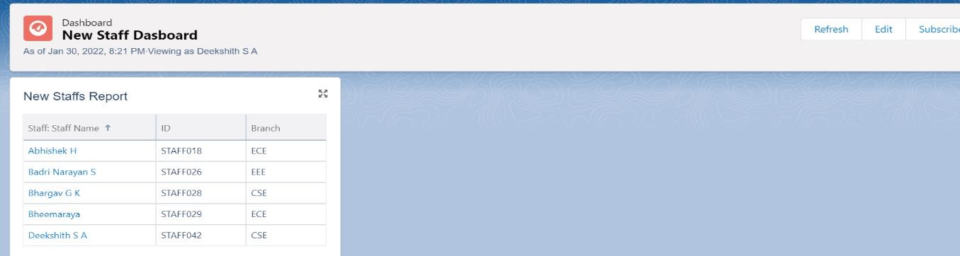

**To Create a Syllabus Dashboard:**

* 1. Go to “Dashboard tab” and then click on “New Folder” and give it any Name.
  2. Click on “New Dashboard” and then name it as “Syllabus dashboard” and select folder that you have created Click on Create.
  3. Click on the report that you have created and click on that and click select.
  4. Select any style to represent the data in dashboard.
  5. Add any filter(s), otherwise it is optional.
  6. Click on Save and Click Run.

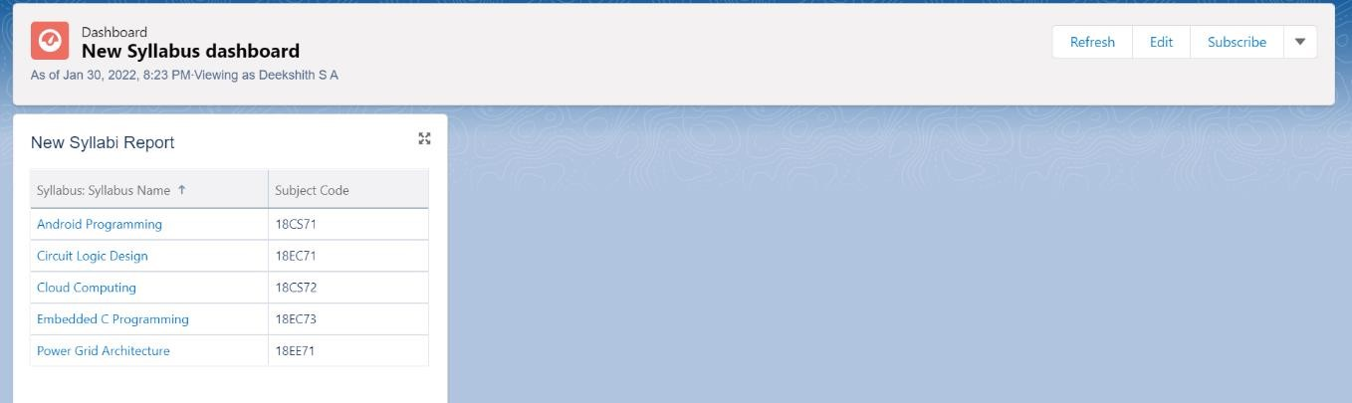

**To Create an Activities Dashboard:**

* 1. Go to “Dashboard tab” and then click on “New Folder” and give it any Name.
  2. Click on “New Dashboard” and then name it as “Activities dashboard” and select folder that you have created Click on Create.
  3. Click on the report that you have created and click on that and click select.
  4. Select any style to represent the data in dashboard.
  5. Add any filter(s), otherwise it is optional.
  6. Click on Save and Click Run

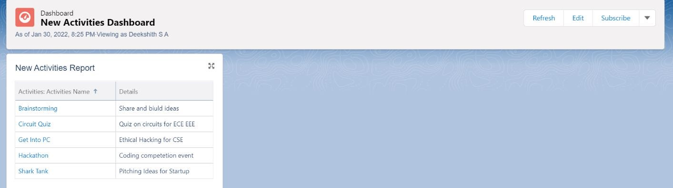

#### CLOUD ANALYST

Cloud Analyst is a tool developed at the University of Melbourne whose goal is to support evaluation of social networks tools according to geographic distribution of users and data centres. In this tool, communities of users and data canters supporting the social networks are characterized and, based on their location; parameters such as user experience while using the social network application and load on the data centre are obtained/logged.

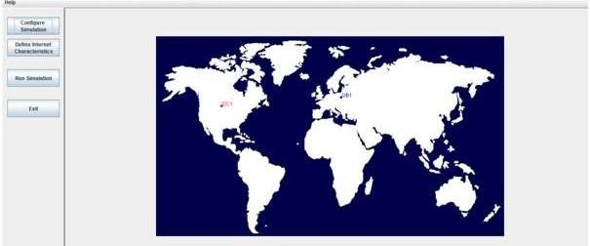

Cloud Analyst is developed by Bhathiya Wickremasinghe et al. at the CLOUDS Laboratory. It is built on top of CloudSim and separates the simulation experimentation from a programming task enabling one to concentrate on the simulation parameters rather than the technicalities of programming. Simulation in Cloud Analyst involves the following steps:

1. Defining and configuration of User Bases.

1. Defining and configuring Data Centers

1. Allocating of Virtual Machines in Data Centers.

1. Review and Adjustment of various other parameters such as Packet size, Number of packets, Bandwidth, and Load balancing policies.

The Cloud Analyst enables us to model different scenarios of CSPs and User Bases, and provides a comprehensive output detailing the response time, Data Center processing time and total cost involved in the communication and computation.

**Installing and Running Cloud Analyst:**

* + 1. Download CloudAnalyst

* + 1. Extract the files from the zip file which will give following folder structure.

3.Click on run.bat file.

4. The user can then configure the simulation which includes

* + Simulation Duration
  + Number of User Bases
  + Service broker policy
  + Data Center Configuration
  + Load Balancing Policy

5. To run the simulation, click on Run Simulation.

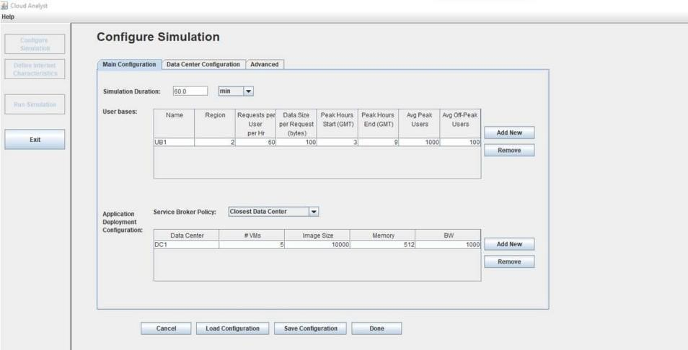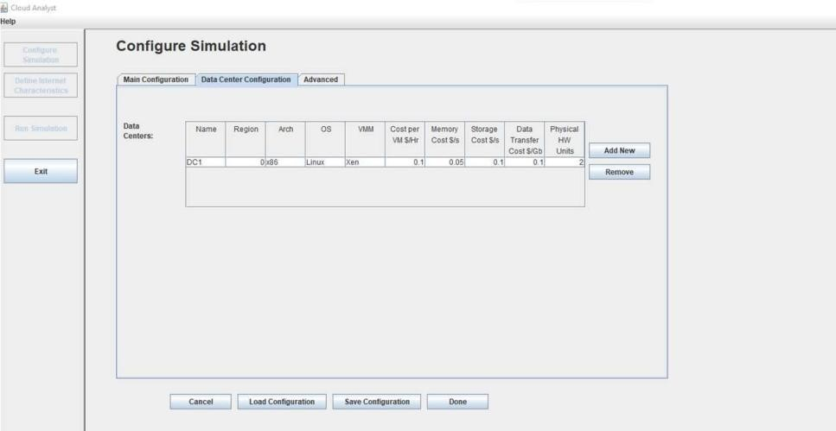

#### Cloud Analyst Simulations

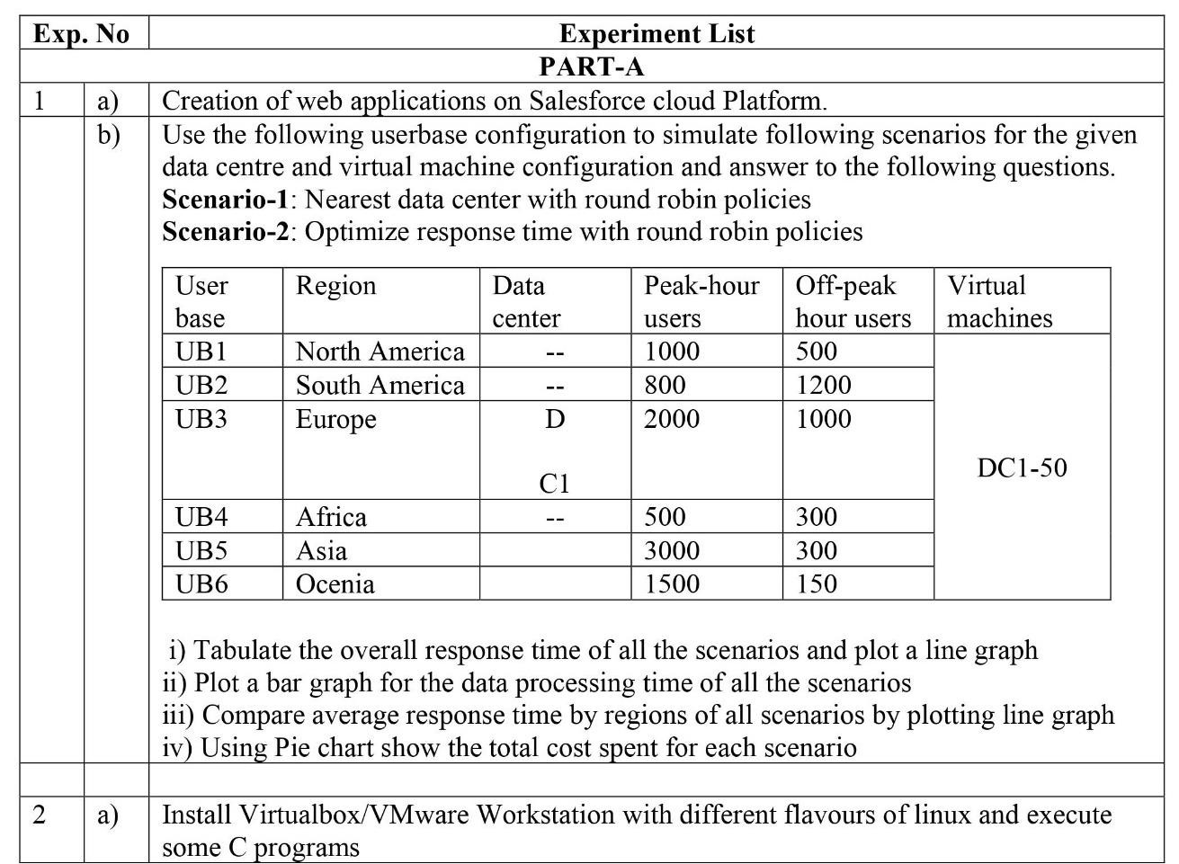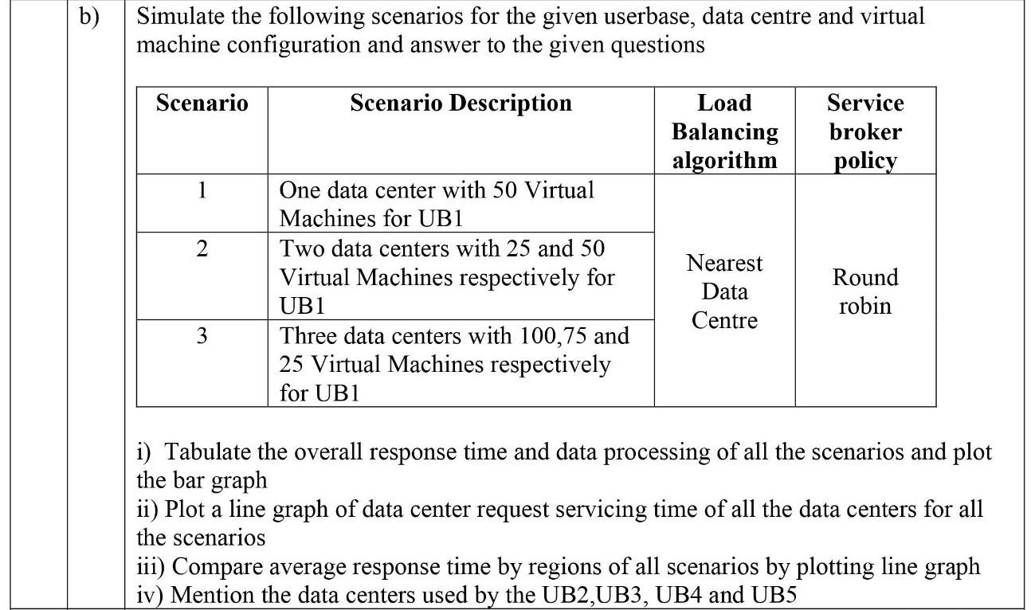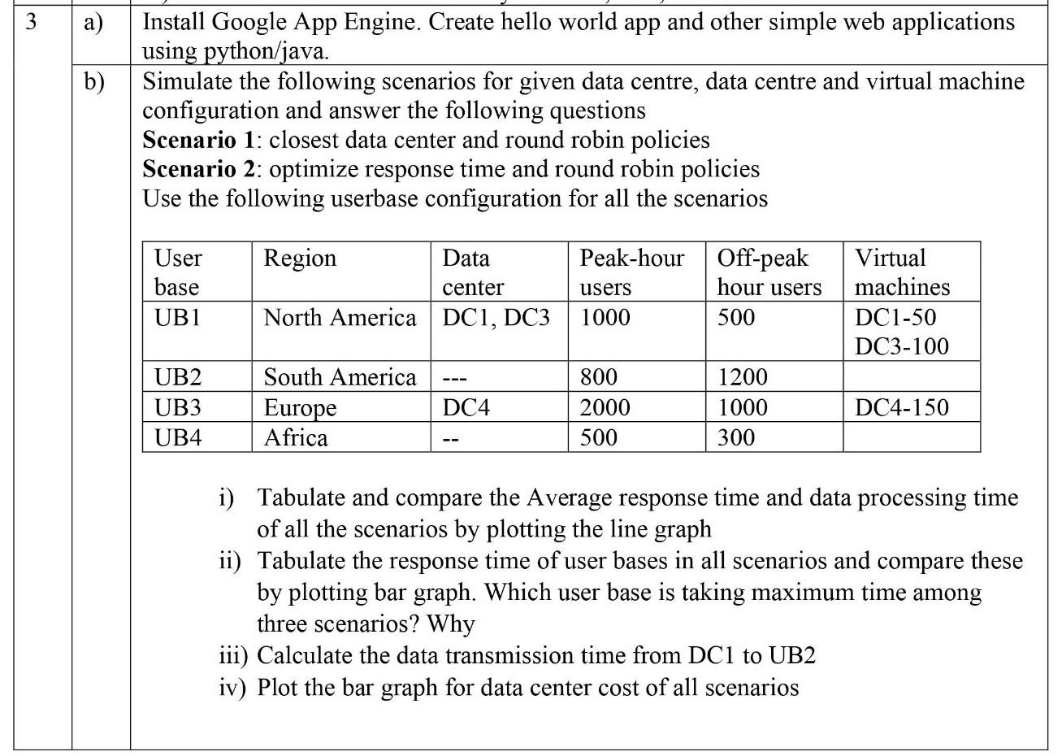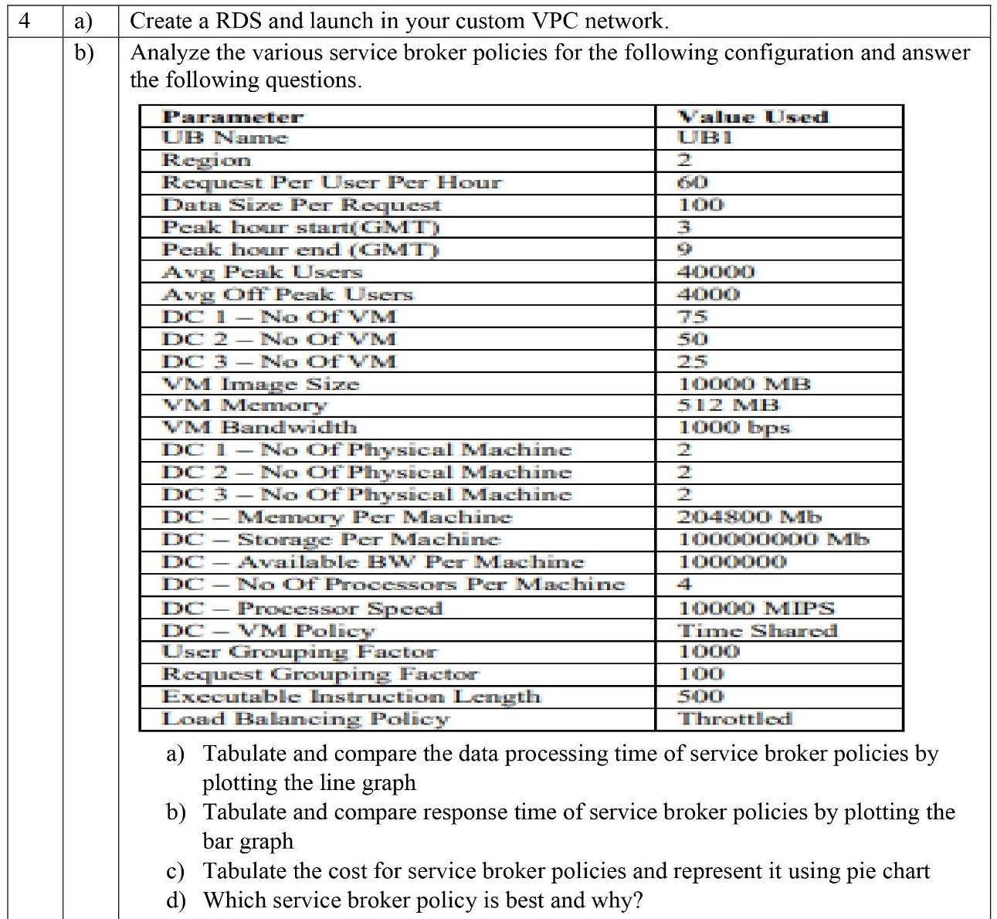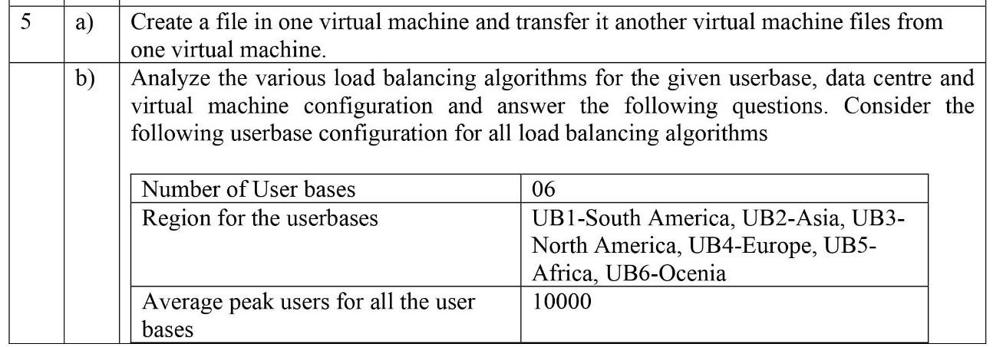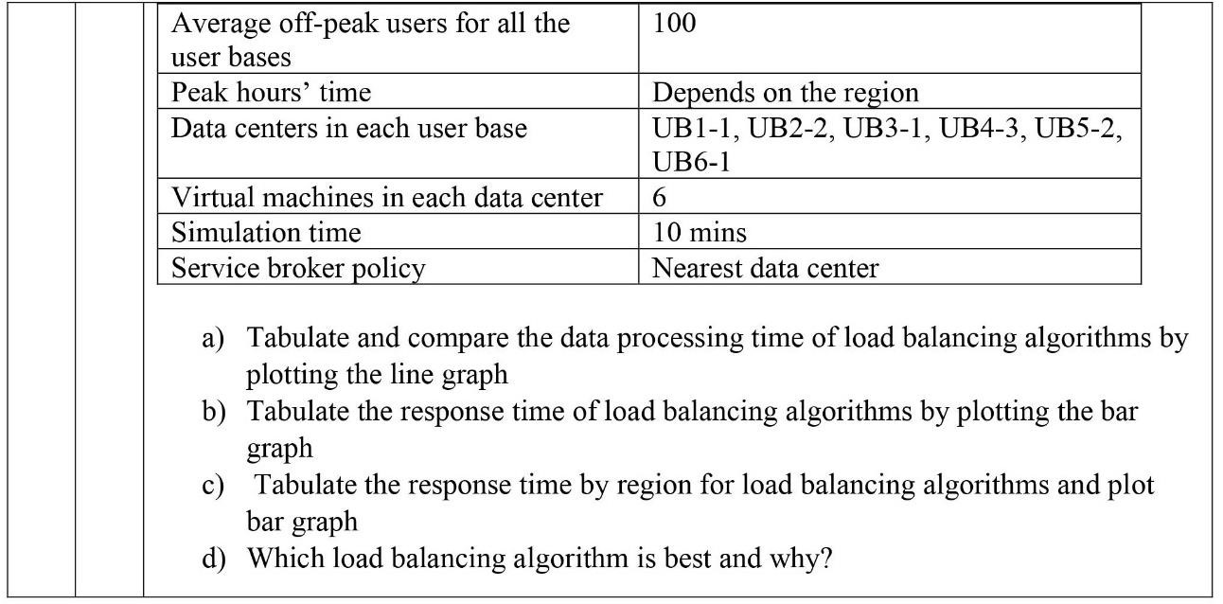

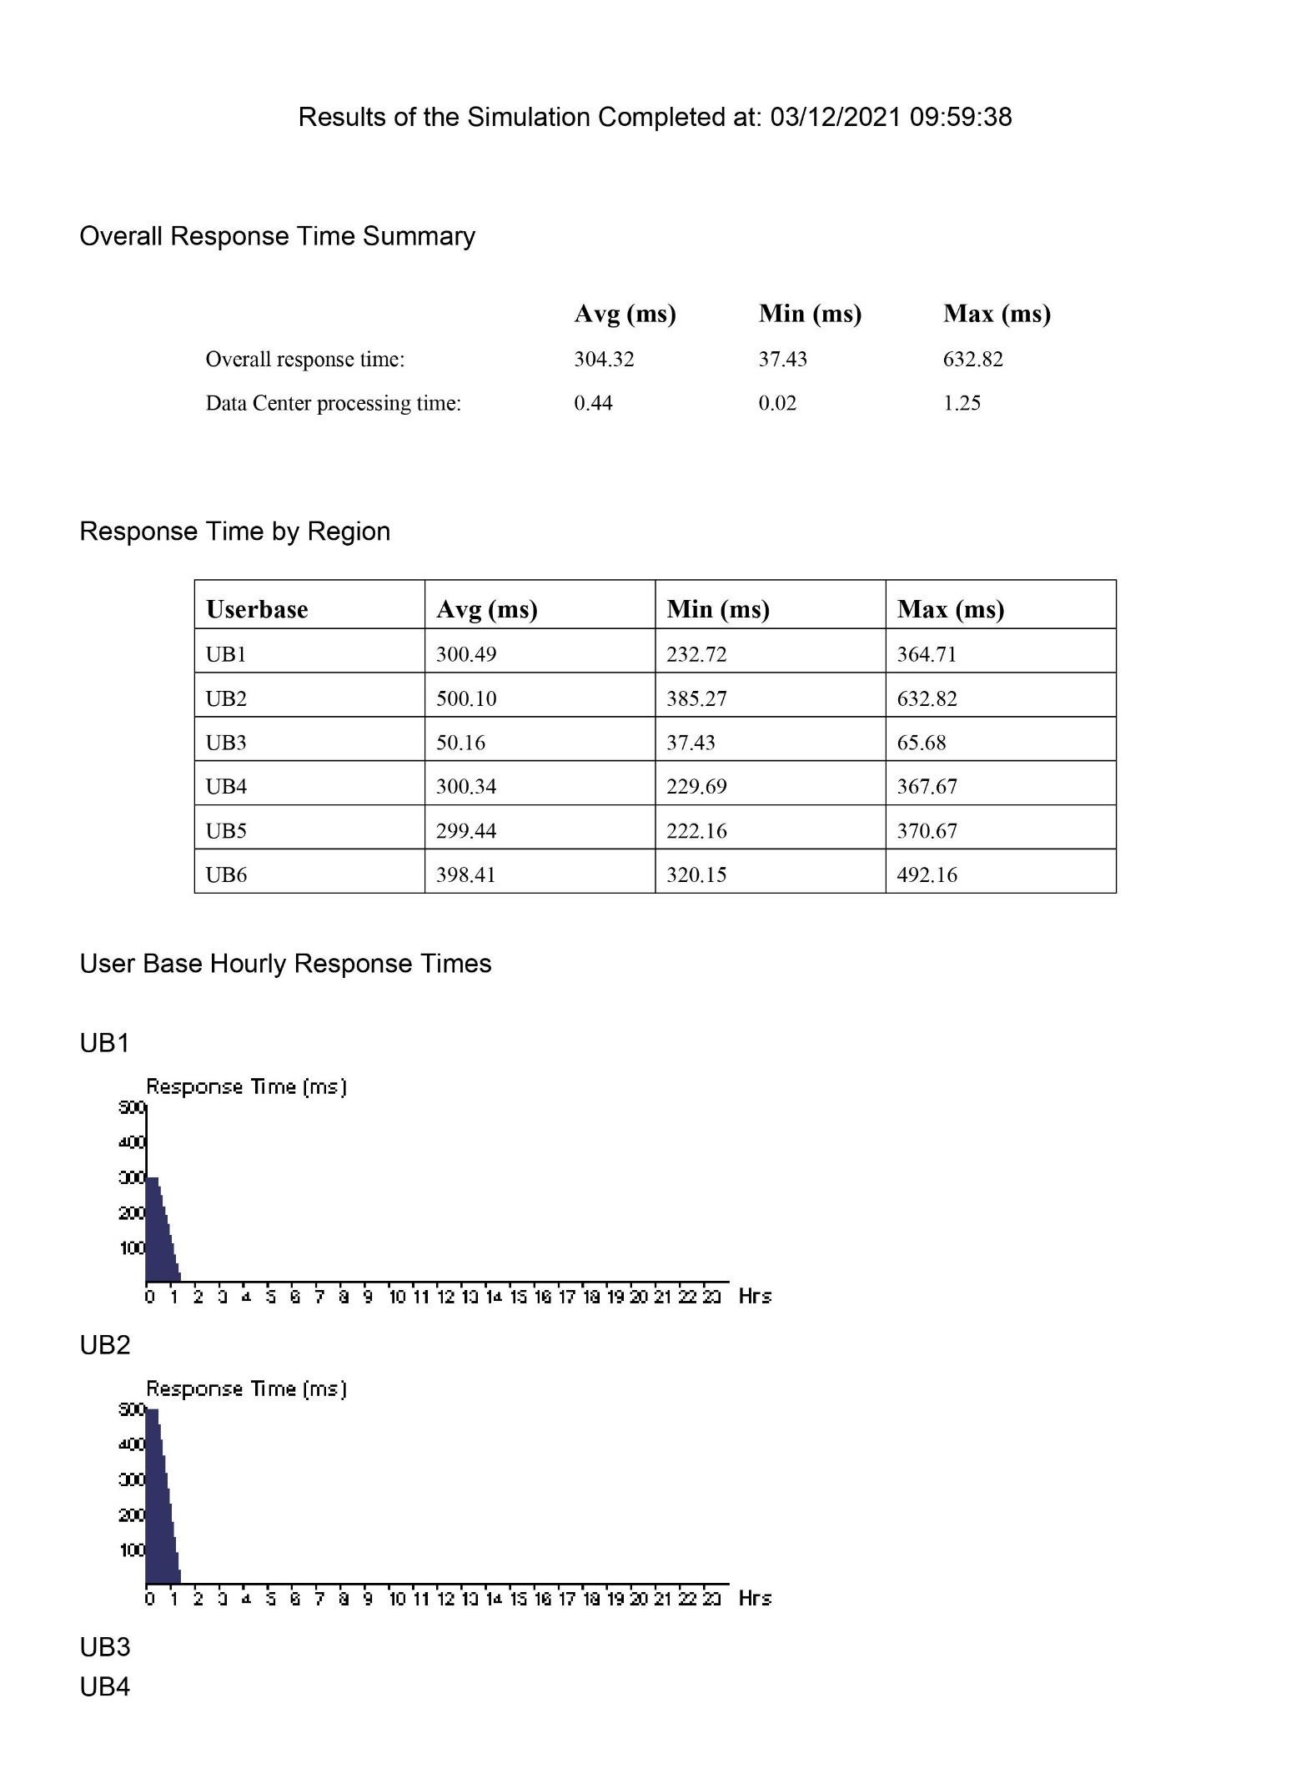

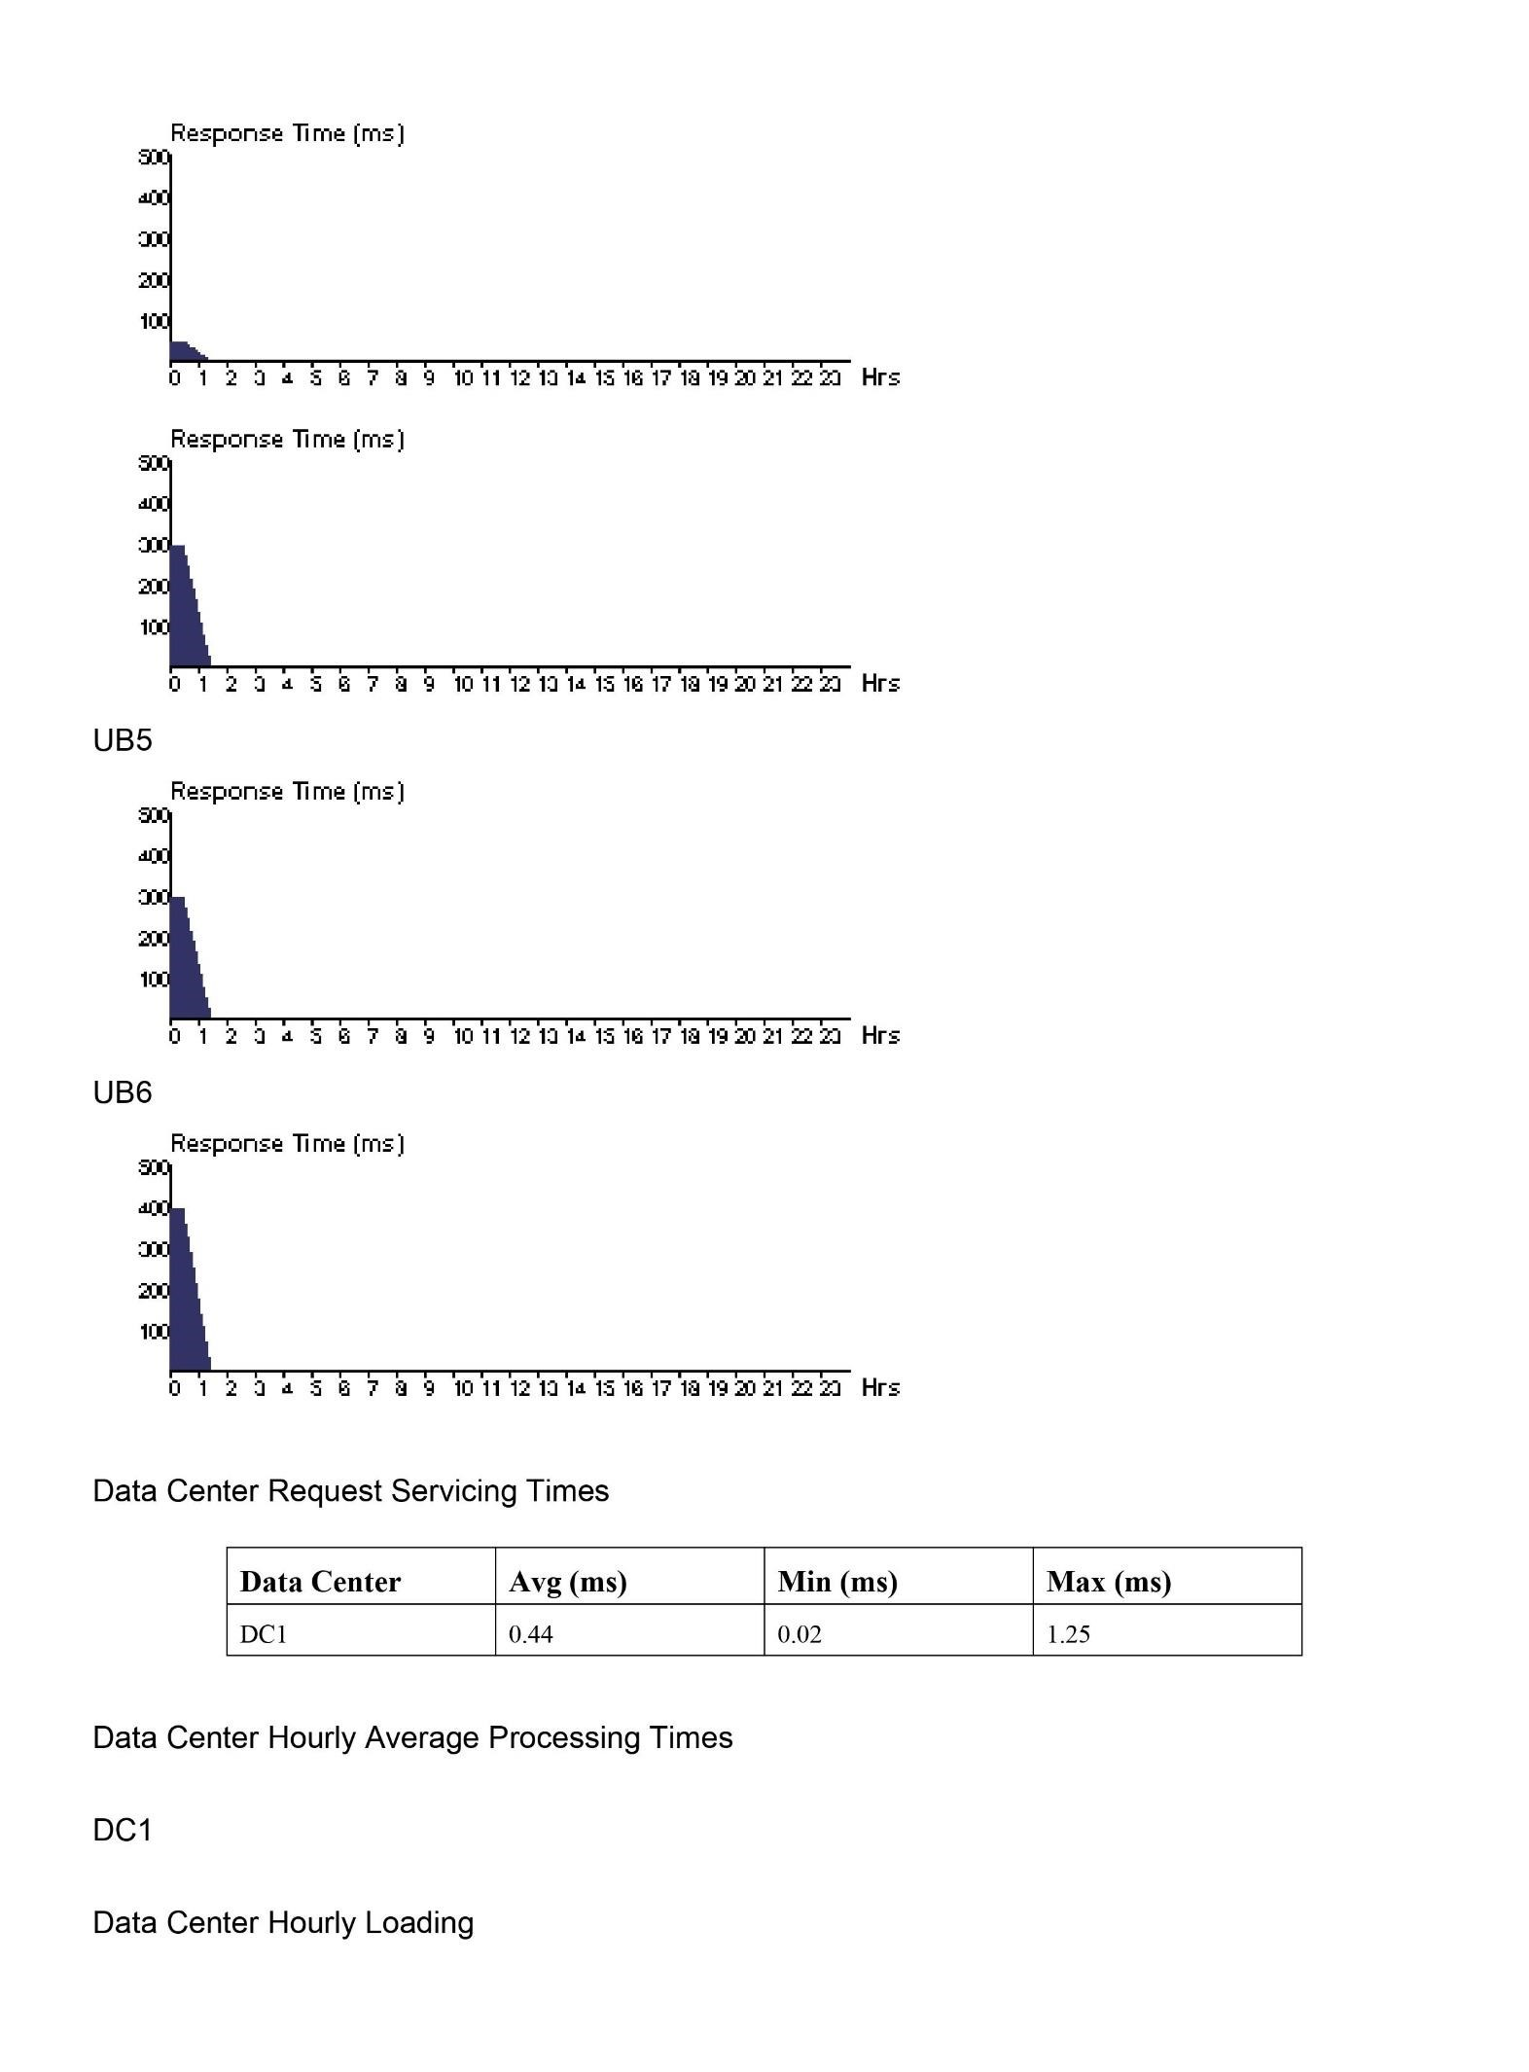

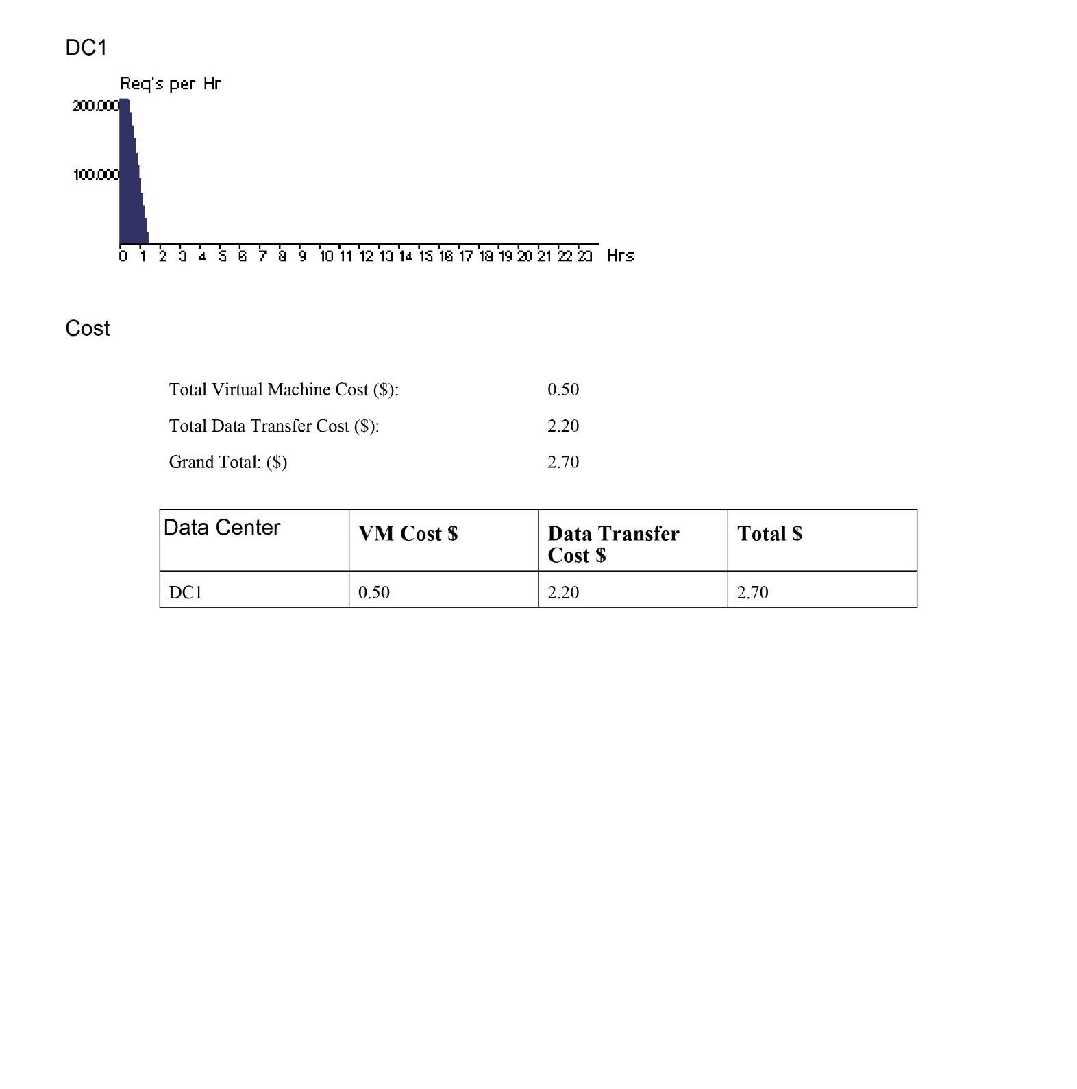

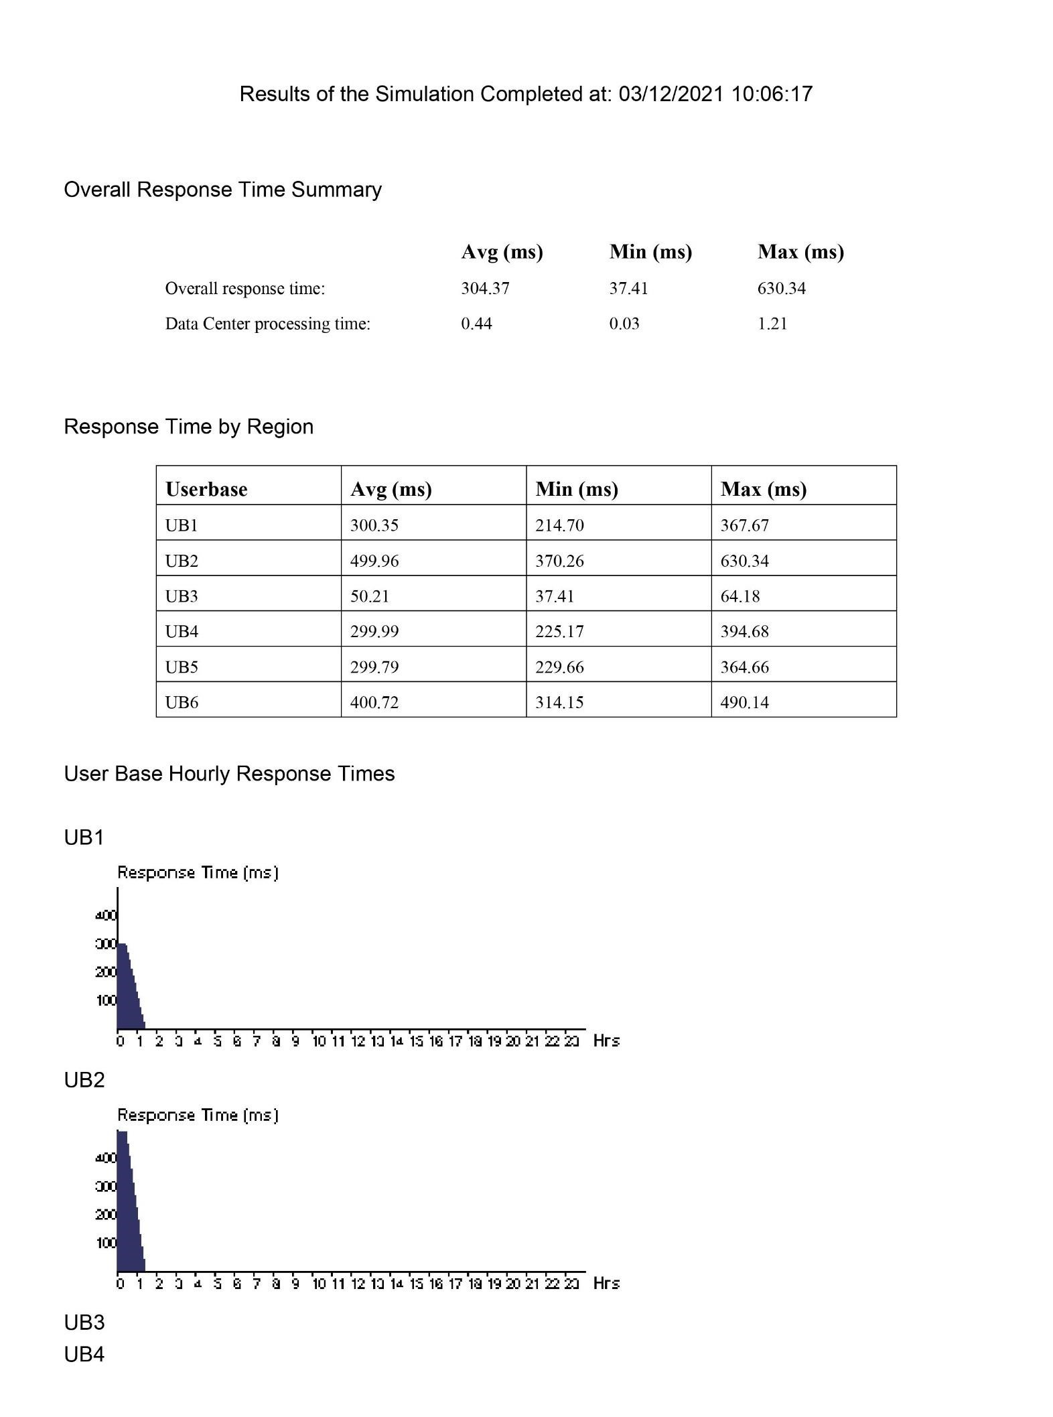

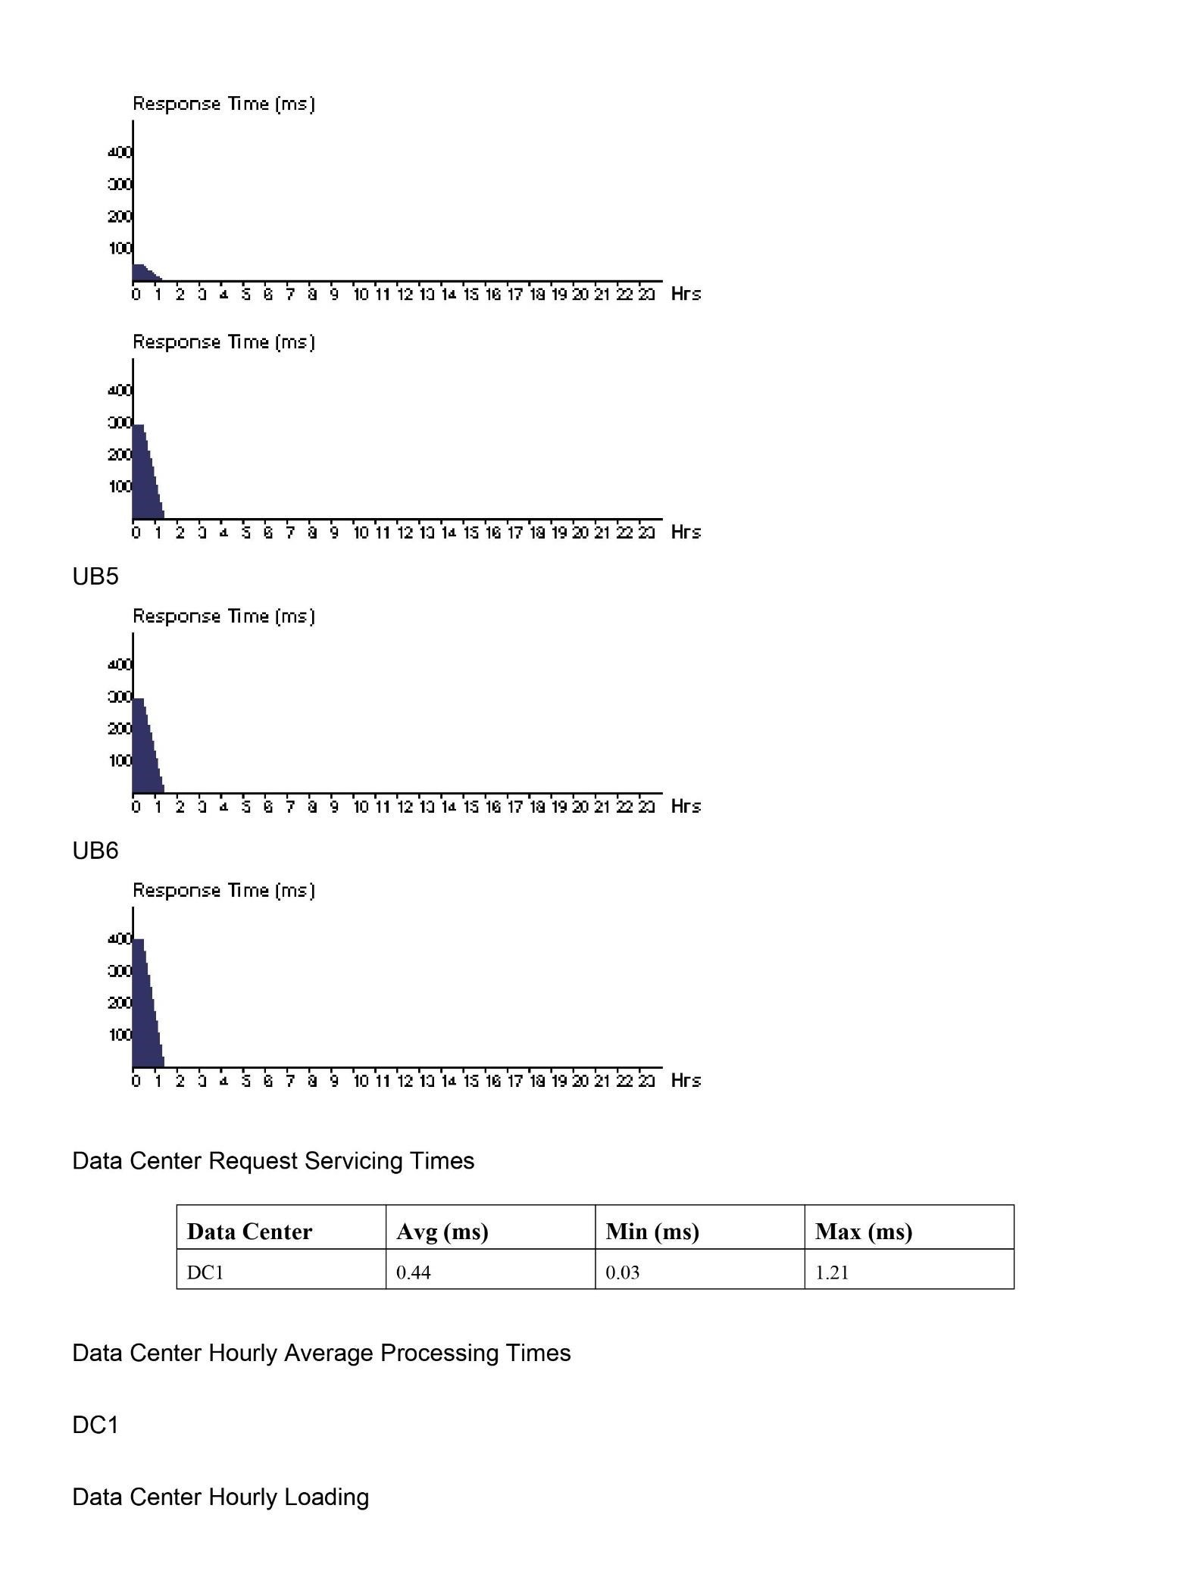

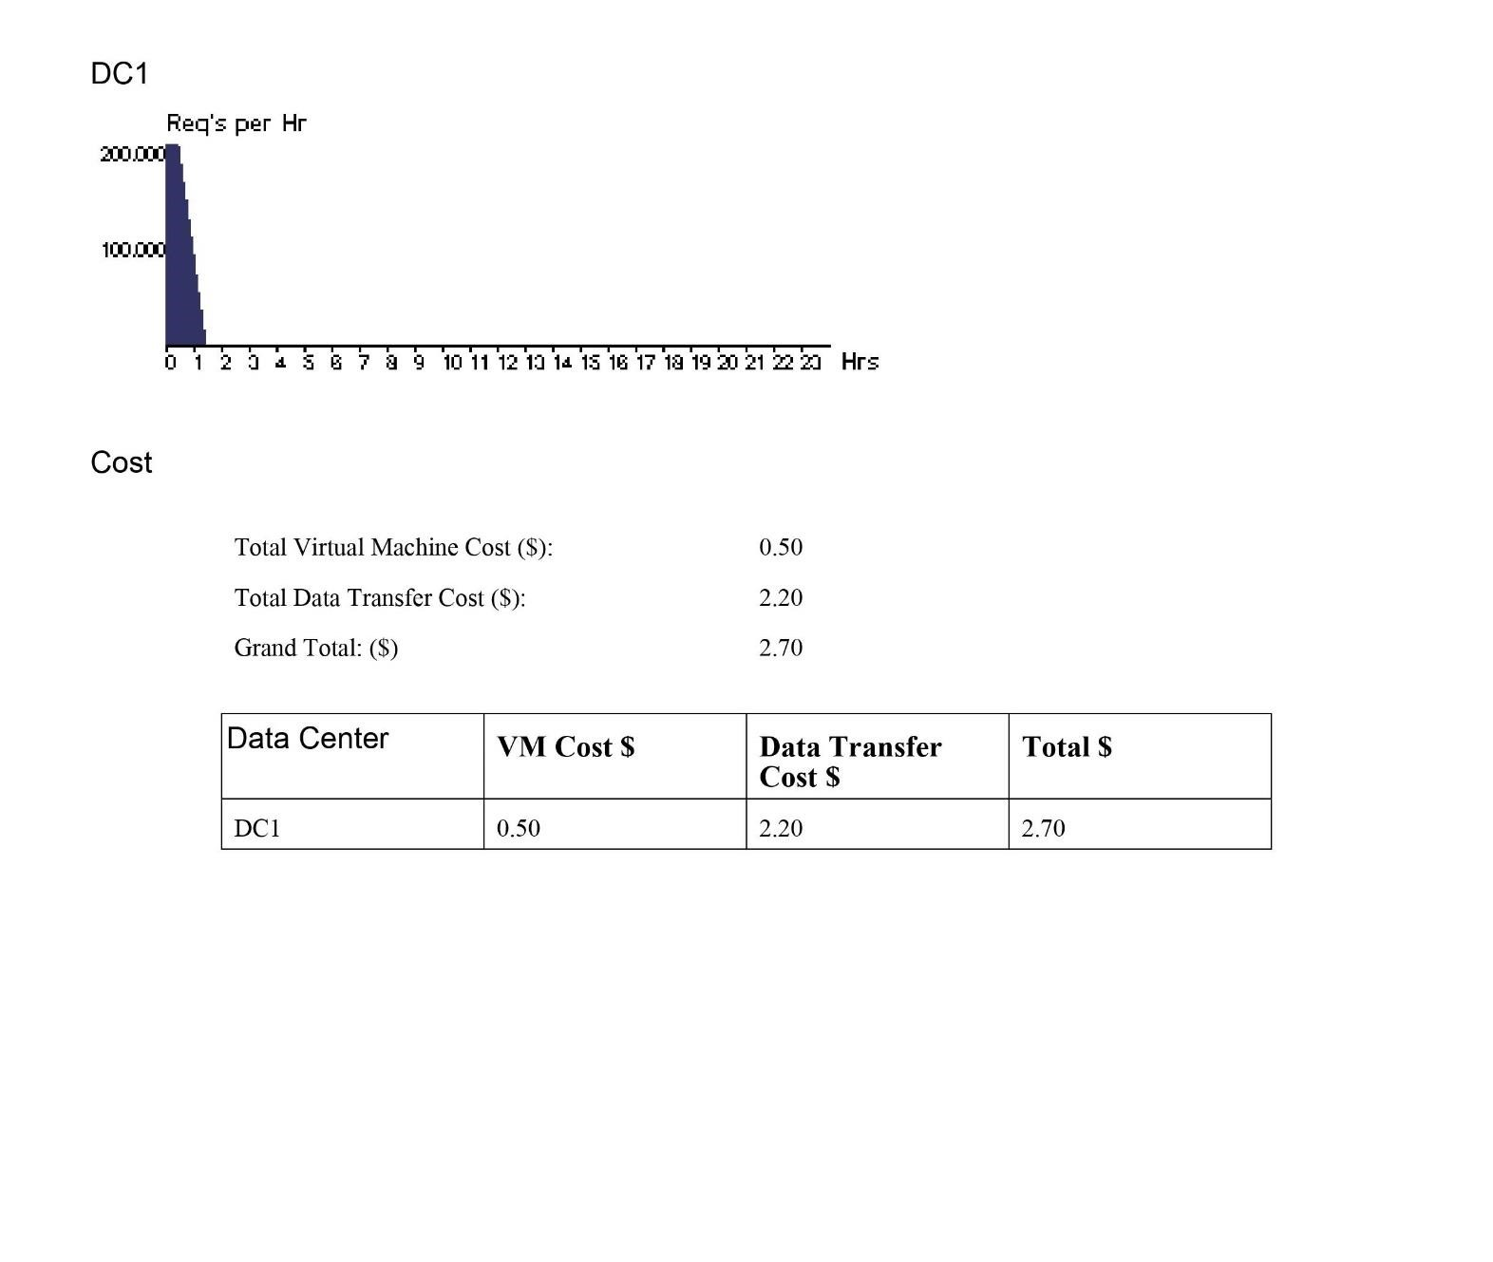

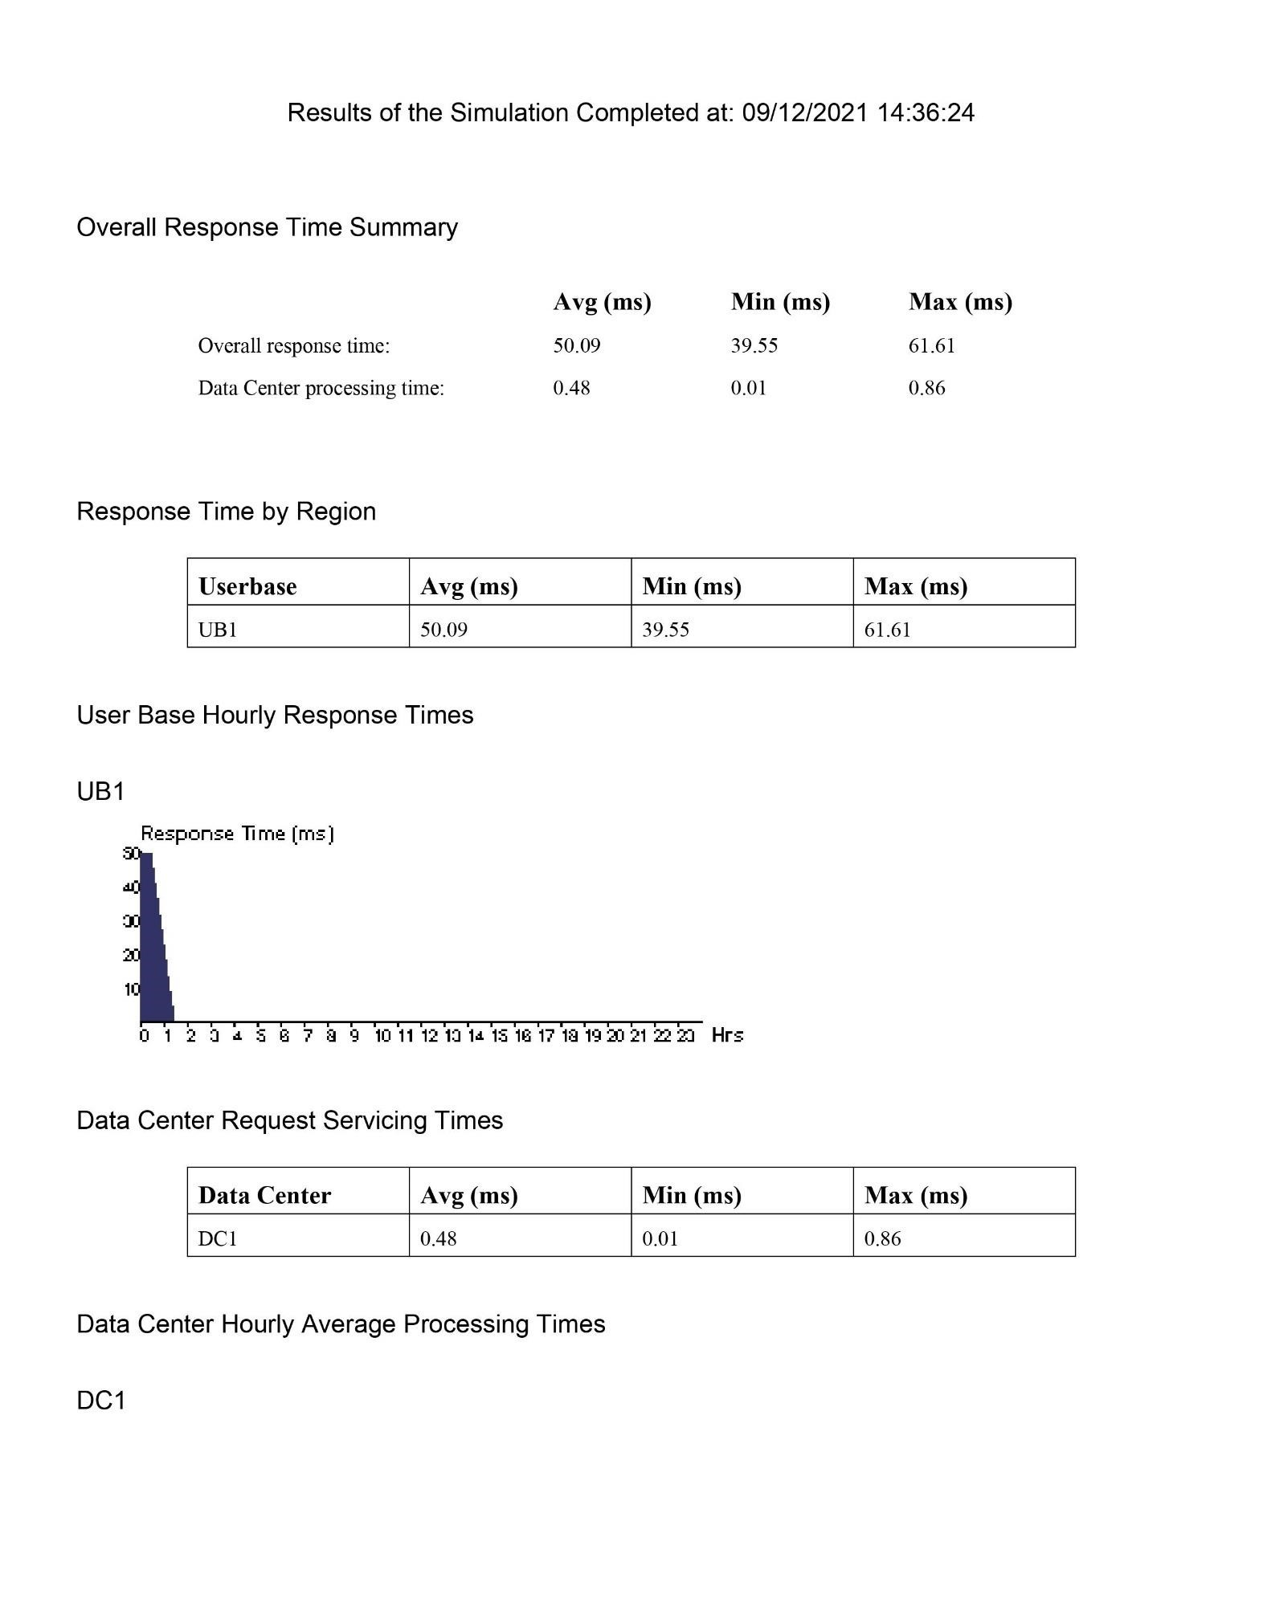

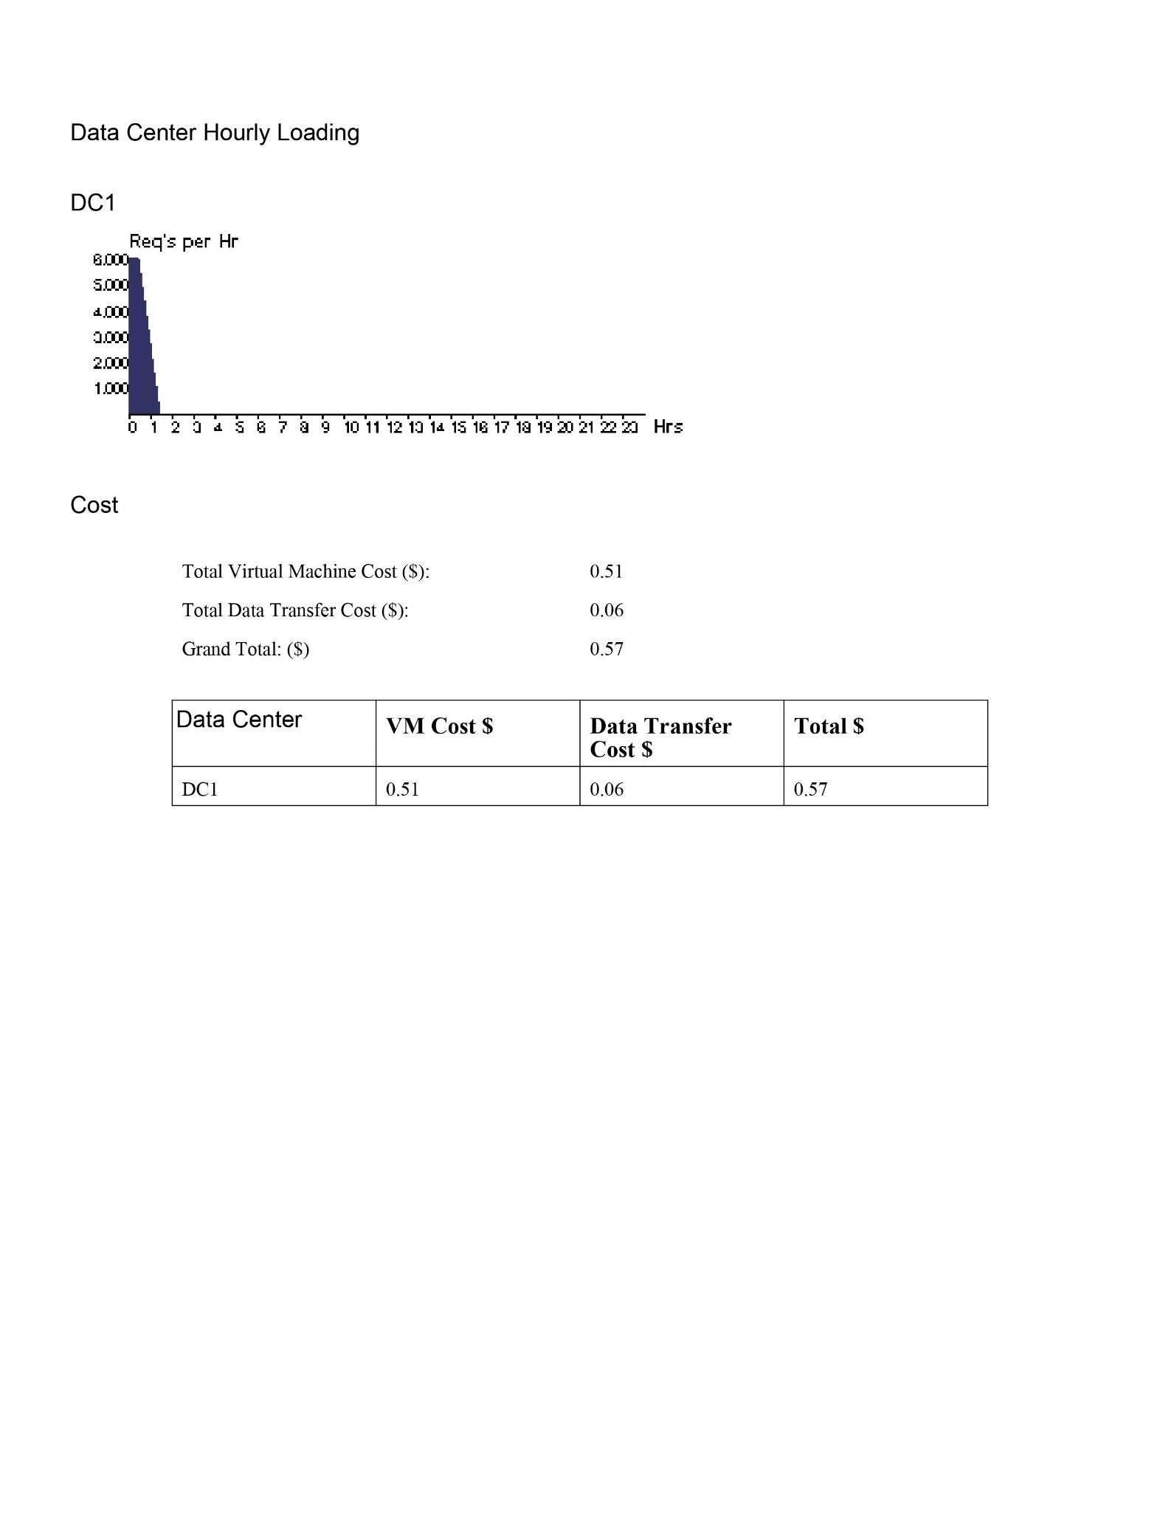

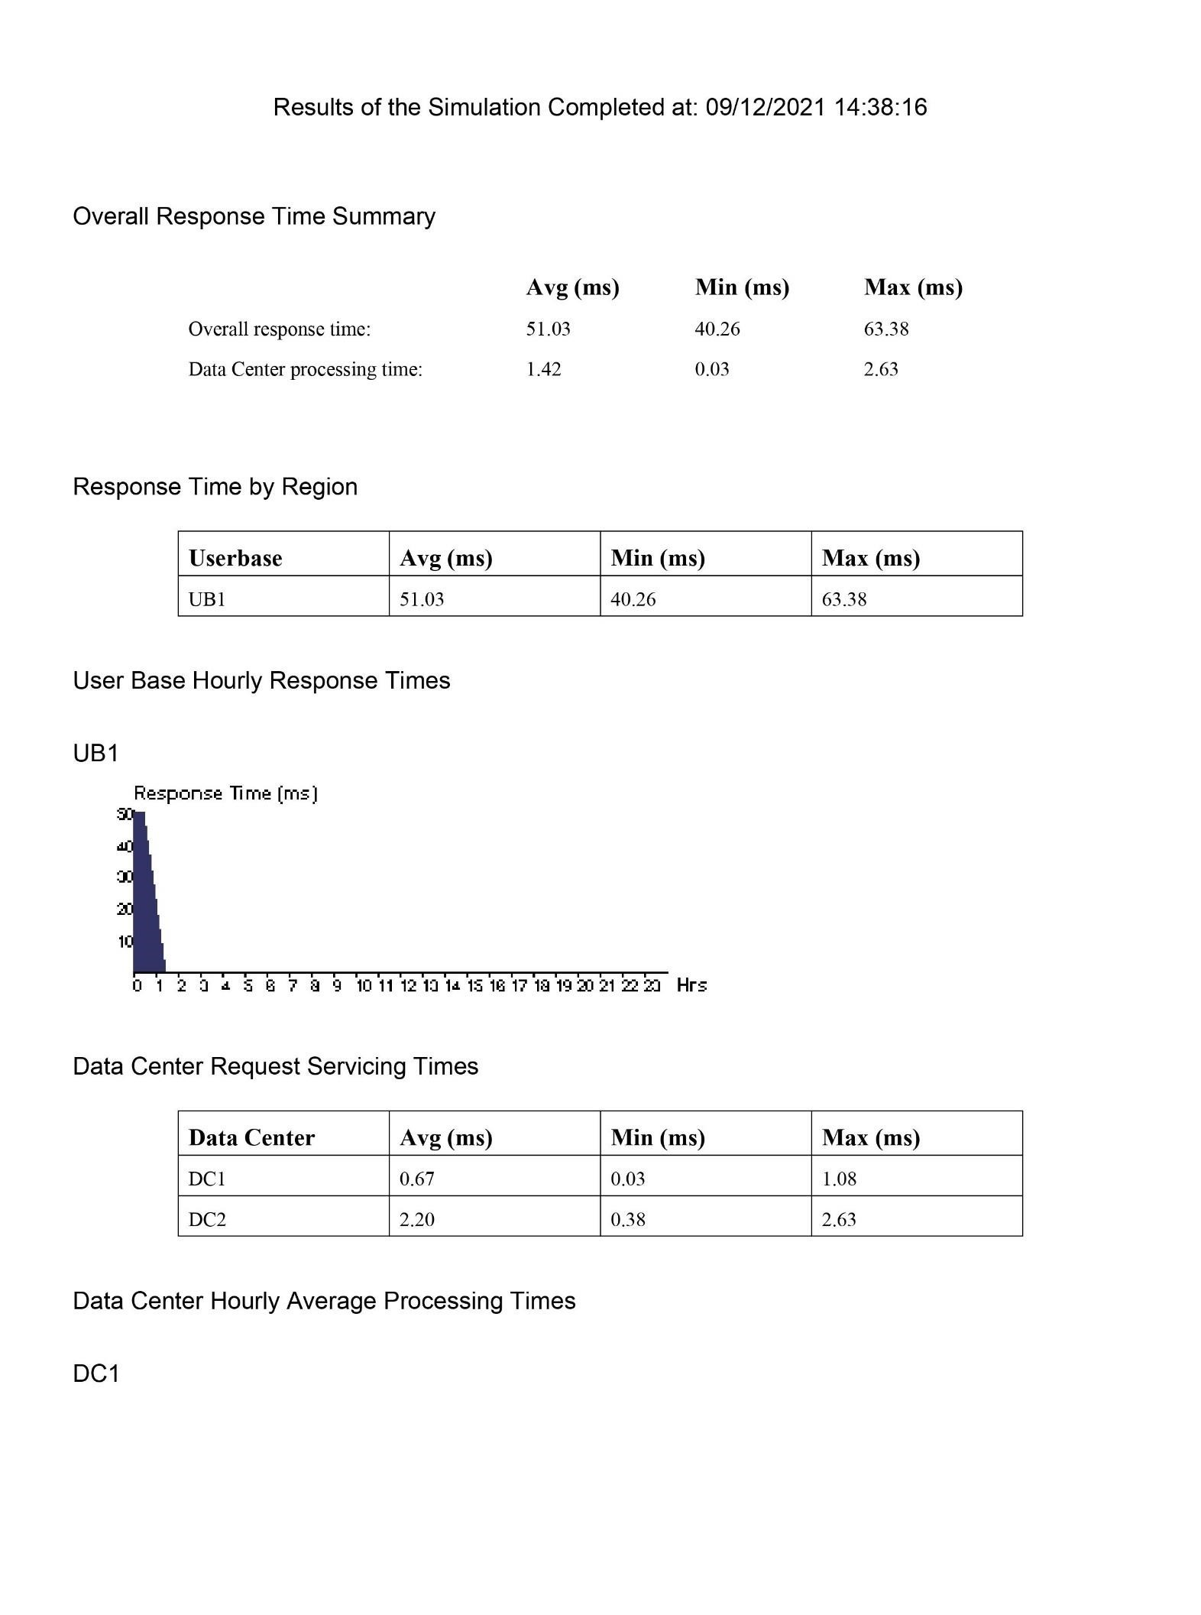

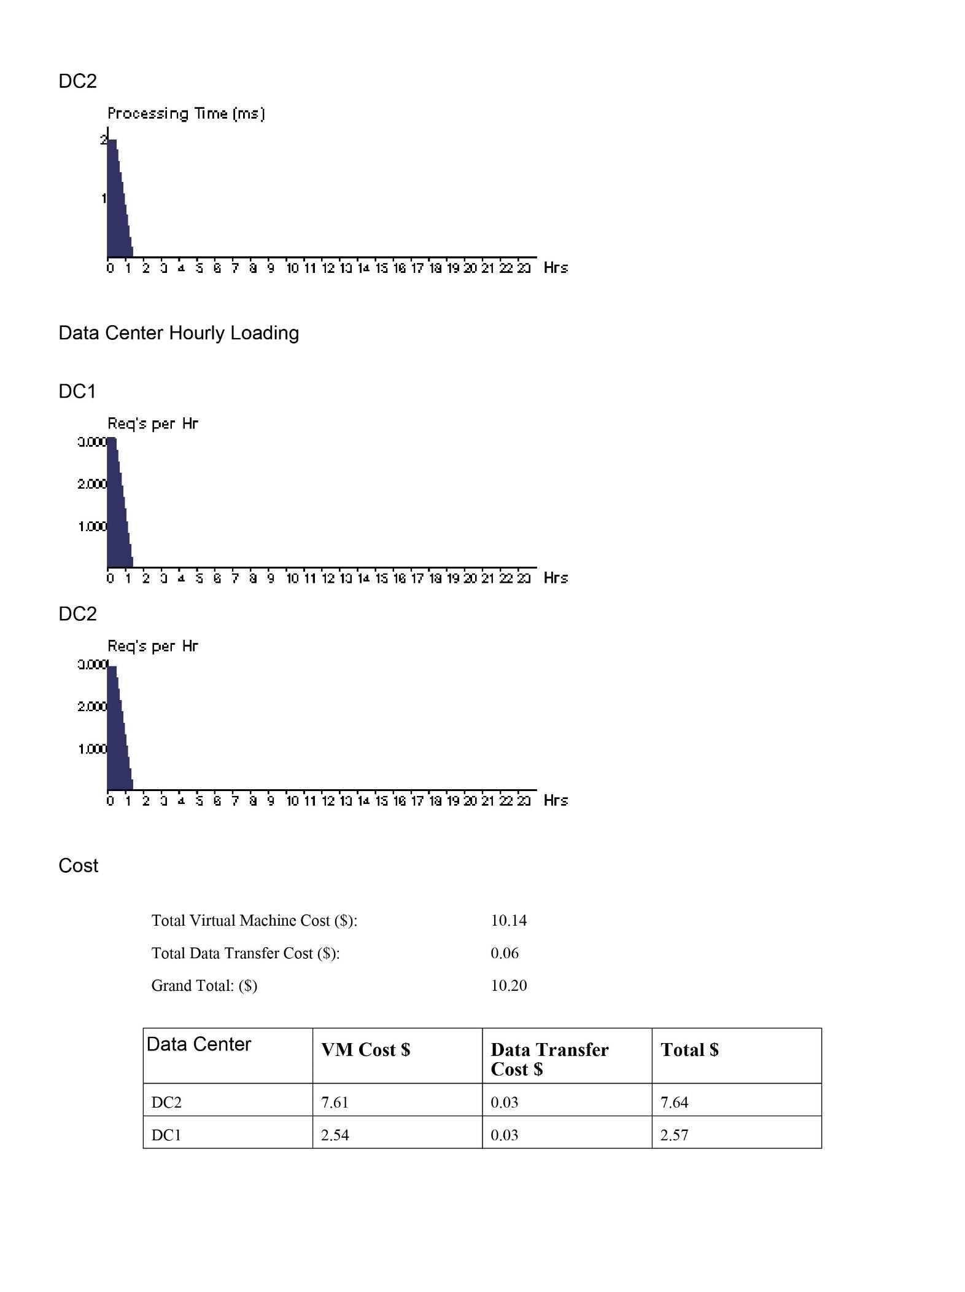

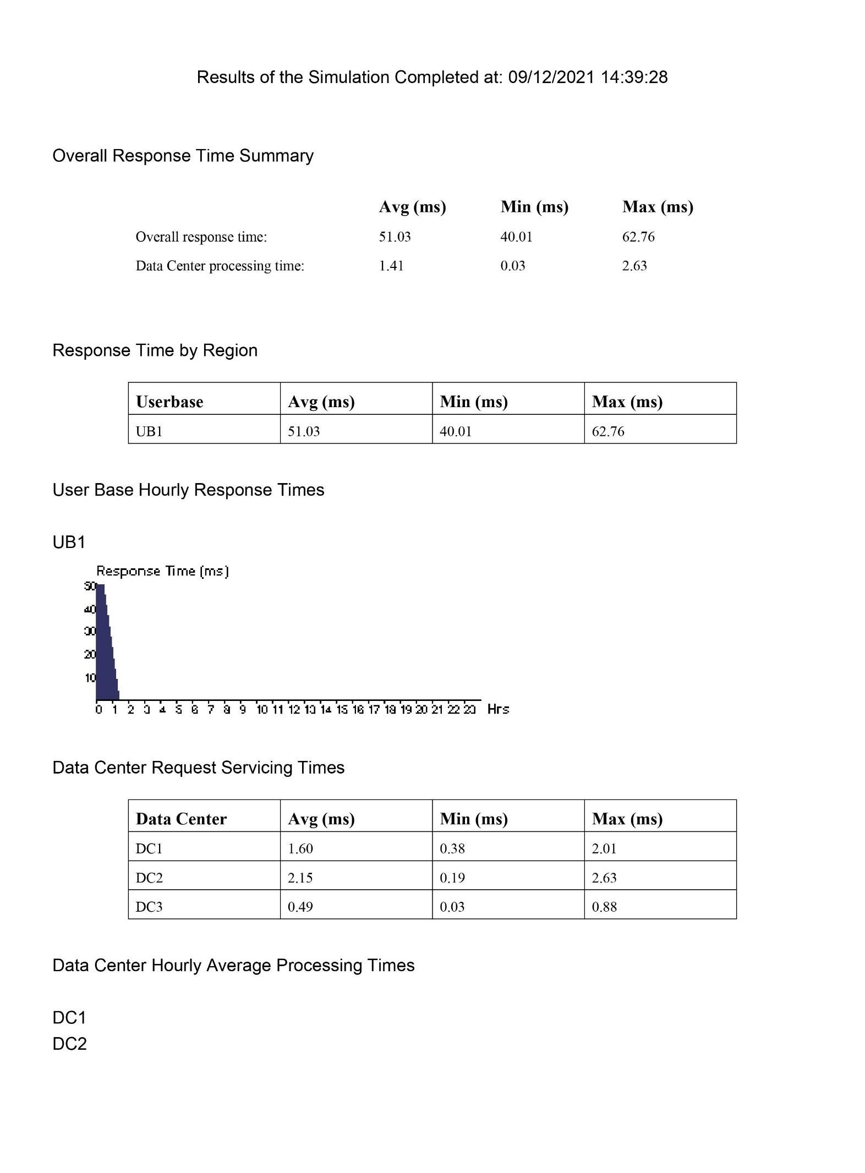

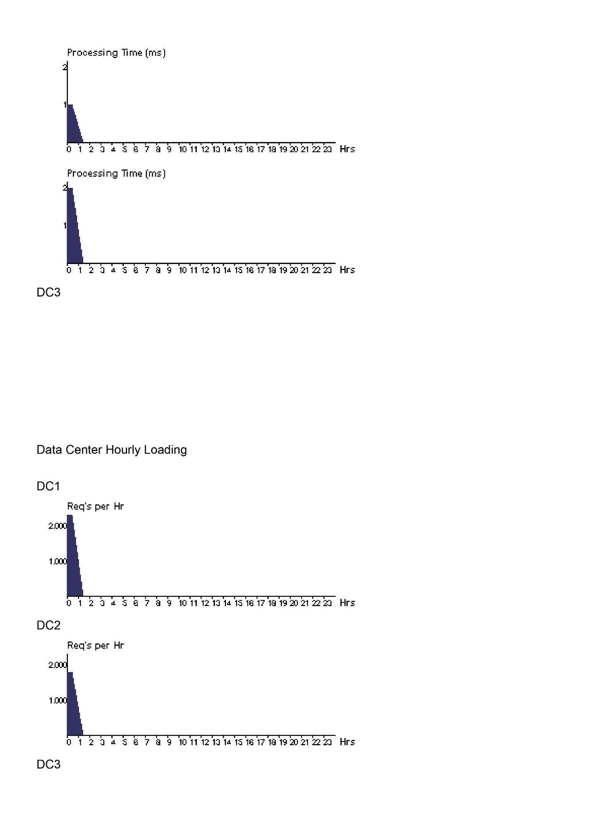

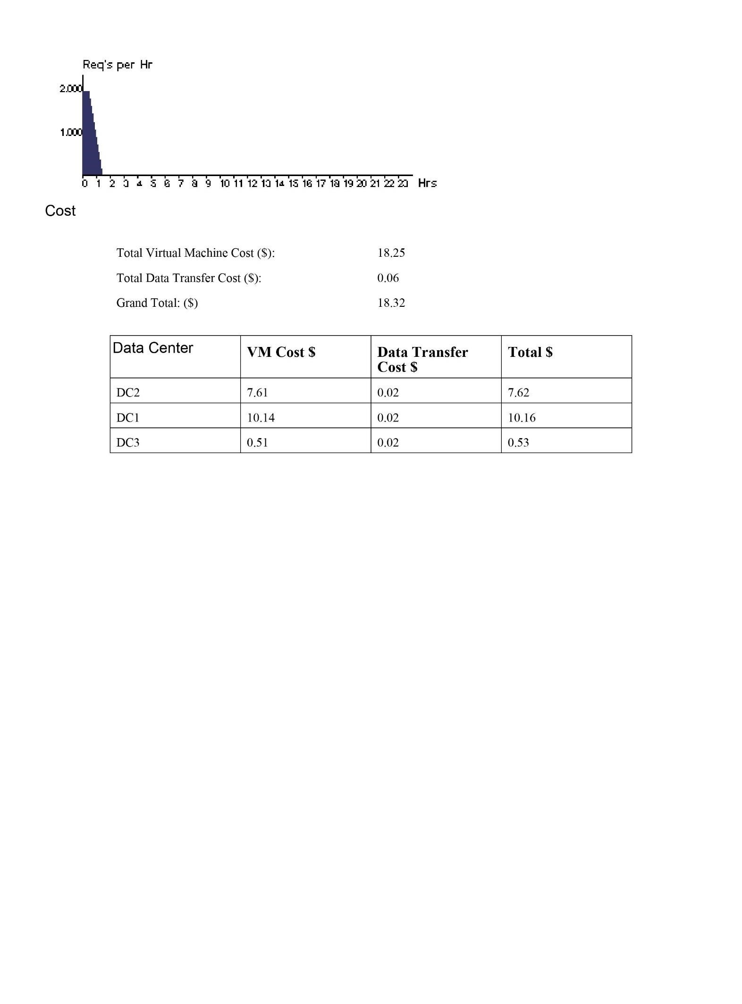

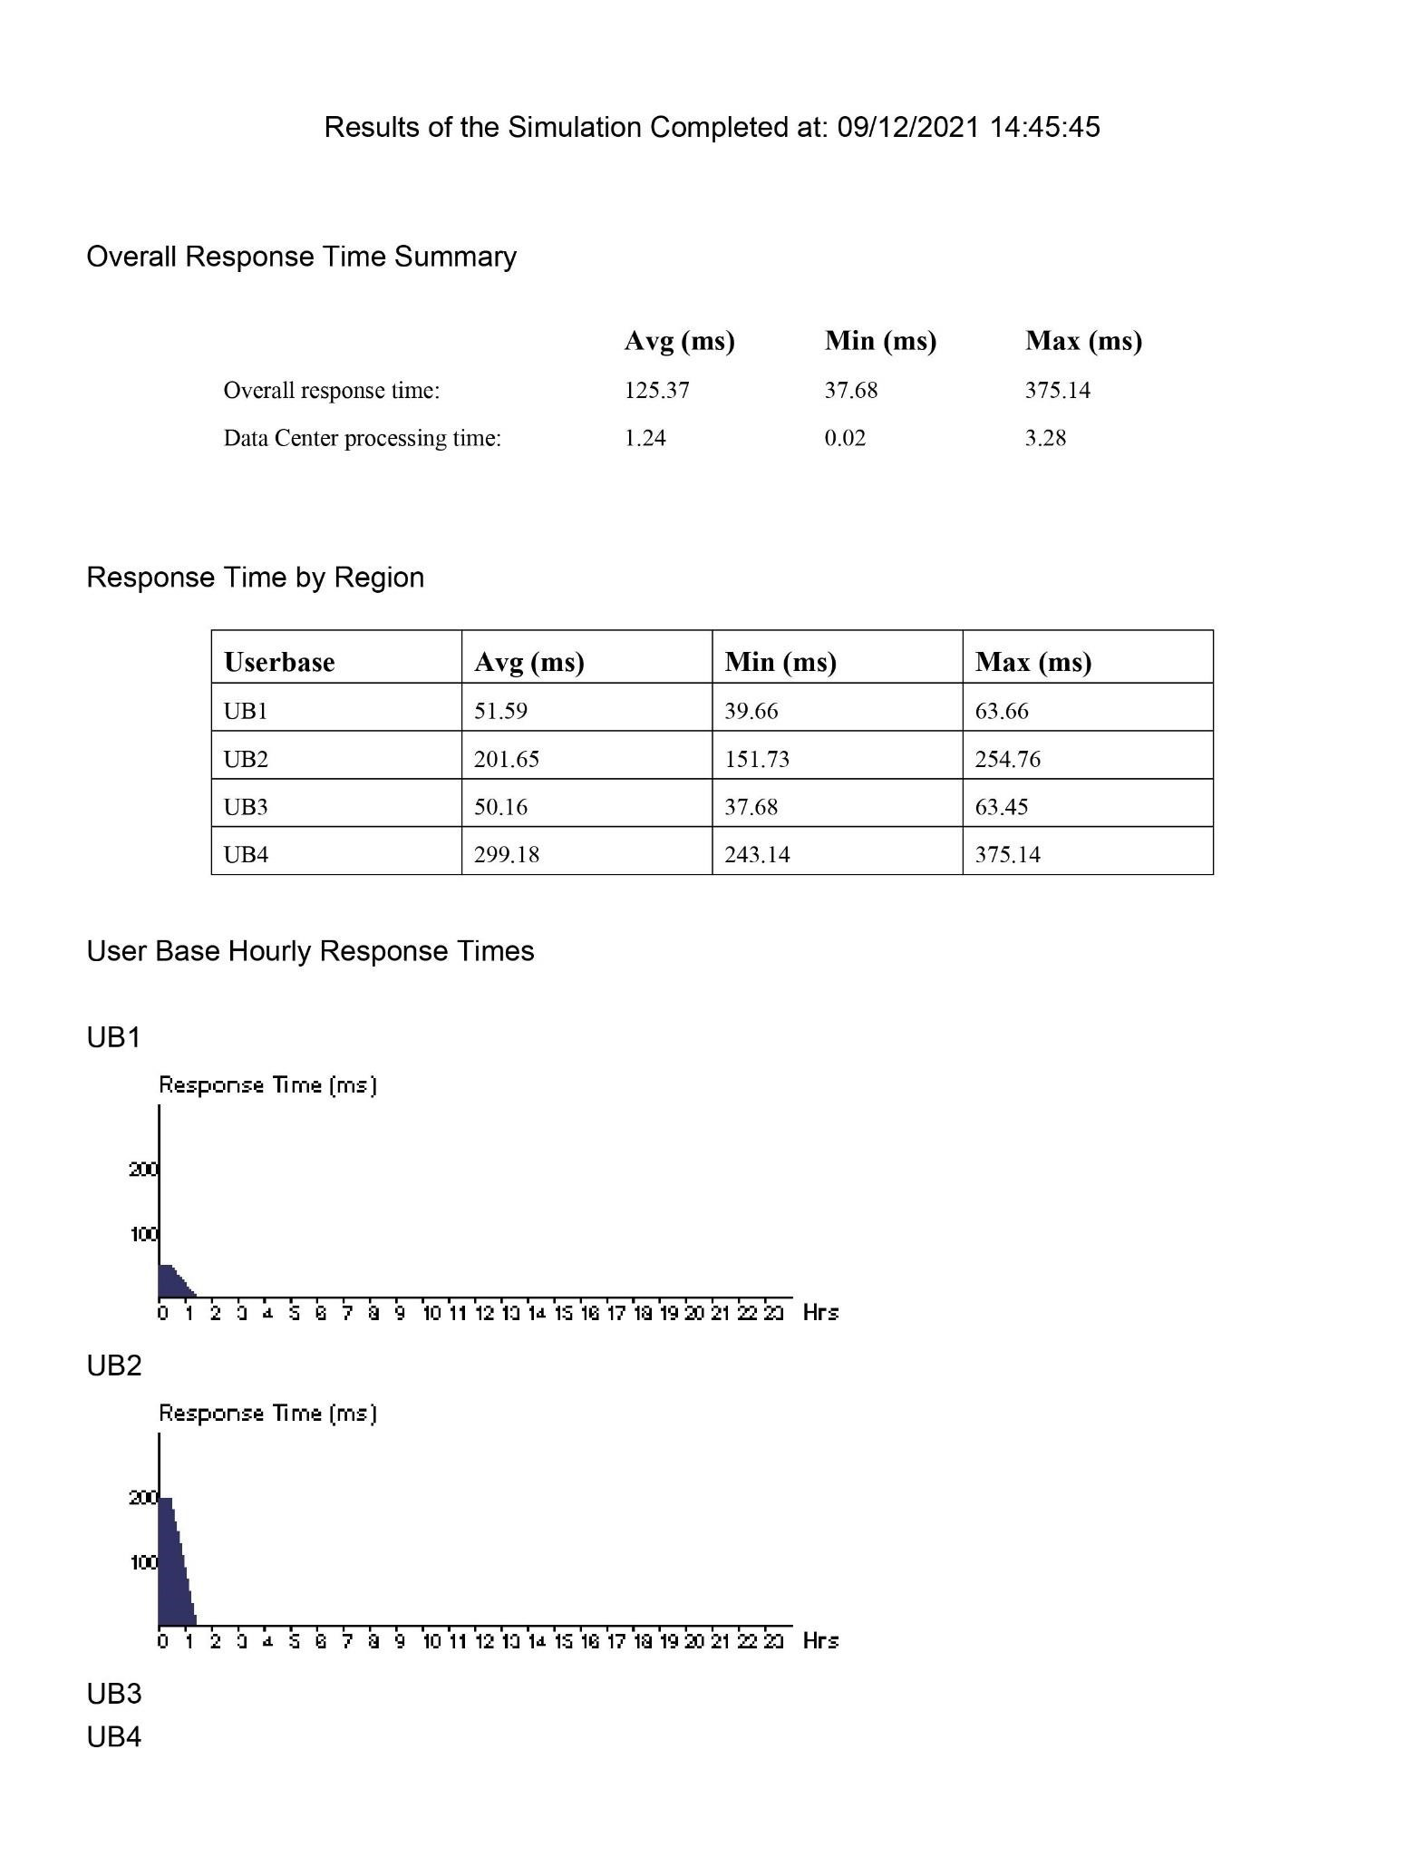

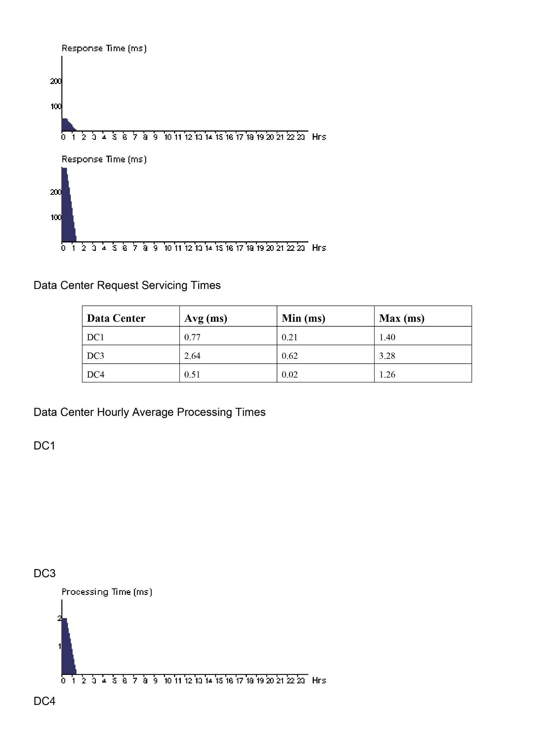

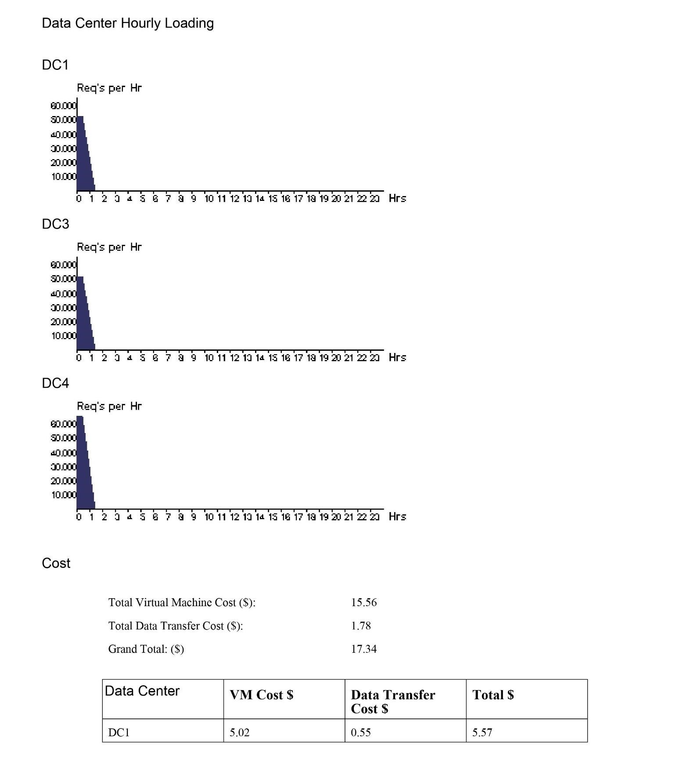

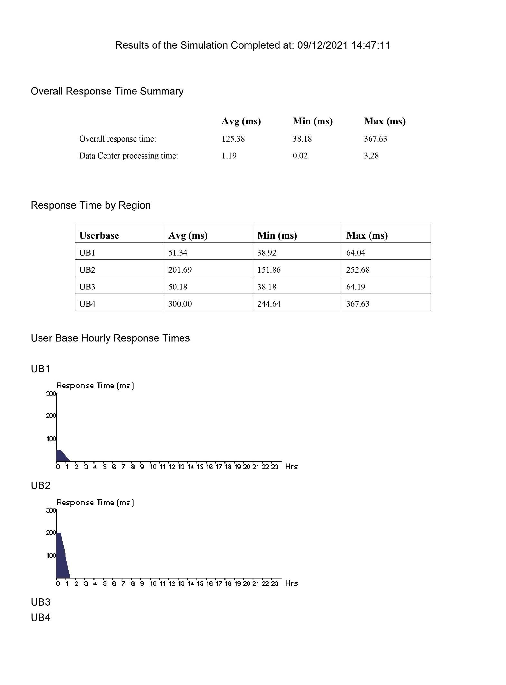

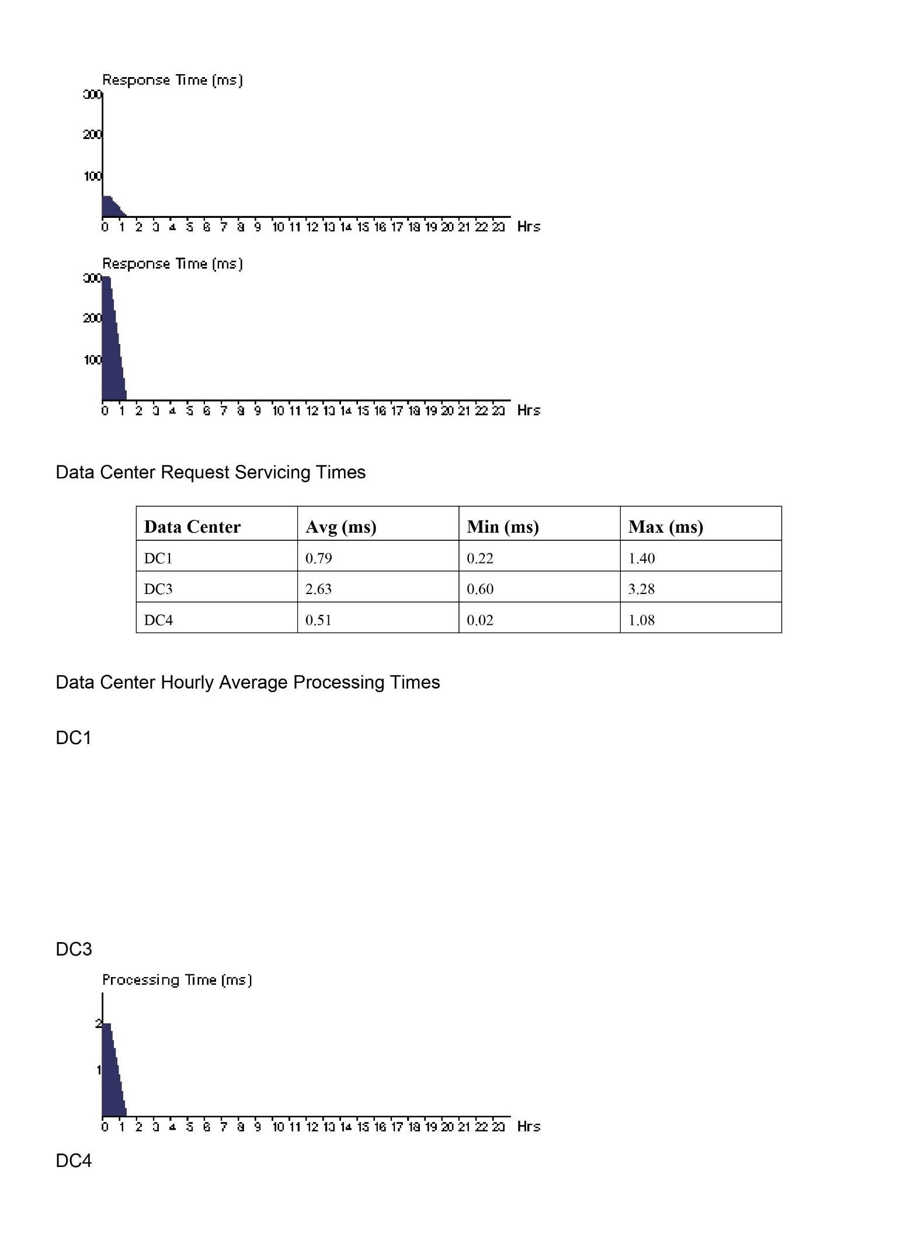

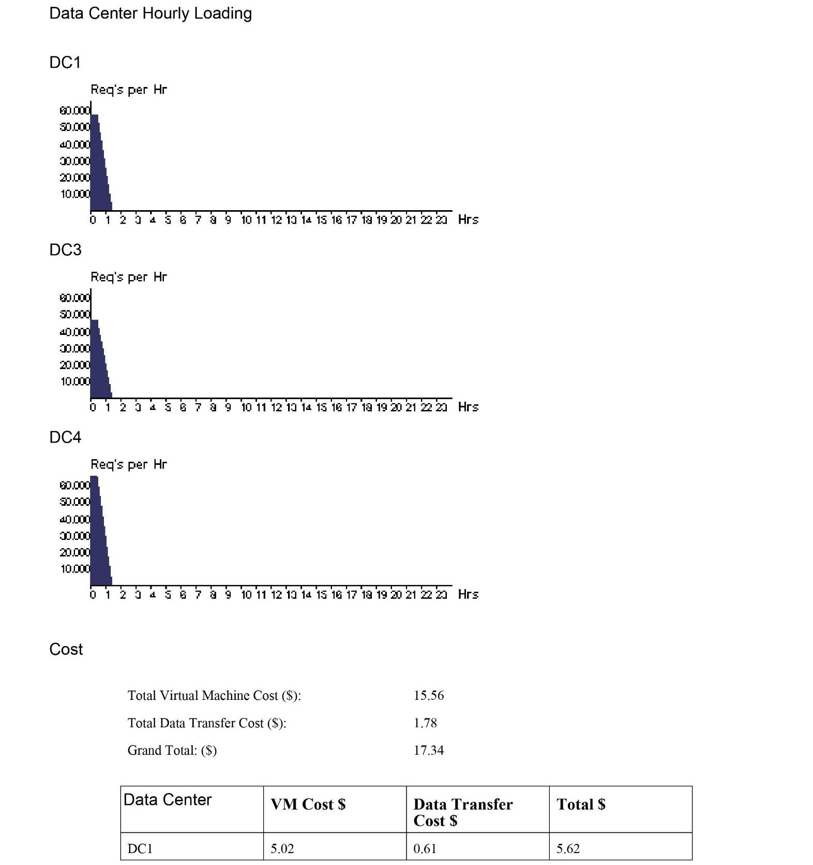

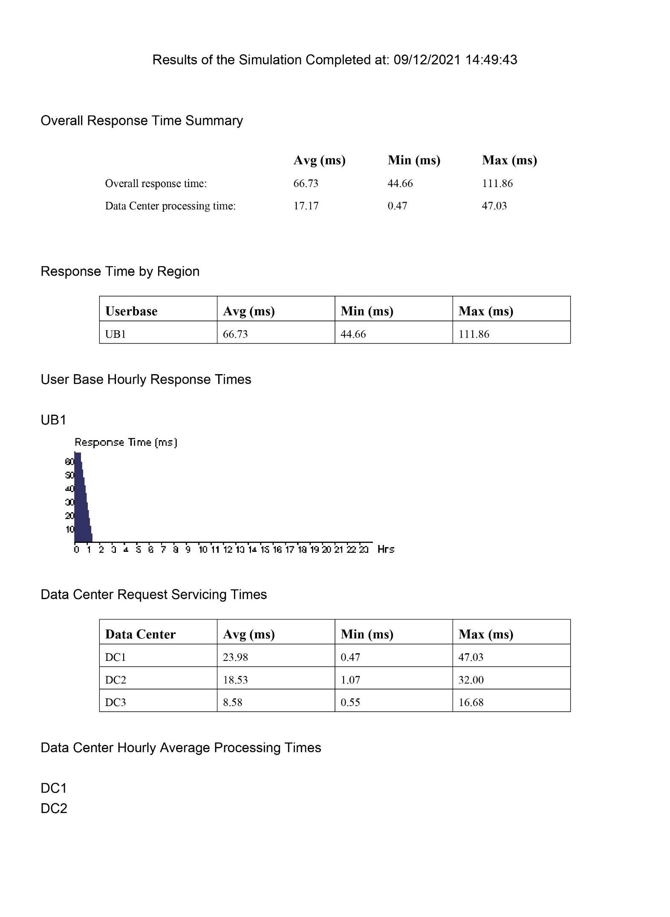

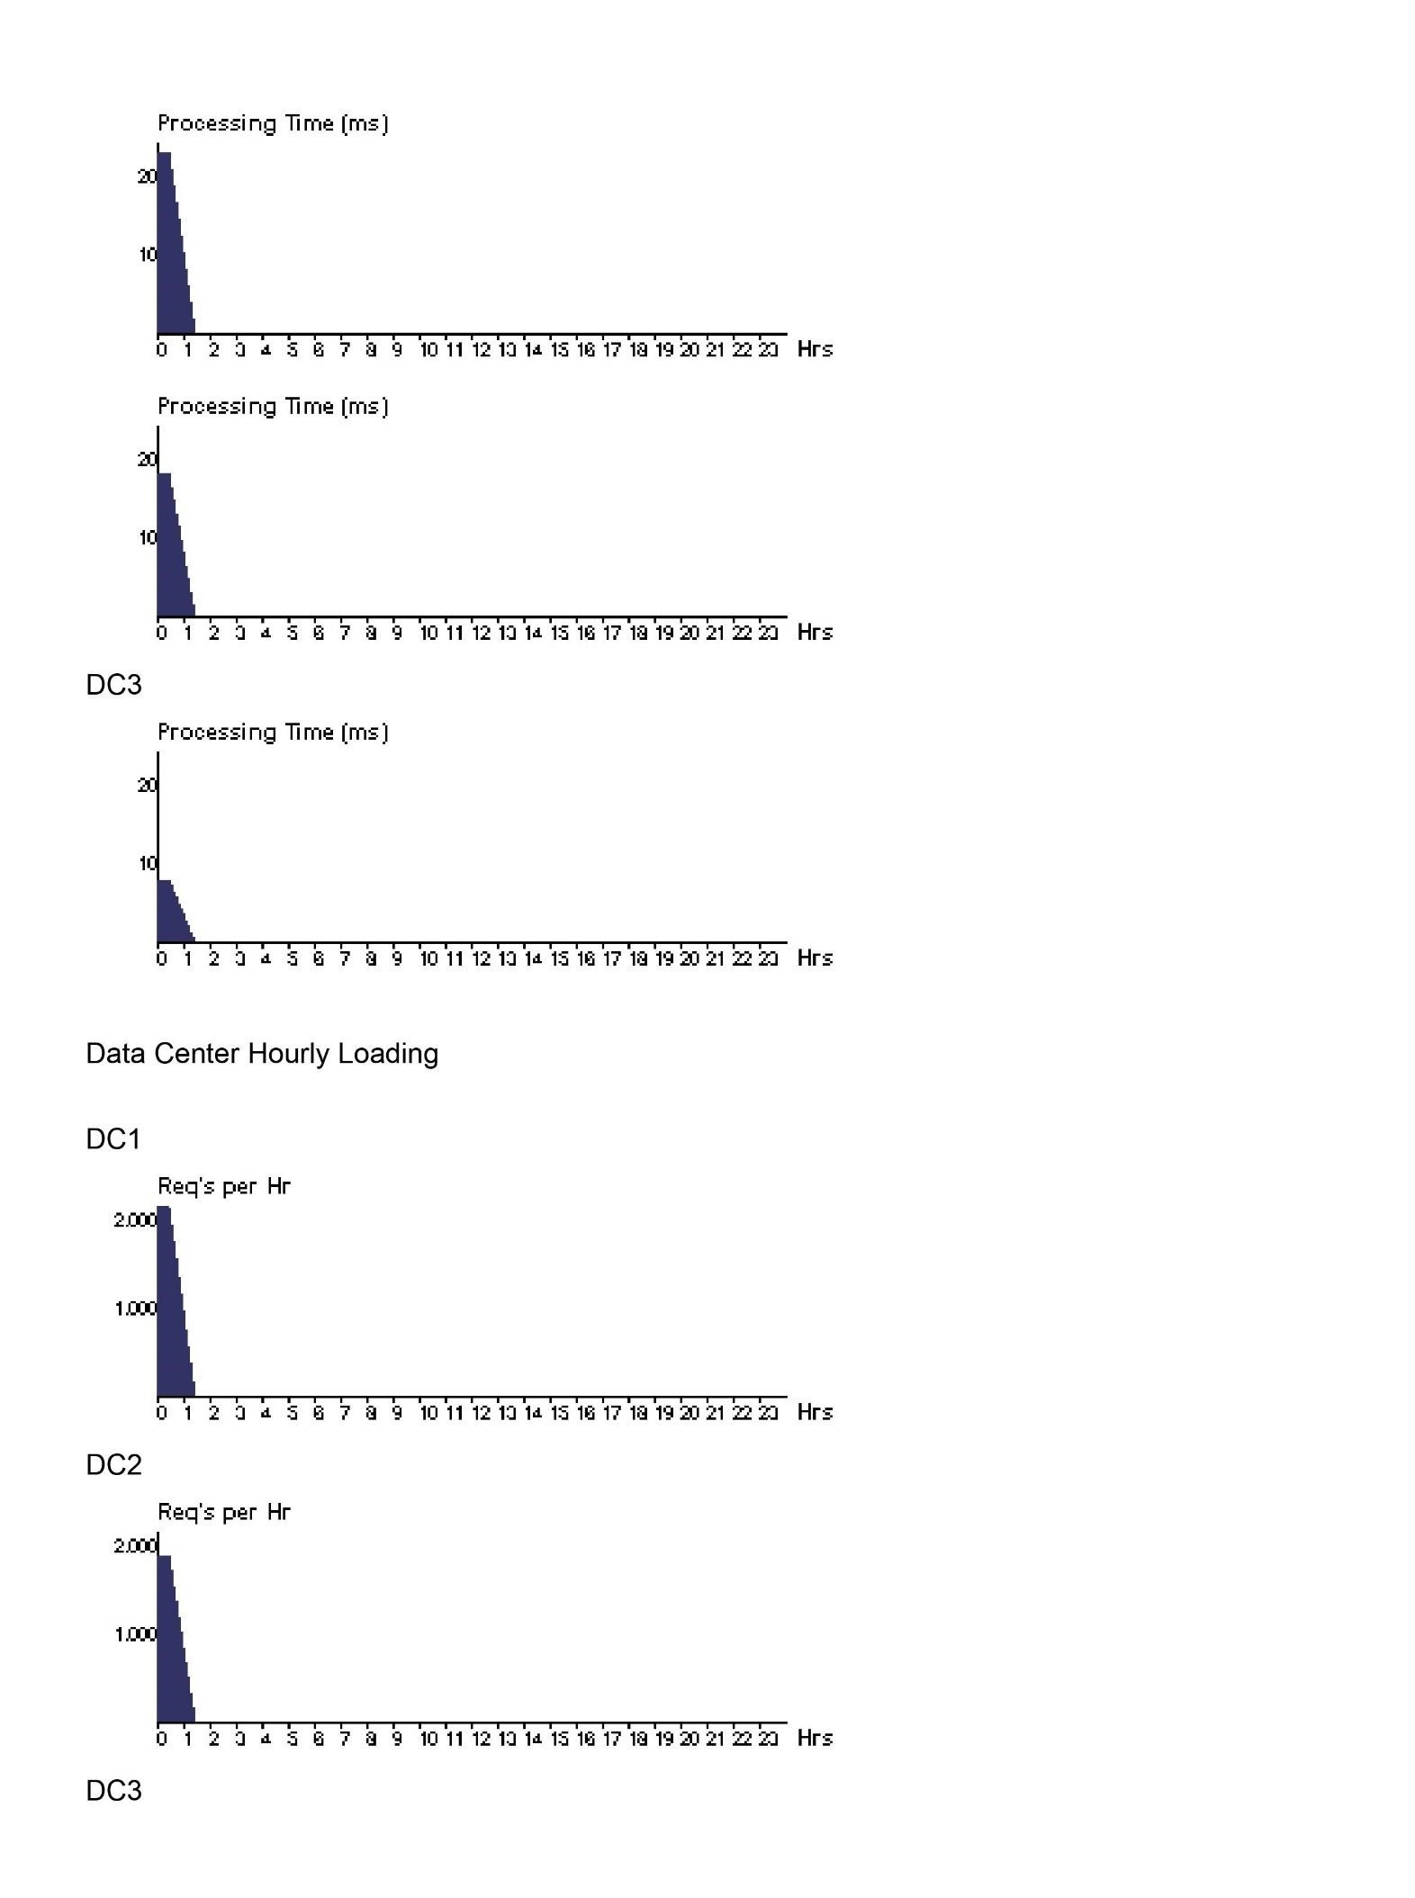

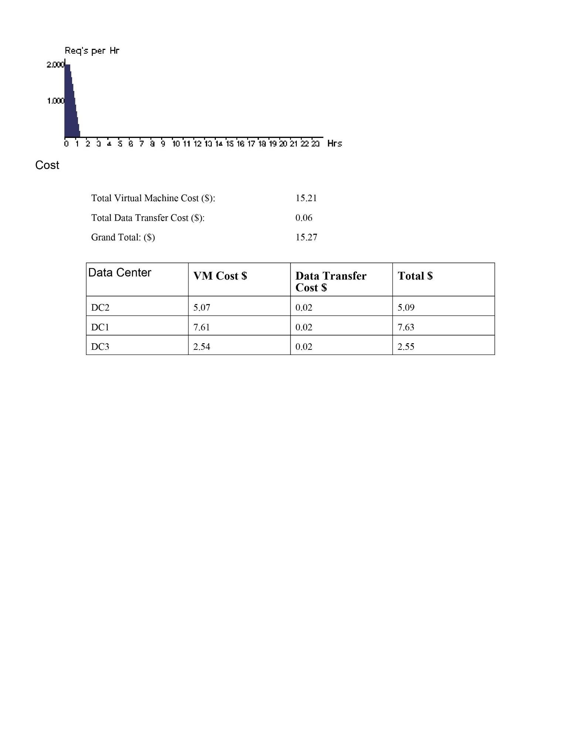

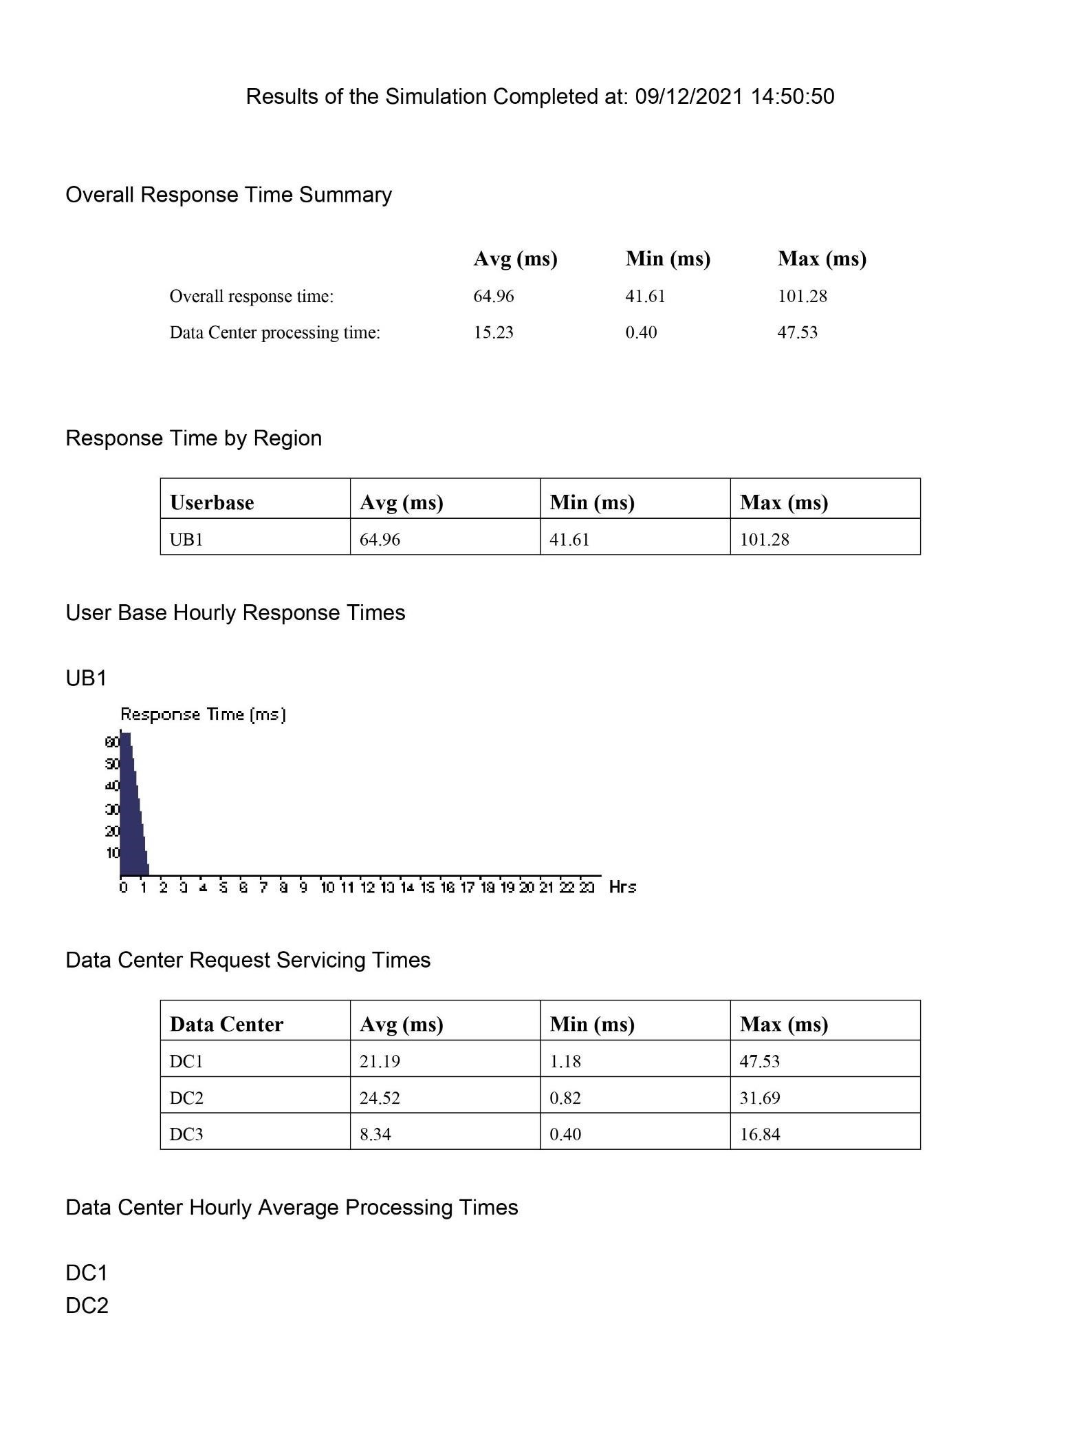

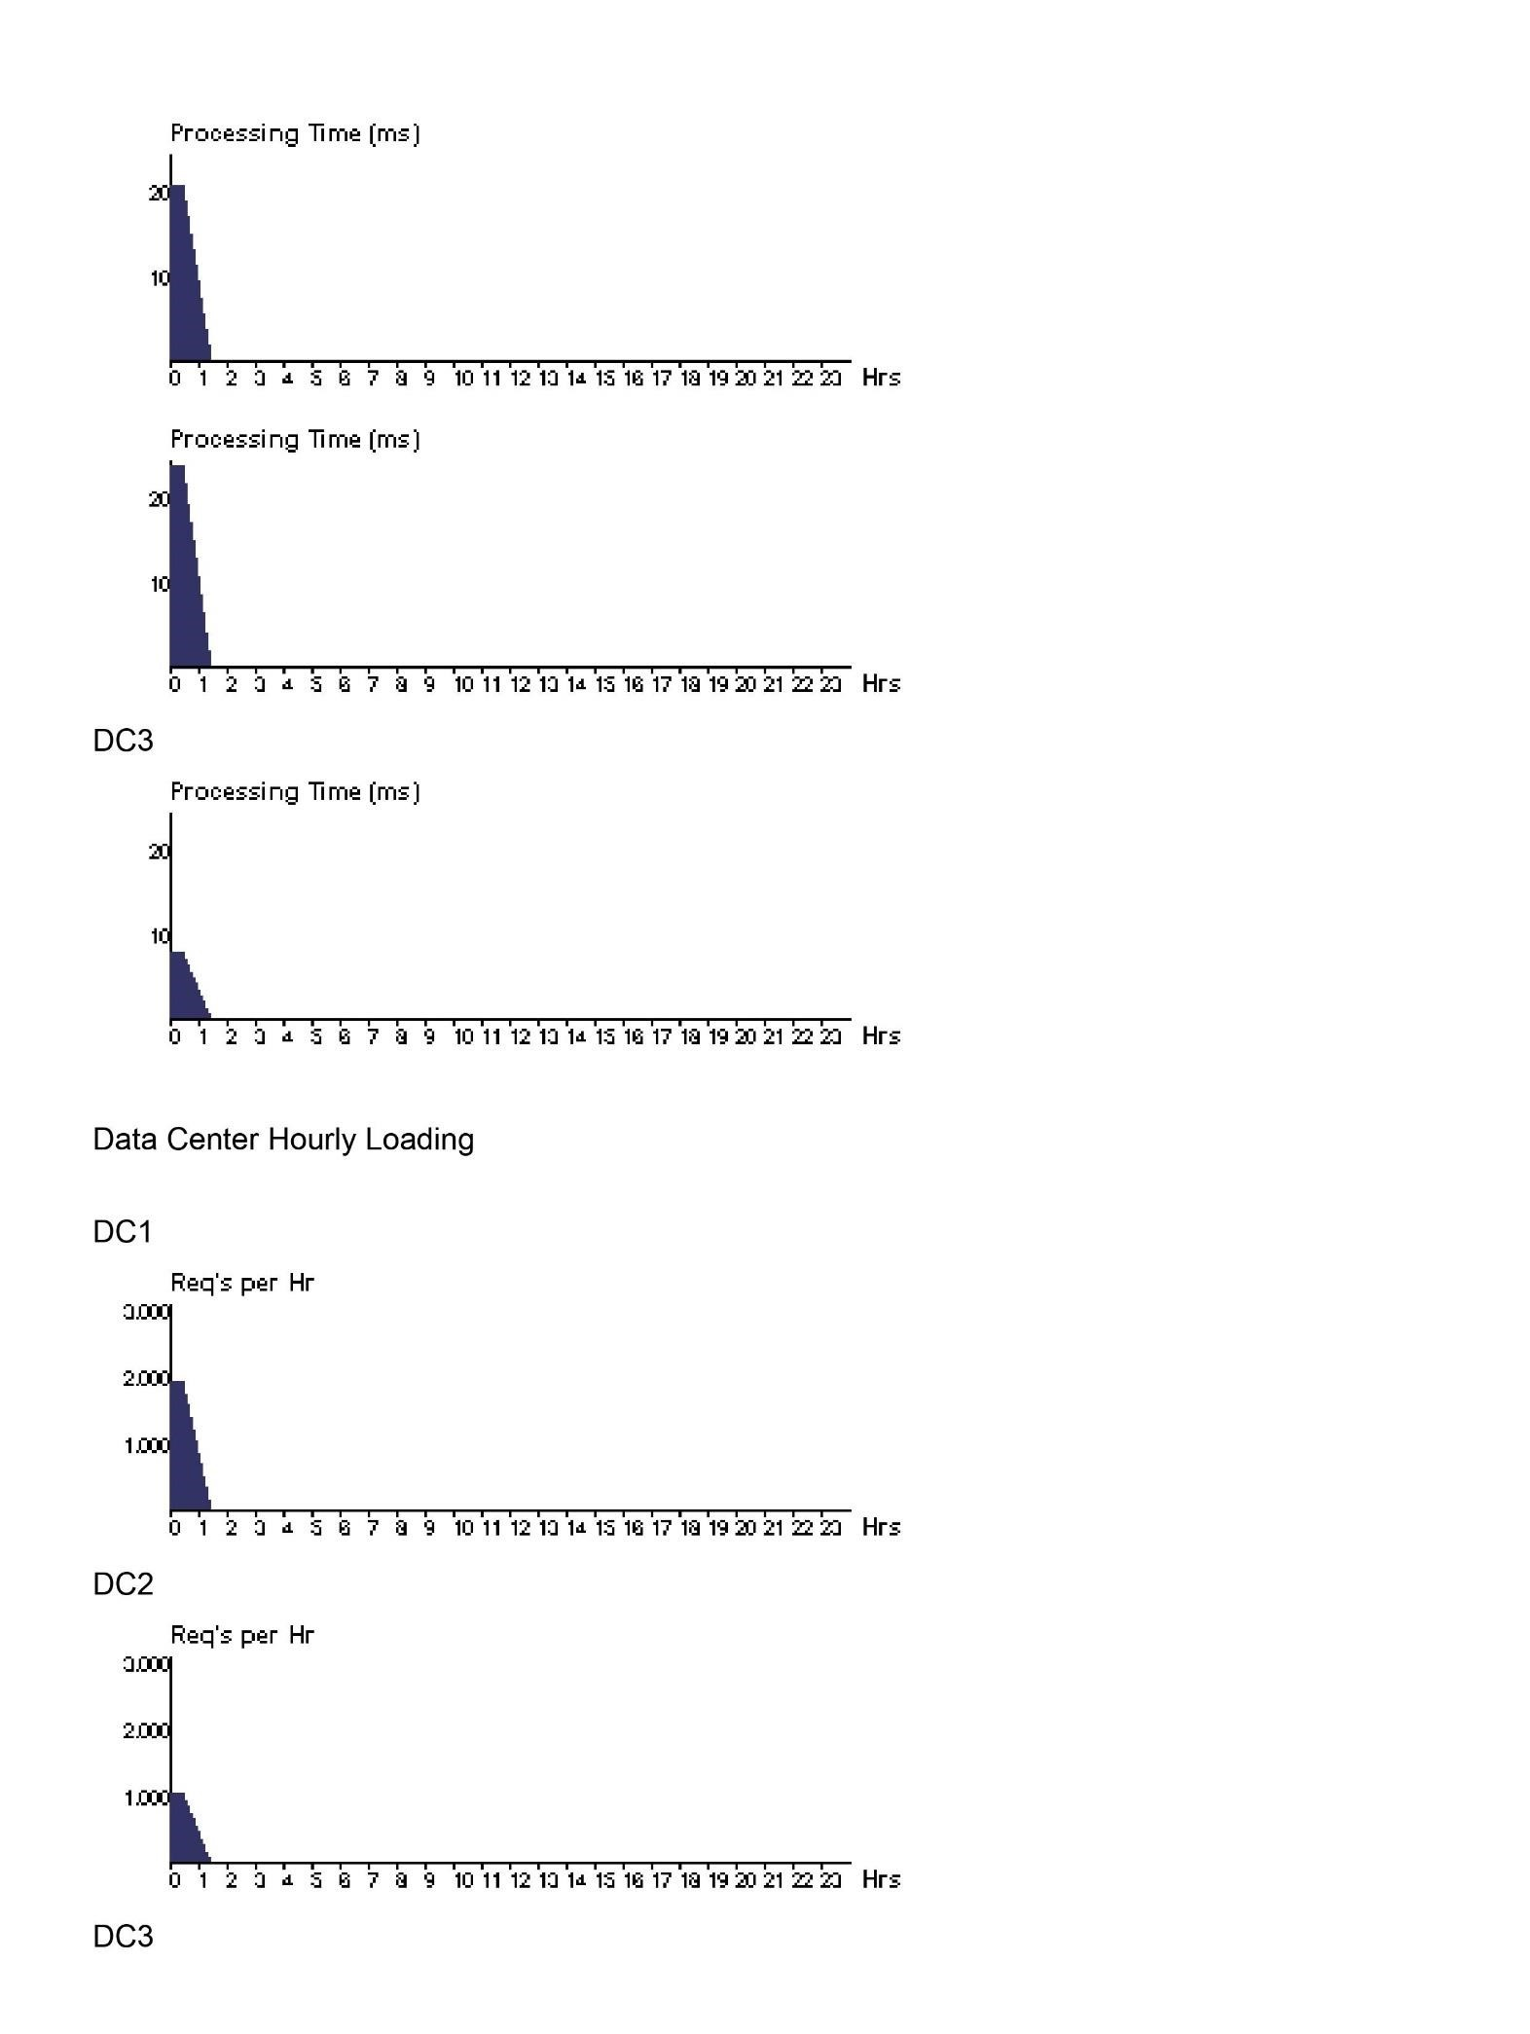

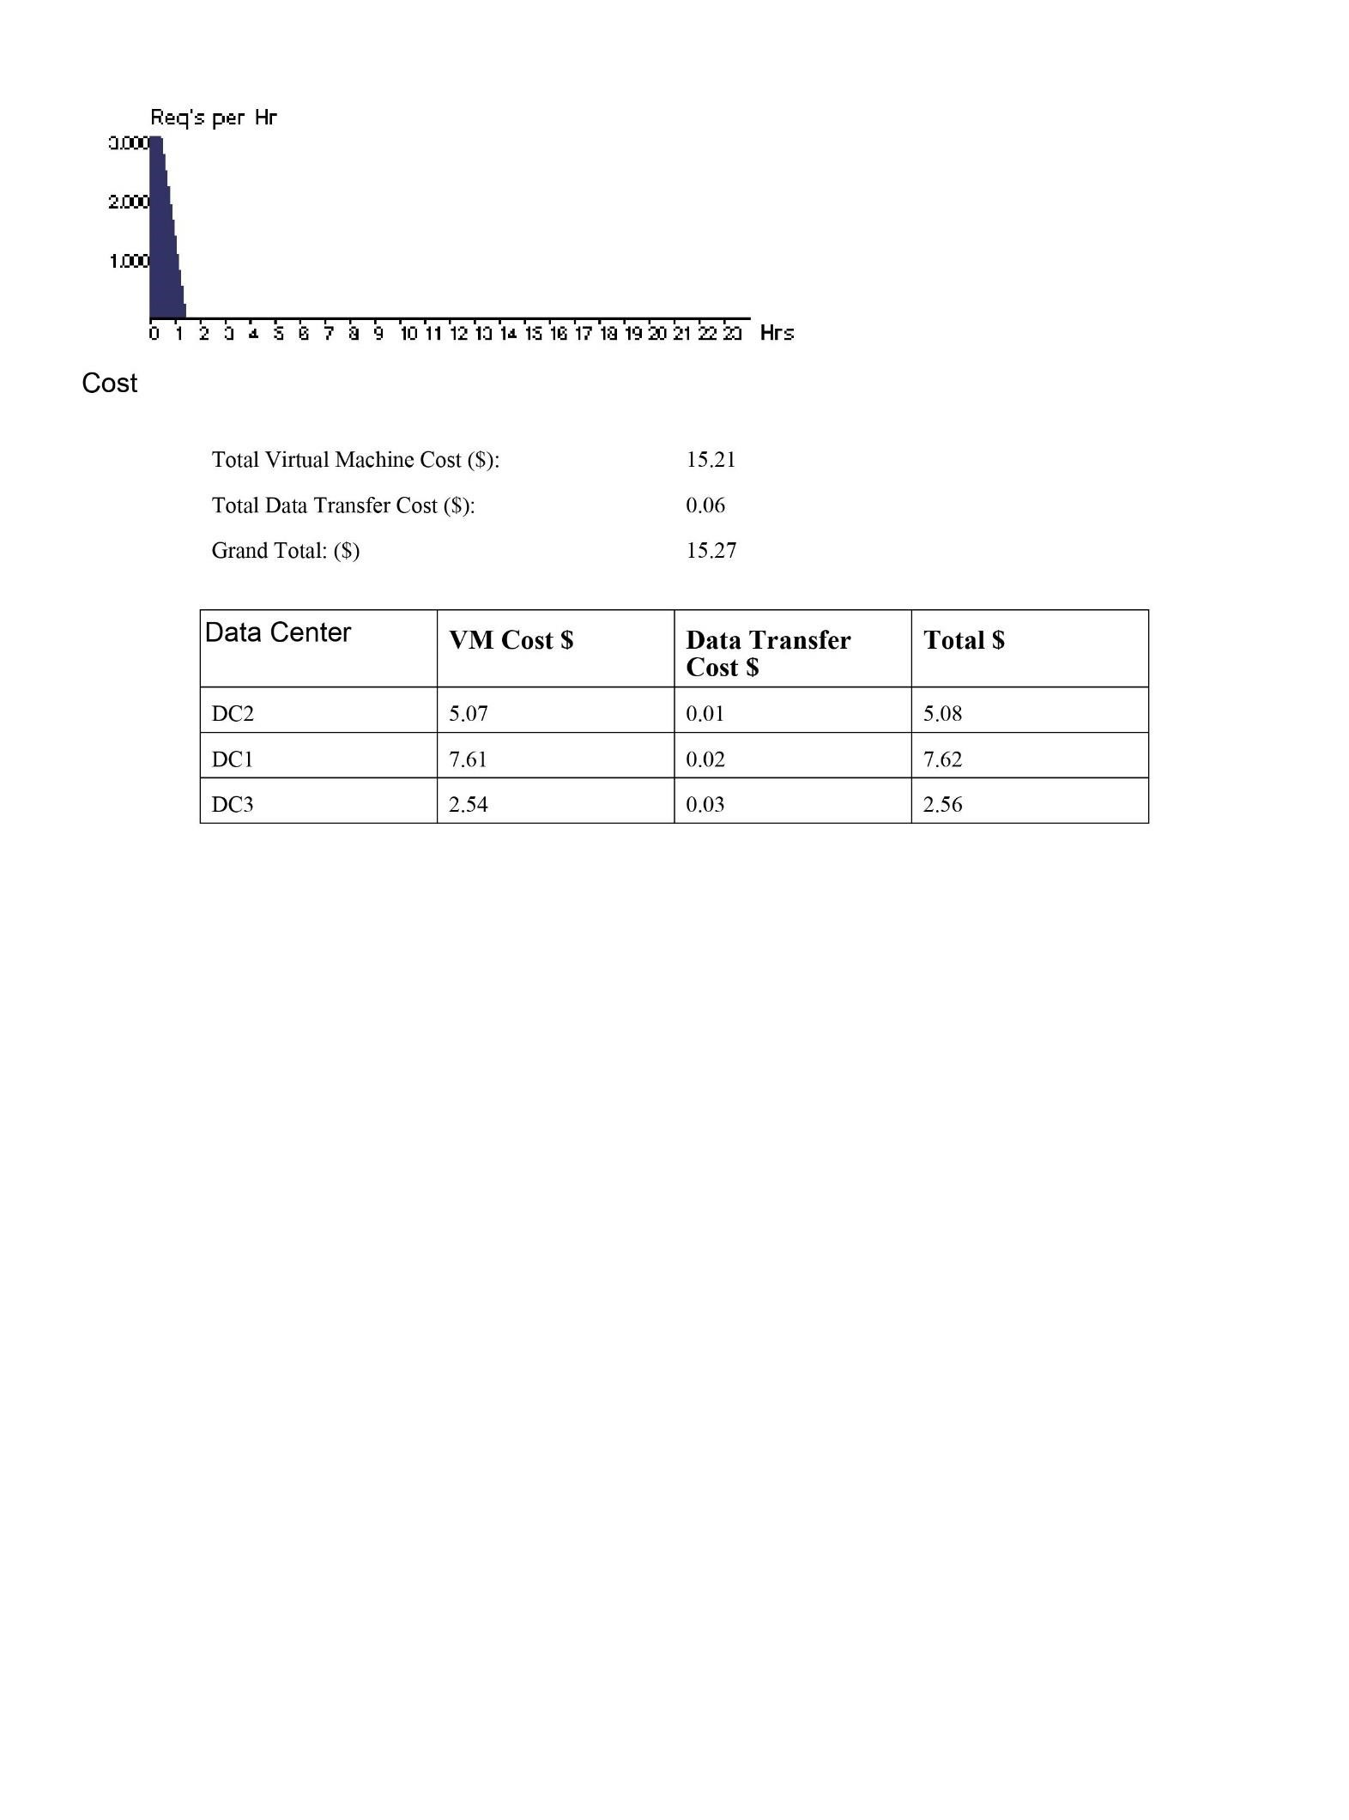

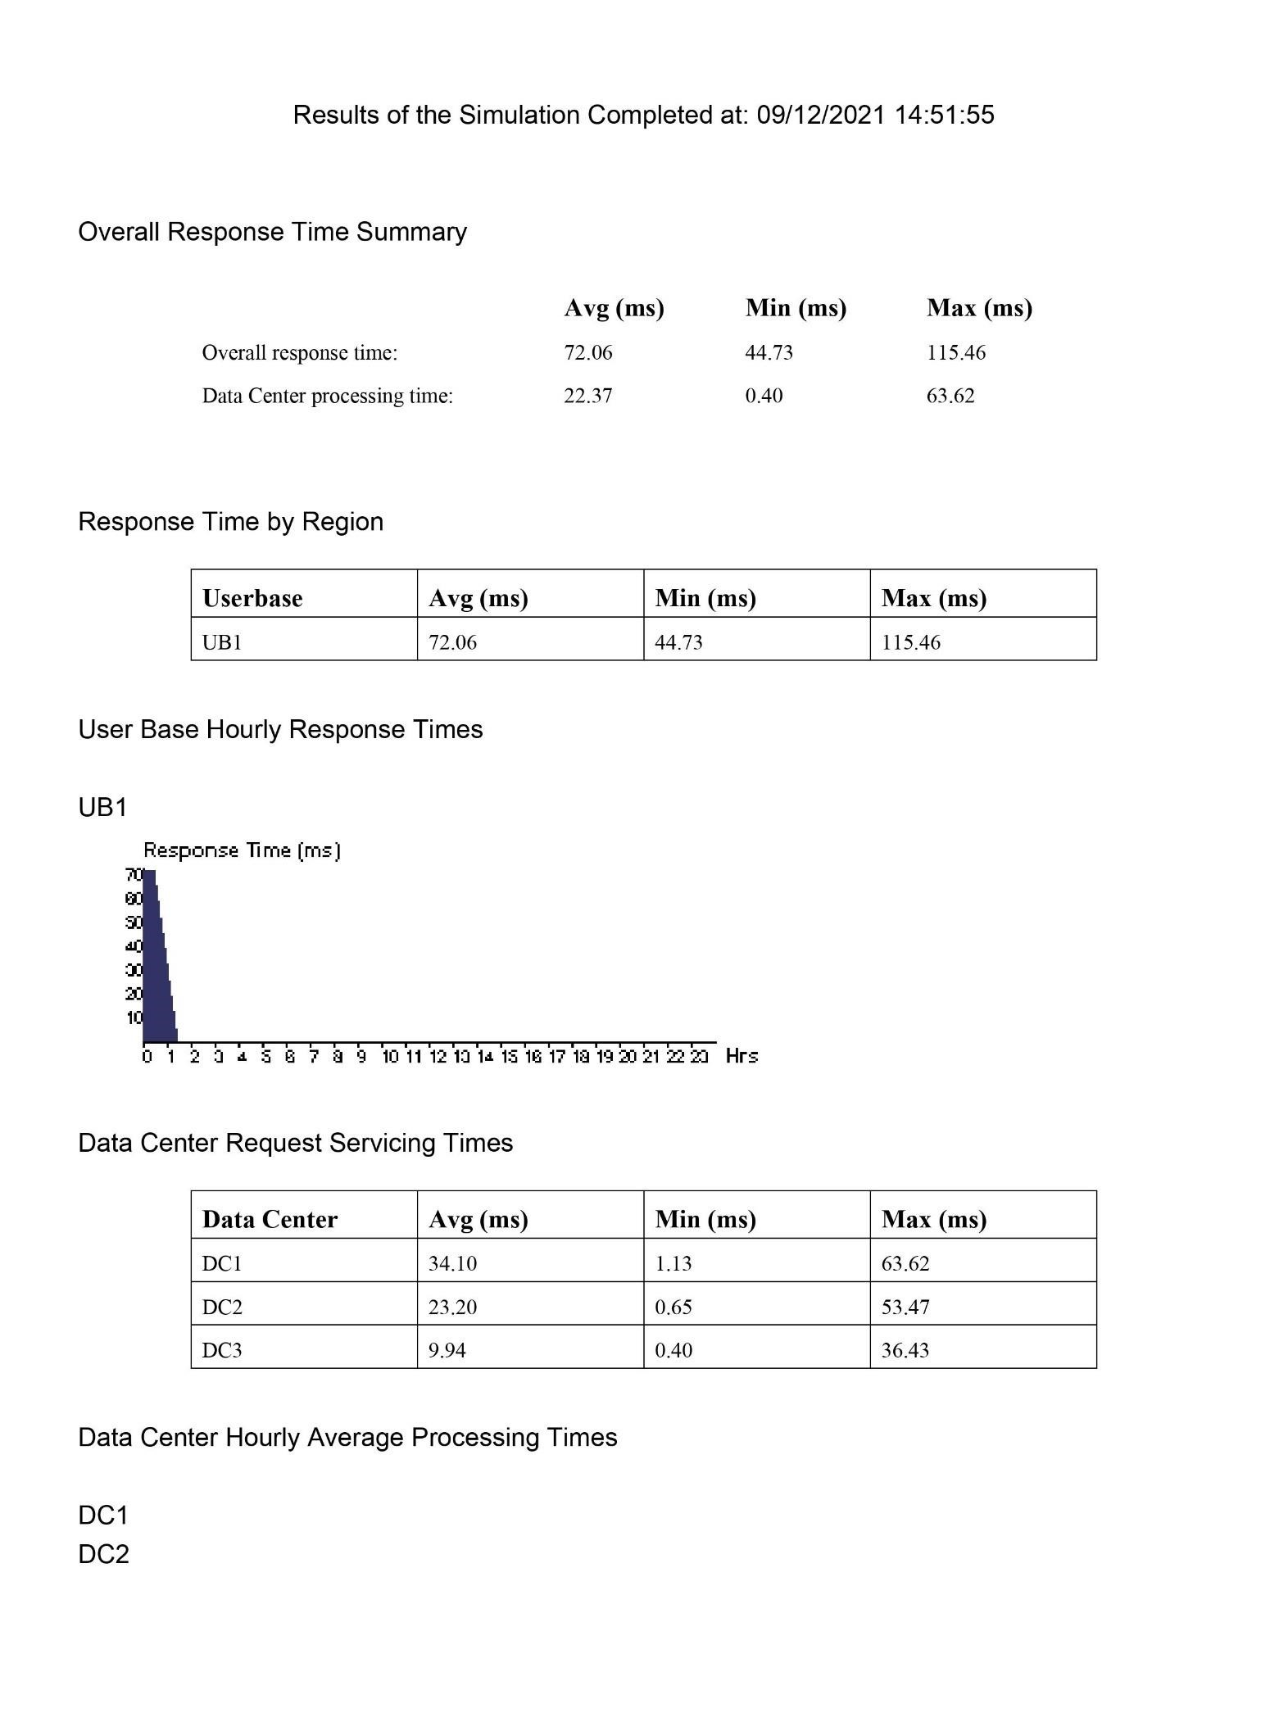

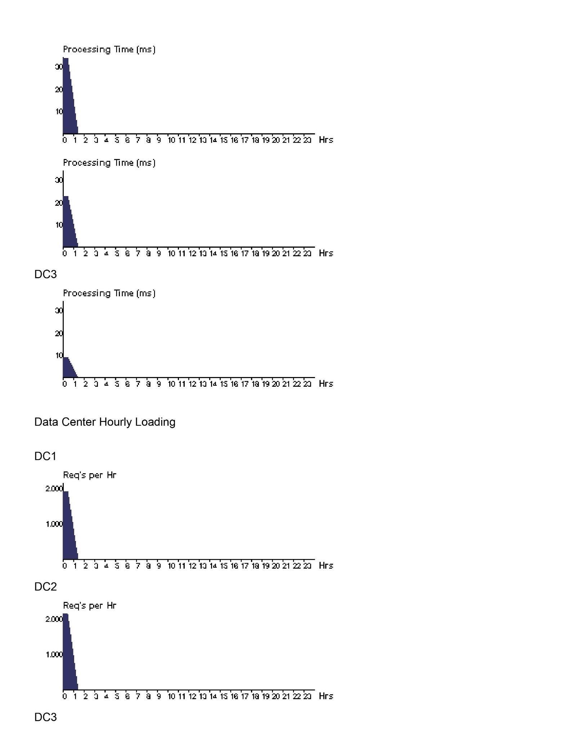

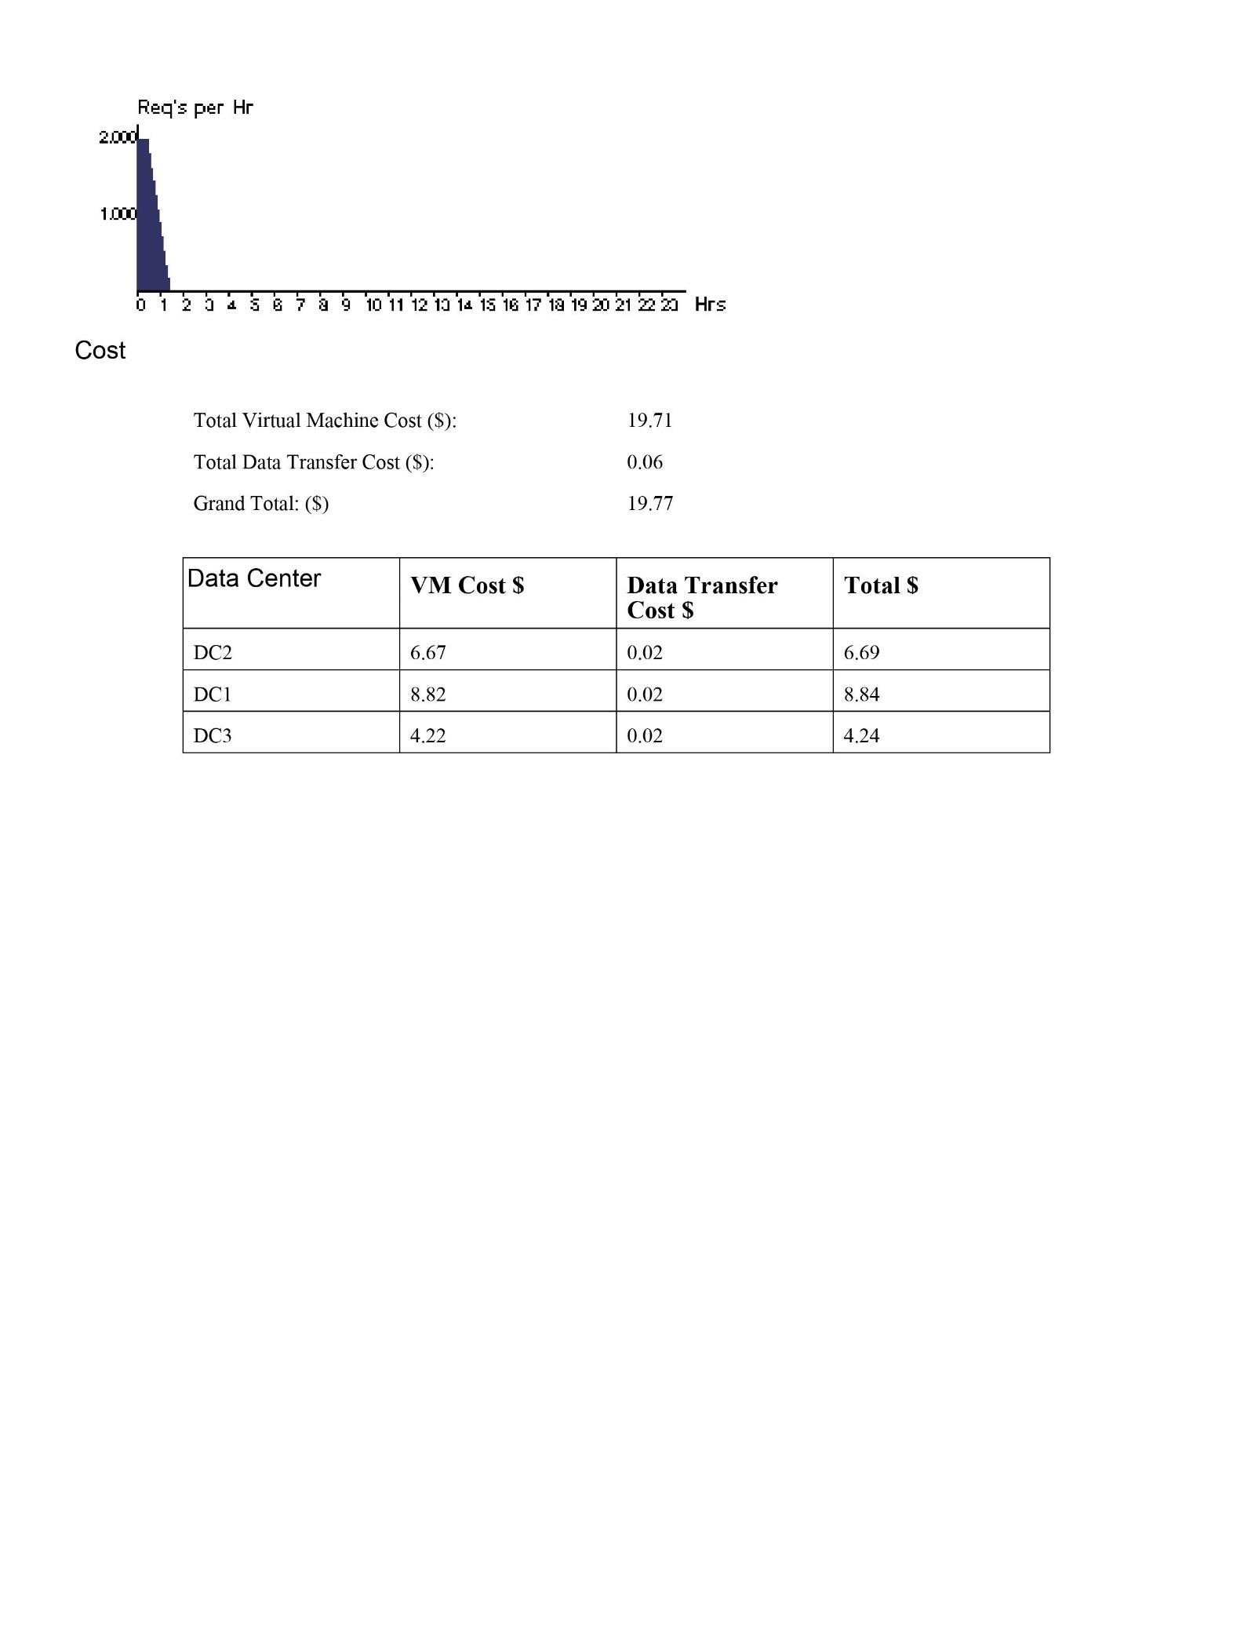

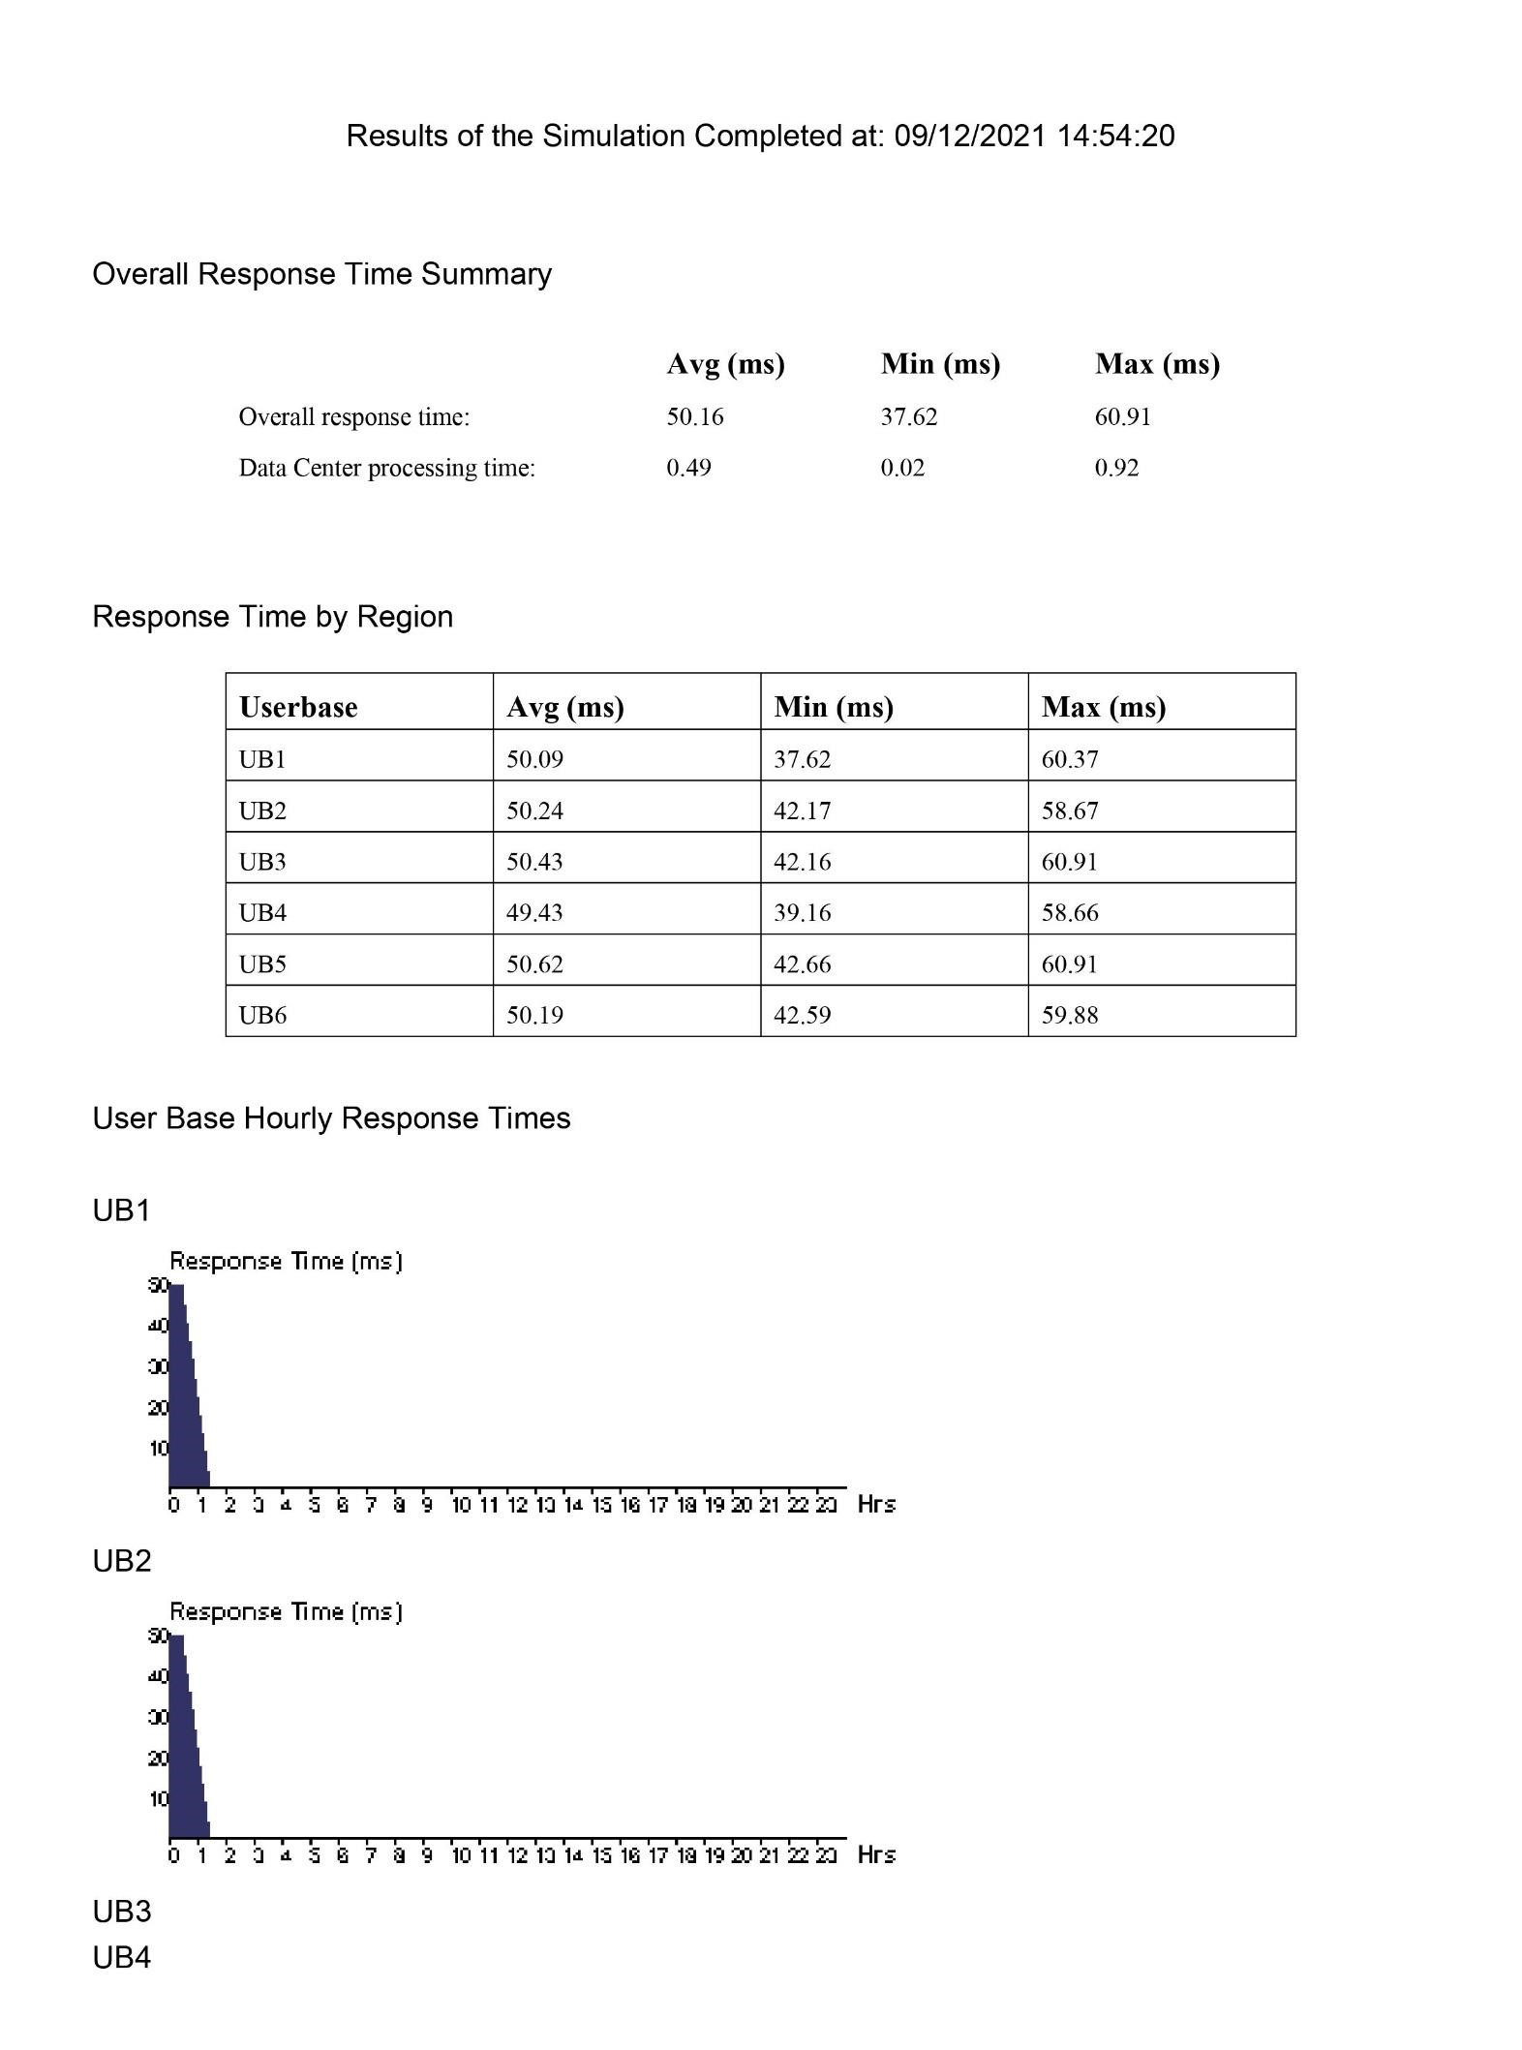

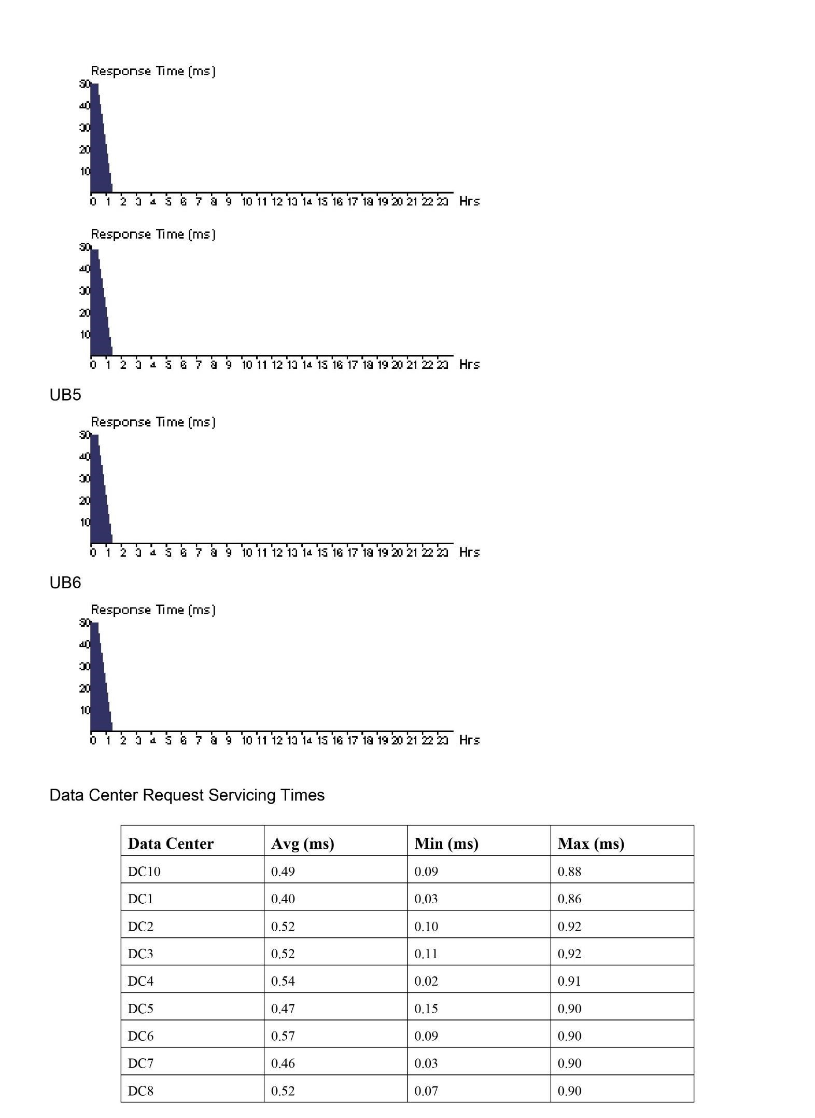

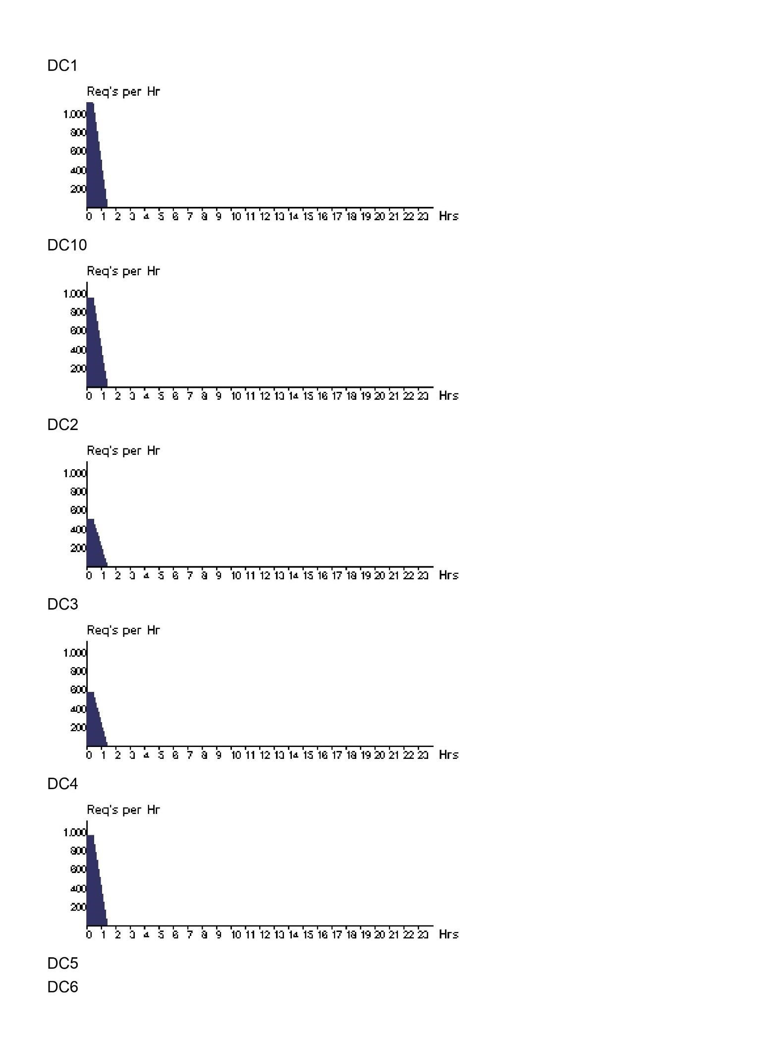

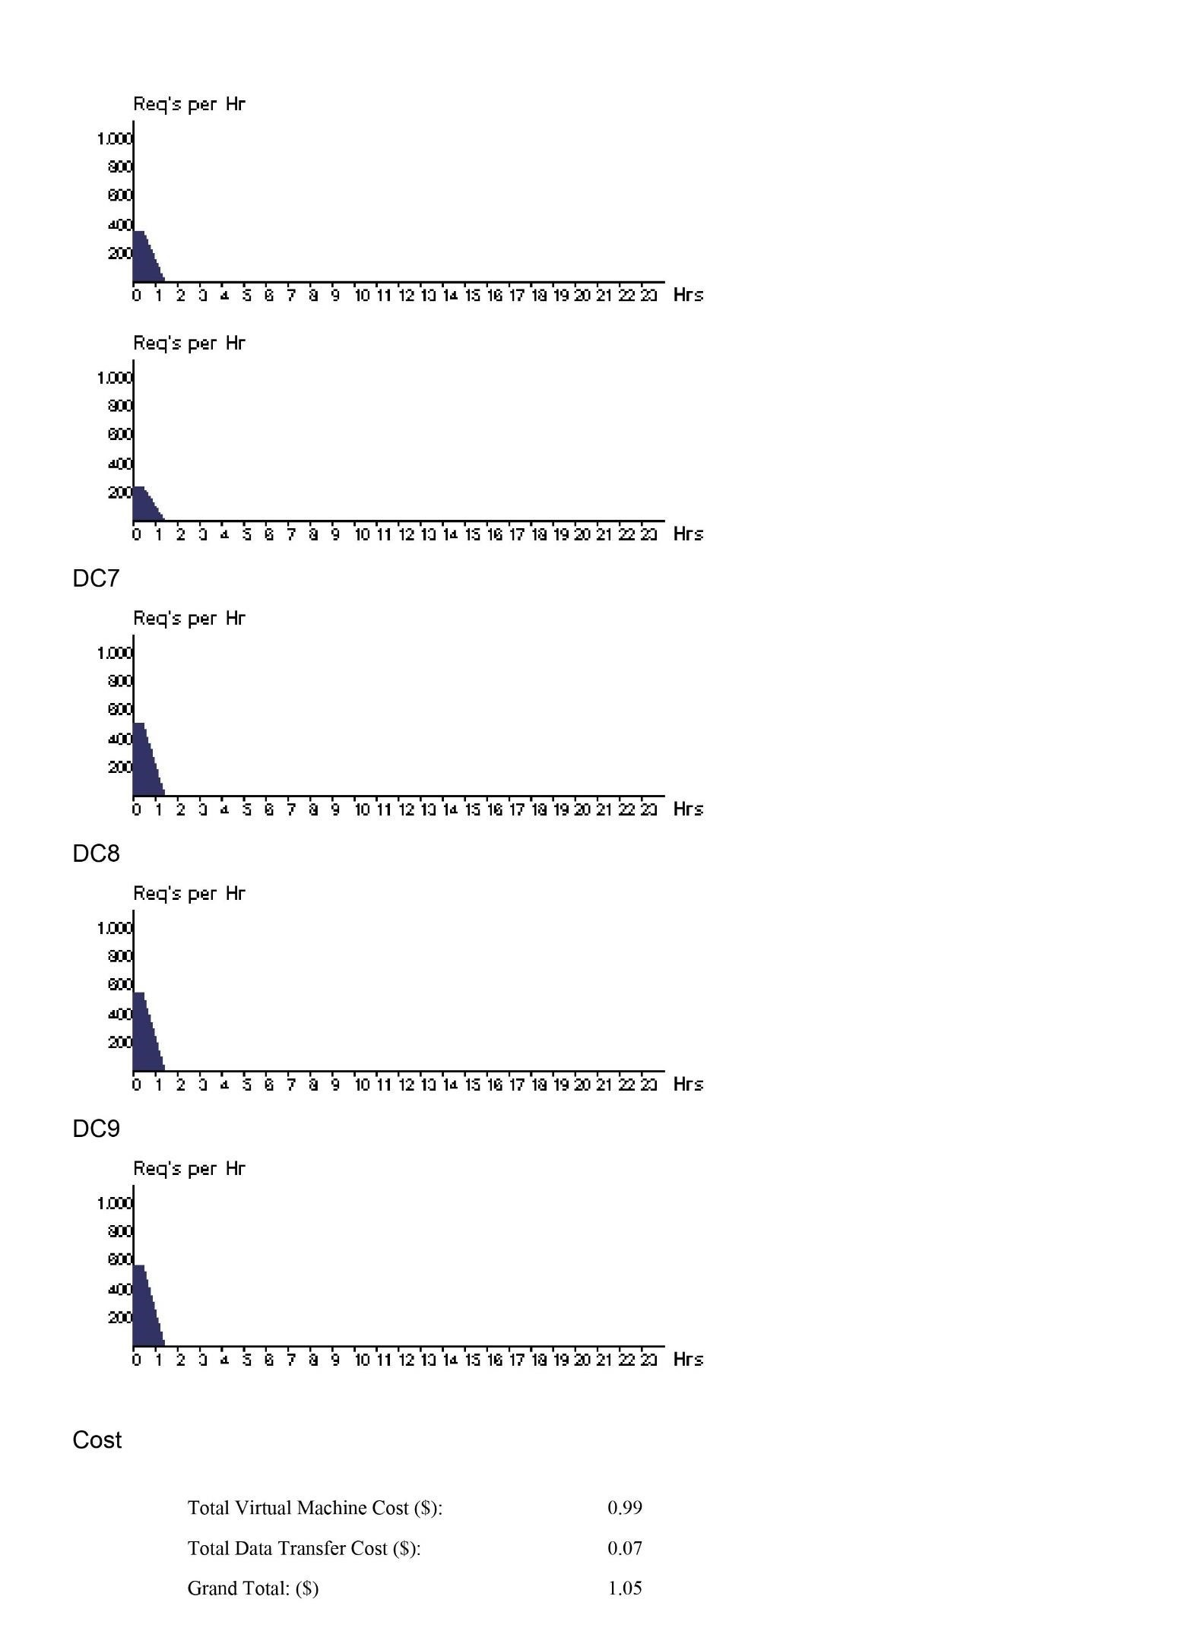

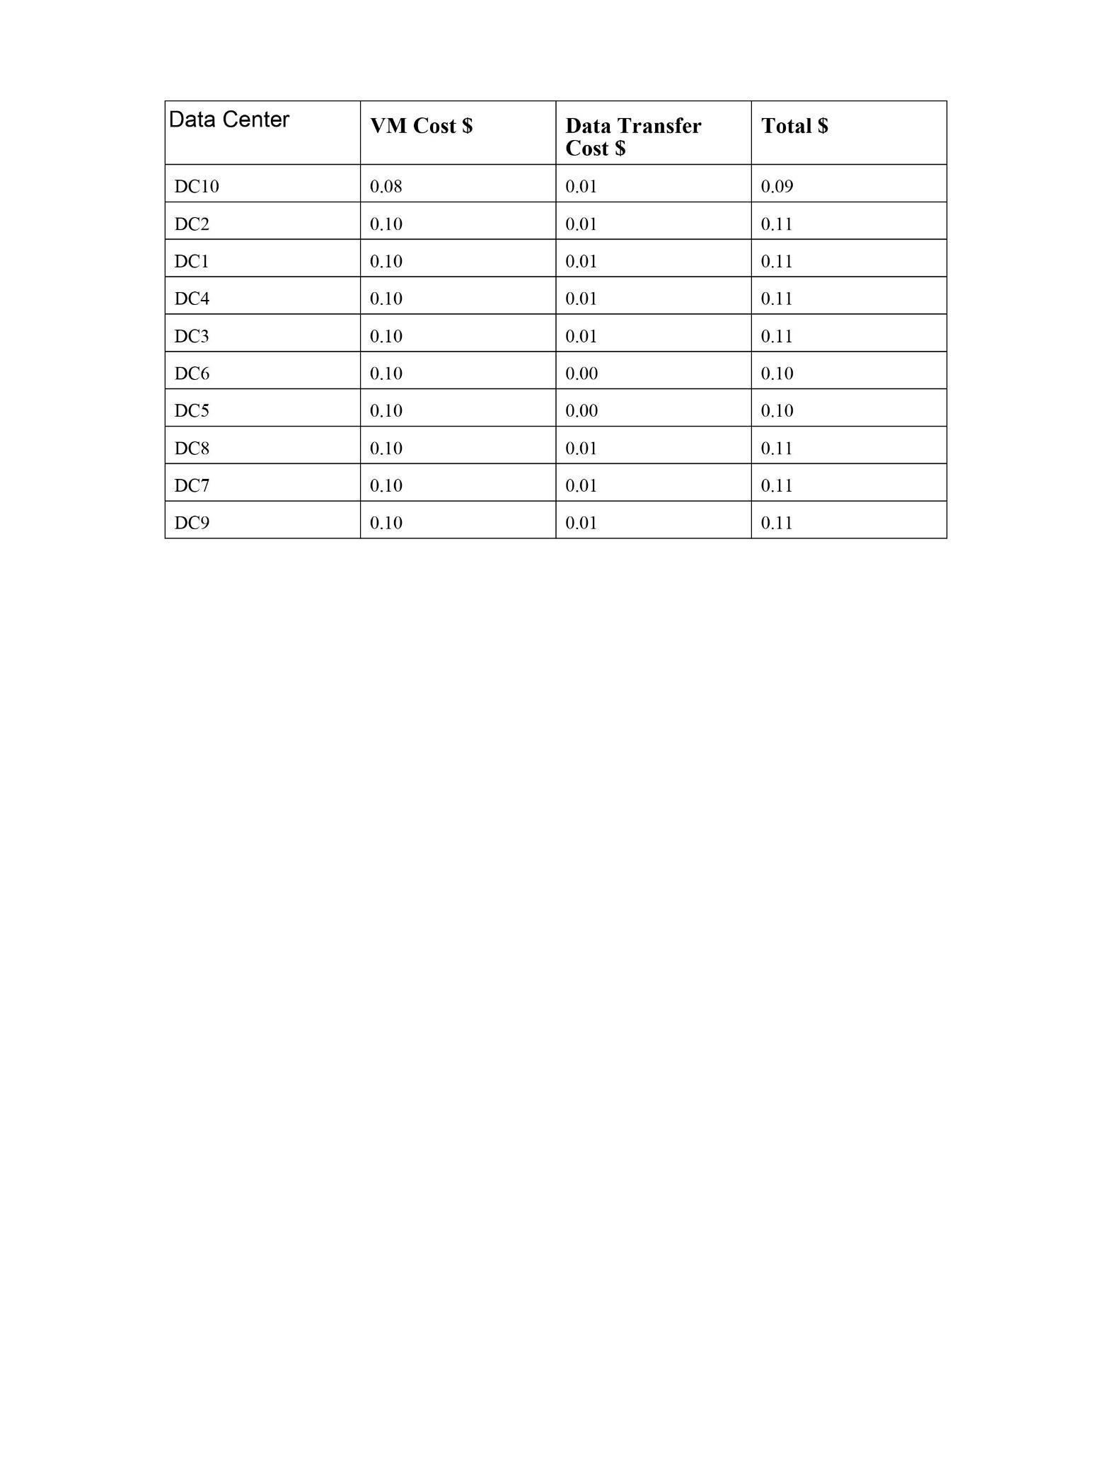

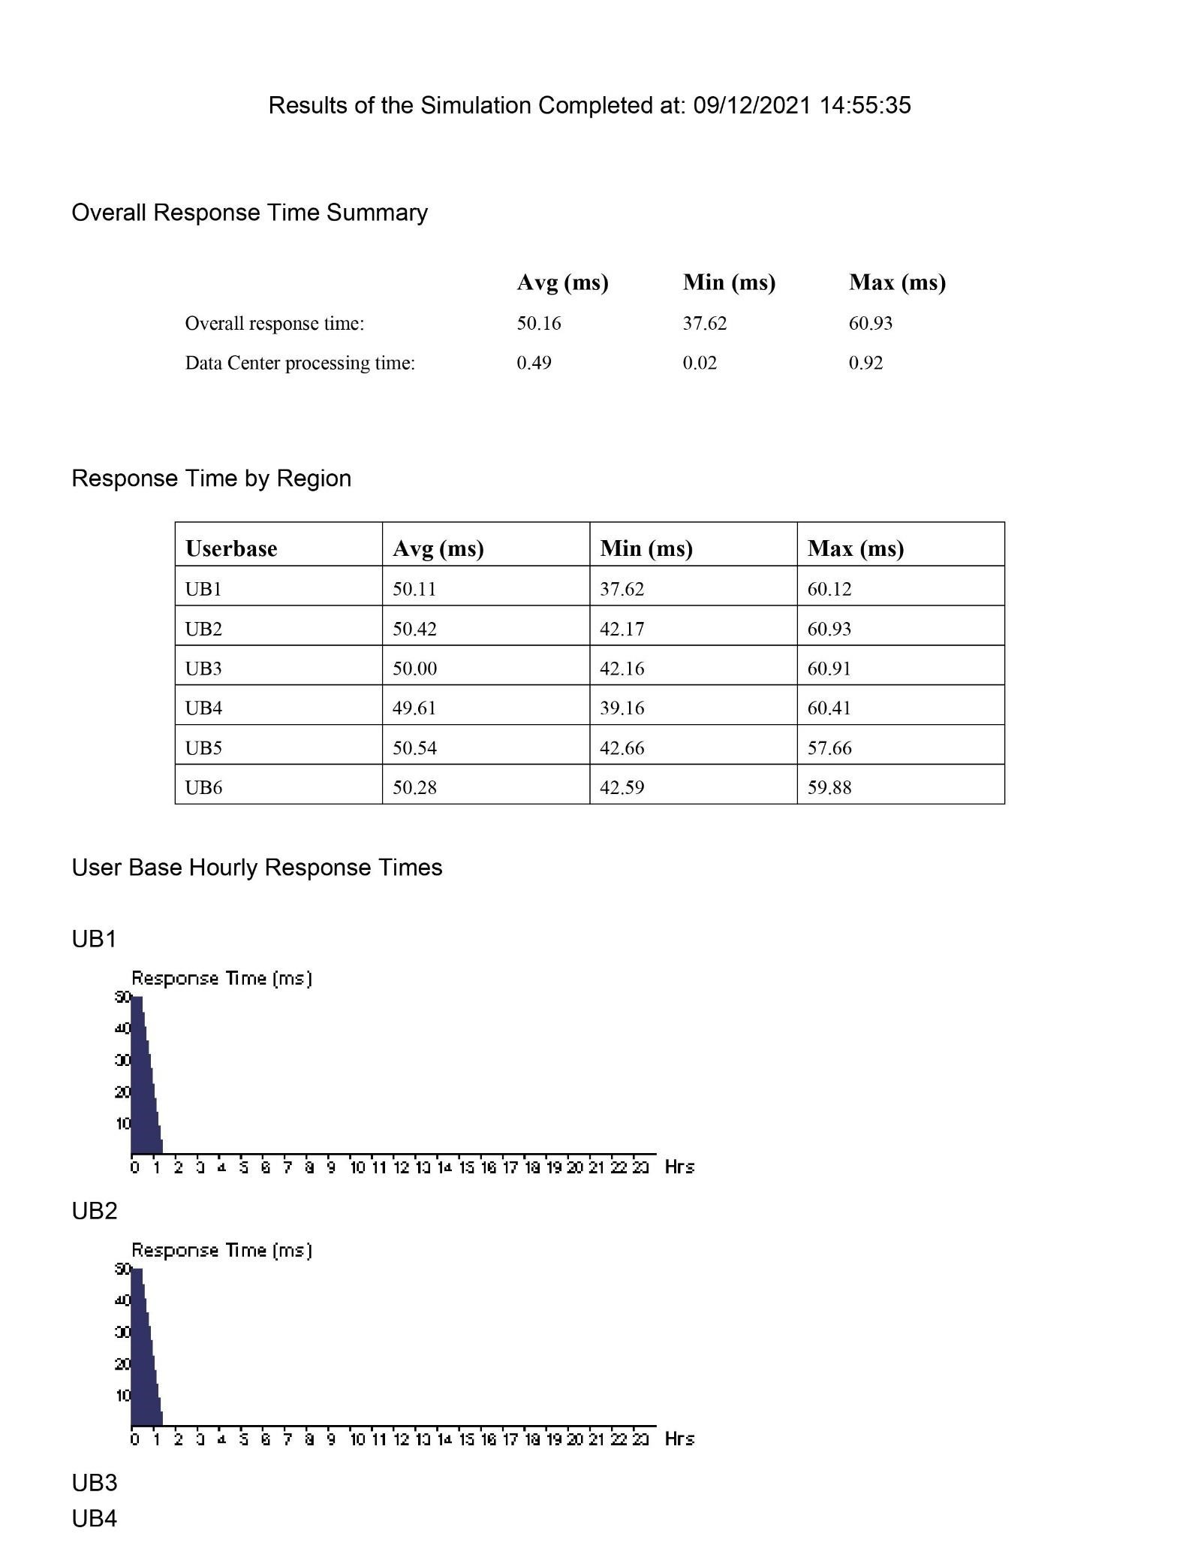

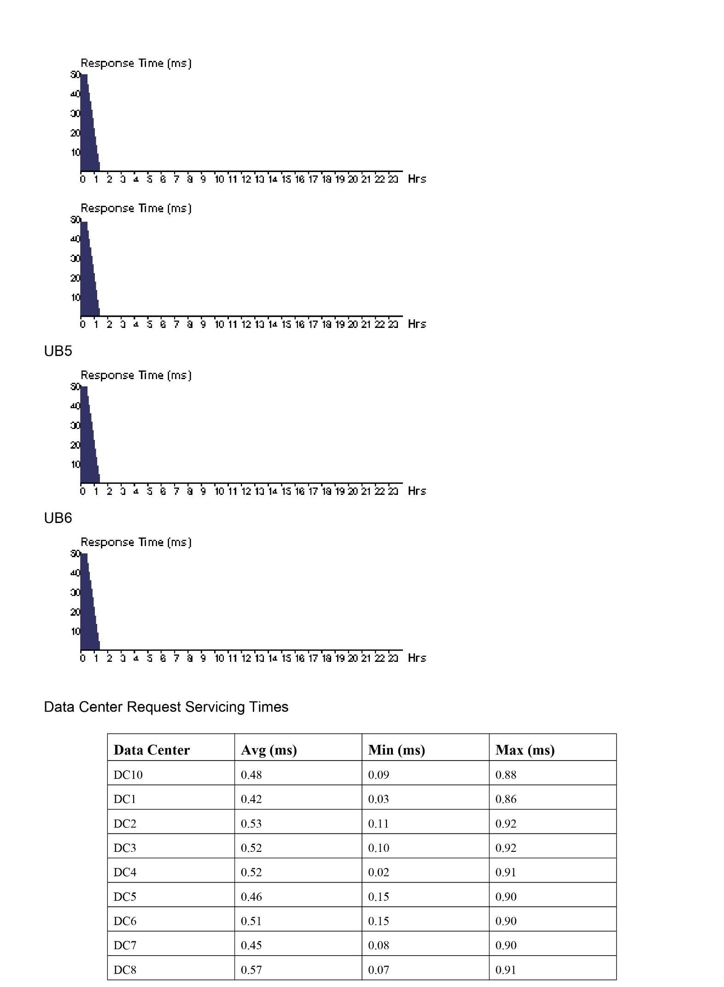

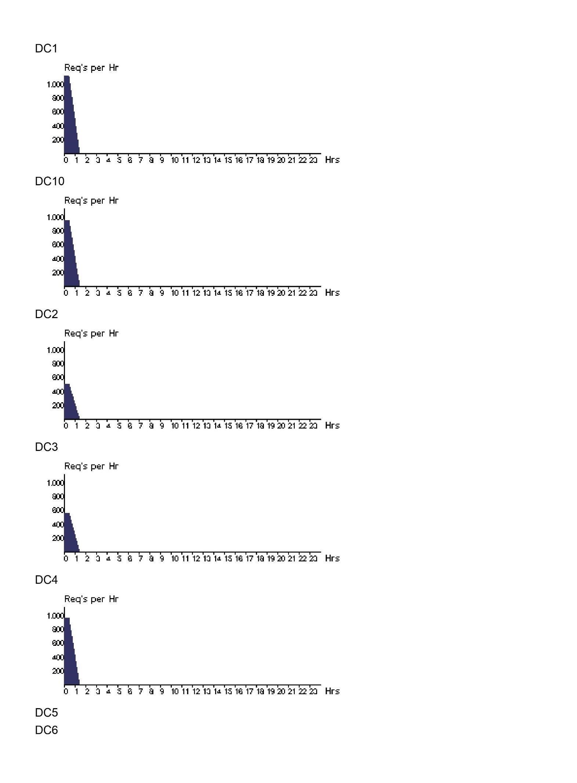

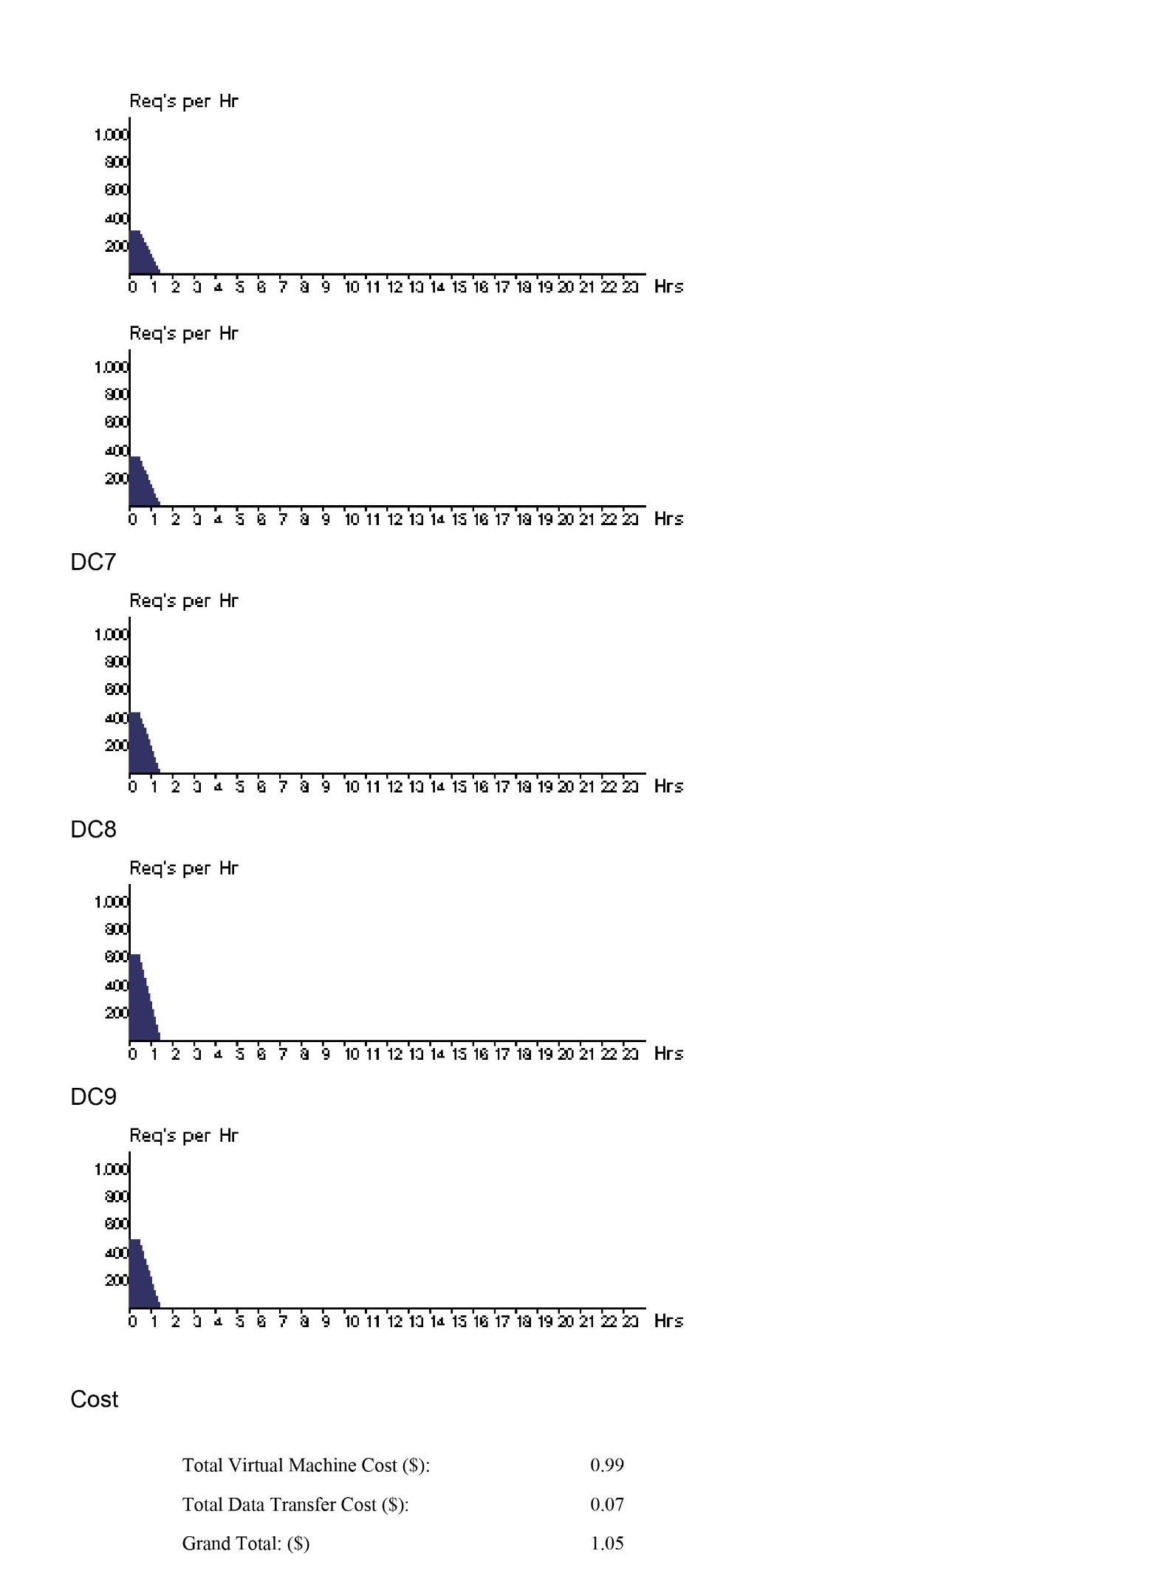

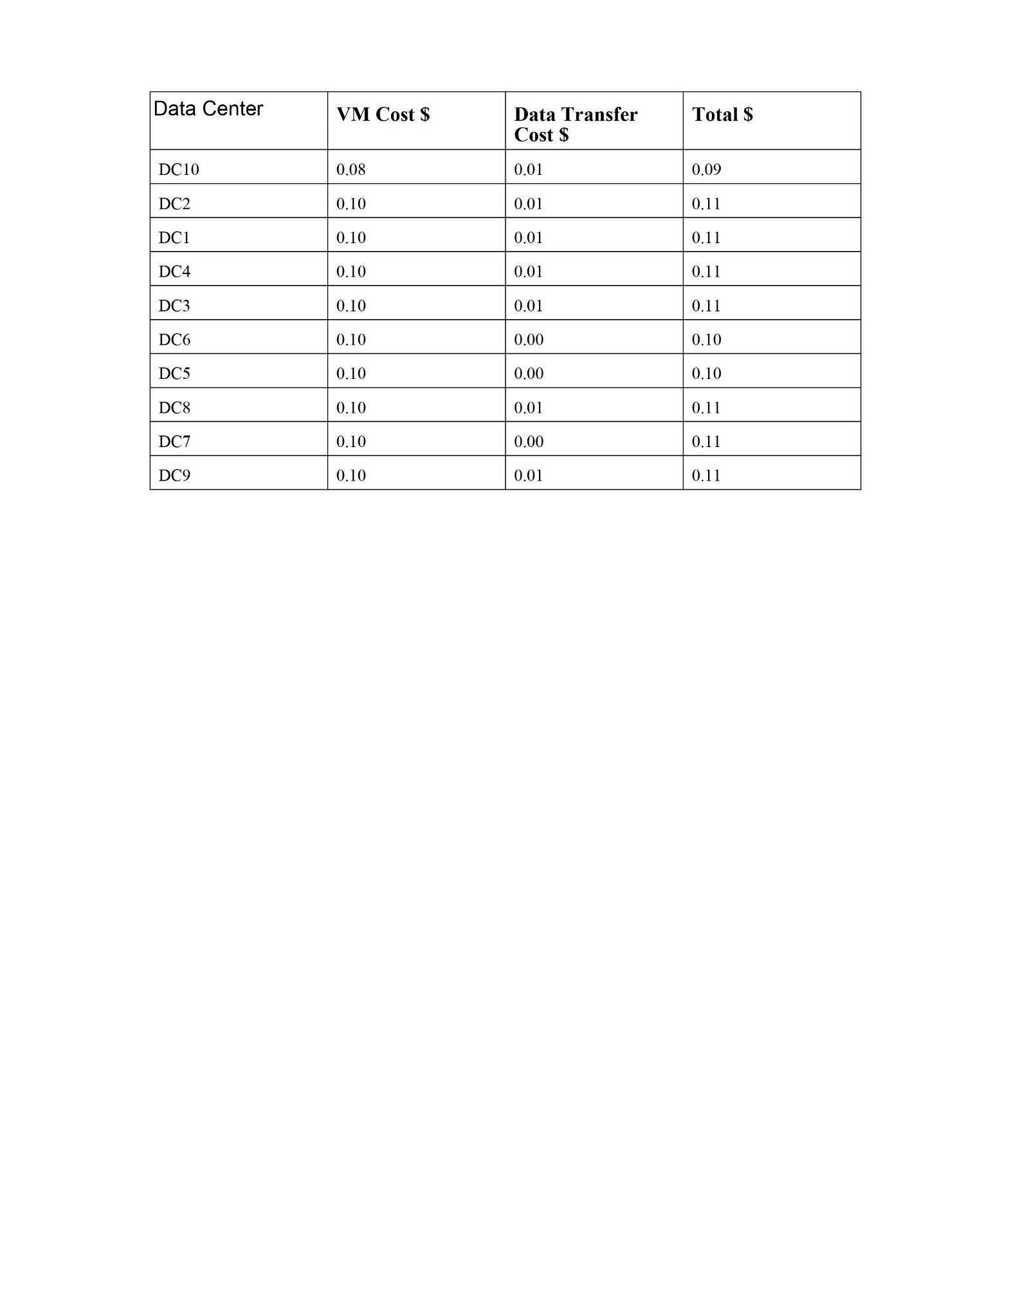

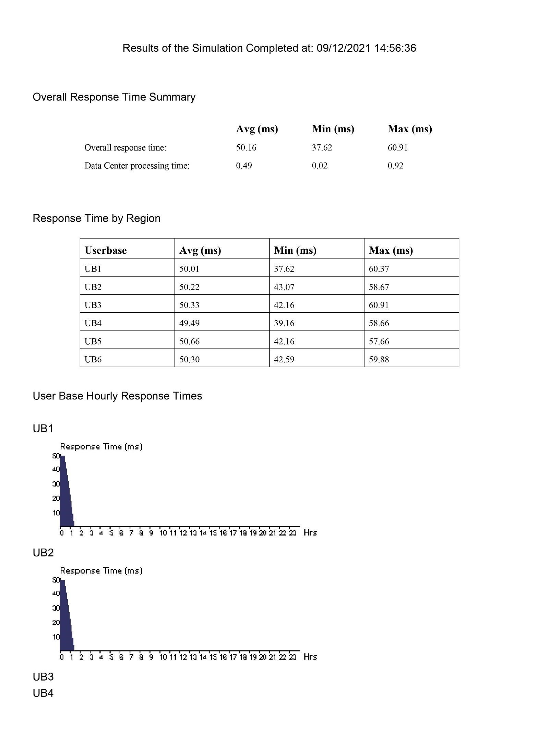

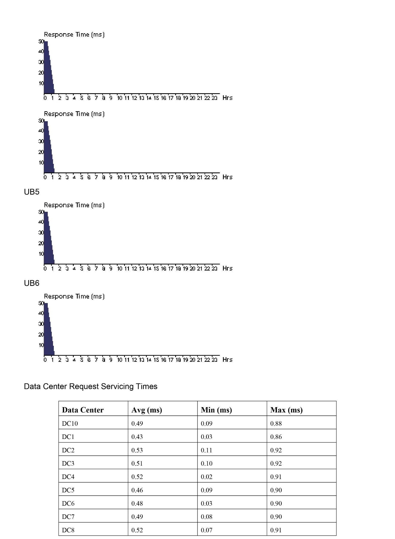

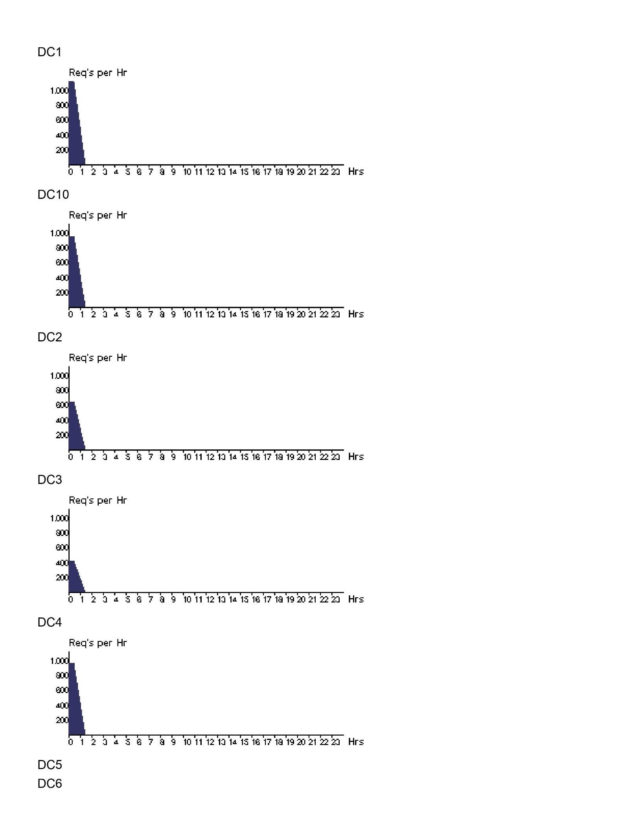

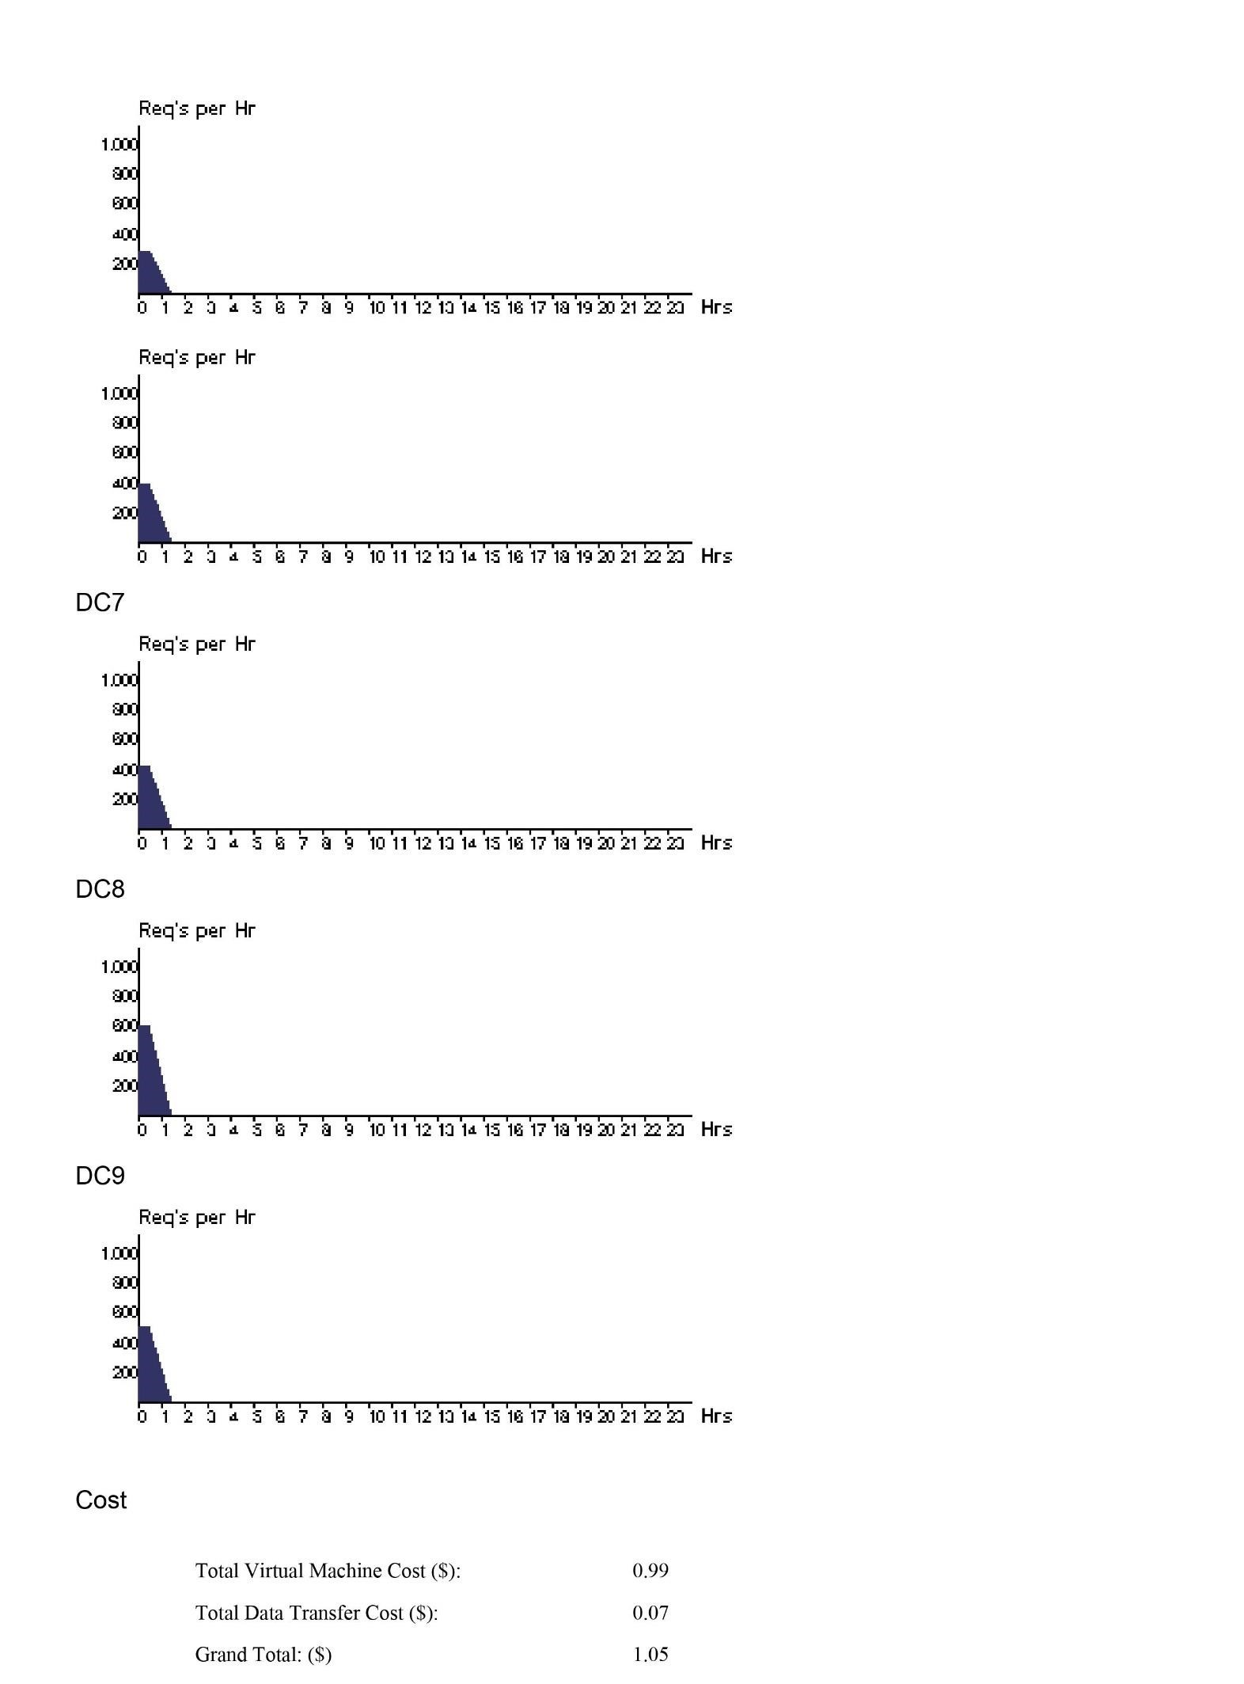

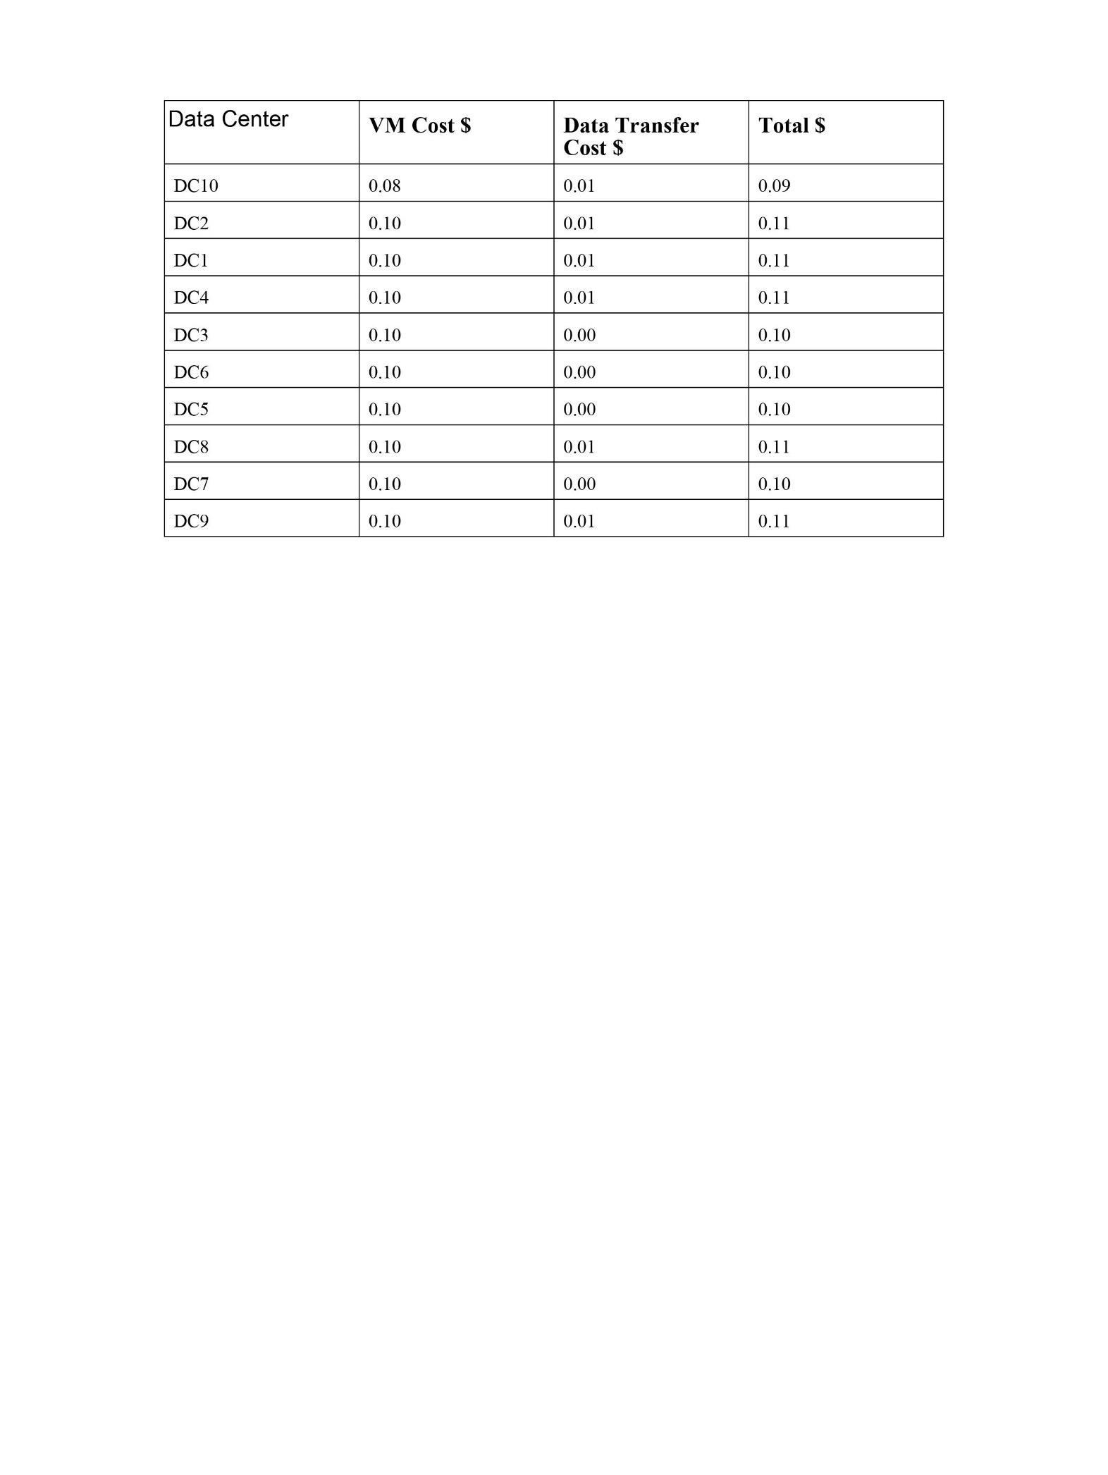

#### 4A - Create a RDS and launch in your custom VPC network

Step 1: Open “AWS Management Console”. Click on “VPC” service.

Step 2: Click “Subnets” on the left panel.

Step 3: Now you can see there is one subnet group (Public Subnet) created in your VPC (Your VPC id/11.0.0.0/16). Now Click on “Create Subnet” button.

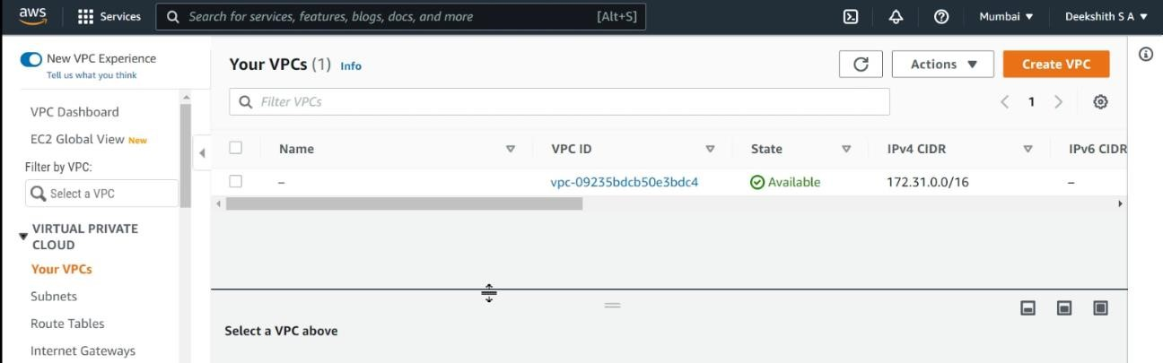

Step 4: Give a Name to the subnet and select you own VPC from the “VPC drop down”. Select an

“availability zone” (Which is not used by “Public Subnet” of your VPC). Give CIDR block range. Click on “Yes, Create” button.

Step 5: Now you can see the subnet is created in your VPC.

Step 6: Click on “Services”. Click on “RDS” service.

Step 7: Click on “Subnet Groups” on the left panel. (Note: Before creating the subnet groups you need to note down your VPC ID and subnets for that VPC).

Step 8: Click on “Create DB Subnet Group” button.

Step 9: Give a name to the “Subnet”. Select your own “VPC ID”. Select the “Availability Zone” and “subnet”. Click on “Add” button.

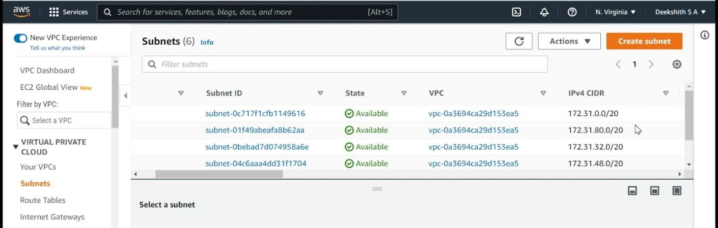

Step 10: Now select another “Availability Zone” and “Subnet”. Click on “Yes, Create” button. (Note: Before clicking on “Yes, create” check that two subnets are added or not) Step 11: Now you can see that “DB subnet group” is created.

Step 12: Click on “RDS Dashboard” on the left panel. Click on “Get Started” button

Step 13: Select your desired “Database Engine” from the list and click on “Select” button.

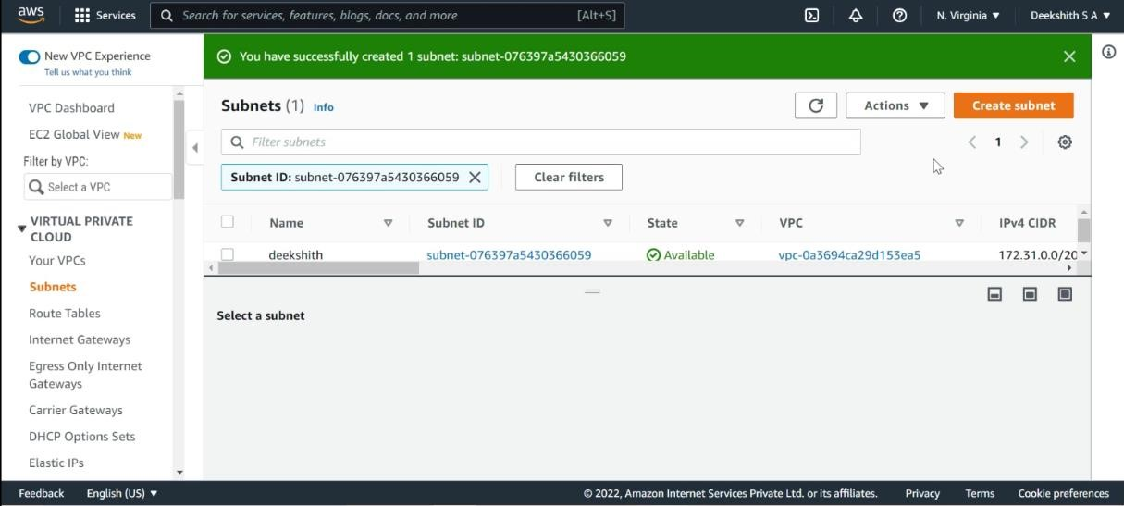

Step 14: If you want multi-AZ Deployment, select the “first radio button” otherwise select the “second radio button”. Click on “Next” button.

Step 15: Select your desired DB instance from the “DB Instance Class” drop down. Select Multi-AZ option from the drop down. Select the storage type from the drop down and give 95 your desired storage space range. Enter the Details (DB instance Identifier, Master user name, password and confirm password). Click on “Next” button.

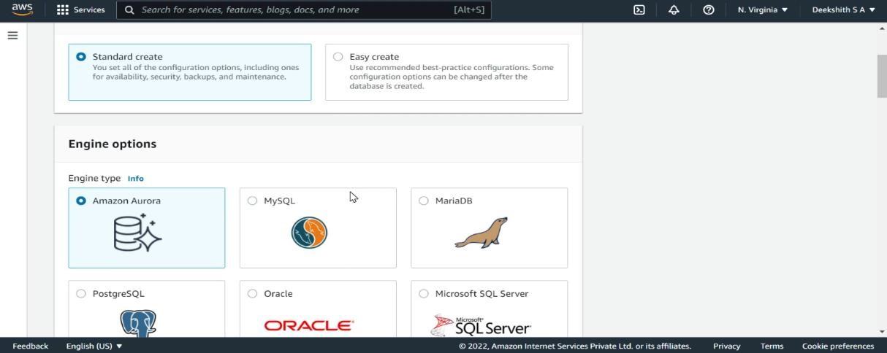

Step 16: Select your own VPC ID from the “VPC Dropdown”. Select the “public accessibility” from the dropdown. Select your desired Availability Zone from the dropdown. Give a name to your Database and check the database port is and mention the “Backup retention period” as per your needs and if you want a Time frame for your backup, configure the time frame from “Backup Window” Dropdown. Click on “Launch DB Instance” button.

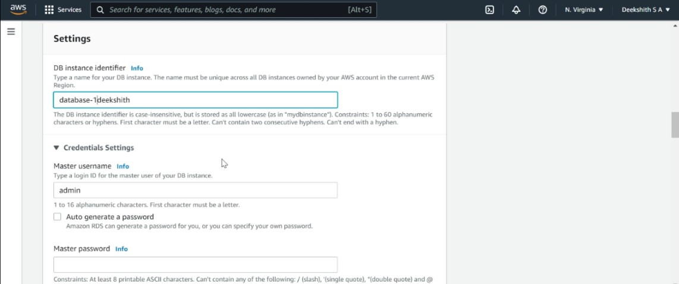

Step 17: Click on “Close” button.

Step 18: Now you can see one DB instance is created. (It will take 5-10min to create the database instance). You will have the DB name, VPC ID, End Point (which is used to connect to the DB Instance from your EC2 instance) and etc…

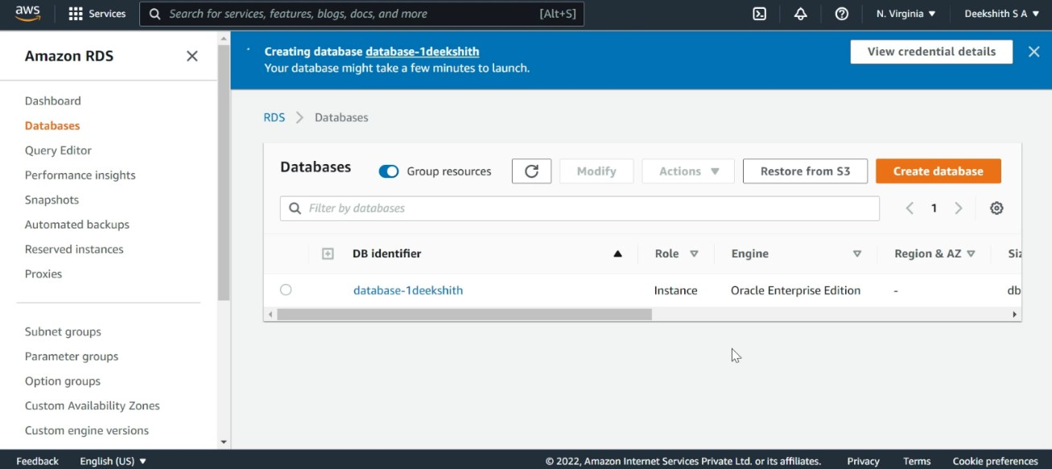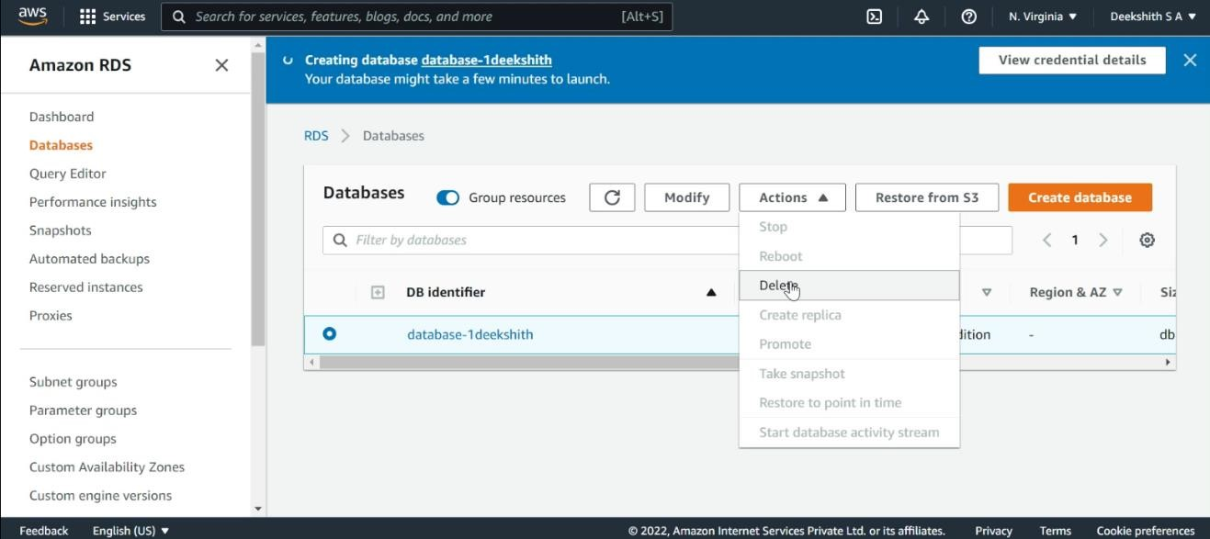

Note: To connect to the Database from your Ec2 Instance, you need the following. a). RDS end point.

1. Database Name.
2. Master username.
3. Master Password.
4. Port Number.

#### 2A - Install Virtualbox/VMware Workstation with different flavours of linux and execute some C programs

**Virtual Box**

VirtualBox is a powerful x86 and AMD64/Intel64 virtualization product for enterprise as well as home use. Not only is VirtualBox an extremely feature rich, high-performance product for enterprise customers, it is also the only professional solution that is freely available as Open-Source Software under the terms of the GNU General Public License (GPL) version 2. See "About VirtualBox" for an introduction.

Presently, VirtualBox runs on Windows, Linux, Macintosh, and Solaris hosts and supports a large number of guest operating systems including but not limited to Windows (NT 4.0, 2000, XP, Server 2003, Vista, Windows 7, Windows 8, Windows 10), DOS/Windows 3.x, Linux (2.4, 2.6, 3.x and 4.x), Solaris and Open Solaris, OS/2, and OpenBSD.

VirtualBox is being actively developed with frequent releases and has an ever- growing list of features, supported guest operating systems and platforms it runs on. VirtualBox is a community effort backed by a dedicated company: everyone is encouraged to contribute while Oracle ensures the product always meets professional quality criteria.

**History**

VirtualBox was first offered by Innotek GmbH from Weinstadt, Germany, under a proprietary software license, making one version of the product available at no cost for personal or evaluation use, subject to the VirtualBox Personal Use and Evaluation License (PUEL). In January 2007, based on counsel by LiSoG, Innotek GmbH released VirtualBox Open-Source Edition (OSE) as free and open-source software, subject to the requirements of the GNU General Public License (GPL), version 2. Innotek GmbH also contributed to the development of OS/2 and Linux support in virtualization and OS/2 ports of products from Connectix which were later acquired by Microsoft. Specifically, Innotek developed the "additions" code in both Windows Virtual PC and Microsoft Virtual Server, which enables various host–guest OS interactions like shared clipboards or dynamic viewport resizing.

Sun Microsystems acquired Innotek in February 2008.Following the acquisition of Sun Microsystems by

Oracle Corporation in January 2010, the product was re- branded as "Oracle VM VirtualBox”. In December 2019, VirtualBox started supporting only hardware-assisted virtualization, dropping support for Software- based one. **Features**

* Snapshots of the RAM and storage that allow reverting to a prior state.
* Screenshots and screen video capture
* "Host key" for releasing the keyboard and mouse cursor to the host system if captured (coupled) to the guest system, and for keyboard shortcuts to features such as configuration, restarting, and screenshot. By default, it is the right-side CTRL key.
* Mouse pointer integration, meaning automatic coupling and uncoupling of mouse cursor when moved inside and outside the virtual screen, if supported by guest operating system.
* Seamless mode – the ability to run virtualized applications side by side with normal desktop applications Shared clipboard
* Shared folders through "guest additions" software
* Special drivers and utilities to facilitate switching between systems
* Ability to specify amount of shared RAM, video memory, and CPU execution cap
* Ability to emulate multiple screens
* Command line interaction (in addition to the GUI)
* Public API (Java, Python, SOAP, XPCOM) to control VM configuration and execution
* Nested paging for AMD-V and Intel VT (only for processors supporting SLAT and with SLAT enabled)
* Limited support for 3D graphics acceleration (including OpenGL up to (but not including) 3.0 and Direct3D 9.0c via Wine's Direct3D to OpenGL translation)
* SMP support (up to 32 virtual CPUs per virtual machine), since version 3.0
* Teleportation (aka Live Migration)
* 2D video output acceleration (not to be mistaken with video decoding acceleration), since version 3.1
* EFI has been supported since version 3.1 (Windows 7 guests are not supported).

**VM Ware**

VMware, Inc. is an American cloud computing and virtualization technology company with headquarters in California. VMware was the first commercially successful company to virtualize the x86 architecture. VMware’s desktop software runs on Microsoft Windows, Linux, and macOS, while its enterprise software hypervisor for servers, VMware ESXi, is a bare-metal hypervisor that runs directly on server hardware without requiring an additional underlying operating system. VMware's most notable products are its hypervisors. VMware became well known for its first type 2 hypervisor known as GSX. This product has since evolved into two hypervisor product lines: VMware's type 1 hypervisors running directly on hardware and their hosted type 2 hypervisors. VMware software provides a completely virtualized set of hardware to the guest operating system. VMware software virtualizes the hardware for a video adapter, a network adapter, and hard disk adapters. The host provides pass-through drivers for guest USB, serial, and parallel devices. In this way, VMware virtual machines become highly portable between computers, because every host looks nearly identical to the guest. In practice, a system administrator can pause operations on a virtual machine guest, move or copy that guest to another physical computer, and their resume execution exactly at the point of suspension. Alternatively, for enterprise servers, a feature called vMotion allows the migration of operational guest virtual machines between similar but separate hardware hosts sharing the same storage (or, with vMotion Storage, separate storage can be used, too). Each of these transitions is completely transparent to any users on the virtual machine at the time it is being migrated.

VMware's products predate the virtualization extensions to the x86 instruction set, and do not require virtualization-enabled processors. On newer processors, the hypervisor is now designed to take advantage of the extensions. However, unlike many other hypervisors, VMware still supports older processors. In such cases, it uses the CPU to run code directly whenever possible (as, for example, when running user-mode and virtual 8086 mode code on x86). When direct execution cannot operate, such as with kernel-level and realmode code, VMware products use binary translation (BT) to re-write the code dynamically. The translated code gets stored in spare memory, typically at the end of the address space, which segmentation mechanisms can protect and make invisible. For these reasons, VMware operates dramatically faster than emulators, running at more than 80% of the speed that the virtual guest operating system would run directly on the same hardware. In one study VMware claims a slowdown over native ranging from 0–6 percent for the VMware ESX Server.

**Products:**

**Desktop software**

VMware Workstation, introduced in 1999, was the first product launched by VMware. This software suite allows users to run multiple instances of x86 or x86-64 -compatible operating systems on a single physical personal computer. Workstation Pro version 15.5.1 was released in Nov 2019.

VMware Fusion provides similar functionality for users of the Intel Mac platform, along with full compatibility with virtual machines created by other VMware products.

VMware Workstation Player is freeware for non-commercial use, without requiring a license, and available for commercial use with permission. It is similar to VMware Workstation, with reduced functionality.

**Server software**

VMware ESXi, an enterprise software product, can deliver greater performance than the freeware VMware Server, due to lower system computational overhead. VMware ESXi, as a "bare-metal" product, runs directly on the server hardware, allowing virtual servers to also use hardware more or less directly. In addition, VMware ESXi integrates into VMware vCenter, which offers extra services.

**Cloud management software**

VMware vRealize Suite – a cloud management platform purpose-built for a hybrid cloud.

VMware Go is a web-based service to guide users of any expertise level through the installation and configuration of VMware vSphere Hypervisor.

VMware Cloud Foundation – Cloud Foundation provides an easy way to deploy and operate a private cloud on an integrated SDDC system.

VMware Horizon View is a virtual desktop infrastructure (VDI) product.

**Application management**

The VMware Workspace Portal was a self-service app store for workspace management.

**Storage and availability**

VMware's storage and availability products are composed of two primary offerings:

VMware vSAN (previously called VMware Virtual SAN) is software-defined storage that is embedded in VMware's ESXi hypervisor. The vSphere and vSAN software run on industry-standard x86 servers to form a hyper- converged infrastructure (or HCI). However, network operators need to have servers from HCL (Hardware Compatibility List) to put one into production. The first release, version 5.5, was released in March 2014. The 6th generation, version 6.6, was released in April 2017.New features available in VMware vSAN 6.6 include native data at rest encryption, local protection for stretched clusters, analytics, and optimized solidstate drive performance. The VMWare 6.7 version was released in April 2018, Users now have improved monitoring tools and new workflows, it is closer to feature parity. The vCenter Server Appliance architecture is moving around to an easy deployment method.

VMware Site Recovery Manager (SRM) automates the failover and failback of virtual machines to and from a secondary site using policy-based management.

**Networking and security products**

VMware NSX is VMware's network virtualization product marketed using the term software-defined data centre (SDDC). The technology included some acquired from the 2012 purchase of Nicira. Software Defined Networking (SDN) allows the same policies that govern Identity and Access Management (IAM) to dictate levels of access to applications and data through a totally converged infrastructure not possible with legacy network and system access methods.

**Other products**

Workspace ONE allows mobile users to access apps and data.

The VIX (Virtual Infrastructure eXtension) API allows automated or scripted management of a computer virtualized using either VMware's vSphere, Workstation, Player, or Fusion products. VIX provides bindings for the programming languages C, Perl, Visual Basic, VBscript and C#.

Herald is a communications protocol from VMware for more reliable Bluetooth communication and range finding across for mobile devices. Herald code is available under an Open-source license and was implemented in the Australian Government's COVID Safe app for contact tracing on 19 December 2020.

**Guest OS**

A guest operating system (guest OS) is an operating system (OS) that is secondary to the OS originally installed on a computer, which is known as the host operating system. The guest OS is either part of a partitioned system or part of a virtual machine (VM) setup. A guest OS provides an alternative OS for a device.

In disk partitioning, a guest OS is simply another instance of the same operating system that can boot up for controlling a certain partitioned memory set. A virtual machine (VM) process is much different, in that a guest OS can be a different OS alternative. In VM setups, a guest OS is delivered through a virtual machine environment through a tool called a hypervisor. Again, the machine will typically have a host OS, where the guest OS will operate "within" the host OS. This can lead to limitations on file saving and other operations within the guest OS, depending on whether the guest OS is said to be "persistent."

Part of the emergence of guest operating systems in VM systems has to do with the benefits provided by virtualization. These revolutions in computing coincide with the more general concept of cloud computing, where resources are delivered, rather than hosted, in physical local hardware setups. In addition, a guest OS often takes advantage of a lean OS to build, where memory requirements are further alleviated. VM setups can help with licensing issues, system requirements, and more, making these an attractive part of outsourced computing services.

Step 1: To download and install the VMware product visit the official website of VMware. <https://www.vmware.com/in/products/workstation-pro/workstationproevaluation.html>

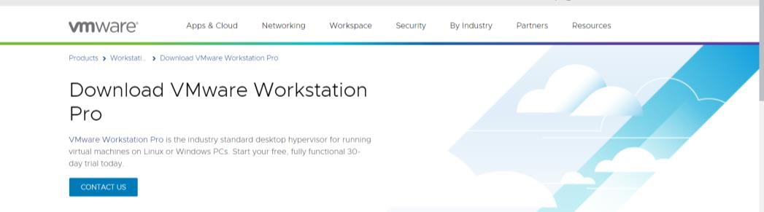

Step 2: Click on Download VM WorkStation for Windows. The installation file gets downloaded in the specified location and is now ready for installation.

Step 3: Click on the download file to install the VMWare Workstation 16 Pro. Popup will appear Step 4: Once the initialization gets completed, Click Next

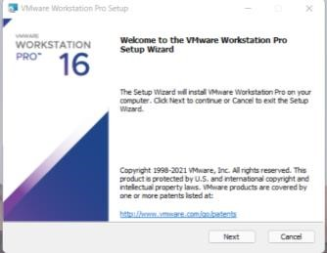

Step 5: Accept the terms and click on Next. In the next screen, it will ask for some additional features, it is not mandatory to check this box. Click on Next.

Step 6: On the next screen, some checkboxes are populated, Check them as per your requirement. Click on Next.

Step 7: At this step, VMware Workstation is ready to install. Click on Install.

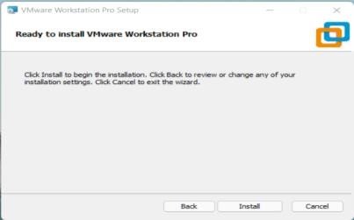

Step 8: Once the installation gets completed you will see the following dialogue box. Click on Finish. If you have purchased the product and have a license key, then you can click on License to enter the key.

Step 9: Upon Finish, the window will close, and You can see VMware Workstation installed icon on your Desktop. Double Click on the Icon to open the application.

Step 10: For the first time opening, if you have not entered the License key in the previous steps, then it will ask for a license key.

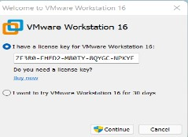

Finally, this will open a window of VMware Workstation Pro.

Step 11: Click on File



New Virtual Machine. A New Virtual Machine Wizard will appear. Click on

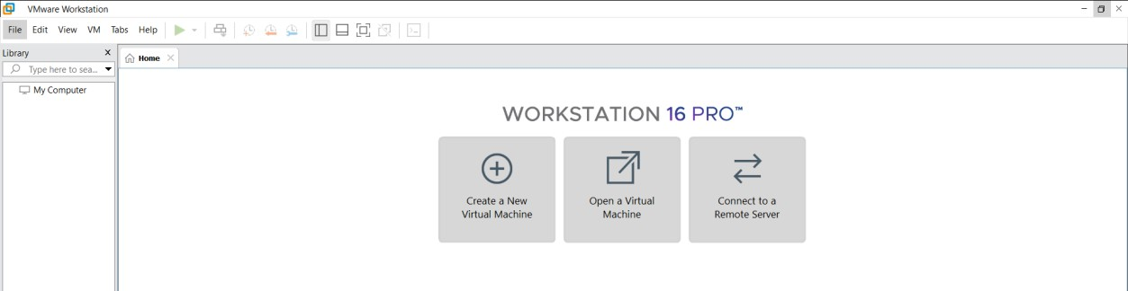

Typical.

Step 12: Select the ISO File and click on Next

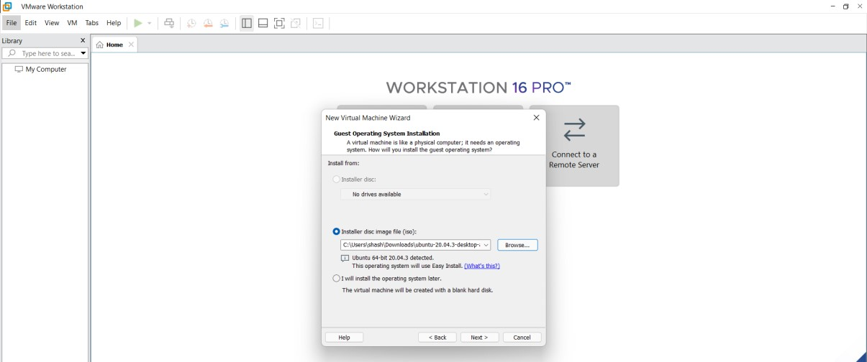

Step 13: Fill in the required details such as username, password and click on next.

Step 14: Name the virtual machines.

Step 15: Allocate the memory and select Split virtual disk into multiple files and click on next. Click on Customize Hardware. Set the memory size to 4GB

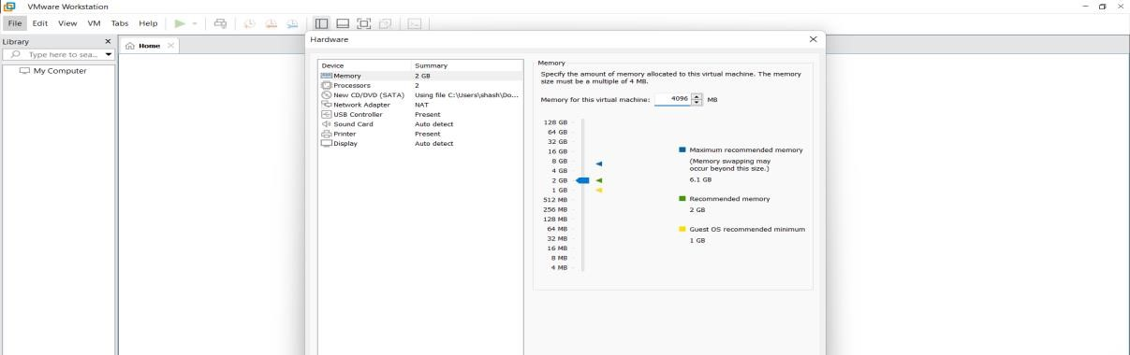

Step 16 : Click on Finish. You can see that Ubuntu gets installed in the VM Ware Workstation.

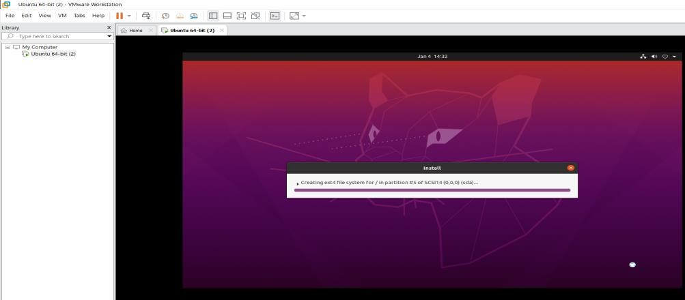

Step 17: Login and Open Terminal and Execute a simple C Program

Step 18: Using gedit write a simple C Code. Use the following commands on the terminal:

* To Open the Editor - gedit sample.c
* To Compile the code - gcc sample.c
* To Get the output - ./a.out

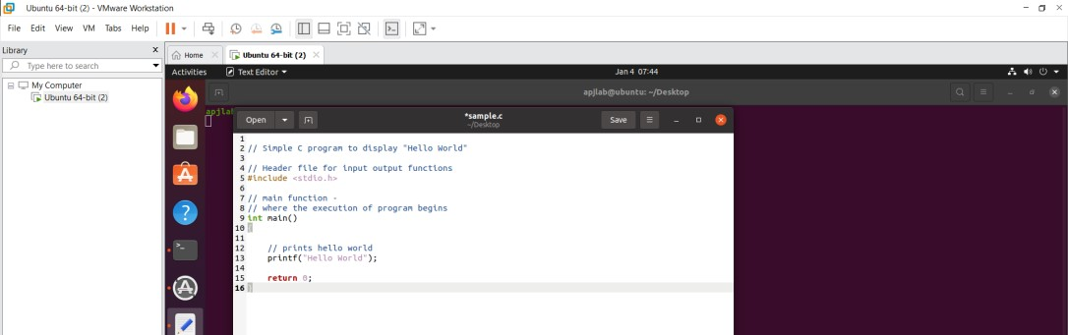

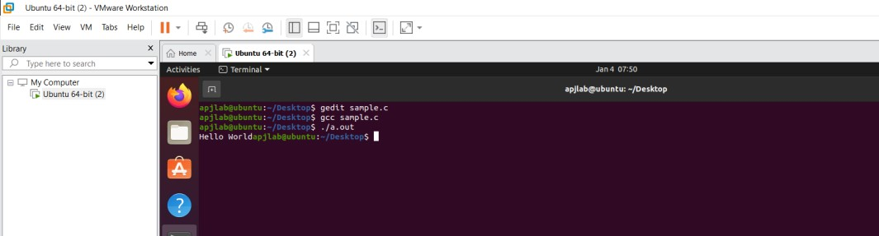

**5A - Create a file in one virtual machine and transfer/share it with the host machine.**

**Virtualization and File Sharing**

**Virtualization**

Virtualization is the process of running a virtual instance of a computer system in a layer abstracted from the actual hardware. Most commonly, it refers to running multiple operating systems on a computer system simultaneously. To the applications running on top of the virtualized machine, it can appear as if they are on their own dedicated machine, where the operating system, libraries, and other programs are unique to the guest virtualized system and unconnected to the host operating system which sits below it.

There are many reasons why people utilize virtualization in computing. To desktop users, the most common use is to be able to run applications meant for a different operating system without having to switch computers or reboot into a different system. For administrators of servers, virtualization also offers the ability to run different operating systems, but perhaps, more importantly, it offers a way to segment a large system into many smaller parts, allowing the server to be used more efficiently by a number of different users or applications with different needs. It also allows for isolation, keeping programs running inside of a virtual machine safe from the processes taking place in another virtual machine on the same host.

**Working of Virtualization:**

Software called hypervisors separate the physical resources from the virtual environments—the things that need those resources. Hypervisors can sit on top of an operating system (like on a laptop) or be installed directly onto hardware (like a server), which is how most enterprises virtualize. Hypervisors take your physical resources and divide them up so that virtual environments can use them.

Resources are partitioned as needed from the physical environment to the many virtual environments. Users interact with and run computations within the virtual environment (typically called a guest machine or virtual machine). The virtual machine functions as a single data file. And like any digital file, it can be moved from one computer to another, opened in either one, and be expected to work the same.

When the virtual environment is running and a user or program issues an instruction that requires additional resources from the physical environment, the hypervisor relays the request to the physical system and caches the changes—which all happens at close to native speed (particularly if the request is sent through an open- source hypervisor based on KVM, the Kernel-based Virtual Machine).

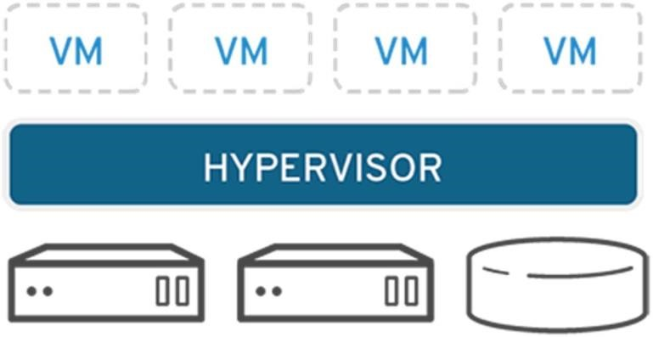

**File Sharing**

Transferring Files to and from Virtual Machines can be done in the following ways:

* Creating a Shared Folder in VirtualBox
* Dragging and Dropping Files in VirtualBox
* Managing Files with NextCloud

**Creating a Shared Folder in VirtualBox**

A shared folder is a folder that makes its files available on both the guest machine and the host machine at the same time. Creating a shared folder between the guest and the host allows you to easily manage files that should be present on both machines. The course virtual machines are ready to use shared folders right away, but if you are using the virtual machine on your personal computer, then you will need to specify which folder to use as shared storage.

**Shared Folders on SCS Lab Computers using Course VMs:**

If you are using a course VM on a lab computer, it is likely that a shared folder has already been set up for you. On the desktop of your course VM, you should notice a folder titled Shared Folders. Inside this folder, you will find any folders that have been shared between the course VM and lab computers. You should see two folders that have already been configured for you: Z_DRIVE and Temp. Z_DRIVE gives you access to your Windows Account Z:\ drive. This is storage that is persistent to your SCS account and available as a network drive on the lab computers. Temp gives you access to the folder found at D:\temp on the lab computer. Files stored in this folder are local to the machine, meaning that they can be accessed faster but will delete from the system when you log out. If you are working with data that you will need to use again, use the Z_DRIVE for your shared folder. If you need a faster read/write speed, use the Temp folder, but remember to back up your files, or they will be deleted when you log off the computer.

**Shared Folders on Personal Computers**

If you are using your own personal machine, you will need to configure VirtualBox to look in the right place for your shared files. First, click on the guest machine you intend to share files with. From there, you can select the guest Settings and navigate to Shared Folders on the left side menu. To create a new shared folder, either click the New Folder icon on the right menu or right-click the empty list of shared folders and click Add Shared Folder. From here, there are six options:

* **Folder Path**: The folder name on the host machine. Click the drop-down menu and navigate to the folder you would like to share.
* **Folder Name**: This is the name of the folder as it will appear on the guest machine.
* **Read-Only**: If you check read-only, the guest machine will be unable to write changes to the folder. This is valuable when you only want to send files to the virtual machine, but do not want to risk having the files modified by the guest.
* **Auto-Mount**: When any external storage is connected to a computer, it must be mounted in order to be used. It is recommended that you turn on auto-mounting unless you are familiar with the process of mounting a drive yourself.
* **Mount Point**: Unless you already know about mount points, leave this blank.
* **Make Permanent**: If you check this, the shared folder will be a permanent machine folder. If it is not checked, the folder will not be shared after a shutdown.

On the course virtual machines, when you load into the desktop, you should see a folder labelled Shared Folders. In there, you will see any folders that are currently mounted and being shared.

**Dragging and Dropping Files in VirtualBox**

If you only need to transfer a few files quickly, you can simply drag and drop the files in. On the top bar of the running guest machine, click on Devices > Drag and Drop and make sure that Bidirectional is selected. This means that you will be able to drag files from the host to the guest and from the guest to the host. Once bidirectional drag and drop is checked, you should be able to begin dragging and dropping files.

**NOTE**: Sometimes when dragging files into the course VM, you may not be able to drag them into the file browser directly. If you encounter this issue, you should drag your files onto the Desktop and move the files around from there. You should see the cursor change when it is ready to drop files.

You can also drag files from the guest machine into the host. To do this, simply open the file browser on the host to where you would like to drop the files and drag the files from the virtual machine into the file browser of the host. File transfers should be pretty quick; if the virtual machine seems stuck when transferring, simply cancel the transfer and try again.

**Managing Files with NextCloud**

On any virtual machine, including VirtualBox, VMWare, or the virtual machines hosted on the SCS OpenStack, you can access the SCS NextCloud services to move files between multiple machines and your SCS Windows Account storage. NextCloud offers you all of your SCS storage in one remote location, similar to how you might use other file hosting services like Dropbox or Google Drive. Before trying to use NextCloud, you should check that you can access the service by logging in here. If you can access the NextCloud services, you can browse the various file storage services available to you:

* **Linux Home**: These are the files from your SCS Linux Account
* **Windows Home**: These are the files from your SCS Windows Account and your lab Z:\ drive.
* **NextCloud**: In addition to the other storage accounts provided to you by the SCS, you can also upload up to 20GB of files directly to NextCloud.

With NextCloud, you can upload your files from any machine with an internet connection and download them onto any other machine with an internet connection. For example, you can move project files off of your virtual machine, onto the NextCloud storage, and then download them on your personal laptop. Alternatively, you can upload files from your personal PC onto the NextCloud storage, place them into the Windows home folder, and access those files from either the lab Z:\ drive or download them on a virtual machine like VirtualBox or OpenStack.

**Uploading Files to NextCloud from a Lab Computer**

If you would like to upload files from a lab computer, the easiest way to do this is to place the files you would like to transfer into your Z:\ drive. These files will be automatically backup into your NextCloud storage under the Windows home folder. After that, you can move them into the main NextCloud storage or choose to keep them in your Z:\drive.

**Uploading Files to NextCloud from a VM or Other PC**

If you would like to upload files from either a VM or any other computer, you can log in to the

NextCloud service using any of the available interfaces, such as the web interface. Press the “+” icon in the top left of the file browser and select Upload File. From here, you can choose to keep it in the main NextCloud storage, move it into your Windows Account storage (the Windows home folder), or into your Linux Account storage (the Linux Home folder).

**Downloading NextCloud Files to a VM or Other PC**

Once your files are uploaded, you will be able to download those files onto any machine, which can connect to NextCloud. First, log in to your preferred NextCloud interface (e.g., the web interface). Navigate to the folder which contains the files you would like to download. Once you are in the target folder, click the checkbox next to each file you would like to download. Above the file listing, you should notice the context bar changing to tell you how many files you have selected and a button labelled Actions. Click Actions > Download.

If you selected a single file, it will prompt you to confirm the download. If you have chosen more than one file, NextCloud will place all of the selected files into a zip archive. Before you can use the files, you will need to extract them from the archive. Once you have downloaded your file or extracted your archive, you are ready to use your files on your machine.

Step 1: To download and install the VMware product visit the official website of VMware. <https://www.vmware.com/in/products/workstation-pro/workstationproevaluation.html>



Step 2: Click on Download VM WorkStation for Windows. The installation file gets downloaded in the specified location and is now ready for installation.

Step 3: Click on the download file to install the VMWare Workstation 16 Pro. Popup will appear Step 4: Once the initialization gets completed, Click Next



Step 5: Accept the terms and click on Next. In the next screen, it will ask for some additional features, it is not mandatory to check this box. Click on Next.

Step 6: On the next screen, some checkboxes are populated, Check them as per your requirement. Click on Next.

Step 7: At this step, VMware Workstation is ready to install. Click on Install.



Step 8: Once the installation gets completed you will see the following dialogue box. Click on Finish. If you have purchased the product and have a license key, then you can click on License to enter the key.

Step 9: Upon Finish, the window will close, and You can see VMware Workstation installed icon on your Desktop. Double Click on the Icon to open the application.

Step 10: For the first time opening, if you have not entered the License key in the previous steps, then it will ask for a license key.



Finally, this will open a window of VMware Workstation Pro.

Step 11: Click on File



New Virtual Machine. A New Virtual Machine Wizard will appear. Click on



Typical.

Step 12: Select the ISO File and click on Next



Step 13: Fill in the required details such as username, password and click on next.

Step 14: Name the virtual machines.

Step 15: Allocate the memory and select Split virtual disk into multiple files and click on next. Click on Customize Hardware. Set the memory size to 4GB

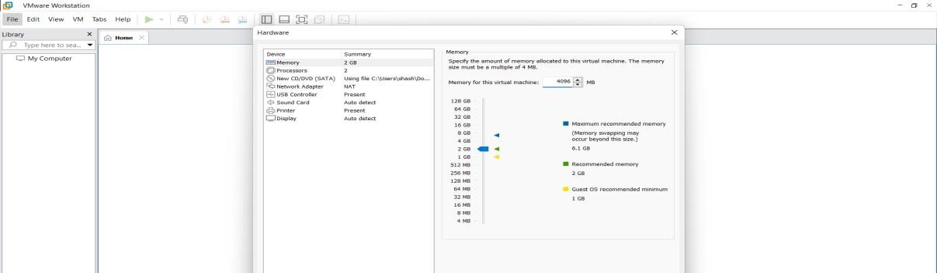

Step 16 : Click on Finish. You can see that Ubuntu gets installed in the VM Ware Workstation.



Step 17: Open the terminal and type the following command:

**sudo apt install samba**

Wait for the installation to complete and close the terminal.

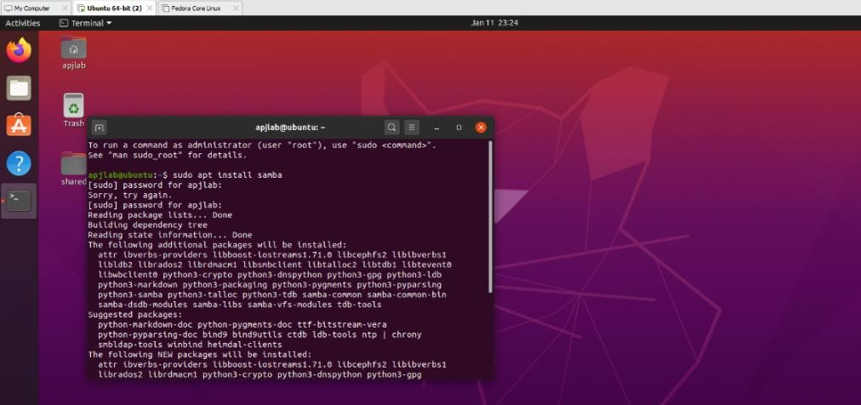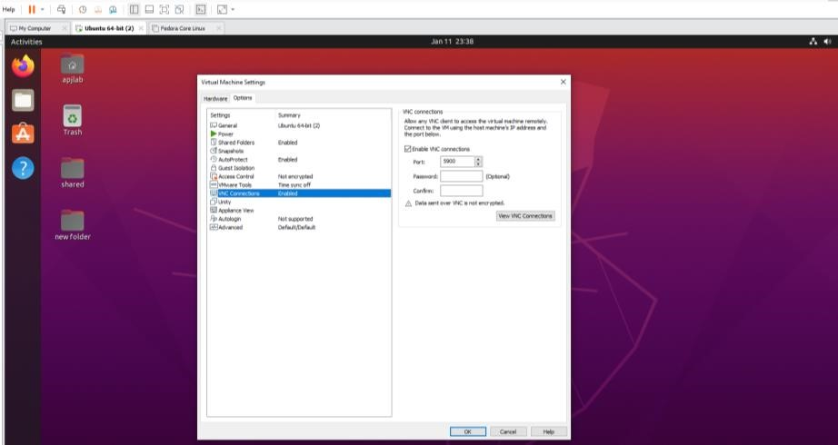

Step 18: Click on VM on top and click on Settings. A window appears. Click on Options and Enable Shared Folders, Auto Protect, VNC Connections and click on OK

Step 19: Click on permissions and set Read and Write Permissions for Owner, Group and Others.

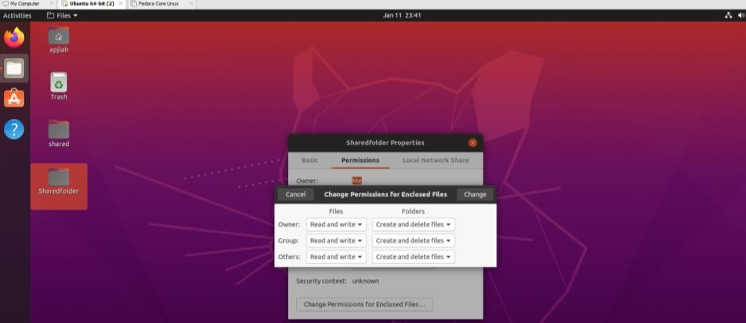

Step 20: Close all the windows and click on Settings

Step 21: Click on Wired Settings and window appears as shown in the below picture. Copy the IPv4 address.

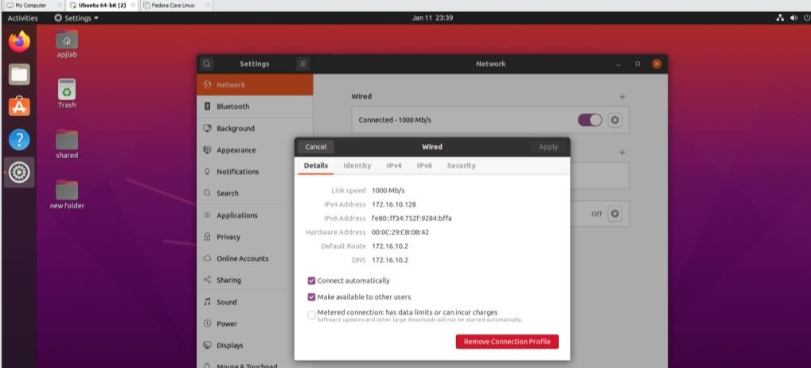

Step 22: Open RUN on Windows and type the IP Address with the “\\”. For example, if the IPv4 Address copied is 172.16.10.128 in the Run window enter \\172.16.10.128

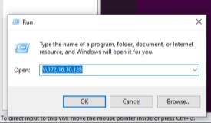

Step 23: A window appears showing the folder that was shared. The user can now access the folder.

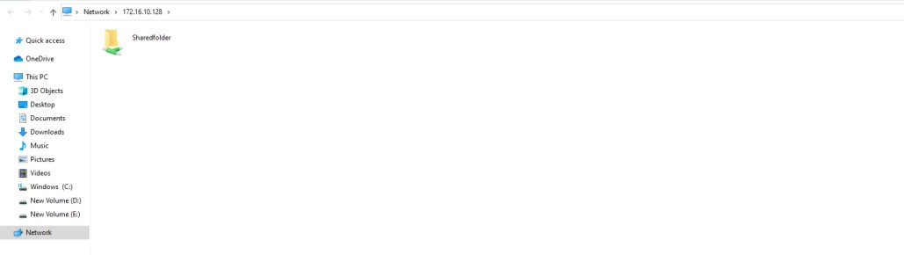

#### 3A - Install Google App Engine. Create hello world app and other simple web applications using python/java

**Google App Engine** (often referred to as GAE or simply App Engine) is a cloud computing platform as a service for developing and hosting web applications in Google-managed data centers. Applications are sandboxed and run across multiple servers. App Engine offers automatic scaling for web applications—as the number of requests increases for an application, App Engine automatically allocates more resources for the web application to handle the additional demand. The service is free up to a certain level of consumed resources and only in standard environment but not in flexible environment. Fees are charged for additional storage, bandwidth, or instance hours required by the application. It was first released as a preview version in April 2008 and came out of preview in September 2011.

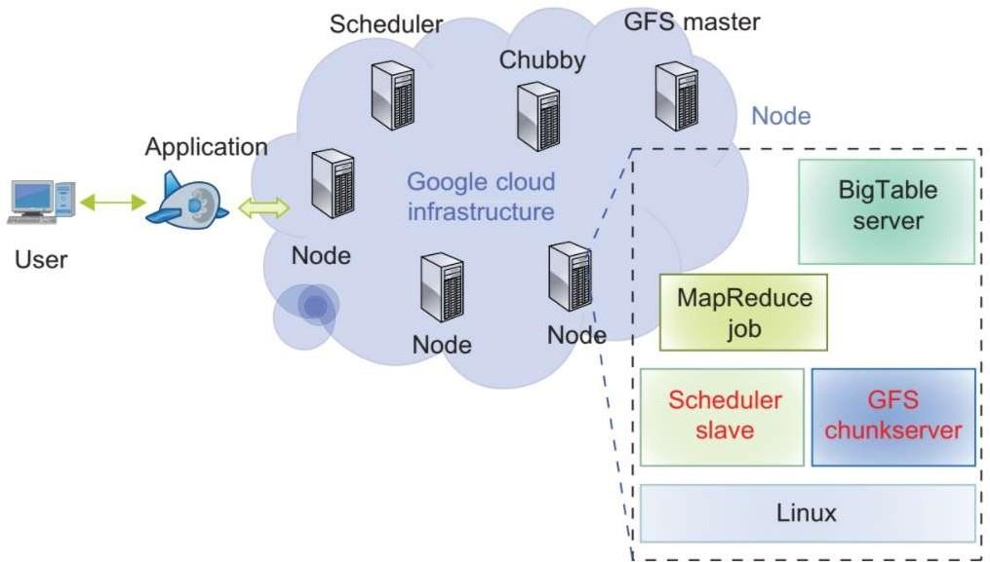

Google App Engine primarily supports Go, PHP, Java, Python, Node.js, .NET, and Ruby applications, although it can also support other languages via "custom runtimes”. Python web frameworks that run on Google App Engine include Django, CherryPy, Pyramid, Flask, web2py and webapp2, as well as a custom Google-written webapp framework and several others designed specifically for the platform that emerged since the release. Any Python framework that supports the WSGI using the CGI adapter can be used to create an application; the framework can be uploaded with the developed application. Third-party libraries written in pure Python may also be uploaded.

Google App Engine supports many Java standards and frameworks. Core to this is the servlet 2.5 technology using the open-source Jetty Web Server, along with accompanying technologies such as JSP. Java Server Faces operates with some workarounds. A newer release of App Engine Standard Java in Beta supports Java8, Servlet 3.1 and Jetty9.Though the integrated database, Google Cloud Datastore, may be unfamiliar to programmers, it is accessed and supported with JPA, JDO, and by the simple low-level API. There are several alternative libraries and frameworks you can use to model and map the data to the database such as Objectify, Slim3 and Jello framework. The Spring Framework works with GAE. However, the Spring Security module (if used) requires workarounds. Apache Struts 1 is supported, and Struts 2 runs with workarounds. The Django web framework and applications running on it can be used on App Engine with modification. Django-nonrel aims to allow Django to work with non-relational databases and the project includes support for App Engine.

**Reliability and support**

* All billed App Engine applications have a 99.95% uptime SLA.
* App Engine is designed in such a way that it can sustain multiple datacentre outages without any downtime. This resilience to downtime is shown by the statistic that the High Replication Datastore saw 0% downtime over a period of a year.
* Paid support from Google engineers is offered as part of Premier Accounts.

#### Bulk downloading

SDK version 1.2.2 adds support for bulk downloads of data using Python. The open-source Python projects gaebar, approcket, and gawsh also allow users to download and back up App Engine data. No method for bulk downloading data from GAE using Java currently exists. **Restrictions**

* Developers have read-only access to the filesystem on App Engine. Applications can use only virtual filesystems, like gae-filestore.
* App Engine can only execute code called from an HTTP request (scheduled background tasks allow for self-calling HTTP requests).
* Users may upload arbitrary Python modules, but only if they are pure-Python; C and Pyrex modules are not supported.
* Java applications may only use a subset (The JRE Class White List) of the classes from the JRE standard edition. This restriction does not exist with the App Engine Standard Java8 runtime.
* A process started on the server to answer a request can't last more than 60 seconds (with the 1.4.0 release, this restriction does not apply to background jobs anymore).
* Does not support sticky sessions (a.k.a. session affinity), only replicated sessions are supported including limitation of the amount of data being serialized and time for session serialization.

App Engine provides more infrastructure to make it easy to write scalable applications, but can only run a limited range of applications designed for that infrastructure. App Engine's infrastructure removes many of the system administration and development challenges of building applications to scale to hundreds of requests per second and beyond. Google handles deploying code to a cluster, monitoring, failover, and launching application instances as necessary. While other services let users install and configure nearly any *NIX compatible software, App Engine requires developers to use only its supported languages, APIs, and frameworks. Current APIs allow storing and retrieving data from the documentoriented Google Cloud Datastore database; making HTTP requests; sending e-mail; manipulating images; and caching. Google Cloud SQL can be used for App Engine applications requiring a relational MySQL compatible database backend. Per-day and per-minute quotas restrict bandwidth and CPU use, number of requests served, number of concurrent requests, and calls to the various APIs, and individual requests are terminated if they take more than 60 seconds or return more than 32MB of data.

Google App Engine's integrated Google Cloud Datastore database has a SQL-like syntax called "GQL" (Google Query Language). GQL does not support the Join statement. Instead, one-to-many and many-to-many relationships can be accomplished using ReferenceProperty (). Google Firestore is the successor to Google Cloud Datastore and replaces GQL with a document-based query method that treats stored objects as collections of documents.

**Google App Engine Features:**

* Blob store for serving large data objects;
* GAE Cloud Storage for storing data objects;
* Page Speed Service for automatically speeding up webpage load times;
* URL Fetch Service to issue HTTP requests and receive responses for efficiency and scaling; and
* Memcache for a fully managed in-memory data store.

**Benefits of GAE**

* Ease of setup and use. GAE is fully managed, so users can write code without considering IT operations and back-end infrastructure. The built-in APIs enable users to build different types of applications. Access to application logs also facilitates debugging and monitoring in production.
* Pay-per-use pricing. GAE's billing scheme only charges users daily for the resources they use. Users can monitor their resource usage and bills on a dashboard.
* Scalability. Google App Engine automatically scales as workloads fluctuate, adding and removing application instances or application resources as needed.
* Security. GAE supports the ability to specify a range of acceptable Internet Protocol (IP) addresses. Users can allow list specific networks and services and blocklist specific IP addresses.

**GAE challenges**

* Lack of control. Although a managed infrastructure has advantages, if a problem occurs in the back-end infrastructure, the user is dependent on Google to fix it.
* Performance limits. CPU-intensive operations are slow and expensive to perform using GAE. This is because one physical server may be serving several separate, unrelated app engine users at once who need to share the CPU.
* Limited access. Developers have limited, read-only access to the GAE filesystem.
* Java limits. Java apps cannot create new threads and can only use a subset of the Java runtime environment standard edition classes.

**Install Google App Engine. Create hello world app and other simple web applications using python/java**

Step 1: Create an account on Google App Engine.

Step 2: Log in to your Google App Engine Account.

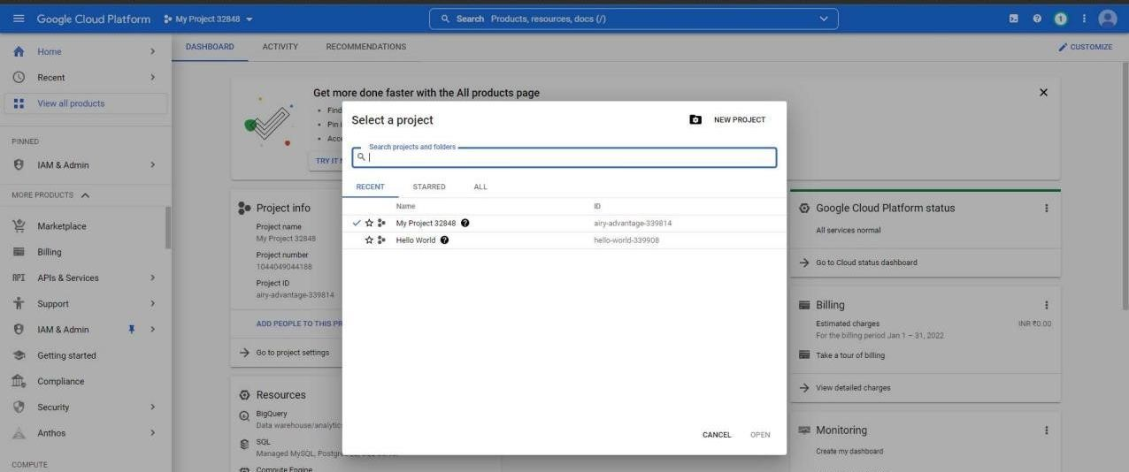

Step 3: Create a New Project and give a Project Name and click on create.

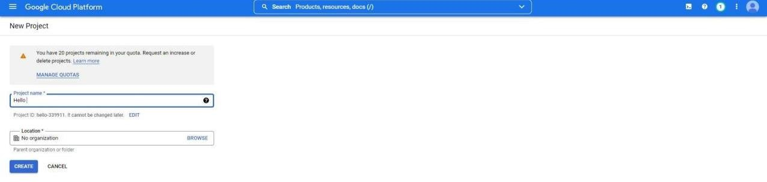

Step 4: Once the project is created click on Activate Cloud Shell on the top right corner.

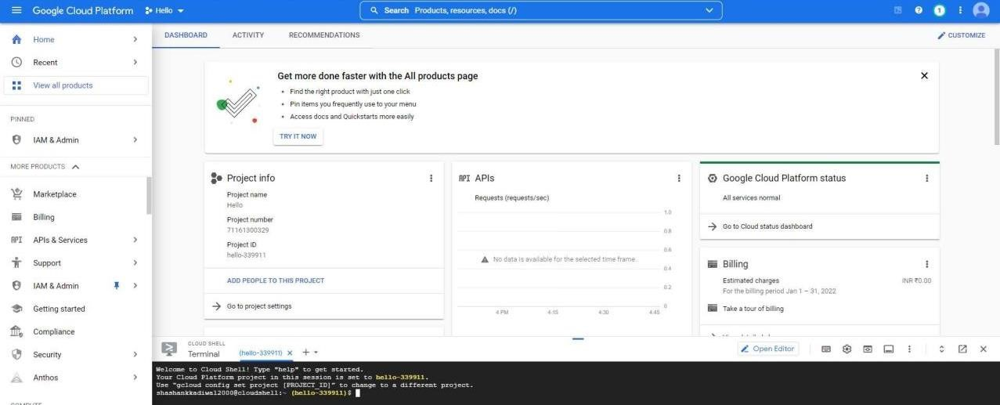

Step 5: Once the cloud shell gets activated type the following command in the terminal and choose the region as South Asia *gcloud app create*

Click on Open Editor.

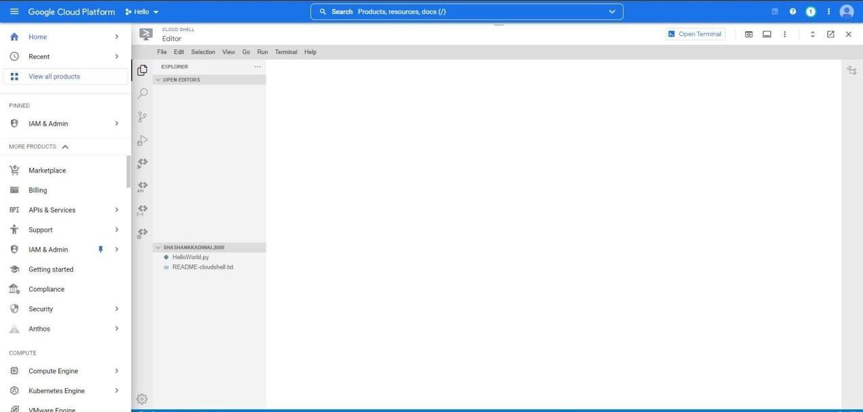

Step 6: Click on File, then, New File.

Step 7: Name the File as main.py and type the following code: *from flask import Flask app = Flask( name ) @app.route('/') def index(): return 'Hello World' app.run(host='127.0.0.1', port=80)*

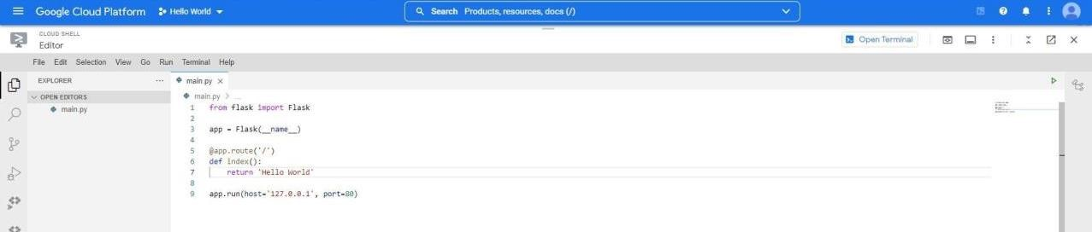

Step8: Create a app.yaml file

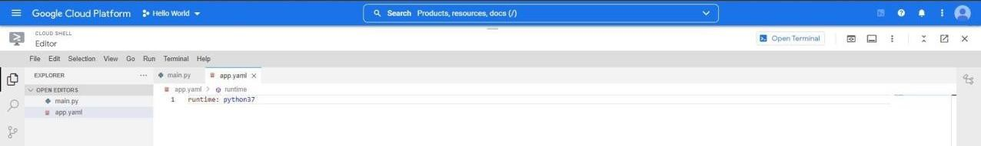

Step 9: Go to terminal and type the following command *python main.py*

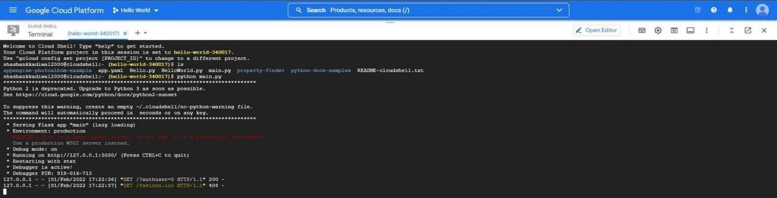

Note: If Flask is not installed, please use the following command

*pip install flask*

Step 10: Open the https link

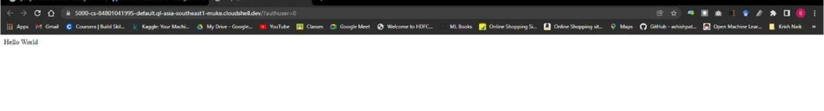

**Dr. AMBEDKAR INSTITUTE OF TECHNOLOGY**

Near Jnana Bharathi Campus, Bengaluru

-

560 056.

)

(

An Autonomous Institution, Aided by Government of Karnataka

MINI PROJECT REPORT

ON

**“UDEMY COURSE RECOMMENDATION SYSTEM”**

BACHELOR OF ENGINEERING

IN

**COMPUTER SCIENCE AND ENGINEERING**

SUBMITTED

BY

**D**

**EEKSHITH**

**S A**

**042**

**1**

**DA18CS**

UNDER THE GUIDANCE OF

**Mr. Praveena M V**

**Asst.Prof, Dept. of CSE**

**Dr.AIT**

**Department of Computer Science & Engineering**

**2021**

**-**

**22**



**Dr.**

**AMBEDKAR INSTITUTE OF TECHNOLOGY**

Near Jnana Bharathi Campus, Bengaluru

-

560 056.

(

An Autonomous Institution, Aided by Government of Karnataka

)

**CERTIFICATE**

This is to certify that the project entitled

**“UDEMY**

**COURSE RECOMMENDATION SYSTEM**

**”**

submitted in the partial fulfillment of the requirement of the 7th semester Cloud Computing

laboratory curriculum during the year 2021

-

22

is a result of bonafide work carried out by

-

**DEEKSHITH S A**

**DA18CS**

**1**

**042**

Signature of the guide

**Mr.**

**Praveena M V**

**Asst.Prof, Dept. of CSE**

**Dr.AIT**

1

.Internal Examiner

2

.External Examiner

**Dr. Siddaraju**

,

Head of Department

Department of CSE, Dr.AIT



#### ACKNOWLEDGEMENT

The sense of contention and elation that accompanies the success of this seminar and the report could be incomplete without mentioning the names of people who have helped me in accomplishing them, people whose constant guidance, support and encouragement resulted in the realization.

I consider myself privileged to express our gratitude and respect towards all those who guided me through the project, **“UDEMY COURSE RECOMMENDATION SYSTEM”.**

I take this opportunity to thank, **Dr. M Meenakshi, Principal, Dr. Ambedkar Institute of Technology,** Bengaluru for his support and encouragement.

I am grateful to **Dr. Siddaraju, Head of Department, CSE, Dr. Ambedkar Institute of Technology**, Bengaluru for providing encouragement and support.

I consider ourselves privileged to express our gratitude and respect towards our guide **Mr.Praveena.M.V** for constant guidance and support for the completion of the project.

Lastly, I thank all the members of the staff both teaching and non-teaching, friends and last but not the least our parents and family, for helping me directly or indirectly in the completion of the project.

**DEEKSHITH S A**

**ABSTRACT**

In this hustling world, online education is a necessity for each one of us to learn and upgrade our CVs and knowledge. E-Learning regains our confidence for work and we can work more enthusiastically. For learning favourable content online, we can utilize Course recommendation system, which are more reliable, since searching of preferred courses will require more and more time which one cannot afford to waste.

In this project, to improve the quality of a course recommendation system, a Hybrid approach by combining content based filtering and collaborative filtering, using Exploratory Data Analysis is presented in the proposed methodology and comparative results have been shown which depicts that the proposed approach shows an improvement in the accuracy, quality and scalability of the course recommendation system than the pure approaches in three different datasets. Hybrid approach helps to get the advantages from both the approaches as well as tries to eliminate the drawbacks of both methods.

**CONTENTS**

# Chapter No Title Page

**No.**

**Chapter 1 Introduction** 130

**Chapter 2 Literature Review**

**2.1** Python 131

2.2 Heroku 133

2.3 Jupyter Notebook 135

2.4 HTML 135

2.5 CSS 135

2.6 Flask 135

2.7 Numpy 135

2.8 Pandas 136

2.9 Scikit Learn 136

**Chapter 3 Requirement Specification**

3.1 Hardware Requirements 137

3.2 Software Requirements 137

**Chapter 4 Design**

4.1 Data Gathering and Preparation 139

4.2 Data Wrangling 139

4.3 Data Analysis 139

4.4 Train Model 140

4.5 Test Model 140

4.6 Deployment 140

**Chapter 5 Development** 141

**Chapter 6 Results** 162

**Chapter 7 Deployment** 164

7.1 Cloud Deployment 164

7.2 Deploying on Heroku 165

**Conclusion** 170

**Bibliography**

#### INTRODUCTION

Recommendation systems have become very popular and are integrated into many applications that we use every day. We are recommended music pieces, articles, books, and movies by many websites and devices in our everyday life. Education is another example of a domain where recommendation systems can help make better and wiser decisions that can affect someone’s future. With the growing number of available online courses, it is difficult to choose the right courses.

In this project, a proof-ofconcept of a course recommendation system is proposed that takes the users’ career goals into consideration in order to help them with choosing the right path toward their desired future job.

Recommendation systems have become extremely popular in recent years, and are used in a variety of applications, as can be observed in daily web browsing. For instance, Amazon1 usually suggests additional items, and YouTube2 provides a recommendation list of further videos. Sometimes the recommendations we receive are surprising as they are exactly the things that we were looking for or things that we are interested in. One of the popular categories in Netflix 3, that uses recommendation systems is called “Top picks for you”. Google Scholar 4 is another popular tool with a recommendation system, useful for getting article recommendations, relevant to a research area. All it needs is the creation of a public Scholar profile. It then analyzes articles, scans the entire web looking for new articles relevant to the user’s research area. Social networks such as Facebook 5 and Instagram6 also have recommendation systems for friend suggestions, pages the user may like, groups to join, or hashtags to use while posting.

Three main approaches for recommendation systems can be distinguished as follows:

1. Collaborative filtering systems recommend items to users based on their similarities to other users. In this method, the system collects and analyzes a large amount of information on user behaviors and activities and then recommends items which are already chosen by other users, which have similar attributes.
2. Content-based filtering systems recommend items to users based on item similarities. Contentbased recommendation systems have profiles of items which contain item descriptions and profiles of user preferences. For example, in the case of movies; the name of the director, actors, genre of the movie and other attributes are provided on item profile. Also, a user profile is built to indicate the type of items that a user likes; the director that a user has shown interest in, the genre of movies a user prefers, actors that a user has watched frequently in movies, etc. In other words, this approach tries to recommend items that are similar to some other items that a user already have chosen or liked in the past.
3. Hybrid recommendation systems that combine collaborative and content-based filtering have recently been demonstrated to be more effective in many cases. Hybrid approaches can be implemented in several ways, such as: making content based and collaborative-based predictions separately and then combining them; adding content-based capabilities to a collaborative-based approach (and vice versa).

**CHAPTER 2**

#### LITERATURE REVIEW

## 2.1 PYTHON

Python is an interpreted, object-oriented, high-level programming language with dynamic semantics. Its highlevel built-in data structures, combined with dynamic typing and dynamic binding, make it very attractive for Rapid Application Development, as well as for use as a scripting or glue language to connect existing components together. Python’s simple, easy to learn syntax emphasizes readability and therefore reduces the cost of program maintenance.

Python supports modules and packages, which encourages program modularity and code reuse. The Python interpreter and the extensive standard library are available in source or binary form without charge for all major platforms, and can be freely distributed. Python is dynamically typed and garbage-collected. It supports multiple programming paradigms, including procedural, object- oriented, and functional programming. Python is a general purpose and high-level programming language. We can use Python for developing desktop GUI applications, websites and web applications. Also, Python, as a high-level programming language, allows you to focus on core functionality of the application by taking care of common programming tasks.

Modules in Python are simply Python files with a .py extension. The name of the module will be the name of the file. A Python module can have a set of functions, classes or variables defined and implemented. A module can contain executable statements as well as function definitions. These statements are intended to initialize the module. They are executed only the first time the module name is encountered in an import statement.

**Features of Python are as follows:**

* Easy to Learn and Use
* Expressive Language
* Interpreted Language
* Free and Open Source
* Object-Oriented Language
* Extensible
* Large Standard Library

Flight Price Prediction using Google App Engine

**Advantages of Python are:**

1. **Presence of Third-Party Modules:** The Python Package Index (PyPI) contains numerous third- party modules that make Python capable of interacting with most of the other languages and platforms.

1. **Extensive Support Libraries:** Python provides a large standard library which includes areas like internet protocols, string operations, web services tools and operating system interfaces. Many high use programming tasks have already been scripted into the standard library which reduces length of code to be written significantly.

1. **Open Source and Community Development:** Python language is developed under an OSI- approved open-source license, which makes it free to use and distribute, including for commercial purposes. Further, its development is driven by the community which collaborates for its code through hosting conferences and mailing lists, and provides for its numerous modules.

1. **Learning Ease and Support Available:** Python offers excellent readability and uncluttered simpleto-learn syntax which helps beginners to utilize this programming language. The code style guidelines, PEP 8, provide a set of rules to facilitate the formatting of code. Additionally, the wide base of users and active developers has resulted in a rich internet resource bank to encourage development and the continued adoption of the language.

1. **User-friendly Data Structures:** Python has built-in list and dictionary data structures which can be used to construct fast runtime data structures. Further, Python also provides the option of dynamic high-level data typing which reduces the length of support code that is needed.

1. **Productivity and Speed:** Python has cleaned object-oriented design, provides enhanced process control capabilities, and4 possesses strong integration and text processing capabilities and its own unit testing framework, all of which contribute to the increase in its speed and productivity. Python is considered a viable option for building complex multi-protocol network applications.

Flight Price Prediction using Google App Engine

**Disadvantages of Python are as follows**:

1. Speed: Python is slower than C or C++.
2. Mobile Application Development: Python is not a very good language for mobile application development.
3. Memory Consumption: Python is not a good choice for memory intensive tasks.
4. Database Access: Python has limitations with database access. Runtime Errors are more.

## 2.2 HEROKU

Heroku is a cloud platform as a service (PaaS) supporting several programming languages. One of the first cloud platforms, Heroku has been in development since June 2007, when it supported only the Ruby programming language, but now supports Java, Node.js, Scala, Clojure, Python, PHP, and Go.For this reason, Heroku is said to be a polyglot platform as it has features for a developer to build, run and scale applications in a similar manner across most languages. Heroku was acquired by Salesforce.com in 2010 for $212 million.



Heroku was initially developed by James Lindenbaum, Adam Wiggins, and Orion Henry for supporting projects that were compatible with the Ruby programming platform known as Rack. The prototype development took around six months. Later on, Heroku faced setbacks because of lack of proper market customers as many app developers used their own tools and environment.[citation needed] In January 2009, a new platform was launched which was built almost from scratch after a three-month effort. In October 2009, Byron Sebastian joined Heroku as CEO. On December 8, 2010, Salesforce.com acquired Heroku as a wholly owned subsidiary of Salesforce.com. On July 12, 2011, Yukihiro "Matz" Matsumoto, the chief designer of the Ruby programming language, joined the company as Chief Architect, Ruby.That same month, Heroku added support for Node.js and Clojure. On September 15, 2011, Heroku and Facebook introduced Heroku for Facebook. At present Heroku supports Redis databases in addition to its standard PostgreSQL.

Applications that are run on Heroku typically have a unique domain used to route HTTP requests to the correct application container or dyno. Each of the dynos are spread across a "dyno grid" which consists of several servers. Heroku's Git server handles application repository pushes from permitted users.

All Heroku services are hosted on Amazon's EC2 cloud-computing platform.

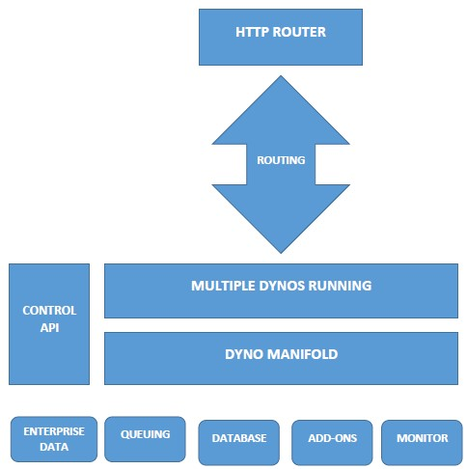

##### Products

**The Heroku Platform**

The Heroku network runs the customer's apps in virtual containers which execute on a reliable runtime environment. Heroku calls these containers "Dynos". These Dynos can run code written in Node, Ruby, PHP, Go, Scala, Python, Java, or Clojure. Heroku also provides custom buildpacks with which the developer can deploy apps in any other language. Heroku lets the developer scale the app instantly just by either increasing the number of dynos or by changing the type of dyno the app runs in.

**Heroku Postgres**

Heroku Postgres is the Cloud database (DBaaS) service for Heroku based on PostgreSQL. Heroku Postgres provides features like continuous protection, rollback, and high availability; also forks, followers, and dataclips.

**Heroku Redis**

Heroku Redis is the customized Redis from Heroku to provide a better developer experience. It is fully managed and is provided as a service by Heroku. It helps in managing instances with a CLI, associate data with Postgres to gain business insights using SQL tools, and lets customer gain performance visibility.

**Heroku Teams**

Heroku Teams is a team management tool which provides collaboration and controls to bring a customer's developers, processes, and tools together in order to build better software. With Heroku Teams, teams can self-organize, add, and manage members, get fine-grained control with app-level permissions and also use collaboration tools like Heroku Pipelines. It also provides delegated administration and centralized billing.

**Heroku Enterprise**

Heroku Enterprise provides services to large companies which help them to improve collaboration among different teams. It provides a set of features like fine-grained access controls, identity federation, and private spaces to manage their enterprise application development process, resources, and users. **Heroku Connect**

Heroku Connect lets users create Heroku apps that can easily integrate with Salesforce deployments at scale. This is done by having a seamless data synchronization between Heroku Postgres databases and Salesforce organizations.

**Heroku Elements**

Heroku Elements provides users with Add-ons (tools and services for developing, extending, and operating the app), Buildpacks (which automate the build processes for the preferred languages and frameworks) and Buttons (a tool for the one-click provisioning, configuring, and deployment of third party components, libraries and patterns).

## 2.3 JUPYTER NOTEBOOK

Jupyter Notebook (formerly IPython Notebooks) is a web-based interactive computational environment for creating Jupyter notebook documents. The "notebook" term can colloquially make reference to many different entities, mainly the Jupyter web application, Jupyter Python web server, or Jupyter document format depending on context. A Jupyter Notebook document is a JSON document, following a versioned schema, containing an ordered list of input/output cells which can contain code, text (using Markdown), mathematics, plots and rich media, usually ending with the “. ipynb" extension.

A Jupyter Notebook can be converted to a number of open standard output formats (HTML, presentation slides, LaTeX, PDF, ReStructuredText, Markdown, Python) through "Download as" in the web interface, via the nbconvert library or "jupyter nbconvert" command line interface in a shell. To simplify visualization of Jupyter notebook documents on the web, the nbconvert library is provided as a service through NbViewer which can take a URL to any publicly available notebook document, convert it to HTML on the fly and display it to the user.

## 2.4 HTML

The Hypertext Markup Language, or HTML is the standard markup language for documents designed to be displayed in a web browser. It can be assisted by technologies such as Cascading Style Sheets and scripting languages such as JavaScript.

## 2.5 CSS

Cascading Style Sheets is a style sheet language used for describing the presentation of a document written in a markup language such as HTML. CSS is a cornerstone technology of the World Wide Web, alongside HTML and JavaScript.

## 2.6 FLASK

Flask is a micro web framework written in Python. It is classified as a microframework because it does not require particular tools or libraries. It has no database abstraction layer, form validation, or any other components where pre-existing third-party libraries provide common functions.

## 2.7 NUMPY

NumPy is a library for the Python programming language, adding support for large, multi- dimensional arrays and matrices, along with a large collection of high-level mathematical functions to operate on these arrays. The ancestor of NumPy, Numeric, was originally created by Jim Hugunin with contributions from several other developers. In 2005, Travis Oliphant created NumPy by incorporating features of the competing Numarray into Numeric, with extensive modifications. NumPy is open-source software and has many contributors. NumPy is a NumFOCUS fiscally sponsored project.

## 2.8 PANDAS

Pandas is a software library written for the Python programming language for data manipulation and analysis. In particular, it offers data structures and operations for manipulating numerical tables and time series. It is free software released under the three-clause BSD license. The name is derived from the term "panel data", an econometrics term for data sets that include observations over multiple time periods for the same individuals. Its name is a play on the phrase "Python data analysis" itself. Wes McKinney started building what would become pandas at AQR Capital while he was a researcher there from 2007 to 2010.

## 2.9 SCIKIT LEARN

Scikit-learn is a free software machine learning library for the Python programming language. It features various classification, regression and clustering algorithms including support vector machines, random forests, gradient boosting, k-means and DBSCAN, and is designed to interoperate with the Python numerical and scientific libraries NumPy and SciPy. Scikit-learn is a NumFOCUS fiscally sponsored project.

# CHAPTER 3 REQUIREMENT SPECIFICATION

The hardware and software components of a computer system that are required to install and use software efficiently are specified in the SRS. The minimum system requirements need to be met for the programs to run at all times on the system.

## 3.1 HARDWARE REQUIREMENTS

The hardware requirements specify the necessary hardware which provides us the platform to implement our programs.

* 2.2 GHz processor (Pentium).
* 8 GB RAM (System Memory).
* 20 GB of hard-drive space.
* VGA capable of 1024 x 768 screen resolution.
* Necessary computer peripherals such as keyboard etc.

## 3.2 SOFTWARE REQUIREMENTS

The software requirement specifies the pre-installed software needed to run the code being implemented in this project.

* Windows Operating System
* Anaconda
* Google Colab
* GitHub
* VSCode
* Python 3.7

# CHAPTER 4

#### DESIGN

Flask is a micro web framework written in Python. It is classified as a microframework because it does not require particular tools or libraries. It has no database abstraction layer, form validation, or any other components where pre-existing third-party libraries provide common functions. However, Flask supports extensions that can add application features as if they were implemented in Flask itself. Extensions exist for object-relational mappers, form validation, upload handling, various open authentication technologies and several common framework related tools.

Natural language processing (NLP) is a subfield of linguistics, computer science, and artificial intelligence concerned with the interactions between computers and human language, in particular how to program computers to process and analyze large amounts of natural language data. The goal is a computer capable of "understanding" the contents of documents, including the contextual nuances of the language within them. The technology can then accurately extract information and insights contained in the documents as well as categorize and organize the documents themselves.

The learning procedures used during machine learning automatically focus on the most common cases, whereas when writing rules by hand it is often not at all obvious where the effort should be directed.

Automatic learning procedures can make use of statistical inference algorithms to produce models that are robust to unfamiliar input (e.g. containing words or structures that have not been seen before) and to erroneous input (e.g. with misspelled words or words accidentally omitted).

Systems based on automatically learning the rules can be made more accurate simply by supplying more input data. However, systems based on handwritten rules can only be made more accurate by increasing the complexity of the rules, which is a much more difficult task. In particular, there is a limit to the complexity of systems based on handwritten rules, beyond which the systems become more and more unmanageable. However, creating more data to input to machine-learning systems simply requires a corresponding increase in the number of man-hours worked, generally without significant increases in the complexity of the annotation process.

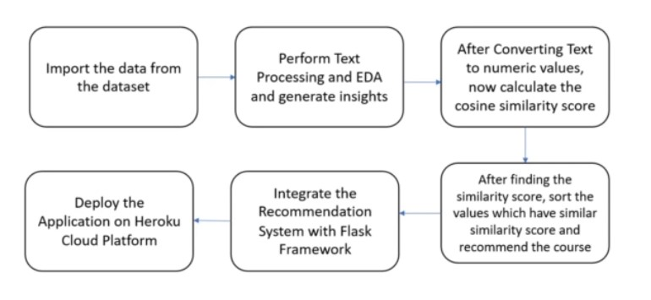

## 4.1 Data Gathering and Preparation:

Data collection is defined as the procedure of collecting, measuring and analysing accurate insights for research using standard validated techniques. A researcher can evaluate their hypothesis on the basis of collected data. In most cases, data collection is the primary and most important step for research, irrespective of the field of research. The approach of data collection is different for different fields of study, depending on the required information. The most critical objective of data collection is ensuring that information-rich and reliable data is collected for statistical analysis so that data-driven decisions can be made for research.

In our application the data is collected by open-source communities such as Kaggle and is curated and prepared for analysis in a structured format which can be used for predictive analysis. The data set for our application is collected from Kaggle which is an open-source community where users can get datasets for statistical analysis.

## 4.2 Data Wrangling

Data wrangling—also called data cleaning, data remediation, or data munging—refers to a variety of processes designed to transform raw data into more readily used formats. The exact methods differ from project to project depending on the data you’re leveraging and the goal you’re trying to achieve. Some examples of data wrangling include:

* Merging multiple data sources into a single dataset for analysis
* Identifying gaps in data (for example, empty cells in a spreadsheet) and either filling or deleting them
* Deleting data that’s either unnecessary or irrelevant to the project you’re working on
* Identifying extreme outliers in data and either explaining the discrepancies or removing them so that analysis can take place

Data wrangling can be a manual or automated process. In scenarios where datasets are exceptionally large, automated data cleaning becomes a necessity. In organizations that employ a full data team, a data scientist or other team member is typically responsible for data wrangling. In smaller organizations, non-data professionals are often responsible for cleaning their data before leveraging it.

## 4.3 Data Analysis:

Data analysis is defined as a process of cleaning, transforming, and modelling data to discover useful information for business decision-making. The purpose of Data Analysis is to extract useful information from data and taking the decision based upon the data analysis. A simple example of Data analysis is whenever we take any decision in our day-to-day life is by thinking about what happened last time or what will happen by choosing that particular decision. This is nothing but analysing our past or future and making decisions based on it. For that, we gather memories of our past or dreams of our future. So that is nothing but data analysis. Now same thing analyst does for business purposes, is called Data Analysis.

##### 4.4 Training the Model

Model training is the phase in the data science development lifecycle where practitioners try to fit the best combination of weights and bias to a machine learning algorithm to minimize a loss function over the prediction range. The purpose of model training is to build the best mathematical representation of the relationship between data features and a target label (in supervised learning) or among the features themselves (unsupervised learning). Loss functions are a critical aspect of model training since they define how to optimize the machine learning algorithms.

Pre-trained models (PTMs) for NLP are deep learning models (such as transformers) which are trained on a large dataset to perform specific NLP tasks. PTMs when trained on the large corpus can learn universal language representations, which can be beneficial for downstream NLP tasks and can avoid training a new model from scratch. That way, pre-trained models can be termed reusable NLP models which NLP developers can use to quickly build an NLP application. Transformers provides a suite of pre-trained deep learning NLP models across different NLP tasks such as text classification, question answering, machine translation, etc. These pre-trained NLP tasks are available for free, with no NLP knowledge required to use them. The first generation Pre-trained models were trained to learn good word embeddings. However, the latest or 2nd generation PTM is trained to learn contextual word embeddings. Details on different types of pre-trained models will be taken up in my next blogs.

## 4.5 Test Model

Model Evaluation is an integral part of the model development process. It helps to find the best model that represents our data and how well the chosen model will work in the future. Evaluating model performance with the data used for training is not acceptable in data science because it can easily generate over optimistic and overfitted models. There are two methods of evaluating models in data science, Hold-Out and CrossValidation. To avoid overfitting, both methods use a test set (not seen by the model) to evaluate model performance. In this method, the mostly large dataset is randomly divided to three subsets:

1. Training set is a subset of the dataset used to build predictive models.
2. Validation set is a subset of the dataset used to assess the performance of model built in the training phase. It provides a test platform for fine tuning model's parameters and selecting the best-performing model. Not all modelling algorithms need a validation set.
3. Test set or unseen examples is a subset of the dataset to assess the likely future performance of a model. If a model fit to the training set much better than it fits the test set, overfitting is probably the cause.

## 4.6 Deployment

Software deployment includes all of the steps, processes, and activities that are required to make a software system or update available to its intended users. Today, most IT organizations and software developers deploy software updates, patches and new applications with a combination of manual and automated processes. Some of the most common activities of software deployment include software release, installation, testing, deployment, and performance monitoring.

Cloud deployment is the process of deploying an application through one or more hosting models—software as a service (SaaS), platform as a service (PaaS) and/or infrastructure as a service (IaaS)—that leverage the cloud. This includes architecting, planning, implementing and operating workloads on cloud.

# CHAPTER 5

#### DEVELOPMENT

**App.py**

from os import read

from flask import Flask, request, render_template

import pandas as pd import numpy as np import neattext.functions as nfx

from sklearn.feature_extraction.text import TfidfVectorizer, CountVectorizer from sklearn.metrics.pairwise import cosine_similarity, linear_kernel

from dashboard import getvaluecounts, getlevelcount, getsubjectsperlevel, yearwiseprofit

app = Flask(__name__)

def getcosinemat(df):

countvect = CountVectorizer()

cvmat = countvect.fit_transform(df['Clean_title']) return cvmat

# getting the title which doesn't contain stopwords and all which we removed with the help of nfx

def getcleantitle(df):

df['Clean_title'] = df['course_title'].apply(nfx.remove_stopwords)

df['Clean_title'] = df['Clean_title'].apply(nfx.remove_special_characters)

return df

def cosinesimmat(cv_mat):

return cosine_similarity(cv_mat)

def readdata():

df = pd.read_csv('UdemyCleanedTitle.csv') return df

# this is the main recommendation logic for a particular title which is choosen

def recommend_course(df, title, cosine_mat, numrec):

course_index = pd.Series(

df.index, index=df['course_title']).drop_duplicates()

index = course_index[title]

scores = list(enumerate(cosine_mat[index]))

sorted_scores = sorted(scores, key=lambda x: x[1], reverse=True)

selected_course_index = [i[0] for i in sorted_scores[1:]]

selected_course_score = [i[1] for i in sorted_scores[1:]]

rec_df = df.iloc[selected_course_index]

rec_df['Similarity_Score'] = selected_course_score

final_recommended_courses = rec_df[[

'course_title', 'Similarity_Score', 'url', 'price', 'num_subscribers']]

return final_recommended_courses.head(numrec)

# this will be called when a part of the title is used,not the complete title!

def searchterm(term, df): result_df = df[df['course_title'].str.contains(term)]

top6 = result_df.sort_values(by='num_subscribers', ascending=False).head(6) return top6

# extract features from the recommended dataframe

def extractfeatures(recdf):

course_url = list(recdf['url']) course_title = list(recdf['course_title'])

course_price = list(recdf['price'])

return course_url, course_title, course_price

@app.route('/', methods=['GET', 'POST']) def hello_world():

if request.method == 'POST':

my_dict = request.form

titlename = my_dict['course']

print(titlename) try:

df = readdata() df = getcleantitle(df)

cvmat = getcosinemat(df)

num_rec = 6

cosine_mat = cosinesimmat(cvmat)

recdf = recommend_course(df, titlename, cosine_mat, num_rec)

course_url, course_title, course_price = extractfeatures(recdf)

# print(len(extractimages(course_url[1])))

dictmap = dict(zip(course_title, course_url))

if len(dictmap) != 0:

return render_template('index.html', coursemap=dictmap, coursename=titlename, showtitle=True)

else:

return render_template('index.html', showerror=True, coursename=titlename)

except:

resultdf = searchterm(titlename, df) if resultdf.shape[0] > 6:

resultdf = resultdf.head(6)

course_url, course_title, course_price = extractfeatures( resultdf) coursemap = dict(zip(course_title, course_url)) if len(coursemap) != 0:

return render_template('index.html', coursemap=coursemap, coursename=titlename, showtitle=True)

else:

return render_template('index.html', showerror=True, coursename=titlename)

else:

course_url, course_title, course_price = extractfeatures( resultdf) coursemap = dict(zip(course_title, course_url)) if len(coursemap) != 0:

return render_template('index.html', coursemap=coursemap, coursename=titlename, showtitle=True)

else:

return render_template('index.html', showerror=True, coursename=titlename)

return render_template('index.html')

@app.route('/dashboard', methods=['GET', 'POST']) def dashboard():

df = readdata()

valuecounts = getvaluecounts(df)

levelcounts = getlevelcount(df)

subjectsperlevel = getsubjectsperlevel(df)

yearwiseprofitmap, subscriberscountmap, profitmonthwise, monthwisesub = yearwiseprofit( df)

return render_template('dashboard.html', valuecounts=valuecounts, levelcounts=levelcounts,

subjectsperlevel=subjectsperlevel, yearwiseprofitmap=yearwiseprofitmap,

subscriberscountmap=subscriberscountmap, profitmonthwise=profitmonthwise, monthwisesub=monthwisesub)

if __name__ == '__main__':

app.run(debug=True)

**dashboard.py**

import pandas as pd

def getvaluecounts(df):

return dict(df['subject'].value_counts())

def getlevelcount(df):

return dict(list(df.groupby(['level'])['num_subscribers'].count().items())[1:])

def getsubjectsperlevel(df):

ans = list(dict(df.groupby(['subject'])['level'].value_counts()).keys()) alllabels = [ans[i][0]+'_'+ans[i][1] for i in range(len(ans))] ansvalues = list(dict(df.groupby(['subject'])[

'level'].value_counts()).values())

completedict = dict(zip(alllabels, ansvalues))

return completedict

def yearwiseprofit(df):

df['price'] = df['price'].str.replace('TRUE|Free', '0') df['price'] = df['price'].astype('float') df['profit'] = df['price'] * df['num_subscribers']

# Converting the time column to year,month,day and many more

df['published_date'] = df['published_timestamp'].apply( lambda x: x.split('T')[0])

# dropping of that index which has '3 hours' as time

df = df.drop(df.index[2066])

# converting the published date to pandas datetime object

df['published_date'] = pd.to_datetime(

df['published_date'], format="%Y-%m-%d")

df['Year'] = df['published_date'].dt.year

df['Month'] = df['published_date'].dt.month

df['Day'] = df['published_date'].dt.day

df['Month_name'] = df['published_date'].dt.month_name()

profitmap = dict(df.groupby(['Year'])['profit'].sum())

subscribersmap = dict(df.groupby(['Year'])['num_subscribers'].sum())

profitmonthwise = dict(df.groupby(['Month_name'])['profit'].sum())

monthwisesub = dict(df.groupby(['Month_name'])['num_subscribers'].sum())

return profitmap, subscribersmap,profitmonthwise,monthwisesub

**course_recommendation_system.ipynb**

import pandas as pd import numpy as np import neattext.functions as nfx import seaborn as sn

from sklearn.feature_extraction.text import TfidfVectorizer,CountVectorizer from sklearn.metrics.pairwise import cosine_similarity,linear_kernel

# %%

df = pd.read_csv('udemy_courses.csv')

df.head()

# %%

# list all the methods present in the neattext function

dir(nfx)

# %%

df['course_title'].iloc[1:5]

# %%

# generating clean text by removing the stopwords and special characters

df['Clean_title'] = df['course_title'].apply(nfx.remove_stopwords)

df['Clean_title'] = df['Clean_title'].apply(nfx.remove_special_characters)

df['Clean_title'].iloc[1:5]

# %%

# vectorizing the course_title

countvect = CountVectorizer()

cv_mat = countvect.fit_transform(df['Clean_title'])

cv_mat

# %%

cv_mat.todense()

# %%

df_cv_words = pd.DataFrame(cv_mat.todense(),columns=countvect.get_feature_names())

df_cv_words

# %%

# cosine similarity matrix

cosine_sim_mat = cosine_similarity(cv_mat)

cosine_sim_mat

# %%

# drop duplicates

course_index = pd.Series(df.index,index = df['course_title']).drop_duplicates()

# %%

course_index

course_dict = dict(course_index)

course_keys = list(course_dict.keys())

touse = {} counter = 0 keyword = 'Java' for key,value in course_dict.items(): if keyword in key:

touse[counter] = key

counter+=1

touse

# %%

temp = df[df['course_title'].str.contains('Python')]

temp.head()

# %%

top6 = temp.sort_values(by = 'num_subscribers',ascending=False).head(6)

top6

# %%

index = course_index['How To Maximize Your Profits Trading Options']

# %%

scores = list(enumerate(cosine_sim_mat[index])) scores

# %%

sorted_score = sorted(scores,key = lambda x:x[1],reverse=True) sorted_score

# %%

# so the sorted score list is a collection of tuples

# which have the index and the value,so i will select the indices first

sorted_indices = [i[0] for i in sorted_score[1:]]

sorted_values = [i[1] for i in sorted_score[1:]]

sorted_values

# %%

recommended_result_df = df.iloc[sorted_indices]

recommended_result_df

recommended_result_df['Similarity_Score'] = np.array(sorted_values)

recommended_result_df

# %%

use_df = recommended_result_df[['Clean_title','Similarity_Score']] use_df

# %%

def recommend_course(title,numrec = 10):

course_index = pd.Series(

df.index, index=df['course_title']).drop_duplicates()

index = course_index[title]

scores = list(enumerate(cosine_sim_mat [index]))

sorted_scores = sorted(scores, key=lambda x: x[1], reverse=True)

selected_course_index = [i[0] for i in sorted_scores[1:]]

selected_course_score = [i[1] for i in sorted_scores[1:]]

rec_df = df.iloc[selected_course_index]

rec_df['Similarity_Score'] = selected_course_score

final_recommended_courses = rec_df[[

'course_title', 'Similarity_Score', 'url', 'price', 'num_subscribers']]

return final_recommended_courses.head(numrec)

ans = recommend_course('Trading Options Basics',20)

ans

# %%

ans.shape

# %%

ans.columns

# %%

df.head()

df.to_csv('UdemyCleanedTitle.csv',index = None)

# %%

**Index.html**

<!doctype html>

<html lang="en">

<head>

<!-- Required meta tags -->

<meta charset="utf-8">

<meta name="viewport" content="width=device-width, initial-scale=1, shrink-to-fit=no">

<!-- Bootstrap CSS --> <link rel="stylesheet"

href="https://stackpath.bootstrapcdn.com/bootstrap/4.3.1/css/bootstrap.min.css" integrity="sha384ggOyR0iXCbMQv3Xipma34MD+dH/1fQ784/j6cY/iJTQUOhcWr7x9JvoRxT2MZw1T" crossorigin="anonymous">

<title>Course Recommendation | Home</title>

</head>

<body>

<nav class="navbar navbar-expand-lg navbar-dark bg-dark">

<div class="container-fluid">

<a class="navbar-brand" href="/">Udemy Course Recommendation System</a> <button class="navbar-toggler" type="button" data-bs-toggle="collapse" data-bstarget="#navbarSupportedContent" aria-controls="navbarSupportedContent" aria-expanded="false" aria-label="Toggle navigation">

<span class="navbar-toggler-icon"></span>

</button>

<div class="collapse navbar-collapse" id="navbarSupportedContent">

<ul class="navbar-nav me-auto mb-2 mb-lg-0">

<li class="nav-item">

<a class="nav-link active" aria-current="page" href="/">Home</a>

</li>

<li class="nav-item">

<a class="nav-link" href="/dashboard">Dashboard</a>

</li>

</ul>

</div>

</div>

</nav>

<main role="main">

<section class="jumbotron text-center">

<div class="container">

<h4 class="jumbotron-heading">Enter The Name of the Course for Recommendations</h4>

<div class="form-floating my-4">

<form action="/" method="POST">

<div class="mb-3">

<input name="course" type="text" class="form-control" id="course">

</div>

<button type="submit" class="btn btn-primary">Recommend</button>

</form>

</div>

{% if showtitle%}

<h4 class="jumbotron-heading">Recommendations for Course <span style = "color: red; font-size:1.5rem;">"{{coursename}}"</span> are shown below</h4>

{%endif%}

</div>

</section>

<div class="album py-5 bg-light">

<div class="container">

{%if showerror%}

<div class="card text-center">

<div class="card-body">

<h5 class="card-title">Special title treatment</h5>

<p class="card-text">Seems Like the Course for {{coursename}} is not available currently,we'll report it to the Course Administrator for uploading the course :)</p> <a href="/" class="btn btn-primary">Home Page</a>

</div>

</div>

{%endif%}

<div class="row">

{%for course in coursemap%}

<div class="col-md-4">

<div class="card mb-4 shadow-sm">

<div class="card-body bg-dark">

<p class="card-text" style = "color:white;">{{course}}</p>

<div class="d-flex justify-content-between align-items-center">

<div class="btn-group">

<a href="{{coursemap[course]}}" target = "_blank" class="btn btn-outlinedanger" style = "color: white;">View Course</a>

</div>

</div>

</div>

</div>

</div>

{%endfor%}

</div>

</div>

</div>

</main>

<!-- Optional JavaScript -->

<!-- jQuery first, then Popper.js, then Bootstrap JS -->

<script src="https://code.jquery.com/jquery-3.3.1.slim.min.js" integrity="sha384-

q8i/X+965DzO0rT7abK41JStQIAqVgRVzpbzo5smXKp4YfRvH+8abtTE1Pi6jizo" crossorigin="anonymous"></script>

<script src="https://cdnjs.cloudflare.com/ajax/libs/popper.js/1.14.7/umd/popper.min.js" integrity="sha384-

UO2eT0CpHqdSJQ6hJty5KVphtPhzWj9WO1clHTMGa3JDZwrnQq4sF86dIHNDz0W1" crossorigin="anonymous"></script>

<script src="https://stackpath.bootstrapcdn.com/bootstrap/4.3.1/js/bootstrap.min.js"

integrity="sha384-JjSmVgyd0p3pXB1rRibZUAYoIIy6OrQ6VrjIEaFf/nJGzIxFDsf4x0xIM+B07jRM" crossorigin="anonymous"></script>

</body>

</html>

----------------------------------------------------------------------------------------------------------------------------

**Dashboard.html**

<!doctype html>

<html lang="en">

<head>

<!-- Required meta tags --> <meta charset="utf-8">

<meta name="viewport" content="width=device-width, initial-scale=1, shrink-to-fit=no">

<!-- Bootstrap CSS --> <link rel="stylesheet"

href="https://stackpath.bootstrapcdn.com/bootstrap/4.3.1/css/bootstrap.min.css" integrity="sha384ggOyR0iXCbMQv3Xipma34MD+dH/1fQ784/j6cY/iJTQUOhcWr7x9JvoRxT2MZw1T" crossorigin="anonymous">

<!-- datasource -->

<script src="https://cdn.jsdelivr.net/npm/chart.js@2.8.0"></script>

<script src="https://cdn.jsdelivr.net/npm/chartjs-plugin-datasource@0.1.0"></script>

<script src="http://d3js.org/d3.v3.min.js" charset="utf-8"></script>

<script src="http://d3js.org/d3.v3.min.js"></script>

<title>Course Recommendation | Dashboard</title>

</head>

<body>

<nav class="navbar navbar-expand-lg navbar-dark bg-dark">

<div class="container-fluid">

<a class="navbar-brand" href="/">Udemy Course Recommendation System</a> <button class="navbar-toggler" type="button" data-bs-toggle="collapse" data-bstarget="#navbarSupportedContent" aria-controls="navbarSupportedContent" aria-expanded="false" aria-label="Toggle navigation">

<span class="navbar-toggler-icon"></span>

</button>

<div class="collapse navbar-collapse" id="navbarSupportedContent">

<ul class="navbar-nav me-auto mb-2 mb-lg-0">

<li class="nav-item">

<a class="nav-link active" aria-current="page" href="/">Home</a>

</li>

<li class="nav-item">

<a class="nav-link" href="/dashboard">Dashboard</a>

</li>

</ul>

</div>

</div>

</nav>

<div class="row">

<!-- Number of Subscribers Domain Wise -->

<div class="col-md-4 col-sm-6">

<div class="card-body">

<label for="banana" style="text-align:center;font-size:1.5rem;font-weight: bold;">Number of

Subscribers Domain Wise</label>

<div class="chart-container my-3" style="position: relative;">

<canvas height="400" width="400" id="chart"></canvas>

</div>

</div>

</div>

<!-- Number of Courses Level Wise -->

<div class="col-md-4 col-sm-6">

<div class="card-body">

<label for="banana" style="text-align:center;font-size:1.5rem;font-weight: bold;">Number of Courses Level Wise</label>

<div class="chart-container my-3" style="position: relative;">

<canvas height="400" width="400" id="chart2"></canvas>

</div>

</div>

</div>

<!-- >Number of Subscribers Year Wise-->

<div class="col-md-4 col-sm-6">

<div class="card-body">

<label for="banana" style="text-align:center;font-size:1.5rem;font-weight: bold;">Number of Subscribers Year Wise</label>

<div class="chart-container my-3" style="position: relative;">

<canvas height="200" width="200" id="chart3"></canvas>

</div>

</div>

</div>

<!--Profit Year Wise-->

<div class="col-md-4 col-sm-6">

<div class="card-body">

<label for="banana" style="text-align:center;font-size:1.5rem;font-weight: bold;">Profit Gained Year Wise</label>

<div class="chart-container my-3" style="position: relative;">

<canvas height="400" width="400" id="chart4"></canvas>

</div>

</div>

</div>

<!-- Profit Month Wise -->

<div class="col-md-4 col-sm-6">

<div class="card-body">

<label for="banana" style="text-align:center;font-size:1.5rem;font-weight: bold;">Profit

Earned Month Wise</label>

<div class="chart-container my-3" style="position: relative;">

<canvas height="400" width="400" id="chart5"></canvas>

</div>

</div>

</div>

<!--Subscribers Count Month Wise-->

<div class="col-md-4 col-sm-6">

<div class="card-body">

<label for="banana" style="text-align:center;font-size:1.5rem;font-weight: bold;">Subscribers Count Month Wise</label>

<div class="chart-container my-3" style="position: relative;">

<canvas height="400" width="400" id="chart6"></canvas>

</div>

</div>

</div>

<!--Number of Subscribers enrolled per subject category-->

<div class = "col-md-12">

<div class="chart-container my-3">

<label for="banana" style="text-align:center;font-size:1.3rem;font-weight: bold;">Number of

Subscribers enrolled per subject category</label>

<canvas id="chart7"></canvas>

</div>

</div>

</div>

{%block javascript%}

<script>

var valuecounts = {{valuecounts|safe}}; var levelcounts = {{levelcounts|safe}};

var subjectsperlevel = {{subjectsperlevel|safe}};

var subscriberscountmap = {{subscriberscountmap|safe}};

var yearwiseprofitmap = {{yearwiseprofitmap|safe}};

var profitmonthwisemap = {{profitmonthwise|safe}};

var monthwisesubmap = {{monthwisesub|safe}};

var domainname = new Array(); var countdomain = new Array(); var levelname = new Array();

var levelcount = new Array();

var levelname2 = new Array(); var levelcount2 = new Array(); var years = new Array(); var profitcount = new Array();

var subscriberscount = new Array();

var months = new Array(); var profitmonthwise = new Array();

var subscriberscountmonth = new Array();

// count per domain first chart

for(const item in valuecounts){ domainname.push(item)

countdomain.push(valuecounts[item])

}

//Number of Courses Level Wise

for(const item in levelcounts){ levelname.push(item)

levelcount.push(levelcounts[item])

}

// Subjects per level {last chart} for(const item in subjectsperlevel){ levelname2.push(item)

levelcount2.push(subjectsperlevel[item])

}

// YearWise Profit

for(const item in yearwiseprofitmap){

years.push(item)

profitcount.push(yearwiseprofitmap[item])

}

// YearWise Subscribers Count

for(const item in subscriberscountmap){

subscriberscount.push(subscriberscountmap[item])

}

//profit monthwise

for(const item in profitmonthwisemap){

months.push(item)

profitmonthwise.push(profitmonthwisemap[item])

}

//subscriberscount monthwise

for(const item in monthwisesubmap){

subscriberscountmonth.push(monthwisesubmap[item])

}

// Chart1

var ctx = document.getElementById('chart').getContext('2d'); var myChart = new Chart(ctx, { type: 'doughnut',

data: {

labels: domainname, datasets: [{ label: domainname, data: countdomain, backgroundColor: [ 'rgb(255, 99, 132)',

'rgb(75, 192, 192)',

'rgb(255, 205, 86)',

'rgb(201, 203, 207)',

'rgb(54, 162, 235)',

'rgba(153, 102, 255)',

'rgba(255, 159, 64)',

'rgba(250, 157, 60)'

],

hoverOffset: 4

}]

}

})

// Chart2

var ctx = document.getElementById('chart2').getContext('2d'); var myChart = new Chart(ctx, { type: 'doughnut', data: { labels: levelname, datasets: [{ label: levelname, data: levelcount, backgroundColor: [ 'rgb(255, 99, 132)',

'rgb(75, 192, 192)',

'rgb(255, 205, 86)',

'rgb(201, 203, 207)',

'rgb(54, 162, 235)',

'rgba(153, 102, 255)',

'rgba(255, 159, 64)',

'rgba(250, 157, 60)'

],

hoverOffset: 4

}]

}

})

//Chart 3

var ctx = document.getElementById('chart3').getContext('2d'); var myChart = new Chart(ctx, {

type: 'bar', data: { labels: years,

datasets: [{

label: "Number of Subscribers", data: subscriberscount, backgroundColor: [ 'rgba(255, 99, 132, 0.2)',

'rgba(54, 162, 235, 0.2)',

'rgba(255, 206, 86, 0.2)',

'rgba(75, 192, 192, 0.2)',

'rgba(153, 102, 255, 0.2)',

'rgba(255, 159, 64, 0.2)',

'rgba(250, 157, 60, 0.1)',

'rgba(250, 157, 62, 0.6)',

'rgba(250, 157, 50, 0.4)',

'rgba(250, 157, 40, 0.5)',

'rgba(250, 157, 10, 0.2)',

'rgba(250, 157, 30, 0.3)',

],

borderColor: [

'rgba(255, 99, 132, 1)',

'rgba(54, 162, 235, 1)',

'rgba(255, 206, 86, 1)',

'rgba(75, 192, 192, 1)',

'rgba(153, 102, 255, 1)',

'rgba(255, 159, 64, 1)',

'rgba(250, 157, 60, 0.1)'

],

borderWidth: 2.5

}]

}

})

//Chart 4

var ctx = document.getElementById('chart4').getContext('2d'); var myChart = new Chart(ctx, {

type: 'bar', data: { labels: years, datasets: [{

label: "Profit Earned Year Wise",

data: profitcount, backgroundColor: [ 'rgba(255, 99, 132, 0.2)',

'rgba(54, 162, 235, 0.2)',

'rgba(255, 206, 86, 0.2)',

'rgba(75, 192, 192, 0.2)',

'rgba(153, 102, 255, 0.2)',

'rgba(255, 159, 64, 0.2)',

'rgba(250, 157, 60, 0.1)',

'rgba(250, 157, 62, 0.6)',

'rgba(250, 157, 50, 0.4)',

'rgba(250, 157, 40, 0.5)',

'rgba(250, 157, 10, 0.2)',

'rgba(250, 157, 30, 0.3)',

],

borderColor: [

'rgba(255, 99, 132, 1)',

'rgba(54, 162, 235, 1)',

'rgba(255, 206, 86, 1)',

'rgba(75, 192, 192, 1)',

'rgba(153, 102, 255, 1)',

'rgba(255, 159, 64, 1)',

'rgba(250, 157, 60, 0.1)'

],

borderWidth: 2.5

}]

}

})

//Chart 5

var ctx = document.getElementById('chart5').getContext('2d'); var myChart = new Chart(ctx, {

type: 'bar', data: { labels: months,

datasets: [{

label: "Profit Earned Month Wise", data: profitmonthwise, backgroundColor: [ 'rgba(255, 99, 132, 0.2)',

'rgba(54, 162, 235, 0.2)',

'rgba(255, 206, 86, 0.2)',

'rgba(75, 192, 192, 0.2)',

'rgba(153, 102, 255, 0.2)',

'rgba(255, 159, 64, 0.2)',

'rgba(250, 157, 60, 0.1)',

'rgba(250, 157, 62, 0.6)',

'rgba(250, 157, 50, 0.4)',

'rgba(250, 157, 40, 0.5)',

'rgba(250, 157, 10, 0.2)',

'rgba(250, 157, 30, 0.3)',

],

borderColor: [

'rgba(255, 99, 132, 1)',

'rgba(54, 162, 235, 1)',

'rgba(255, 206, 86, 1)',

'rgba(75, 192, 192, 1)',

'rgba(153, 102, 255, 1)',

'rgba(255, 159, 64, 1)',

'rgba(250, 157, 60, 0.1)'

],

borderWidth: 2.5

}]

}

})

//Chart 6

var ctx = document.getElementById('chart6').getContext('2d'); var myChart = new Chart(ctx, {

type: 'bar', data: { labels: months,

datasets: [{

label: "Subscriber count Month Wise", data: subscriberscountmonth, backgroundColor: [ 'rgba(255, 99, 132, 0.2)',

'rgba(54, 162, 235, 0.2)',

'rgba(255, 206, 86, 0.2)',

'rgba(75, 192, 192, 0.2)',

'rgba(153, 102, 255, 0.2)',

'rgba(255, 159, 64, 0.2)',

'rgba(250, 157, 60, 0.1)',

'rgba(250, 157, 62, 0.6)',

'rgba(250, 157, 50, 0.4)',

'rgba(250, 157, 40, 0.5)',

'rgba(250, 157, 10, 0.2)',

'rgba(250, 157, 30, 0.3)',

],

borderColor: [

'rgba(255, 99, 132, 1)',

'rgba(54, 162, 235, 1)',

'rgba(255, 206, 86, 1)',

'rgba(75, 192, 192, 1)',

'rgba(153, 102, 255, 1)',

'rgba(255, 159, 64, 1)',

'rgba(250, 157, 60, 0.1)'

],

borderWidth: 2.5

}]

}

})

// Chart 7

var ctx = document.getElementById('chart7').getContext('2d'); var myChart = new Chart(ctx, {

type: 'line', data: {

labels: levelname2,

datasets: [

{

label: "Number of Subscribers enrolled per subject category", data: levelcount2, backgroundColor: [ 'rgba(255, 99, 132, 0.2)',

'rgba(54, 162, 235, 0.2)',

'rgba(255, 206, 86, 0.2)',

'rgba(75, 192, 192, 0.2)',

'rgba(153, 102, 255, 0.2)',

'rgba(255, 159, 64, 0.2)',

'rgba(250, 157, 60, 0.1)',

'rgba(250, 157, 62, 0.6)',

'rgba(250, 157, 50, 0.4)',

'rgba(250, 157, 40, 0.5)',

'rgba(250, 157, 10, 0.2)',

'rgba(250, 157, 30, 0.3)',

],

borderColor: [

'rgba(255, 99, 132, 1)',

'rgba(54, 162, 235, 1)',

'rgba(255, 206, 86, 1)',

'rgba(75, 192, 192, 1)',

'rgba(153, 102, 255, 1)',

'rgba(255, 159, 64, 1)',

'rgba(250, 157, 60, 0.1)'

],

borderWidth: 2.5

},

]

}

})

</script>

{%endblock%}

<!-- Optional JavaScript -->

<!-- jQuery first, then Popper.js, then Bootstrap JS -->

<script src="https://code.jquery.com/jquery-3.3.1.slim.min.js" integrity="sha384-

q8i/X+965DzO0rT7abK41JStQIAqVgRVzpbzo5smXKp4YfRvH+8abtTE1Pi6jizo" crossorigin="anonymous"></script>

<script src="https://cdnjs.cloudflare.com/ajax/libs/popper.js/1.14.7/umd/popper.min.js" integrity="sha384-

UO2eT0CpHqdSJQ6hJty5KVphtPhzWj9WO1clHTMGa3JDZwrnQq4sF86dIHNDz0W1" crossorigin="anonymous"></script>

<script src="https://stackpath.bootstrapcdn.com/bootstrap/4.3.1/js/bootstrap.min.js"

integrity="sha384-JjSmVgyd0p3pXB1rRibZUAYoIIy6OrQ6VrjIEaFf/nJGzIxFDsf4x0xIM+B07jRM" crossorigin="anonymous"></script>

</body>

</html>

# CHAPTER 6

#### RESULTS

Model Evaluation is an integral part of the model development process. It helps to find the best model that represents our data and how well the chosen model will work in the future. Evaluating model performance with the data used for training is not acceptable in data science because it can easily generate over optimistic and overfitted models. There are two methods of evaluating models in data science, Hold-Out and CrossValidation. To avoid overfitting, both methods use a test set (not seen by the model) to evaluate model performance.

We tried the application and received an 95% accuracy on the training dataset and approx. 80% accuracy on the test data. The model looks really quite well trained and can be used for prediction of flight prices based on various parameters.

**Ouput dashboard Screenshot**

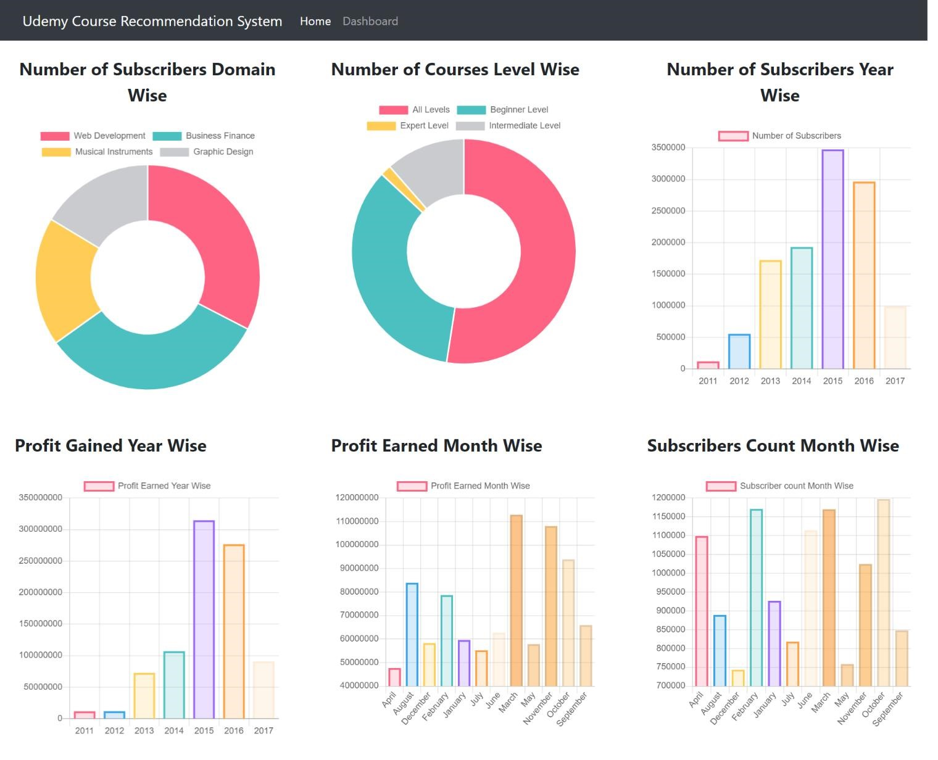

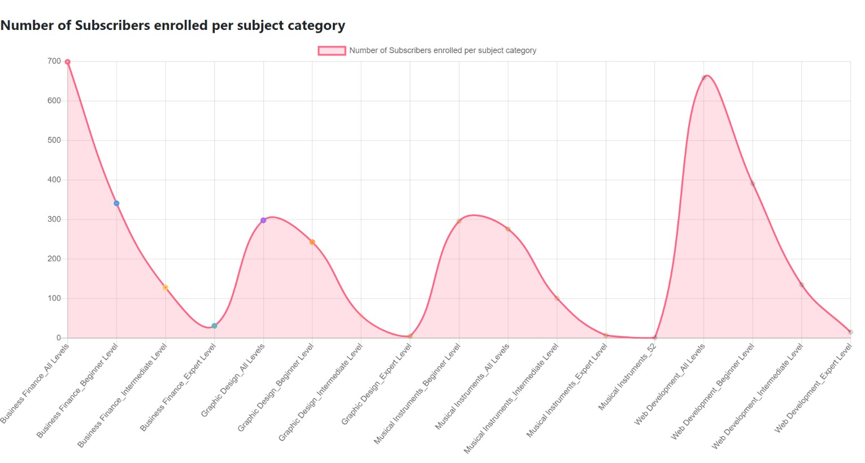

**Search page Screenshot**

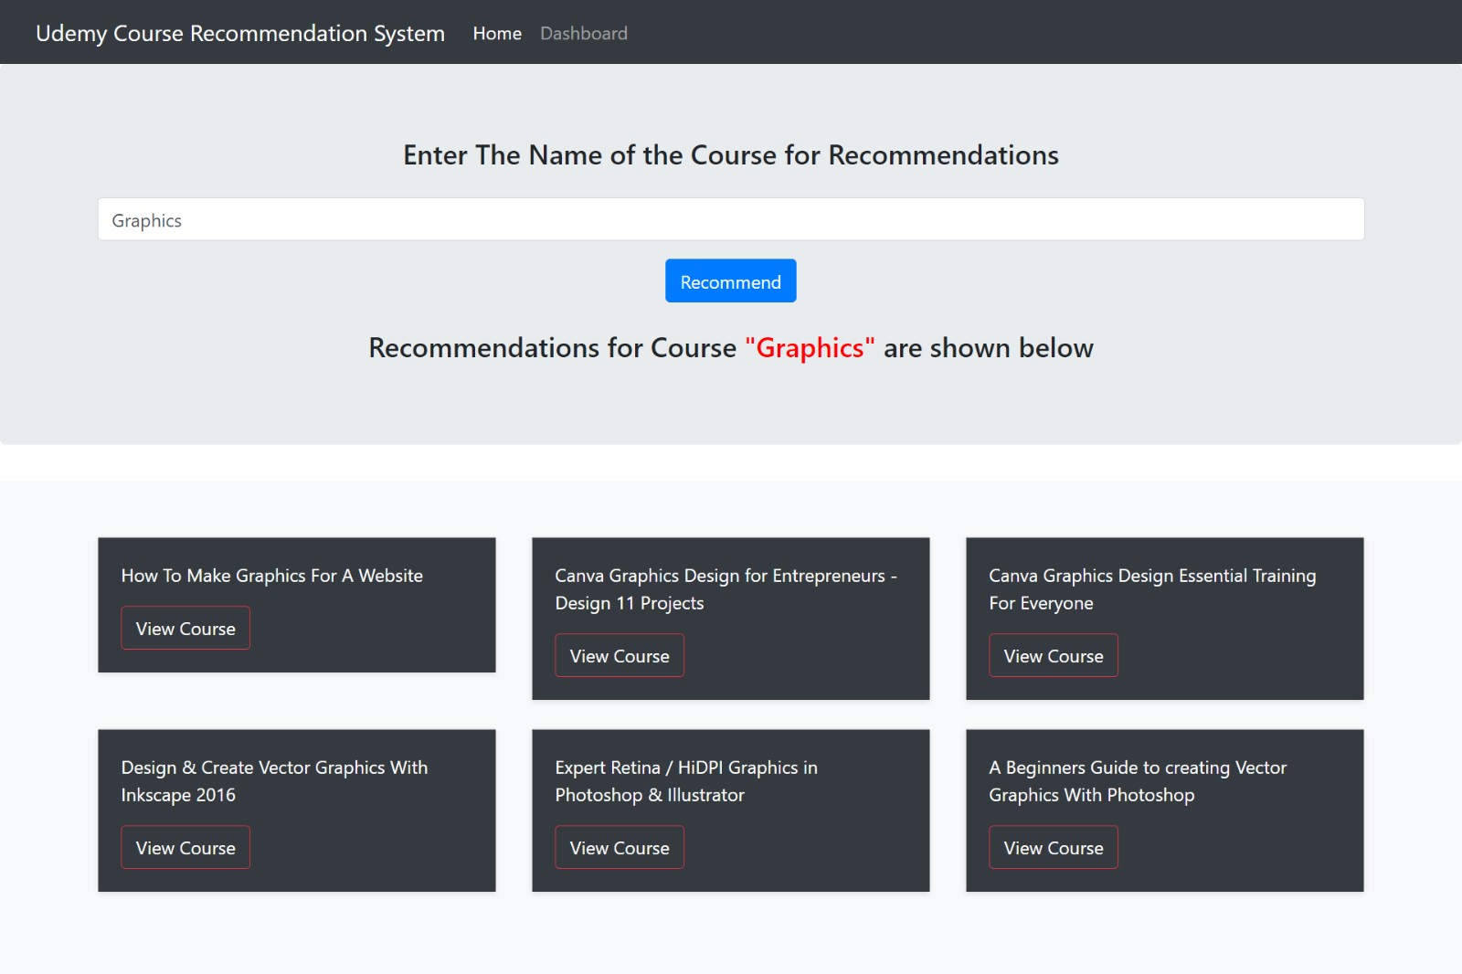

# CHAPTER 7

#### DEPLOYMENT

Software deployment includes all of the steps, processes, and activities that are required to make a software system or update available to its intended users. Today, most IT organizations and software developers deploy software updates, patches and new applications with a combination of manual and automated processes. Some of the most common activities of software deployment include software release, installation, testing, deployment, and performance monitoring.

Software development teams have innovated heavily over the past two decades, creating new paradigms and working methods for software delivery that are designed to meet the changing demands of consumers in an increasingly connected world. In particular, software developers have created workflows that enable faster and more frequent deployment of software updates to the production environment where they can be accessed by users.

## 7.1 CLOUD DEPLOYEMENT

Cloud deployment is the process of deploying an application through one or more hosting models—software as a service (SaaS), platform as a service (PaaS) and/or infrastructure as a service (IaaS)—that leverage the cloud. This includes architecting, planning, implementing and operating workloads on cloud.

**Advantages of Cloud Deployment:**

* Faster and simplified deployments. Automate builds that deploy code, databases and application releases, including resource provisioning.
* Cost savings. Control costs using consumption-based pricing and eliminate capex-heavy on-premises environments.
* Platform for growth. Leverage the global infrastructure provided by cloud service providers (CSPs) to seamlessly expand the business into other geographies.
* New digital business models. Exploit the continuous release of features and services by CSPs, incubate new technologies and innovate digital business models.
* Business resiliency. Architect for the availability and fault-tolerance CSPs offer and ensure disaster recovery and business continuity of applications to make the business resilient.
* Agility and scalability. Use autoscaling and scalability to meet peak demands of the business without provisioning for excess capacity.
* Geographic reach. Access applications from any location, on any device, leveraging the connectivity backbone of CSPs.
* Operational efficiency. Use the inherent automation enabled by cloud to increase operational efficiency and reduce human effort.
* A competitive edge. Leverage infrastructure as code and development, security and operations to reduce the time to market for new features and stay ahead of the competition.
* Empowered users. Increase productivity by empowering users with self-service options on cloud, such as portals, DevOps pipelines, and executive and operational dashboards.

For our application we will be using Google App Engine for deployment of the application which provides a platform as a service to host our applications

## 7.2 Deploying on Heroku:

The process consists of three parts, they are:

1. Setting up a Flask web application
2. Creating a Machine Learning model
3. Deploy the app on Heroku

**Setting up a Flask Web Application for Model Deployment Using Heroku**

We want the user to interact with our webpage, as opposed to a static website where the user merely reads the content. Web applications are websites that have functionality and an interactive element.

In our scenario, a user will have an input field, and we provide a recommendation to the user by collecting sample data. Before that, we must first comprehend how a browser interacts with other online pages by making requests. A standard browser will submit a GET request using the HTTP protocol and a POST request to send data through the web page.

To handle user requests, we have to create a lot of code as Python programmers. Instead of developing repeated code to handle requests, a guy named Armin Ronacher decided to put it in a library and call it flask as a joke.

Flask is a web server framework that requires us to organize our code in a specific way. Begin by creating two folders in your project directory called Models and Templates. We will be using the Static folder to include any optional CSS code. You should create a python file on the same root level as the files and name it app.py. After that, make an index HTML file and save it in the templates directory. The fact that the app.py and index.html files are empty is unimportant.

**Virtual Environment**

We can easily install flask using pip (pip install Flask) and run our web application because flask is just a third-party library. A difficulty arises when the web application is dependent on specific versions of python and other third-party libraries. Imagine that your web application is working great until a thirdparty library update comes along and changes the names of particular functions. Your programme will become unusable as a result of this. We can use a so-called virtual environment to get around this problem(virtualenv).

Consider a virtual environment to be a folder that is ignorant of any other libraries on your computer. It can access only the libraries installed in this location.

We will need you to install virtualenv on your current Python installation to build a virtual environment.

To put it another way, open a terminal (or command) line and write the following:

***pip install virtualenv***

Use the following command to check whether you have it installed in the system:

***virtualenv --version***

After installation, you can create a virtual environment. We should generate virtual environment files inside the MyApp directory. Now change your current directory using CMD or open the MyApp folder and choose New Terminal.

Depending upon your system, use the following commands:

***python3 -m venv virtual (Mac) py -3 -m venv virtual (Windows)***

Now the above command creates a virtual folder with necessary files. For the activation of the environment, use the below command.

***. virtual/bin/activate (Mac) virtualScriptsactivate (Windows)***

Use deactivate to close the environment. Now you should see something similar to this in CMD.

***(virtual) myapp %***

Now you can explore the bin folder inside virtual that consists of pip and python pre-installed. New libraries installed will be added to this folder.

Finally, use this command to download the flask framework.

***pip install Flask***

Now you can see the flask files in your bin folder.

**Model Deployment using Heroku**

We’re ready to start our Heroku deployment now that our model has been trained, the machine learning pipeline has been set up, and the application has been tested locally. There are a few ways to upload your application source code onto Heroku. The easiest way is to link a GitHub repository to your Heroku account.

Although flask is fantastic, they help in local development. It does not handle the kind of queries that a typical web server does. We’ll need to install the gunicorn python library to take care of a large number of requests.

We need to tell Heroku to use the gunicorn now that we’ve installed it. We accomplish this by generating a file called procfile that has no extension (for instance, Procfile.txt is not valid.). The file consists of commands to execute on the startup.

It’s just one line of code that tells a web server which files to run first when someone logs into the application. In this case, the name of our application file is app.py, and the name of the application is also app.

**requirements.txt**

It is a text file containing the python packages required to execute the application. If these packages do not found in the environment application is running, it will fail. I recommend you mention the particular versions of all your libraries.

**Steps for Model Deployment Using Heroku**

Once files had uploaded to the GitHub repository, we are now ready to start deployment on Heroku. Follow the steps below:

1. After sign up on heroku.com then click on Create new app.

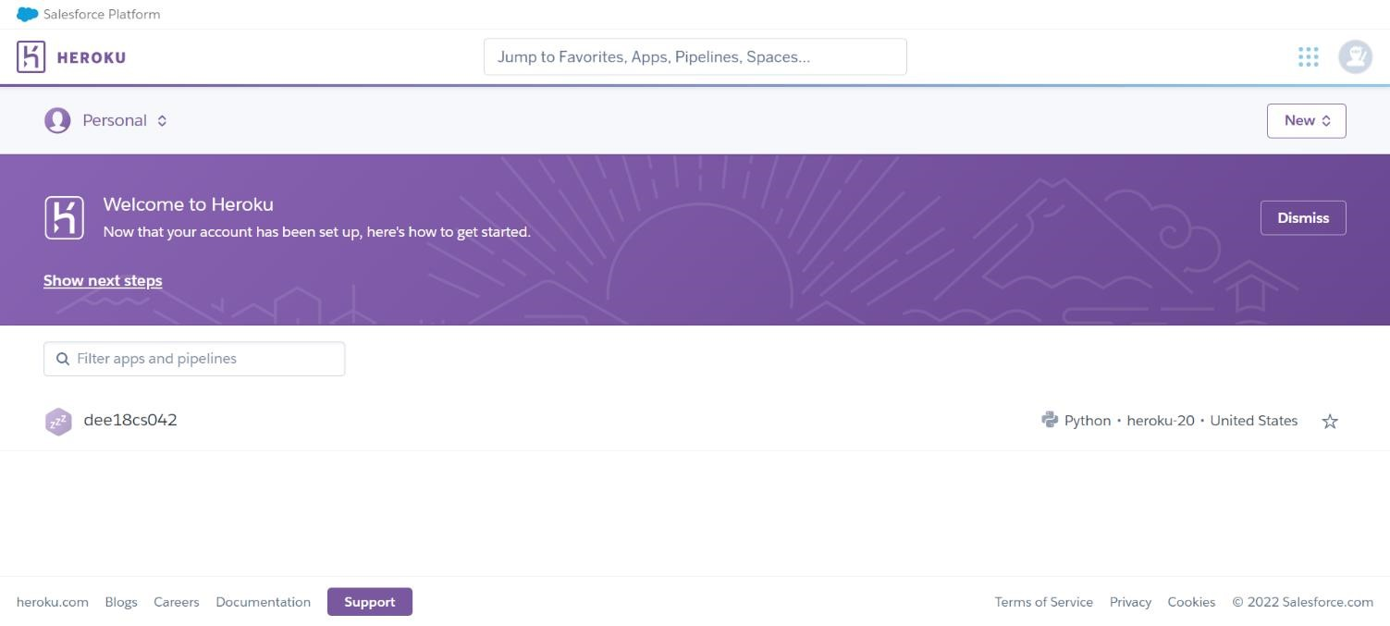

1. Enter App name and region.

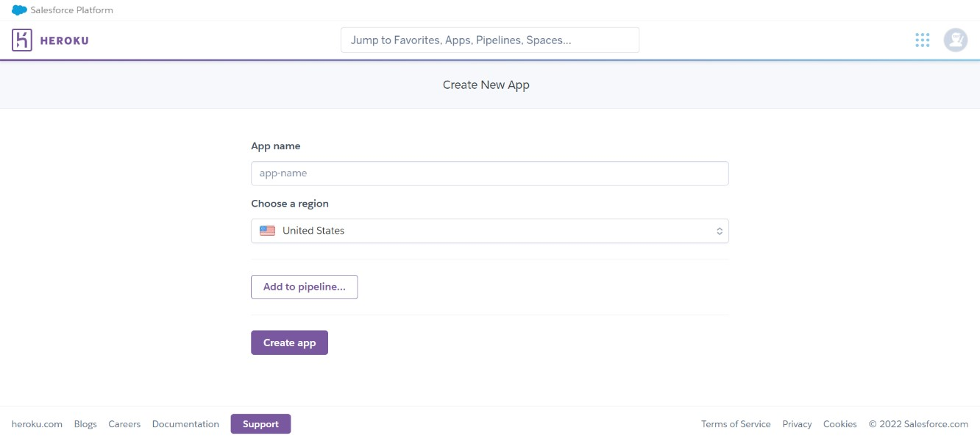

1. Connect to your GitHub repository where code is uploaded In the search, choose the repository where you had uploaded the project code.

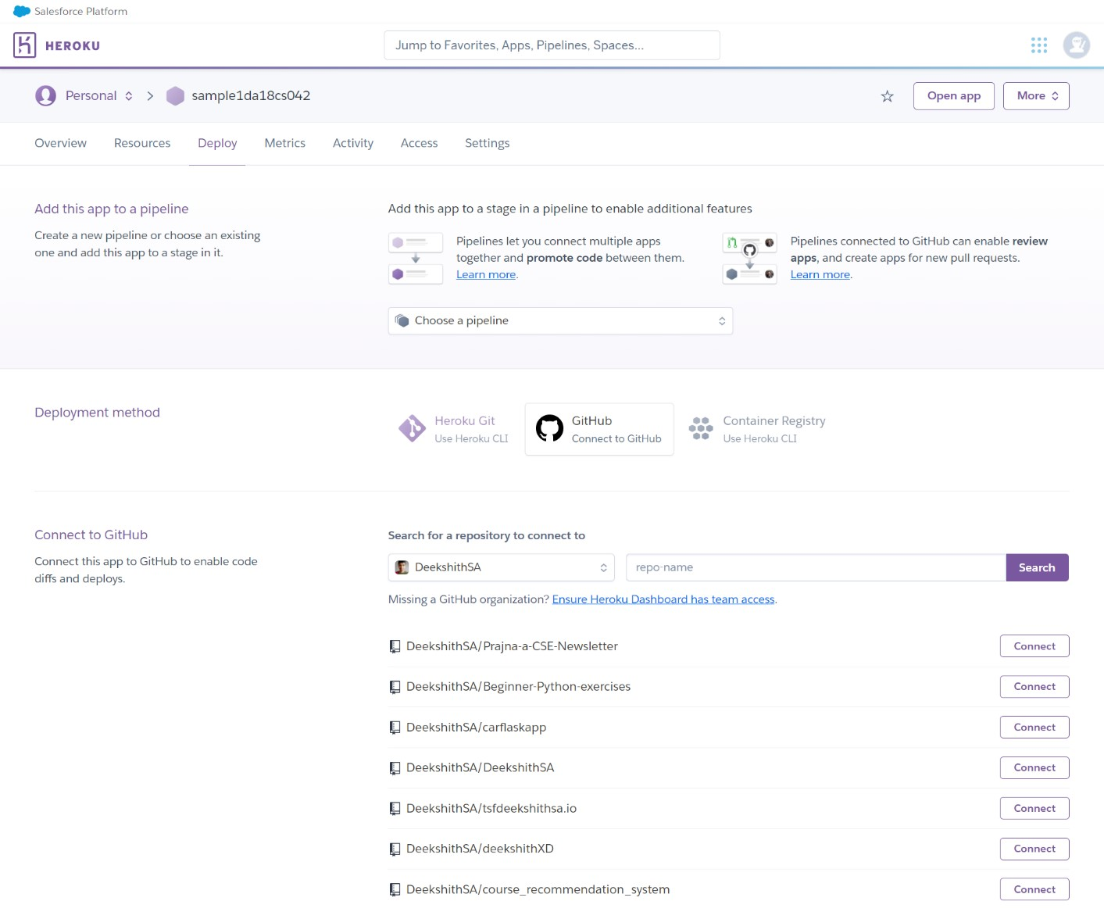

1. Deploy branch

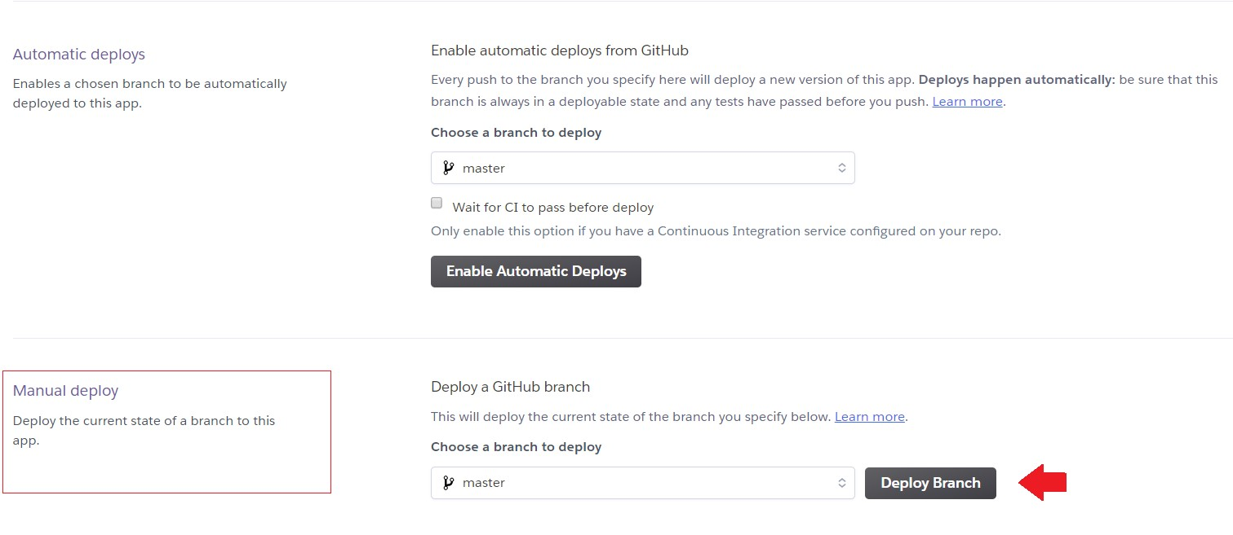

1. Wait 5–10 minutes

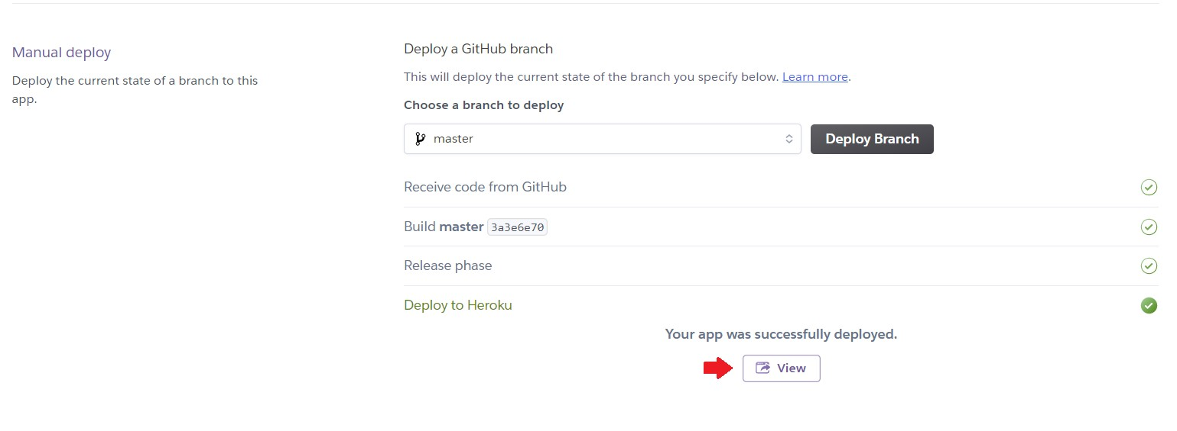

The app is published at URL: <https://dee18cs042.herokuapp.com/>

### CONCLUSION

In this project, to improve the accuracy, quality and scalability of course recommendation system, a Hybrid approach by unifying content based filtering and collaborative filtering; using Singular Value Decomposition (SVD) as a classifier and Cosine Similarity is presented in the proposed methodology. Existing pure approaches and proposed hybrid approach is implemented on three different Movie datasets and the results are compared among them. Comparative results depicts that the proposed approach shows an improvement in the accuracy, quality and scalability of the movie recommendation system than the pure approaches. Also, computing time of the proposed approach is lesser than the other two pure approaches.

#### BIBLIOGRAPHY

**Books:**

Distributed and Cloud Computing: From Parallel Processing to the Internet of Things, Kai Hwang

**URLs:**

<https://vitalflux.com/nlp-pre-trained-models-explained-with-examples/><https://research.library.mun.ca/13339/1/thesis.pdf>

[https://www.analyticsvidhya.com/blog/2021/10/a-complete-guide-on-machine-learning-modeldeployment-using-heroku/](https://www.analyticsvidhya.com/blog/2021/10/a-complete-guide-on-machine-learning-model-deployment-using-heroku/)

#### INDUSTRY CERTIFICATION IN SALESFORCE

